Revision Guide for Chapter 12
Contents
Revision Checklist

Revision Notes
Speed of light 4
Invariance of the speed of light 4
Doppler effect 5
Special relativity: the basic postulates 6
Time dilation 6
Expansion of the Universe 8
Microwave background radiation 9
Galaxy 9

Summary Diagrams
Velocities from radar ranging 11
Distances in light travel time 12
Non-relativistic Doppler shift 13
Space-time diagrams 14
Two-way radar speed measurement 1 15
Two-way radar speed measurement 2 16
Doppler shift: Two-way and one-way 17
Relativistic effects 18
The light clock 19
Time dilation at v/c = 3/5 20
Red shifts of galactic spectra 21
Hubble’s Law and the age of the Universe 22
The ‘age’ of the Universe 23
The cosmic microwave background radiation 24
The ladder of astronomical distances 26
The history of the Universe 27
Measuring black holes 28

Revision Checklist
Back to list of Contents

I can show my understanding of effects, ideas and relationships by describing and explaining:
12: Our Place in the Universe
how radar-type measurements are used to measure distances in the solar system
how distance is measured in time units (e.g. light-seconds, light-years)
Revision Notes: speed of light, invariance of speed of light
Summary Diagrams: Velocities from radar ranging, Distances in light travel time
how relative velocities are measured using radar techniques
e.g. using a simple pulse technique
Revision Notes: Doppler effect
Summary Diagrams: Velocities from radar ranging, Non-relativistic Doppler shift, Space-time diagrams, Two-way radar speed measurement 1, Two-way radar speed measurement 2, Doppler shift – two-way and one-way
Effect of relativistic time dilation
Revision Notes: speed of light, invariance of speed of light, special relativity: the basic postulates, time dilation
Summary Diagrams: Relativistic effects, The light clock, Time dilation at v / c = 3 / 5
the evidence supporting the Hot Big Bang model of the origin of the Universe:
• cosmological red-shifts and the Hubble law
• cosmological microwave background radiation
Revision Notes: expansion of the Universe, microwave background radiation
Summary Diagrams: Red-shifts of galactic spectra, Hubble's law and the age of the Universe, The 'age' of the Universe, The cosmic microwave background radiation

I can use the following words and phrases accurately when describing astronomical and cosmological effects and observations:
2: Our Place in the Universe
microwave background, red-shift, galaxy
Revision Notes: expansion of the Universe, microwave background radiation, galaxy

I can interpret:
2: Our Place in the Universe
charts, graphs and diagrams which use logarithmic ('times') scales to display data, such as distance, size, mass, time, energy, power and brightness
Summary Diagrams: Distances in light travel time, The ladder of astronomical distances, The history of the Universe

I can calculate:
2: Our Place in the Universe
distances and ages of astronomical objects
Summary Diagrams: Distances in light travel time, The history of the Universe, The ladder of astronomical distances
distances and relative velocities using data from radar-type observations
e.g. using time-of-flight
Revision Notes: Doppler effect
Summary Diagrams: Velocities from radar ranging, Two-way radar speed measurement 1, Two-way radar speed measurement 2, Doppler shift – two-way and one-way, Measuring black holes
Effect of relativistic time dilation with
$γ=\frac{1}{\sqrt{1−{v^{2}}/{c^{2}}}}$
Revision Notes: speed of light, invariance of speed of light, special relativity: the basic postulates, time dilation
Summary Diagrams: Relativistic effects, The light clock, Time dilation at v / c = 3 / 5

Revision Notes
Back to list of Contents

Speed of light
The speed of light is the speed at which all electromagnetic radiation (“light”) travels from one place to another.
The speed of light is best thought of as the conversion factor between measures of space and time. If the unit of time is the second, the natural unit of distance becomes the light-second. On this basis, the speed of light is simply unity, 1 light-second per second. If distance is defined in terms of metres, the speed of light is a little less than 300 000 km s–1. No causal influence can pass from one place to another faster than the speed of light. The speed of light in free space, denoted by c, is independent of the velocity of its source or of the velocity of an observer measuring it. The speed of light is today a defined quantity, used to define the metre as the distance travelled by light in a certain time.
The speed of light is a fundamental constant of nature. In the nineteenth century, Maxwell showed theoretically that there should exist electromagnetic waves travelling in free space at a speed c, which could be calculated from the theory and was in good agreement (to three significant figures) with the measured speed of light, 3.00 × 108 m s–1.
Terrestrial methods to measure the speed of light in free space were first developed in the nineteenth century.
More precise methods of measuring the speed of electromagnetic waves in a vacuum have been developed, including Froome's 1958 determination for microwaves accurate to
0.1 km s–1. The speed of light in a vacuum is now defined as 299 792 458.0 m s–1 exactly. This definition is used to define the metre as the length of the path travelled by light in a vacuum during a time interval of 1 / 299 792 458th of a second.
Back to Revision Checklist

Invariance of the speed of light
Light travels at the same speed in empty space relative to any object, no matter how the object is moving relative to any other object.
The speed of light in free space is therefore said to be invariant.
Light and all electromagnetic waves travel at a speed of nearly 300 000 km s–1, which is found to be the same by all observers, no matter how they are moving relative to one another. Ultimately this is because the speed of light is the constant conversion factor between measures of space and time, the same for all observers. It is often useful to think of the speed of light as simply unity – as 1 second of time per light-second of distance.
The invariance of the speed of light is essential to radar measurements of the scale of the solar system. If a signal sent from Earth to another planet returns after say 10 minutes, we assume that it was reflected 5 minutes after it was sent, exactly half-way through the time interval, and that the distance to the planet is 5 light minutes. Thus we assume that the radar signal travels at the same speed on its outward and return journeys, regardless of any relative motion of the Earth and the planet. This would not necessarily be true for a spacecraft sent to the planet and back.
Evidence that the speed of light is invariant was obtained by comparing the time taken by light to travel the same distance in two perpendicular directions. If the speed of light is affected by the speed of the Earth's motion around the Sun which is about 30 km s–1, there would be a time difference between light travelling parallel to the Earth's direction of motion in space and light travelling perpendicular to the Earth's direction of motion. Michelson and Morley devised an experiment to detect this difference but were unable to do so, even though the apparatus they used was capable of measuring the predicted difference. They concluded that the speed of light is not affected by the motion of the Earth. The invariance of the speed of light is one of the postulates of Einstein's theory of special relativity.
Back to Revision Checklist

Doppler effect
The Doppler effect is the change of frequency of waves from a source due to relative motion between the source and the observer. The Doppler shift for sound, which travels through a medium such as air, is slightly different according to whether the source or receiver of the sound is moving relative to the air. However, for velocities v low compared with the speed of sound c, the result is the same: Δ f / f = v / c where Δ f is the change in frequency f. The frequency increases if source and receiver are coming together and decreases if they are moving apart.
For electromagnetic waves, including radar, which travel through empty space, the Doppler effect depends only on the relative velocity v of source and receiver. No meaning can be attached to their absolute movement. But again, for velocities small compared with the speed of light the ratio v / c gives the fractional change in frequency or in wavelength. As with sound, the frequency increases and the wavelength decreases if source and receiver are coming together, and the frequency decreases and the wavelength increases if they are moving apart.
For light from receding objects, this shift to longer wavelengths is towards the red end of the visible spectrum and is referred to as a red shift.
The Doppler effect is the basis of a wide range of applications including radar speed traps, air traffic control, blood flow measurements, imaging techniques and relative velocity measurements in astronomy.
For electromagnetic waves, the full relativistic expression for the Doppler effect for a source receding at relative speed v is:
$\frac{λ+Δλ}{λ}=\sqrt{\frac{1+v/c}{1−v/c}}$.
This can also be written as:
$$\frac{λ+Δλ}{λ}=\frac{1+v/c}{\sqrt{1−{v^{2}}/{c^{2}}}}=γ(1+v/c)$$
in which γ is the relativistic time dilation factor.
If v<<c the relativistic expression is approximated by:
$\frac{Δλ}{λ}≈\frac{v}{c}$ as discussed above.

Back to Revision Checklist

Special relativity: the basic postulates
Relativity starts from the idea that there is no such thing as ‘not moving’, interpreted as ‘being at rest’. This is because all velocities are relative velocities. So ‘at rest’ means simply ‘moving with me’.
This means that the laws of physics cannot depend in any way on the relative motion of platforms from which they are investigated. This is the first postulate of the Special Theory of Relativity:

Postulate 1
Physical laws must take the same form for all observers, no matter what their state of uniform motion relative to one another.
Secondly, relativity takes account of the fact that the speed of light is the same for all observers. This leads to the second postulate:

Postulate 2
The speed of light c is a universal constant. It has the same value, regardless of the motion of the platform from which it is observed.
This means that the speed of light is not merely the speed of something. It is the constant conversion factor between time and space. Distances are measured fundamentally in light travel time. Then the relation between space and time is the same for everybody, regardless of any relative velocities they may have.
1 light-second of distance is 1 second of light time. For that reason, the ‘natural’ value to give to the speed of light is just 1. Distance is then measured in seconds, as is time.
A consequence of this is that all speeds are relative to the speed of light. A speed v must the thought of as the ratio v/c.
It is quite wrong to think of the theory of relativity as saying that ‘everything is relative’. It does say that all speeds are relative. But it then says that many important things, including the form of all the basic laws of physics, are unaffected by relative velocity. So relativity is mainly about what is not relative!
Back to Revision Checklist

Time dilation
The theory of special relativity shows that clocks in motion relative to one another measure time intervals differently. This does not mean that clocks can’t be trusted. A clock travelling with you (so at rest relative to you) will record a time interval known as ‘proper time’, or, less formally ‘wristwatch time’. An observer moving relative to you will see your clock ticking at a different rate, but can calculate the time interval you observe, and this comes out to be exactly what you record. So ‘wristwatch time’ is invariant, even though the clocks differ.
A light clock and ‘wristwatch time’
Think of a clock consisting of two mirrors between which a pulse of light bounces. If the mirrors are distance y apart, the time interval between a pulse of light leaving a mirror and returning is simply 2τ = 2y/c. It forms a simple clock, ticking time at intervals 2τ. This is the time as seen sitting beside the device, at rest with respect to the clock. This is the ‘wristwatch time’, time as reckoned on a clock attached to you and so travelling at the same speed as you relative to anything else.
Time dilation
Now imagine the clock moving past you, at right angles to the spacing between the mirrors.
The light must now seem to take a diagonal path, longer than before. But the speed of light must stay the same. Thus the time t it takes must be longer than the wristwatch time τ.
Suppose the clock travels distance 2x between the departure and return of the light. The light has to travel along a diagonal of length ct, and back along a similar diagonal. The length of each diagonal is, by Pythagoras, given by:
$${\left(\text{ct}\right)}^{2}=x^{2}+{\left(cτ\right)}^{2}$$
If the speed c is to be the same, the times τ and t must be related by:
$$τ^{2}=t^{2}−{\left(x/c\right)}^{2}$$
This is the well-known time dilation. Putting x = vt gives:
$$t=\frac{τ}{\sqrt{1−v^{2}/c^{2}}}$$
or t = γτ where γ is the relativistic factor:
$γ=\frac{1}{\sqrt{1−v^{2}/c^{2}}}$.
Time on a clock moving past you runs slower than on a clock travelling with you. To put it another way, clocks travelling with you record the maximum possible time differences.

The interval between space-time events
The time interval τ is very fundamental. The wristwatch time τ is just the time recorded as you go from one space-time event to another without moving in space. That is, you just sit tight and wait, travelling only in time. One event happens ‘here, now’, and the other happens ‘here, later’. τ is the elapsed time.
The ultimate speed c
What is the wristwatch time for a photon going from one space-time event to another (e.g. from its emission to its absorption)?
In one dimension,
$τ^{2}=t^{2}−{\left(x/c\right)}^{2}$
and the distance x is simply ct. Thus
$$τ^{2}=t^{2}−{\left(\text{ct}/c\right)}^{2}=t^{2}−t^{2}=0$$
Along the path of a photon, the wristwatch time stands still. This is why ‘nothing goes faster than light’. If it did, it would arrive before it left. Effect would precede cause.
The ‘ultimate speed’ c is not a kind of speed barrier. It is part of the basic structure of cause and effect between space-time events. In other words, the speed of light is a fundamental quantity linking measurements of space and time, not merely being the speed of propagation of electromagnetic waves. Its importance is universal.
Back to Revision Checklist

Expansion of the Universe
Evidence for the expansion of the Universe from a hot dense initial state comes from:

- observations of the cosmic microwave background radiation, showing that the Universe has cooled as it expanded,
- observations of the speed of recession of galaxies, from red-shifts of their spectra.

The Big Bang theory of the Universe states that the Universe was created in a massive explosion from a point when space, time and matter were created. This event is thought to have occurred about 14 billion years ago. As the Universe expanded and cooled, first nucleons, then nuclei, atoms, molecules, stars and planets and eventually galaxies formed.

The Big Bang theory originated from the discovery by the American astronomer Edwin Hubble that the distant galaxies are receding from us at speeds in proportion to their distances. Hubble's law states that a galaxy at distance d is receding at speed v = H d, where H is a constant of proportionality known as the Hubble constant.

Estimates of the value of the Hubble constant have varied considerably over the years, mainly because of the difficulty of establishing a good distance scale.

Relationships
Red-shift z = change in wavelength / wavelength emitted = $\frac{Δλ}{λ_{\text{emitted}}}$
Thus wavelength observed / wavelength emitted = $\frac{λ_{\text{emitted}}+Δλ}{λ_{\text{emitted}}}$ = 1 + z
scale of Universe at time of observation / scale of Universe at time of emission = 1 + z

Back to Revision Checklist

Microwave background radiation
The detection of microwave background radiation was one piece of evidence that led to the acceptance of the Big Bang theory of the expansion of the Universe.

Arno Penzias and Robert Wilson discovered the cosmic microwave background radiation. It is understood as the cooled-down relic of hot radiation which once filled the Universe.

The Cosmic Background Explorer (COBE) satellite launched in 1989 very accurately mapped out the microwave background radiation. The measurements confirmed it to be black body radiation at a temperature of 2.7 K.

When the Universe became cool enough, electrons and ions combined to form neutral atoms, the Universe became transparent and photons existing at that time could then travel long distances through the Universe. This change is thought to have occurred when the Universe was about a hundred thousand years old, about a thousandth of its present size and at a temperature of about 3000 K. As a result of the expansion of the Universe, the photons now detected have stretched in wavelength by this factor of about a thousand, so that they are now in the microwave range of the electromagnetic spectrum, at a temperature of the order of 3 K.

Back to Revision Checklist

Galaxy
A galaxy is an assembly of millions of millions of stars, held together by their mutual gravitational attraction (and by “dark matter” also present).

The Sun is one of about 1011 stars in the Milky Way galaxy, our home galaxy, which is over 100 000 light-years in diameter. In comparison, the nearest star to the Sun is just a few light-years away.

Astronomers reckon the Universe contains about 1011 galaxies. The average distance between two neighbouring galaxies is of the order of ten times the diameter of an average galaxy.

Deep space photographs reveal that galaxies group together in clusters, each containing thousands of galaxies, and that clusters link together to form superclusters of galaxies separated by vast empty regions or voids.

Back to Revision Checklist

Summary Diagrams
Back to list of Contents

Velocities from radar ranging
Back to Revision Checklist

Distances in light travel time
Back to Revision Checklist

Non-relativistic Doppler shift

Back to Revision Checklist

Space-time diagrams

Back to Revision Checklist

Two-way radar speed measurement 1

Back to Revision Checklist

Two-way radar speed measurement 2

Back to Revision Checklist

Doppler shift: Two-way and one-way

Back to Revision Checklist

Relativistic effects

Back to Revision Checklist

The light clock

Back to Revision Checklist

Time dilation at v/c = 3/5

Back to Revision Checklist

Red shifts of galactic spectra

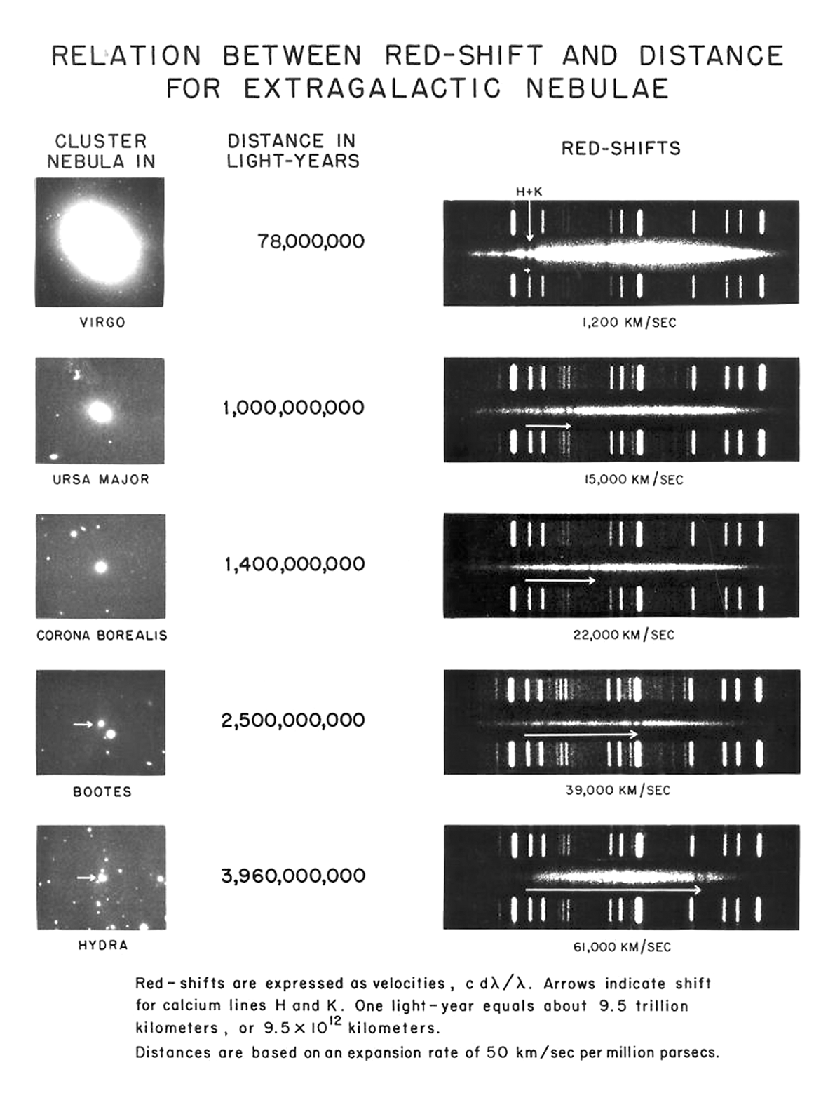

Back to Revision Checklist

Hubble’s Law and the age of the Universe

Back to Revision Checklist

The ‘age’ of the Universe

Back to Revision Checklist

The cosmic microwave background radiation
The decoupling of the radiation – the Universe becomes transparent to electromagnetic radiation.
The expansion of the Universe stretches the wavelength of the radiation, decreasing its frequency and therefore reducing the energy density and lowering the temperature.

Back to Revision Checklist

The ladder of astronomical distances

Here are some techniques for measuring distance, arranged to show how they overlap.

Back to Revision Checklist

The history of the Universe
A spiral timeline showing the history of the Universe on a logarithmic scale
Back to Revision Checklist

Measuring black holes

Back to Revision Checklist

Back to list of Contents

