Revision Guide for Chapter 5
Contents
Revision Checklist

Revision Notes
Electron microscopes and atomic microscopy 4
Crystals 7
Metals 7
Ceramics 7
Polymers 8
Glass 9
Composite material 9
Cracks 10
Bonding 10
Electrical conductivity and resistivity 12
Atom 14

Summary Diagrams
Cracks and stress 15
Stopping cracks 16
Fracture energy and tensile strength 17
Shaping and slipping 18
Metals and metal alloys 19
Ceramic versus metals 20
Explaining stiffness and elasticity 21
Conduction by metals and semiconductors 23
Free electron model of metal 26
Conduction in doped silicon 27
Looking inside wood 28
Looking inside metals and ceramics 29
Looking inside polymers 30
Looking inside glasses 31

Revision Checklist
Back to list of Contents

I can show my understanding of effects, ideas and relationships by describing and explaining:
5: Looking Inside Materials
the evidence we have for the sizes of atoms and molecules
Revision Notes: electron microscopes and atomic microscopy
differences between the mechanical behaviour of different classes of materials - metals, glass and ceramics, polymers, composites – in terms of their structure and bonding, including effects of dislocations and of crack propagation
Revision Notes: crystals, metals, ceramics, polymers, glass, composite material, cracks, bonding
Summary Diagrams: Cracks and stress, Stopping cracks, Fracture energy and tensile strength, Shaping and slipping, Metals and metal alloys, Ceramics versus metals, Explaining stiffness and elasticity
differences between the electrical behaviour of conductors, semi-conductors and insulators, in terms of the number of free charge carriers
Revision Notes: electrical conductivity and resistivity
Summary Diagrams: Conduction by metals and semiconductors, Free electron model of metal, Conduction in doped silicon

I can interpret:
5: Looking Inside Materials
images produced by SEM (scanning electron microscopy), STM (scanning tunnelling microscopy), AFM (atomic force microscopy) and other images to obtain information about the structure of materials
Revision Notes: electron microscopes and atomic microscopy
Summary Diagrams: Looking inside wood, Looking inside metals and ceramics, Looking inside polymers, Looking inside glasses

I can calculate or make justified estimates of:
5: Looking Inside Materials
the size of a molecule or atom
interatomic forces using the value of the Young modulus (e.g. in steel)
Revision Notes: atom
Summary Diagrams: Explaining stiffness and elasticity, Fracture energy and tensile strength

I can show an appreciation of the growth and use of scientific knowledge by:
5: Looking Inside Materials
giving examples of how the properties of a material are linked to its structure and so affect its use
Revision Notes: metals, ceramics, polymers, glass, composite material
Summary Diagrams: Cracks and stress, Stopping cracks, Fracture energy and tensile strength, Shaping and slipping, Metals and metal alloys, Ceramics versus metals, Explaining stiffness and elasticity

In giving a presentation I have shown that I can:
5: Looking Inside Materials
use resources to gather, analyse and communicate information about the properties and uses of a material
e.g. textile fibres, building materials, designed materials, semiconductor materials

Revision Notes
Back to list of Contents

Electron microscopes and atomic microscopy
Modern evidence for the sizes, spacing and arrangement of atoms and molecules in materials comes from microscopes able to resolve very small objects.

In a scanning electron microscope (SEM), the sample is coated with a conducting film and bombarded with a fine scanning electron beam which is focused onto the sample. Electrons are emitted from the impact point and collected by a detector. As the beam scans the surface, the detector current changes according to the number of electrons ejected from the surface. The detector current from the SEM is used to modulate the brightness of a cathode ray tube display, thus re-creating the surface scanned in the SEM.

Surface of a CD-ROM, imaged by scanning electron microscope

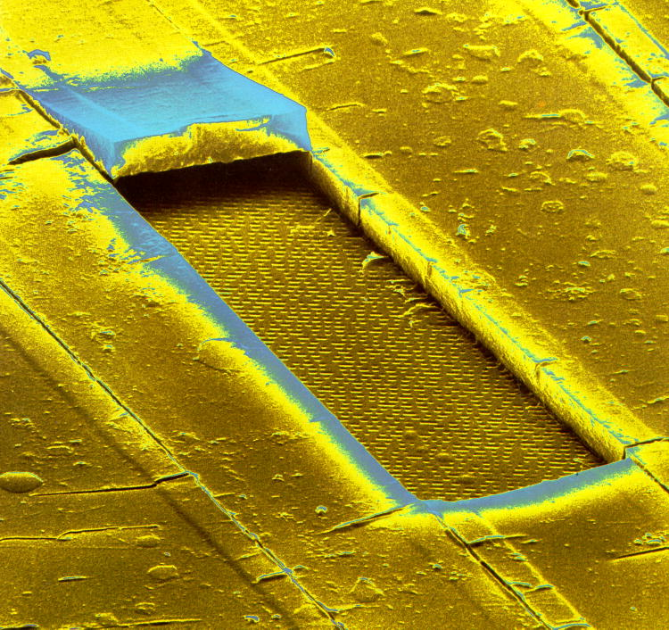

The scanning tunnelling microscope (STM) was invented in 1981 by Gerd Binnig and Heinrich Rohrer. Electrons tunnel across a gap between a surface and a fine conducting tip above the surface. This is a quantum-mechanical effect.

The tunnelling current is very sensitive to the gap width, and so may be used to determine the shape of the surface and to form an image of the surface on a display screen. Surface structures as small as individual atoms can be seen in STM images.

Organic molecules on a silver surface, imaged by scanning tunnelling microscope

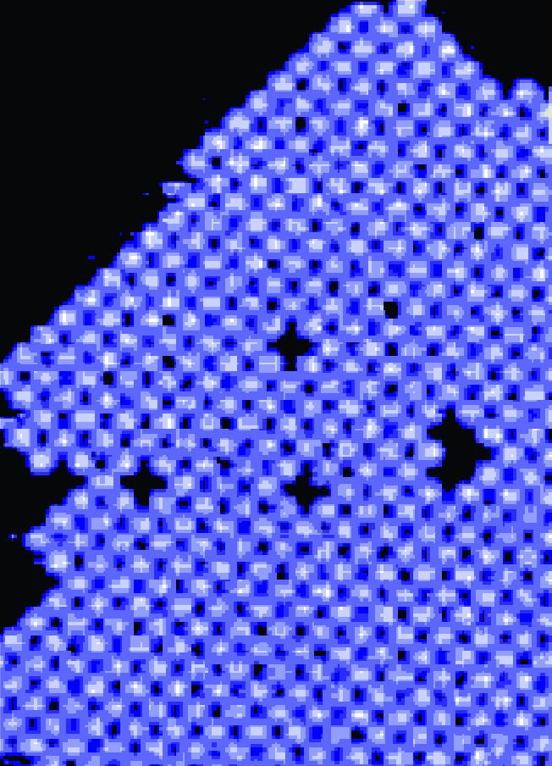

The atomic force microscope (AFM) also uses a probe tip, but detects interatomic forces which pull the tip towards or push it away from the surface. The tip is at the end of a tiny lever which bends as the tip moves. A laser beam reflected from the lever detects this movement.

Back to Revision Checklist

Crystals
Crystals include materials such as sodium chloride and diamond, in which atoms or ions are arranged in a large-scale regular lattice. Sodium chloride is an ionic crystal, in which positive and negative ions are held together by electrical forces between the ions. Diamond is a covalently bonded crystal in which electrons are shared between neighbouring atoms.

Back to Revision Checklist

Metals
Metals are usually shiny, can be worked into shape, are relatively strong and conduct heat and electricity well. The atoms in a metal are ionised, freeing electrons which move throughout the whole material. The positive ions form a crystalline lattice, 'glued together' by this 'sea' of electrons surrounding them. This is the nature of the metallic bond: strong but non-directional.

Generally, metals are polycrystalline, composed of tiny randomly orientated crystal grains. The atoms in each grain are arranged regularly in rows in a lattice.

Stress in a metal causes planes of atoms to slip. Slip is made easier by the presence of dislocations; faults in the crystal lattice. This is what makes metals ductile and malleable. Slip also makes metals tough, because cracks are blunted by slip, and do not propagate well.

Metals are good conductors of electricity because of the presence of conduction electrons. The conduction electrons also increase the thermal conductivity of metals. But note that insulators such as marble (and notably diamond) can also be excellent thermal conductors.

Back to Revision Checklist

Ceramics
Ceramics are materials such as bricks, tiles, plates and cups. All these materials are strong and stiff but are brittle.

Ceramic materials consist of lots of tiny crystals or grains locked together in a glassy cement. This structure is usually achieved by high-temperature firing. Thus a ceramic is a material in which tiny ionic crystals are embedded in an amorphous glass.

Ceramics are opaque. The internal crystal boundaries scatter light falling on the material, so that the light does not penetrate the material.

Ceramics are stiff and strong because the ionic bonding of the crystals is both strong and directional. The crystals are hard to deform. The combination of small irregularly arranged crystals and glassy material binding them together makes the ceramic equally strong and stiff in all directions.

Ceramics are useful because they are resistant to chemicals and to high temperatures.

A major drawback of a ceramic is its brittleness. Cracks propagate rather easily in ceramics. If a crack forms in a ceramic under tension, the stress at the tip of the crack is large because of the small area of the tip. The tip opens up, and the crack propagates. Typically a fractured ceramic or glass shows a clean break. Tiles or sheet glass are cut to size by scribing a crack on the surface, and then bending the material so that the crack runs right through it.

Back to Revision Checklist

Polymers
Polymers are materials composed of long-chain molecules. Each molecule is a long chain of (usually) carbon atoms joined to each other by covalent bonds with other atoms joined to the carbon atoms at regular spacings along the molecule.

In solid polymers, the molecules are either tangled together as an amorphous structure or folded in a regular arrangement as a crystalline structure. Bonds form between polymer molecules that hold them in place relative to each other.

When a polymer such as rubber or polythene is stretched, its molecules become straighter. Before stretching, the molecules are tangled together. The elastic limit of polymers such as polythene can be quite small, so that materials made of it can easily be permanently deformed. This is the origin of the term 'plastic' applied to them.

Back to Revision Checklist

Glass
A glass is a solid whose structure is essentially that of a liquid with the structure 'frozen' in place. A glass is therefore an amorphous solid. The silicate groups in glass form strong bonds with one another to make up a rigid structure without any regularity. The bonds are directional so the atoms are unable to slip past each other.

Other substances that can exist in a glassy state include the glazes on pottery or china, clear toffee and rubber at the temperature of liquid nitrogen.

Glass is brittle. When subjected to stress minute surface cracks concentrate stress at the tip of a crack. The crack widens and travels through the glass, as the tip of the crack fractures, forming a fresh tip where the process repeats. This behaviour is used when cutting glass.

Back to Revision Checklist

Composite material
A composite material is a combination of two or more materials which enhances the desirable properties of each of the component materials.

Consider the combination of features exhibited e.g. by bone, wood, paper, leather, glass fibre and concrete.

Bone is stiff, strong and relatively light-weight compared with steel.
Wood is a little more flexible but is nevertheless very strong and even less dense than bone.
Glass fibre panels are strong, reasonably stiff and much less dense than steel panels.
Concrete is stiff as well as being strong in compression, capable of supporting large loads.

These properties derive from the structure of the composites. For example:

Wood consists of cellulose fibres cemented together by a natural resin called lignin. The fibres provide tensile strength. Because the fibres are intertwined and glued together by the lignin, stresses are shared amongst the fibres, and the wood is reasonably stiff and strong. It is also tough, because if one fibre fails, the extra stress is shared out by the lignin amongst other fibres.

Concrete is a composite of stones held together by cement. Concrete is used extensively in the building and construction industry because it can be moulded into any desired shape and set on site. Concrete is strong in compression because of the presence of the stones which press against each other. Concrete is weak in tension, because cracks easily propagate through the cement. This problem is avoided by using steel reinforcing rods.

Back to Revision Checklist

Cracks
Cracks in an object weaken it and may cause it to break apart. Understanding why certain materials crack more easily than others requires knowledge of the microstructure of the material.
A crack is a partial break in an object, on the surface or inside. Stress causes cracks to propagate, so that the material fractures, often catastrophically.
Brittle objects break suddenly under stress when cracks develop and propagate. Consider a fine crack in the surface of a material which is being bent or pulled, so that the surface is under tension. The walls of the crack are not in contact, so all the stress is concentrated in the small area at the tip of the crack, pulling atoms or ions there apart. Two different things can happen:
1. The particles at the tip are held together by strong directional bonds and cannot slide past one another. They then come apart under the stress, which simply deepens the crack forming a new tip to the crack where the same process continues. The crack propagates rapidly and the material breaks. This is typical of the behaviour of brittle materials.
2. The particles at the tip can slip or flow, as in a metal, in which the bonds holding ions in place are strong but not directional. In addition, in a metal, dislocations in the crystalline structure allow slip and plastic deformation at quite low stresses. The particles slip or flow, the material deforms plastically at the tip, and the area of the tip enlarges. This increase in area may reduce the stress sufficiently to prevent further movement of the particles. Such a material is tough, resistant to the propagation of cracks.
Metals and other materials generally become brittle when made very cold, for example by plunging in liquid nitrogen. At low temperatures, movement of particles is less likely, and cracks propagate more easily.
Back to Revision Checklist

Bonding
Atoms bond together to form molecules, and atoms, ions or molecules bond to form solids and liquids.
An atomic or molecular bond is a force between two atoms, ions or molecules that holds them together. Energy is needed to break a bond, to pull apart the two particles.
The electrons around the nucleus of an uncharged atom can occupy certain fixed energy levels grouped into shells. Each shell can hold a certain number of electrons. The innermost shell can hold two electrons, the next shell outwards can hold eight electrons.
covalent bondA covalent bond is formed where two atoms each contribute an electron to form the bond so that both electrons are shared and count towards a full shell in each atom.
For example, an uncharged carbon atom has two electrons in the inner shell which is therefore full and four electrons in the second innermost shell which can accept eight electrons. Carbon therefore forms four covalent bonds with other atoms. A polymer molecule consists of a long chain of carbon atoms joined together by double or single covalent bonds with other atoms attached by double or single covalent bonds.
An uncharged oxygen atom has six electrons in the second innermost shell, which can accept eight electrons. An oxygen molecule consists of two oxygen atoms sharing electrons to form a double covalent bond.
ionic bondAn ionic bond is formed where an atom with an almost full outermost shell accepts one or more electrons (to fill its outermost shell) from an atom with an almost empty outer shell.
For example, a sodium atom has a single outer-shell electron and a chlorine atom has one missing outer-shell electron. The transfer of the single outer-shell electron from the sodium atom to the chlorine atom therefore leaves both atoms with completely empty or completely full outer shells. The sodium atom therefore becomes a positive ion and the chlorine atom becomes a negative ion. In a sodium chloride crystal the sodium and chlorine ions form a cubic lattice of alternate sodium and chlorine ions, each ion held in place by the electrostatic force between it and the neighbouring ions.
metallic bondMetallic bonds hold the ions of a metal together. Uncharged metal atoms reach 'full-shell' status by losing their outer-shell electrons thus becoming positive ions in a 'sea' of mobile electrons. In effect the mobile electrons glue the ions together.
free electronsIn the solid state, the metal ions form a lattice through which the former outer-shell electrons move freely. These electrons are known as conduction electrons or 'free' electrons to distinguish them from the electrons that remain in each ion. The conduction electrons provide a non-directional bond holding the metal ions in place.
Van der Waals bondNeutral atoms and molecules attract each other due to the attraction between the positive nucleus of an atom and the negative electrons of a different atom. This type of bond is weak compared with ionic, covalent or metallic bonds and is referred to as a Van der Waals bond or a molecular bond.
Neutral atoms and molecules attract each other by this mechanism until they are sufficiently close that their electron shells repel each other and prevent the atoms or molecules moving closer together.

The force between two atoms or molecules is attractive at long range and repulsive at very short range. The equilibrium separation between two atoms in a solid or liquid is the mean distance between two atoms or molecules in the solid or liquid. The bond energy is the energy needed to pull two atoms or molecules apart from equilibrium separation to infinity. Energy supplied to a solid to melt it or to a liquid to vaporise it is used to enable molecules to break free from each other.
Back to Revision Checklist

Electrical conductivity and resistivity
The conductivity measures how easily a material conducts electricity. Resistivity is the inverse of conductivity.

For a conductor of uniform cross-sectional area A and length L, the conductance G is:
$$G=\frac{σA}{L}$$
The conductivity σ of the material can be calculated from the measured conductance G using:
$$σ=\frac{\text{GL}}{A}$$
The SI unit of conductivity is the siemens per metre (S m–1). The siemens is the same as the reciprocal of the ohm (i.e. Ω–1).
The conductivity of a material depends on the number of charge carriers per unit volume in the material and also on how free those charge carriers are to move.

resistivityThe resistivity ρ can be calculated from the resistance of a sample, and the length and cross-sectional area of the sample using:
$$ρ=\frac{\text{RA}}{L}$$
The SI unit of resistivity is the ohm metre (Ω m). Conductivity and resistivity are each the reciprocal of the other.
Relationships
$σ=\frac{\text{GL}}{A}$ $ρ=\frac{\text{RA}}{L}$
$σ=\frac{1}{ρ}$ $ρ=\frac{1}{σ}$
$G=\frac{σA}{L}$ $R=\frac{ρL}{A}$
Back to Revision Checklist

Atom
An atom is the smallest particle of an element that is characteristic of the element.
A molecule consists of two or more atoms joined together by bonds.
An atom consists of a positively charged nucleus surrounded by negatively charged electrons. The nucleus is composed of protons which each carry an equal and opposite charge to the electron, and neutrons which are uncharged. The mass of a proton is almost the same as the mass of a neutron. The electron's mass is about 1/1850th of the mass of a proton or neutron.
atomic numberEach type of atom is represented by the symbol where X is the chemical symbol of the element, and
1. Z is its proton number, which is also referred to as its atomic number
2. A is its mass number, which is the number of protons and neutrons in the nucleus.
Isotopes are atoms of an element that have different numbers of neutrons in the nucleus. For example, the three common isotopes of hydrogen are which consists of 1 proton and 1 electron, (deuterium) which consists of 1 proton and 1 neutron as the nucleus and 1 electron, and (tritium) which has one more neutron than in its nucleus.
moleAtoms and molecules are counted in moles where 1 mole is defined as the number of atoms present in exactly 12 g of (carbon 12). Carbon-12 is chosen as a reference because it can be separated easily from the other carbon isotopes.
AvogadroThe number of atoms in 12 g of carbon-12 has been measured accurately and is equal to 6.02 × 1023. This number is referred to as the Avogadro constant (symbol NA). Thus n moles of substance consisting of identical particles contains n NA such particles.
Molar massThe molar mass M of a substance is the mass of NA particles of the substance. Thus the mass of one particle of the substance of molar mass M is equal to M / NA.
atomic mass unit1 atomic mass unit (u) is defined as one-twelfth of the mass of a carbon-12 atom. A carbon-12 atom has a mass which is equal to 2.0 × 10–23 g (= 12 g / NA).
Hence 1 u = 1/12 × 12 g / NA = 1/ NA in grams = 1.66 × 10–24 g = 1.66 × 10–27 kg.
Because the mass of a proton and of a neutron are both approximately equal to 1 u, the mass number of an isotope is therefore approximately equal to the mass in grams of one mole of the atoms of that isotope. For example, a nucleus of (uranium-238) consists of 238 neutrons and protons and therefore has a mass of approximately 238 u. Hence the mass of NA uranium 238 atoms is approximately 238 g or 0.238 kg.
The number of atoms or molecules in mass m of an element or compound of molar mass M is equal to the number of moles (m / M) × the number of particles per mole NA. This type of calculation is used in radioactivity calculations where the number of atoms in a radioactive isotope has to be determined. For example, the number of atoms in 1 kg of (uranium-238) is (1 / 0.238)NA.
Relationships
The number of atoms or molecules in mass m of an element or compound of molar mass M is equal to (m / M)NA.

Back to Revision Checklist

Summary Diagrams
Back to list of Contents

Cracks and stress
Stress opens cracks to break brittle materials.

Back to Revision Checklist

Stopping cracks

Back to Revision Checklist

Fracture energy and tensile strength

Back to Revision Checklist

Shaping and slipping
Contrasting two models for predicting the strength of a metal.

Back to Revision Checklist

Metals and metal alloys

Back to Revision Checklist

Ceramic versus metals

Back to Revision Checklist

Explaining stiffness and elasticity

Back to Revision Checklist

Conduction by metals and semiconductors

Back to Revision Checklist

Free electron model of metal

Back to Revision Checklist

Conduction in doped silicon

Back to Revision Checklist

Looking inside wood
Here are the important structural features at each length scale, and the properties with each level of detail.

Back to Revision Checklist

Looking inside metals and ceramics
Here are the important structural features at each length scale, and the properties with each level of detail.

Back to Revision Checklist

Looking inside polymers
Here are the important structural features at each length scale, and the properties with each level of detail.

Back to Revision Checklist

Looking inside glasses
Here are the important structural features at each length scale, and the properties with each level of detail.

Back to Revision Checklist

Back to list of Contents

