Revision Guide for Chapter 4
Contents
Revision Checklist

Revision Notes
Materials: properties and uses 4
Materials selection charts 4
Mechanical characteristics of materials 7
Conductors and insulators 8
Semiconductors 8
Stress and strain 9
Stretching and breaking 9
Electrical conductivity and resistivity 11
Uncertainty 12
Calibration 13
Systematic error 14
Random variation 14
Graphs 14
Accuracy and precision 20

Summary Diagrams
The Young modulus 23
Conductivity and resistivity 25
Stress–strain graph for mild steel 26
Range of values of conductivity 27

Revision Checklist
Back to list of Contents

I can show my understanding of effects, ideas and relationships by describing and explaining:
4: Testing Materials
how the electrical and mechanical properties of materials are linked to how they are used
Revision Notes: materials: properties and uses, materials selection charts
mechanical behaviour – types of deformation and fracture, including elastic and plastic deformation, and brittle fracture, of classes of materials:
metals, glass and ceramics, polymers, composites
Revision Notes: mechanical characteristics of materials
electrical behaviour – the differences between metals, semiconductors and insulators
Revision Notes: conductors and insulators, semiconductors

I can use the following words and phrases accurately when describing the properties of materials:
4: Testing Materials
Mechanical properties: stiff, elastic, plastic, ductile, hard, brittle, tough, stress, strain, Young modulus, fracture stress, yield stress
Revision Notes: mechanical characteristics of materials, stress and strain, stretching and breaking
Summary Diagrams: The Young modulus
Electrical properties: resistivity, conductivity
Revision Notes: electrical conductivity and resistivity
Summary Diagrams: Conductivity and resistivity

I can sketch and interpret:
4: Testing Materials
stress–strain graphs to identify the quantities yield stress, fracture stress, Young modulus
Revision Notes: stretching and breaking
Summary Diagrams: Stress–strain graph for mild steel
tables and diagrams comparing materials by properties and relating them to how materials are used, e.g. strength–density and stiffness–density diagrams
Revision Notes: materials selection charts
plots on a logarithmic scale of quantities such as resistivity and conductivity
Summary Diagrams: Range of values of conductivity

I can calculate:
4: Testing Materials
the resistance of a conductor using the equation
$R=\frac{ρl}{A}$
and rearrange the equation to calculate the other quantities
Revision Notes: electrical conductivity and resistivity
Summary Diagrams: Conductivity and resistivity
the conductance of a conductor using the equations
$G=\frac{1}{R}$
and
$G=\frac{σA}{l}$
and rearrange the equations to calculate the other quantities
Revision Notes: electrical conductivity and resistivity
Summary Diagrams: Conductivity and resistivity
tensile stress using the relationship stress = force / area
tensile strain using the relationship strain = extension (or compression) / original length
the Young modulus E using the relationship E = stress / strain
Revision Notes: stress and strain, stretching and breaking
Summary Diagrams: The Young modulus

I can show my ability to make better measurements by:
4: Testing Materials
identifying and estimating the largest source of uncertainty in measurements of mechanical and electrical properties of materials
Revision Notes: uncertainty
identifying possible sources of systematic and zero error in measurements of mechanical and electrical properties of materials
Revision Notes: calibration, systematic error
using dot-plots or histograms of repeated measurements to estimate mean and range of values, and identify possible outliers
Revision Notes: uncertainty, random variation
plotting graphs including uncertainty bars, using them to estimate uncertainty in gradient or intercept
Revision Notes: uncertainty, graphs
considering ways to reduce the largest source of uncertainty in an experiment
Revision Notes: accuracy and precision, uncertainty

I can show an appreciation of the growth and use of scientific knowledge by:
4: Testing Materials
giving examples of and commenting on the uses of materials
Revision Notes: materials: properties and uses, materials selection charts

Revision Notes
Back to list of Contents

Materials: properties and uses
Here are some examples of how the properties of materials help to decide the choice of material for various uses.

An aeroplane wing must not bend much under load, so must be made of a stiff material. The wing must not break suddenly, so the material must be tough, not brittle. The wing must be light, so the material must not be dense. If the wing surface has to be pressed into shape the material must be malleable. The commonest choice of material for the wings of commercial aircraft is an aluminium alloy, though for certain parts (e.g. the rudder) carbon-fibre reinforced plastic has been used. Cost: civil aircraft normally use cheaper materials than do military aircraft.

The material for spectacle lenses must be transparent, and have a high refractive index so that the lenses need not be too thick and thus heavy. The surface should be hard, so as not to scratch easily. The material needs to be stiff, so that the lenses do not deform, and strong so that they do not break if dropped. The material chosen used to be glass, but increasingly transparent plastic materials are used. It is generally the case that the materials available are brittle, so that spectacle lenses do shatter if they break. The cost of shaping the lenses is much greater than the cost of the raw material.

Long distance electricity cables for the National Grid must be very good conductors of electricity. They must be strong, and not too dense, since the cables have to support their own weight in between pylons. The material must be tough so that the cables will not suddenly fracture. Cost is important because the cables use a lot of material. A common choice is an aluminium core, for lightness and high conductivity, with a steel wire sheath for strength, toughness and cheapness.

The outer sleeve of a cartridge fuse in a domestic electrical power plug must clearly be a very good electrical insulator. It must not melt or char when the fuse inside ‘blows’, so the material needs a high melting point and to be chemically stable. A ceramic material is often chosen. Millions are made and sold, so cost matters. Such ceramic materials are usually stiff and strong, making them equally suitable for the insulators of electricity cables, where they must support the weight of the cables.

Back to Revision Checklist

Materials selection charts
Materials selection charts are a graphical way of presenting data about properties of materials. Most mechanical properties extend over several orders of magnitude, so logarithmic scales are used. A 2D plot of a pair of properties is used. Below is Young modulus plotted against density. From this chart you can see:
- the range of values typical of materials in a given class (metals, ceramics, polymers etc)
- the values of Young modulus and density for different particular materials.

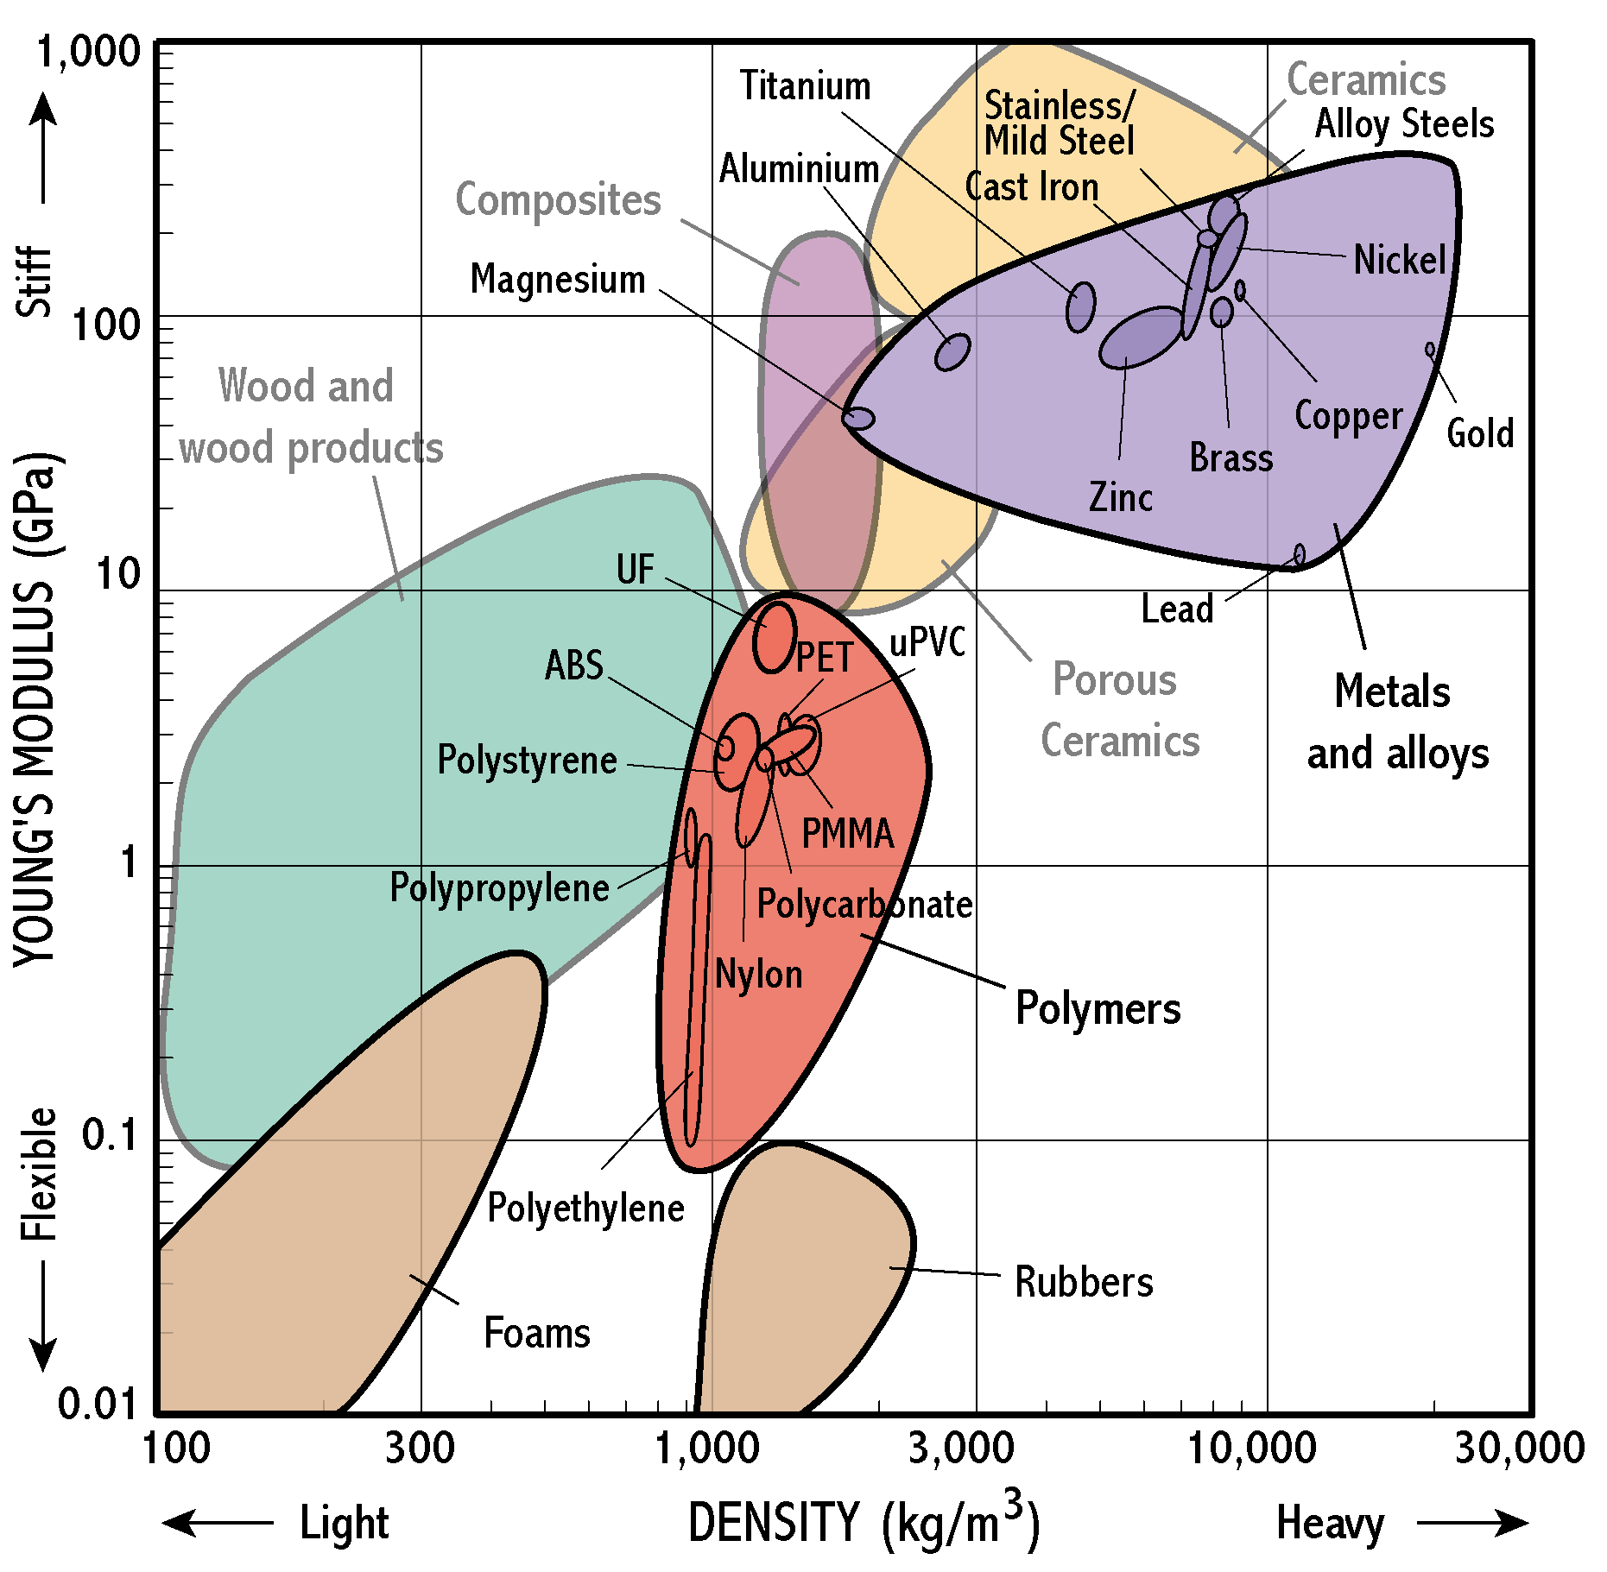

Designers have a challenging task in choosing materials for products, as they usually have to consider many competing objectives and constraints at once – light and stiff, strong and cheap, tough and recyclable (or maybe all of these at once!). Materials selection in design is therefore a matter of assessing trade-offs between several competing requirements.

For example – what materials might be used for a light, stiff bike frame? Notice that most of the metals are stiff, but rather heavy. Strength and toughness also matter. Look at the strength–toughness chart below, with a selection of metals illustrated. Note that in general the toughness of a type of alloy falls as its strength is increased.

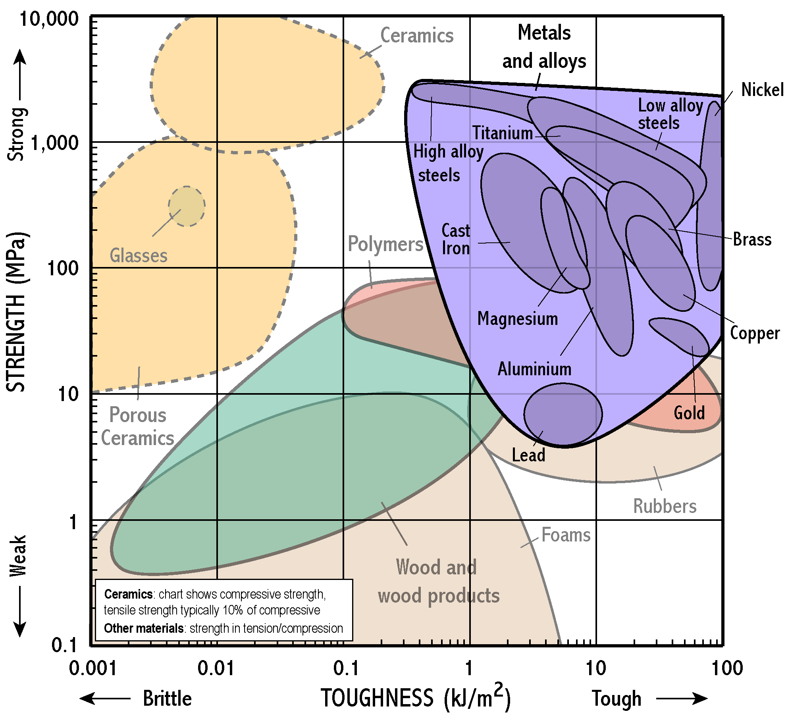

Electrical Properties
The next chart shows electrical resistivity plotted against cost per cubic metre of material. In engineering design, cost is almost always important, so selection charts often show this on one axis.

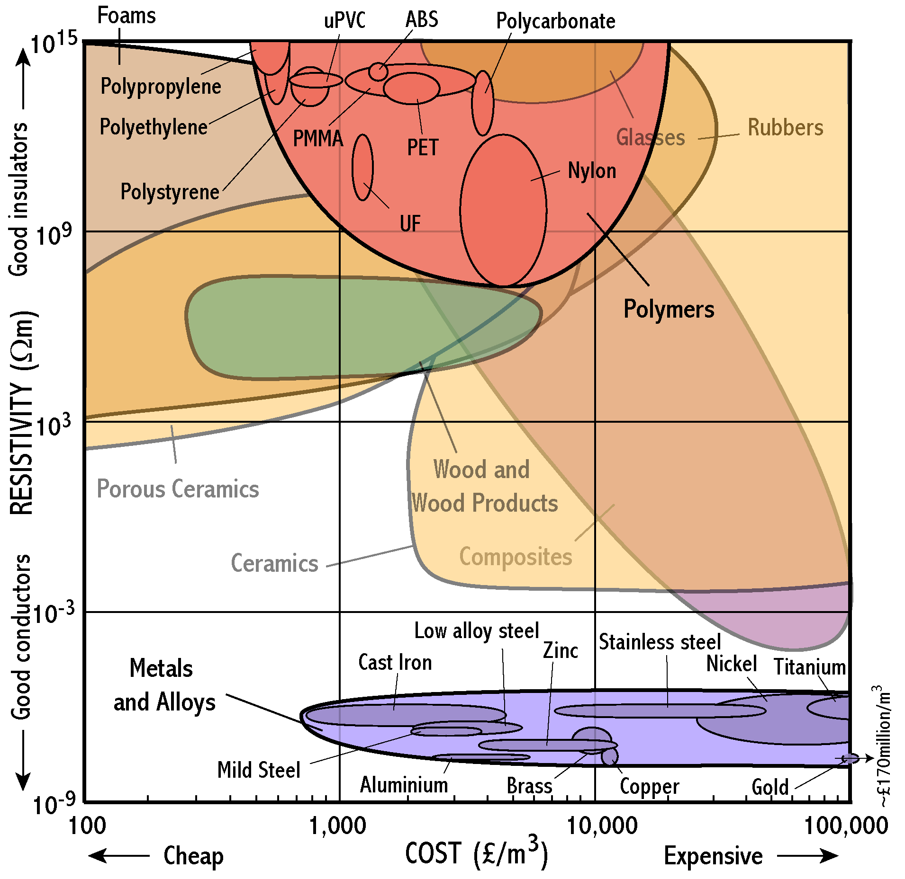

This chart shows that metals have much lower resistivity than almost all other materials. Polymers and ceramics fall at the top of the chart, being insulators. The range of values of resistivity is huge – the diagram covers 24 orders of magnitude. Gold is an excellent conductor, but it is so expensive that it is even off the scale of the chart. Despite this, it is used for electrical contacts in microcircuits.

Back to Revision Checklist

Mechanical characteristics of materials
The mechanical characteristics of a material have to do with its behaviour when subjected to forces which try to stretch, compress, bend or twist it.

The mechanical characteristics of a material include its stiffness, its strength, its flexibility or brittleness and its toughness. Other characteristics include its density, whether or not it is elastic or plastic and whether or not it is ductile and malleable.

A material is:
dense if it has a large mass per unit volume (density). Solid materials vary in density mainly because elements have different atomic masses. Lead is much more dense than aluminium, mainly because lead atoms are much heavier than aluminium atoms.
stiff if it is difficult to stretch or bend the material (e.g. a metal sheet is stiffer than a polythene sheet of the same dimensions). The stiffness is indicated by the Young modulus.
hard if it is difficult to dent the surface of the material (e.g. a steel knife is much harder than a plastic knife). Hardness is tested by machines that indent the surface. Many ceramics are very hard.
brittle if it breaks by snapping cleanly. The brittleness of glass is a consequence of defects such as fine surface cracks, which propagate easily through the material.
tough if the material does not break by snapping cleanly. A tough material is resistant to the propagation of cracks. Toughness is the opposite of brittleness. Metals are tough, and break by plastic flow. There is no one simple measure of toughness, but a tough material will dissipate a large amount of energy per unit area of new fracture surface.
elastic if it regains its shape after stretching (e.g. a rubber band regains its original length when released). When a metal or ceramic stretches elastically, the bonds between neighbouring atoms extend very slightly. In a polymer the atoms rotate about their bonds.
plastic if it undergoes large permanent stretching or distortion before it breaks (e.g. a polythene strip stretches permanently if pulled).
ductile if it is easy to draw a material into a wire (e.g. copper is easier to draw into a wire than tungsten). Metals are ductile because the non-directional metallic bonds allow ions to slide past one another.
malleable if it is easy it is to hammer or press a sheet of material into a required shape (e.g. a lead sheet is easier to fit on a roof than a steel sheet).

Back to Revision Checklist

Conductors and insulators
A conductor is any object that easily allows an electric current through it when it is in a circuit.

Materials can be grouped into conductors or insulators, or in-between as semiconductors, as indicated in the table below:

Classification | Conductivity / S m–1 | Resistivity / Ω m | Carrier density / m3 | Example
Conductor | About 106 or more | About 10–6 or less | About 1025 or more | Any metal, graphite
Insulator | About 10–6 or less | About 106 or more | Less than 1010 | Polythene
Semiconductor at room temperature | About 103 | About 10–3 | About 1020 | Silicon, germanium

Metals are generally very good conductors.

An electrical insulator is a very poor conductor of electricity.

The resistivity of an insulator is of the order of a million million times greater than that of a metal. Insulators such as polythene and nylon are used to insulate wires and metal terminals in electrical fittings and appliances.

Back to Revision Checklist

Semiconductors
Semiconductors are used to make a wide range of electronic devices including electronic chips, light-emitting diodes and solid state lasers.

Semiconductors have conductivities in between the very high conductivity of metals and the very low conductivities of insulators. There are various types of semiconductor, including metal oxides as well as elements like silicon and germanium.

In insulators, essentially all the electrons are tightly bound to atoms or ions, and none are free to move under an external electric field. In effect, these materials do not conduct electricity at all. In metallic conductors, essentially all the atoms are ionised, providing free electrons which can move freely through the ions.

Semiconductors differ from both insulators and metallic conductors. Only a small proportion of atoms are ionised, so that conduction electrons are relatively few in number. Thus a semiconductor does conduct, but not well. The conductivity is increased and controlled by ‘doping’ with traces of other elements.

Back to Revision Checklist

Stress and strain
Tensile stress and compressive stress are the force per unit area acting at right angles to a surface.

Tensile strain is the change of length per unit length. Strain is a ratio of two lengths and therefore has no unit.

The SI unit of stress is the pascal (Pa), equal to 1 N m–2.

If the solid is a bar of uniform cross-sectional area made from a single material, the stress at any point is the same, equal to the applied force divided by the area of cross section. If the cross section of the solid is non-uniform, the stress is greatest where the area of cross section is least.

Back to Revision Checklist

Stretching and breaking
The (engineering) breaking stress of a material = F / A where F is the force needed to break the material by stretching it and A is the initial area of cross section of the material. The actual stress in the material at this point will usually be rather larger, since the area of cross section will be somewhat reduced.

The Young modulus E of a material = tensile stress / tensile strain, provided the limit of elasticity of the material is not exceeded.

A graph of stress against strain for a metal has these features:

- Strain is proportional to stress, up to a limit. This is the initial straight section of the graph. In this part of the graph, the ratio stress / strain is constant and equal to the Young modulus of the material. Here the material behaves elastically.
- The elastic limit is the point beyond which a material does not regain its initial shape when the tension is removed. It is also called the yield point.
- When a material is stretched beyond its elastic limit, and is stretched beyond the yield point, it behaves plastically, suffering permanent deformation. The yield stress is the stress at the yield point.
- As the tension is increased beyond the yield point, the strain increases and a neck forms. Further stretching causes the stress to concentrate at the neck until it breaks. The (engineering) breaking stress is equal to F / A where F is the force needed to break the material by stretching it and A is the initial area of cross section of the material. The breaking stress is also called the ultimate tensile strength of the material.

The fracture energy required to break a material can be defined in several ways. One is the energy needed to create the extra fractured surface area.
Relationships
Consider a length L of material of uniform cross-sectional area A. When under tension T , the material extends to a length L + e, where e is the extension of the material.

- The tensile stress in the material = F / A where F is the tension and A the area of cross section.
The SI unit of tensile stress is the pascal (Pa) which is equal to 1 N m–2.
- The strain in the material = e / L, where e is the extension and L the initial length.
- The Young modulus of elasticity E of a material is equal to tensile stress / tensile strain
$$E=\frac{F/A}{e/L}$$
The SI unit of E is the pascal (Pa) which is equal to 1 N m–2.

Back to Revision Checklist

Electrical conductivity and resistivity
The conductivity measures how easily a material conducts electricity. Resistivity is the inverse of conductivity.

For a conductor of uniform cross-sectional area A and length L, the conductance G is:
$$G=\frac{σA}{L}$$
The conductivity σ of the material can be calculated from the measured conductance G using:
$$σ=\frac{\text{GL}}{A}$$
The SI unit of conductivity is the siemens per metre (S m–1). The siemens is the same as the reciprocal of the ohm (i.e. Ω–1).
The conductivity of a material depends on the number of charge carriers per unit volume in the material and also on how free those charge carriers are to move.

resistivityThe resistivity ρ can be calculated from the resistance of a sample, and the length and cross-sectional area of the sample using:
$$ρ=\frac{\text{RA}}{L}$$
The SI unit of resistivity is the ohm metre (Ω m). Conductivity and resistivity are each the reciprocal of the other.
Relationships
$σ=\frac{\text{GL}}{A}$ $ρ=\frac{\text{RA}}{L}$
$σ=\frac{1}{ρ}$ $ρ=\frac{1}{σ}$
$G=\frac{σA}{L}$ $R=\frac{ρL}{A}$
Back to Revision Checklist

Uncertainty
The uncertainty of an experimental result is the range of values within which the true value may reasonably be believed to lie. To estimate the uncertainty, the following steps are needed.
1. Removing from the data outlying values which are reasonably suspected of being in serious error, for example because of human error in recording them correctly, or because of an unusual external influence, such as a sudden change of supply voltage. Such values should not be included in any later averaging of results or attempts to fit a line or curve to relationships between measurements.
2. Estimating the possible magnitude of any systematic error. An example of a constant systematic error is the increase in the effective length of a pendulum because the string's support is able to move a little as the pendulum swings. The sign of the error is known (in effect increasing the length) and it may be possible to set an upper limit on its magnitude by observation. Analysis of such systematic errors points the way to improving the experiment.
3. Assessing the resolution of each instrument involved, that is, the smallest change it can detect. Measurements from it cannot be known to less than the range of values it does not distinguish.
4. Assessing the magnitude of other small, possibly random, unknown effects on each measured quantity, which may include human factors such as varying speed of reaction. Evidence of this may come from the spread of values of the measurement conducted under what are as far as possible identical conditions. The purpose of repeating measurements is to decide how far it appears to be possible to hold conditions identical.
5. Determining the combined effect of possible uncertainty in the result due to the limited resolution of instruments (3 above) and uncontrollable variation (4 above).
To improve a measurement, it is essential to identify the largest source of uncertainty. This tells you where to invest effort to reduce the uncertainty of the result.
Having eliminated accidental errors, and allowed for systematic errors, the range of values within which the true result may be believed to lie can be estimated from (a) consideration of the resolution of the instruments involved and (b) evidence from repeated measurements of the variability of measured values.
Most experiments involve measurements of more than one physical quantity, which are combined to obtain the final result. For example, the length L and time of swing T of a simple pendulum may be used to determine the local acceleration of free fall, g , using
$$T = 2π\sqrt{\frac{L}{g}}$$
so that
$$g=\frac{4p^{2}L}{T^{2}}\text{.}$$
The range in which the value of each quantity may lie needs to be estimated. To do so, first consider the resolution of the instrument involved – say ruler and stopwatch. The uncertainty of a single measurement cannot be better than the resolution of the instrument. But it may be worse. Repeated measurements under supposedly the same conditions may show small and perhaps random variations.
If you have repeated measurements, ‘plot and look’, to see how the values vary. A simple estimate of the variation is the$\text{spread = }±\frac{1}{2}\text{ range}$.
A simple way to see the effect of uncertainties in each measured quantity on the final result is to recalculate the final result, but adding or subtracting from the values of variables the maximum possible variation of each about its central value. This is pessimistic because it is unlikely that ‘worst case’ values all occur together. However, pessimism may well be the best policy: physicists have historically tended to underestimate uncertainties rather than overestimate them. The range within which the value of a quantity may reasonably be believed to lie may be reduced somewhat by making many equivalent measurements, and averaging them. If there are N independent but equivalent measurements, with range R, then the range of their average is likely to be approximately R divided by the factor √N . These benefits are not automatic, because in collecting many measurements conditions may vary.
Back to Revision Checklist

Calibration
A measuring instrument needs to be calibrated to make sure its readings are accurate.
Calibration determines the relation between the input and the output of an instrument. This is done by measuring known quantities, or by comparison with an already calibrated instrument. For example, an electronic top pan balance is calibrated by using precisely known masses. If the readings differ from what they should be, then the instrument needs to be recalibrated.
Important terms used in the calibration of an instrument include:
The zero reading which should be zero when the quantity to be measured is zero. Electrical instruments are prone to drift off-zero and need to be checked for zero before use.
A calibration graph, which is a graph to show how the output changes as the input varies.
Linearity, which is where the output increases in equal steps when the input increases in equal steps. If the output is zero when the input is zero, the output is then directly proportional to the input, and its calibration graph will be a straight line through the origin. An instrument with a linear scale is usually easier to use than an instrument with a non-linear scale. However, with the advent of digital instruments, linearity has become less important. Given the output, the instrument simply looks up the correct value of the input to record, in a 'look-up' table. The 'look-up' table is the equivalent of a calibration graph.
The resolution of the instrument, which is the smallest change of the input that can be detected at the output.
The sensitivity of the instrument, which is the ratio of change in output for a given change in input. If the calibration graph is curved, then the sensitivity - the slope of the graph - varies across the range.
The reproducibility of its measurements, which is the extent to which it gives the same output for a given input, at different times or in different places. Reproducibility thus includes zero drift and changes in sensitivity.
Most instruments are calibrated using secondary standards which themselves are calibrated from primary standards in specialist laboratories.
Back to Revision Checklist

Systematic error
Systematic error is any error that biases a measurement away from the true value.
All measurements are prone to systematic error. A systematic error is any biasing effect, in the environment, methods of observation or instruments used, which introduces error into an experiment. For example, the length of a pendulum will be in error if slight movement of the support, which effectively lengthens the string, is not prevented, or allowed for.
Incorrect zeroing of an instrument leading to a zero error is an example of systematic error in instrumentation. It is important to check the zero reading during an experiment as well as at the start.
Systematic errors can change during an experiment. In this case, measurements show trends with time rather than varying randomly about a mean. The instrument is said to show drift (e.g. if it warms up while being used).
Systematic errors can be reduced by checking instruments against known standards. They can also be detected by measuring already known quantities.
The problem with a systematic error is that you may not know how big it is, or even that it exists. The history of physics is littered with examples of undetected systematic errors. The only way to deal with a systematic error is to identify its cause and either calculate it and remove it, or do a better measurement which eliminates or reduces it.
Back to Revision Checklist

Random variation
Random variation has to do with small unpredictable variations in quantities.

Truly random variation may be rather rare. However, variations due to a number of minor and unrelated causes often combine to produce a result that appears to vary randomly.

Random variation can be due to uncontrollable changes in the apparatus or the environment or due to poor technique on the part of an observer. They can be reduced by redesigning the apparatus or by controlling the environment (e.g. the temperature). Even so, random variation can still remain. The experimenter then needs to use the extent of such variation to assess the range within which the true result may reasonably be believed to lie.

First, accidental variations with known causes need to have been eliminated, and known systematic errors should have been allowed for. Then, variations of measurements around an average value are often treated as random.

The simplest approach is to suppose that the true result lies somewhere in the range covered by the random variation. This is a bit pessimistic, since it is more likely that the true result lies fairly near the middle of the range than near the extremes.

Back to Revision Checklist

Graphs
Graphs visually display patterns in data and relationships between quantities.

A graph is a line defined by points representing pairs of data values plotted along perpendicular axes corresponding to the ranges of the data values.

Many experiments are about finding a link between two variable quantities. If a mathematical relationship between them is suggested, the suggestion can be tested by seeing how well the graph of the experimental measurements corresponds to the graph of the mathematical relationship, at least over the range of values of data taken. For example, a graph of the tension in a spring against the extension of the spring is expected to be a straight line through the origin if the spring obeys Hooke's law, namely tension = constant × extension. But if the spring is stretched further, the graph of the experimental results is likely to become curved, indicating that Hooke's law is no longer valid in this region.

Many plots of data yield curved rather than straight-line graphs. By re-expressing one or both variables, it may be possible to produce a graph which is expected to be a straight line, which is easier to test for a good fit. Some of the curves and related mathematical relationships met in physics are described below:

Inverse curves are asymptotic at both axes. The mathematical form of relationship for an inverse curve is

$$y = \frac{k}{x^{n}}$$

where n is a positive number and k is a constant.

n = 1: y =k / x

Examples:
Pressure = constant / volume for a fixed amount of gas at constant temperature.

Gravitational potential = constant / distance for an object near a spherical planet.

Electrostatic potential = constant / distance for a point charge near a large charge.

n = 2: y =k / x2

Examples:
Gravitational force between two points masses = constant / distance2.

Electric field intensity = constant / distance2.

Intensity of gamma radiation from a point source = constant / distance2.

Exponential decay

Exponential decay curves are asymptotic along one axis but not along the other axis. Exponential decay curves fit the relationship

$$I = I_{0} e^{−\text{ct}}$$
where I0 is the intensity at t = 0 and c is a constant.
Examples:
Radioactive decay

$$N = N_{0} e^{−λt}\text{.}$$
Capacitor decay

$$Q = Q_{0} e^{− t / \text{CR}}\text{.}$$
Absorption of x-rays and gamma rays by matter

$$I = I_{0} e^{−αx}\text{.}$$
In general, to establish a relationship between two variables or to find the value of a constant in an equation, the results are processed to search for a straight-line relationship. This is because a straight line is much easier to recognise than a specific type of curve. To test a proposed relationship between two variables, the variables are re-expressed if possible to yield the equation for a straight line y = m x + c. For example, a graph of y = pressure against x = 1 / volume should give a straight line through the origin, thus confirming that the gas under test obeys Boyle's law. In the case of a test for an exponential decay curve of the form

$$I = I_{o} e^{−αx}$$
the variable I is re-expressed as its natural logarithm ln I, giving

$$\text{ln} I = \text{ln} I_{0} − αx\text{.}$$
A graph of ln I against x is now expected to be a straight line.

Graphs are a means of communication. To communicate clearly using graphs follow these rules:

- Always choose a scale for each axis so that the points spread over at least 50% of each axis.
- Obtain more points by making more measurements where a line curves sharply.
- Label each axis with the name and symbol of the relevant quantity, and state the appropriate unit of measurement (e.g. pressure p / kPa).
- Prefer graph areas which are wider than they are long ('landscape' rather than 'portrait').
- Put as much information as possible on the graph, for example labeling points informatively.
- When using a computer to generate graphs, always try several different formats and shapes. Choose the one which most vividly displays the story you want the graph to tell.
- Label every graph with a caption which conveys the story it tells, for example 'Spring obeys Hooke's law up to 20% strain', not 'extension against strain for a spring'.

To measure the gradient of a curve at a point on the curve, draw the tangent to the curve as shown below and measure the gradient of the tangent by drawing a large 'gradient triangle'. To measure the gradient of a straight line, draw a large gradient triangle with the line itself as the hypotenuse of the triangle then measure the gradient.

The area under a curve is usually measured by counting the grid squares, including parts of squares over half size as whole squares and disregarding parts of squares less than half size. Graphs in physics where areas are useful include:

speed–time graphs (where area represents distance moved)

force–distance graphs (where area represents work done or energy transferred)

power–time graphs (where area represents energy transferred)

force–time graphs (where area represents change of momentum)

Back to Revision Checklist

Accuracy and precision
A measurement is accurate if it is close to the true value. A measurement is precise if values cluster closely, with small uncertainty.
A watch with an accuracy of 0.1% could be up to five minutes astray within a few days of being set. A space probe with a trajectory accurate to 0.01 % could be more than 30 km off target at the Moon.
Think of the true value as like the bullseye on a target, and measurements as like arrows or darts aimed at the bullseye.

An accurate set of measurements is like a set of hits that centre on the bullseye. In the diagram above at the top, the hits also cluster close together. The uncertainty is small. This is a measurement that gives the true result rather precisely.
On the left, the accuracy is still good (the hits centre on the bullseye) but they are more scattered. The uncertainty is higher. This is a measurement where the average still gives the true result, but that result is not known very precisely.
On the right, the hits are all away from the bullseye, so the accuracy is poor. But they cluster close together, so the uncertainty is low. This is a measurement that has a systematic error, giving a result different from the true result, but where other variations are small.
Finally, at the bottom, the accuracy is poor (systematic error) and the uncertainty is large.
A statement of the result of a measurement needs to contain two distinct estimates:
1. The best available estimate of the value being measured.
2. The best available estimate of the range within which the true value lies.
Note that both are statements of belief based on evidence, not of fact.
For example, a few years ago discussion of the 'age-scale' of the Universe put it at 14 plus or minus 2 thousand million years. Earlier estimates gave considerably smaller values but with larger ranges of uncertainty. The current (2008) estimate is 13.7 ± 0.2 Gy. This new value lies within the range of uncertainty for the previous value, so physicists think the estimate has been improved in precision but has not fundamentally changed.
Fundamental physical constants such as the charge of the electron have been measured to an astonishing small uncertainty. For example, the charge of the electron is 1.602 173 335 × 10–19 C to an uncertainty of 0.000 000 005 × 10–19 C, better than nine significant figures.
There are several different reasons why a recorded result may differ from the true value:
1. Constant systematic bias, such as a zero error in an instrument, or an effect which has not been allowed for.
Constant systematic errors are very difficult to deal with, because their effects are only observable if they can be removed. To remove systematic error is simply to do a better experiment. A clock running slow or fast is an example of systematic instrument error. The effect of temperature on the resistance of a strain gauge is an example of systematic experimental error.
2. Varying systematic bias, or drift, in which the behaviour of an instrument changes with time, or an outside influence changes.
Drift in the sensitivity of an instrument, such as an oscilloscope, is quite common in electronic instrumentation. It can be detected if measured values show a systematic variation with time. Another example: the measured values of the speed of light in a pipe buried in the ground varied regularly twice a day. The cause was traced to the tide coming in on the nearby sea-shore, and compressing the ground, shortening the pipe a little.
3. Limited resolution of an instrument. For example the reading of a digital voltmeter may change from say 1.25 V to 1.26 V with no intermediate values. The true potential difference lies in the 0.01 V range 1.25 V to 1.26 V.
All instruments have limited resolution: the smallest change in input which can be detected. Even if all of a set of repeated readings are the same, the true value is not exactly equal to the recorded value. It lies somewhere between the two nearest values which can be distinguished.
4. Accidental momentary effects, such as a 'spike' in an electrical supply, or something hitting the apparatus, which produce isolated wrong values, or 'outliers'.
Accidental momentary errors, caused by some untoward event, are very common. They can often be traced by identifying results that are very different from others, or which depart from a general trend. The only remedy is to repeat them, discarding them if further measurements strongly suggest that they are wrong. Such values should never be included in any average of measurements, or be used when fitting a line or curve.
5. Human errors, such as misreading an instrument, which produce isolated false recorded values.
Human errors in reading or recording data do occur, such as placing a decimal point wrongly, or using the wrong scale of an instrument. They can often be identified by noticing the kinds of mistake it is easy to make. They should be removed from the data, replacing them by repeated check observations.
6. Random fluctuations, for example noise in a signal, or the combined effect of many unconnected minor sources of variation, which alter the measured value unpredictably from moment to moment.
Truly random variations in measurements are rather rare, though a number of unconnected small influences on the experiment may have a net effect similar to random variation. But because there are well worked out mathematical methods for dealing with random variations, much emphasis is often given to them in discussion of the estimation of the uncertainty of a measurement. These methods can usually safely be used when inspection of the data suggests that variations around an average or a fitted line or curve are small and unsystematic. It is important to look at visual plots of the variations in data before deciding how to estimate uncertainties.
Back to Revision Checklist
Summary Diagrams
Back to list of Contents

The Young modulus
The Young modulus tells you how a material behaves under stress.

Back to Revision Checklist

Conductivity and resistivity
These diagrams show the relationships between conductance and resistance for samples of different sizes, and how to calculate them from the conductivity or resistivity.

Back to Revision Checklist

Stress–strain graph for mild steel
The graph shows how the behaviour of mild steel changes as the stress increases.

Back to Revision Checklist

Range of values of conductivity
The conductivity of the best conductor shown below (silver) is 1024 times greater than the conductivity of the best insulator (polystyrene).

Back to Revision Checklist

Back to list of Contents

