Sample Examination Questions
Contents
NB. Material covered by the AS papers may also appear in A2 papers.

Question number | Question type  (section A or B) | Question focus
1 | A | Ideal transformer
2 | A | Induced EMF
3 | A | Magnetic flux linkage
4 | A | Units for magnetic quantities
5 | A | Dynamo
6 | B | Motor
7 | A | Electric field and potential
8 | A | Force on a moving electric charge due to a magnetic field
9 | A | Electric potential
10 | A | Electric field of a charge
11 | B | Force on a moving electric charge due to a magnetic field
12 | B | Force on a charge in an electric field
13 | A | Kinetic and potential energy of a scattered particle
14 | A | Discrete energy levels in atoms
15 | B | Structure of the nucleus
16 | B | Discrete energy levels
17 | A | Decay of a nucleus
18 | A | Decay of a nucleus
19 | A | Risk
20 | A | Energy change from a nuclear transformation
21 | B | Energy change from a nuclear transformation
22 | B | Activity; absorbed dose; dose equivalent
23 | A | Motor
24 | B | Motor
25 | B | Electric field and potential
26 | B | Force on a moving electric charge due to a magnetic field; ionising radiation
27 | B | Transformation of nuclei; radioactive decay; absorbed dose
28 | B | Relativistic energy and momentum

The Section C questions below are based on the advance notice article ‘Taming Nuclear Fusion’ at the end of this document, which is intended to have been studied before tackling the questions.

Question number | Question type  (section C) | Question focus
29 | C | Population growth and exponentials
30 | C | Binding energies of nuclei
31 | C | Proton-proton interactions and ‘gas laws’ in Sun’s core
32 | C | Magnetic fields in tokamaks
33 | C | Heating plasma in tokomaks.

- Fig. 1.1 shows the construction of a commercial transformer.

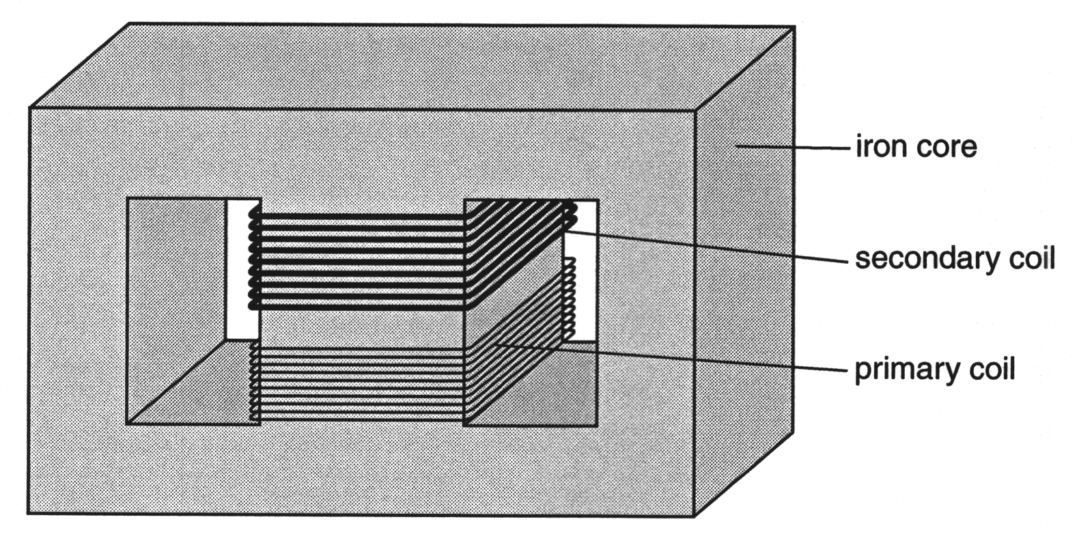

Fig. 1.1

- Here are some facts about the construction of the transformer.
A Both coils are wound on the same part of the core.
B The wire in the secondary coil is thicker than the wire in the primary coil.
C The iron core is made from thin sheets.
Which one of these facts ensures that the rate of change of magnetic flux in the primary coil is equal to that in the secondary coil?

answer ................................. [1]

- The primary coil of the transformer has 1000 turns and the secondary coil has 200 turns. The primary coil is connected to a 400 V, 50 Hz supply.
Calculate the voltage across the secondary coil, and state its frequency.

voltage = ............................... V
frequency =.............................. Hz
[2]

- The magnetic flux linkage of a coil of wire increases steadily by 90 mWb in a time of 450 µs.

(a) Show that the rate of change of magnetic flux linkage is 200 Wb s^{–1}.

(b) State the emf induced across the coil by the rate of change of magnetic flux linkage.

emf = ...................... V [3]

- An iron rod has 400 turns of wire coiled around it. There is a current in the coil. The rod has a cross-sectional area of 1.25 x 10^{–5} m².

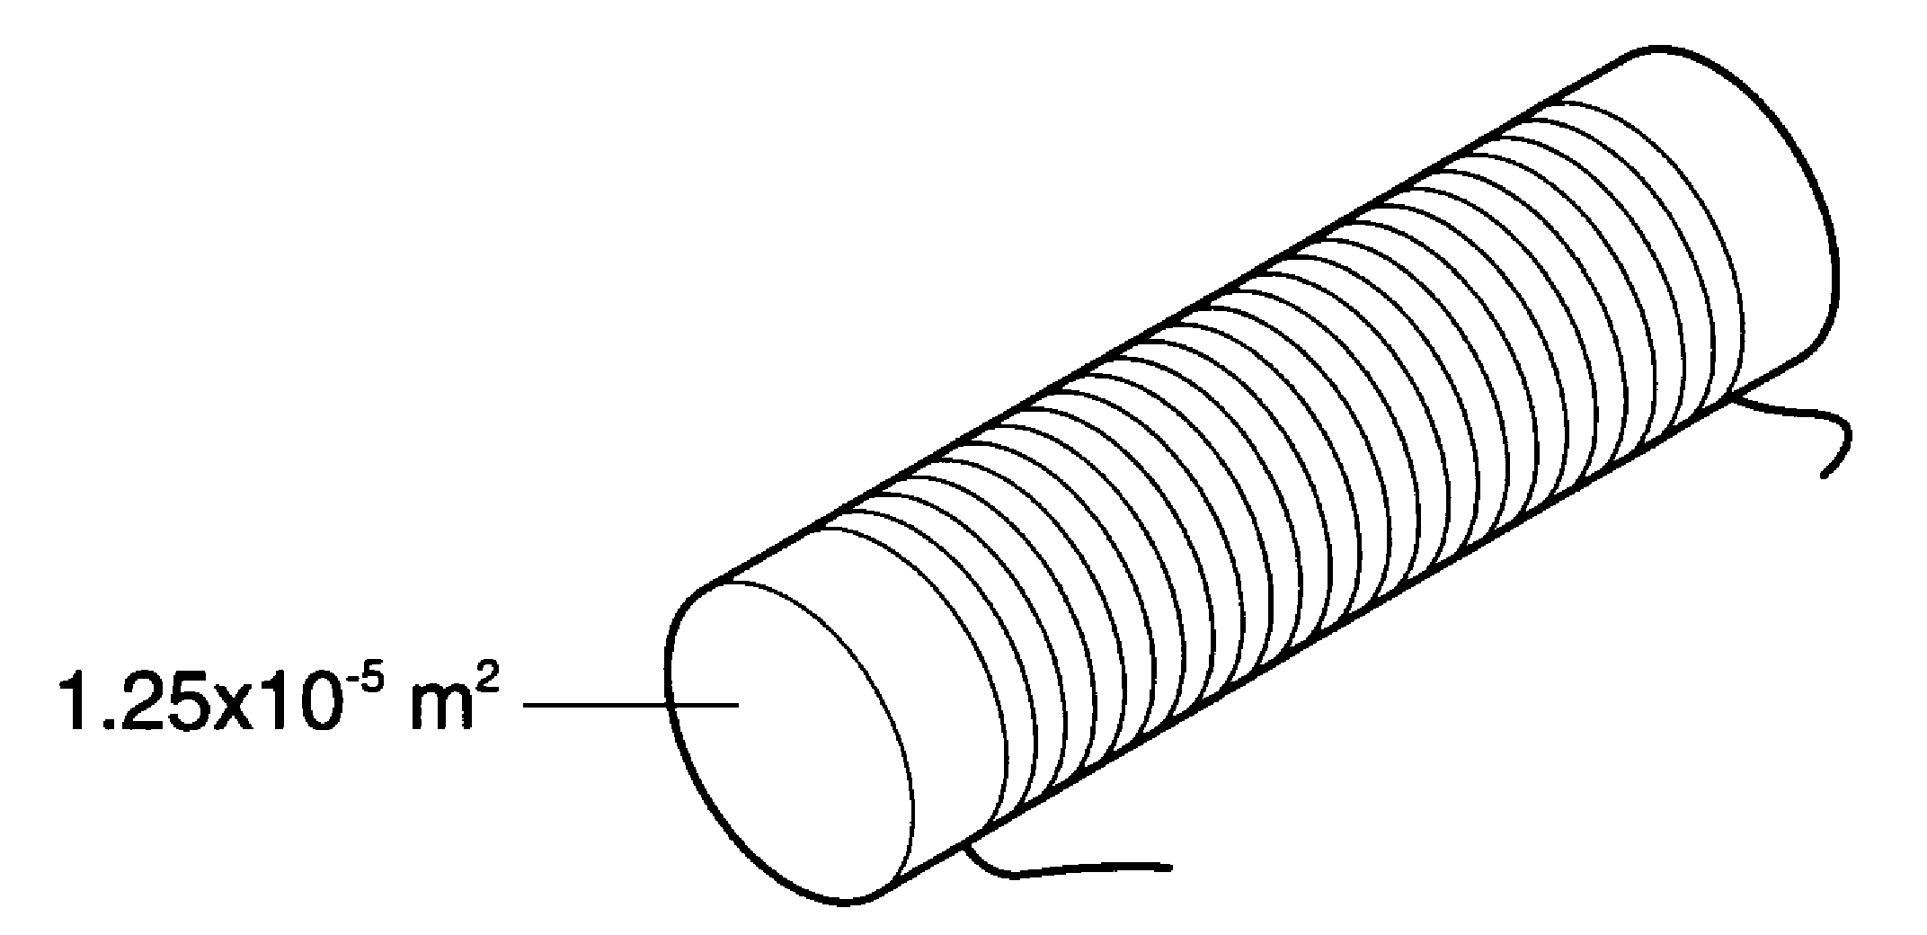

The flux linkage of the coil is 4.0 x 10^{–4} Wb.

- Calculate the flux linking one turn of the coil.

flux = .................... Wb [1]

- Calculate the flux density in the iron.

flux density =.................... T [1]

- Here is a list of units.

ampere (A)
tesla (T)
volt (V)
weber (Wb)

Which unit from the list is the correct choice for

(a) magnetic flux, ......................

(b) magnetic flux density, ......................

(c) rate of change of magnetic flux linkage? ......................
[3]

- Fig. 5.1 shows a simple dynamo.

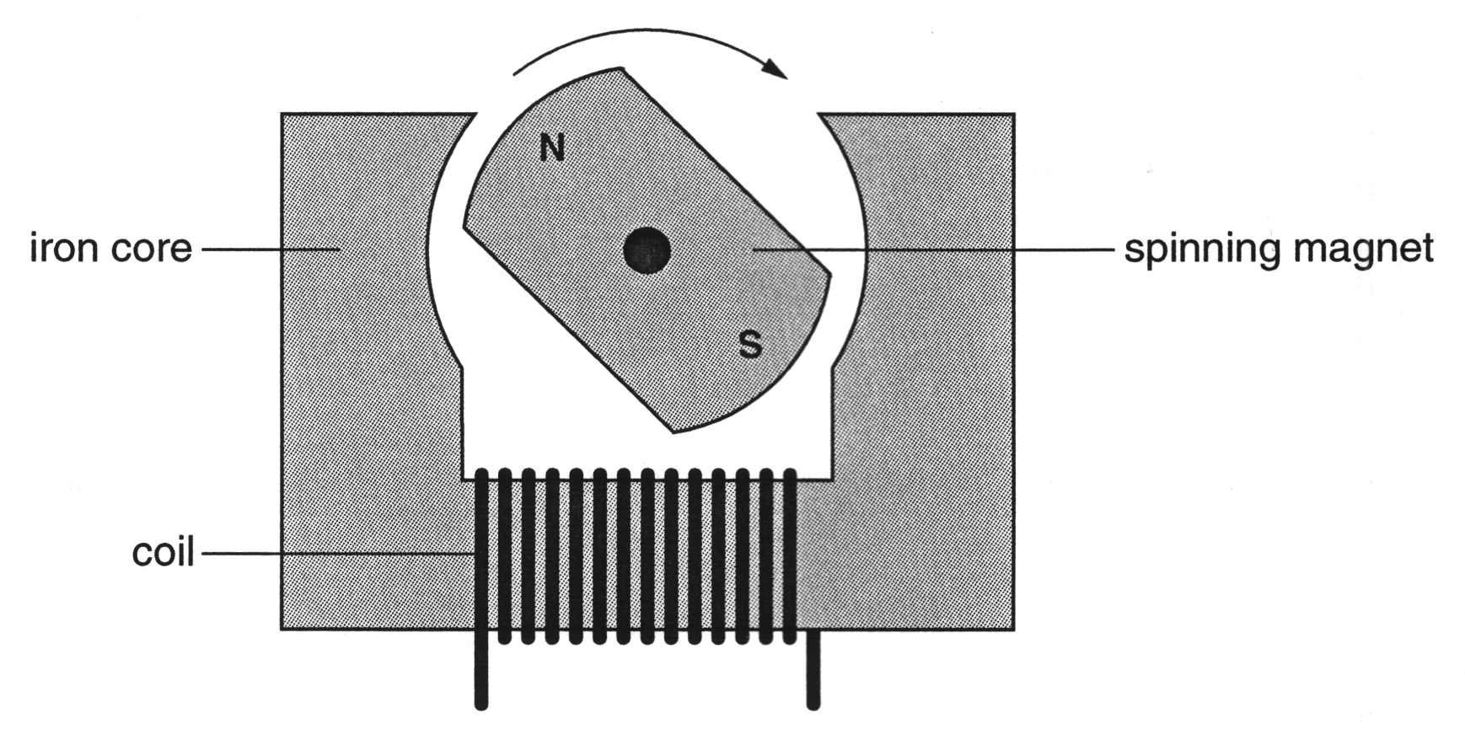

Fig. 5.1

When the magnet is rotated, the emf induced across the coil is 4 V at 10 Hz.
The magnet is now rotated twice as fast.
Which of the following is the new emf induced across the coil?
A 8 V at 10 Hz
B 4 V at 20 Hz
C 8 V at 20 Hz

answer ....................... [1]

- This question is about an induction motor. Part of the induction motor is shown in Fig. 6.1.
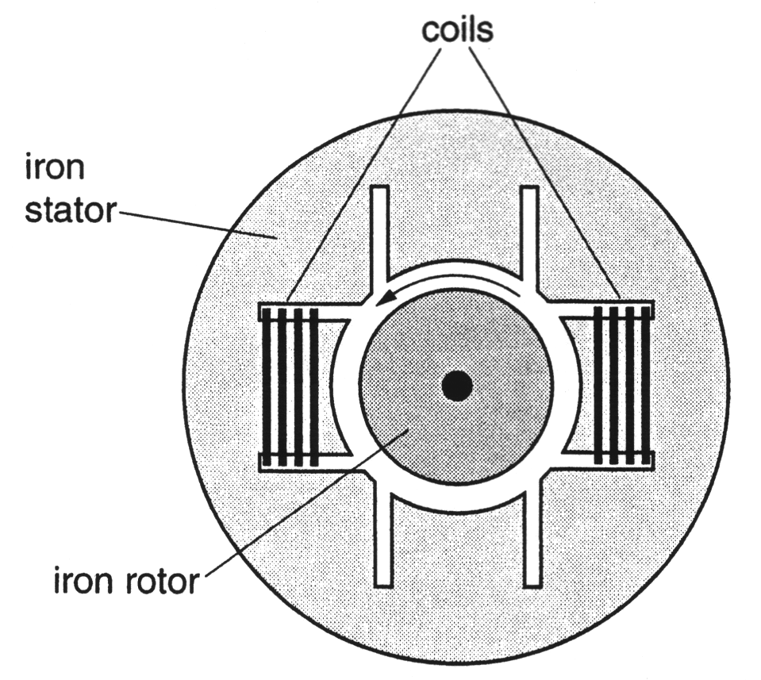

Fig. 6.1

- One pair of coils is shown in Fig. 6.1. At one instant, there is a current in these coils. This current produces a horizontal magnetic field of strength B_{H} in the rotor. (NB: by ‘horizontal’ the question means ‘in the plane of the page and parallel to the top edge’.) On Fig. 6.1, sketch one complete line of flux in the motor due to this current.
[1]

- In fact, the motor has two pairs of coils, as shown in Fig. 6.2.
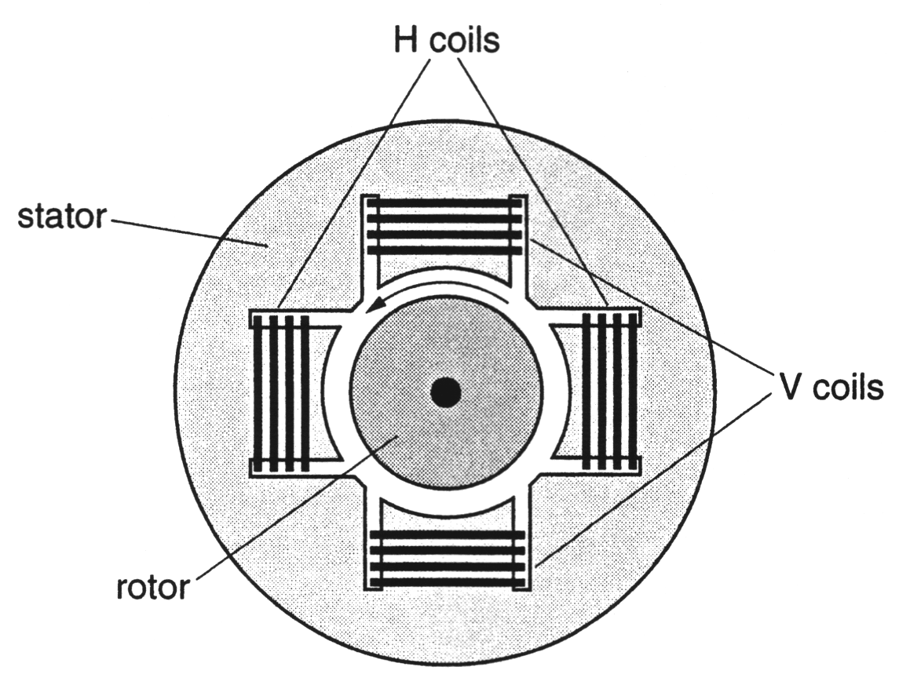

Fig. 6.2

The pair of coils labelled H produce a horizontal magnetic field through the rotor. The pair of coils labelled V produce a vertical magnetic field through the rotor. There is an alternating current in each pair of coils, but there is a phase difference between these currents. This results in horizontal and vertical magnetic fields, B_{H} and B_{V} respectively which vary with time, as shown in Fig. 6.3. (NB: by ‘vertical’ the question means ‘in the plane of the paper parallel to the long side edges.)
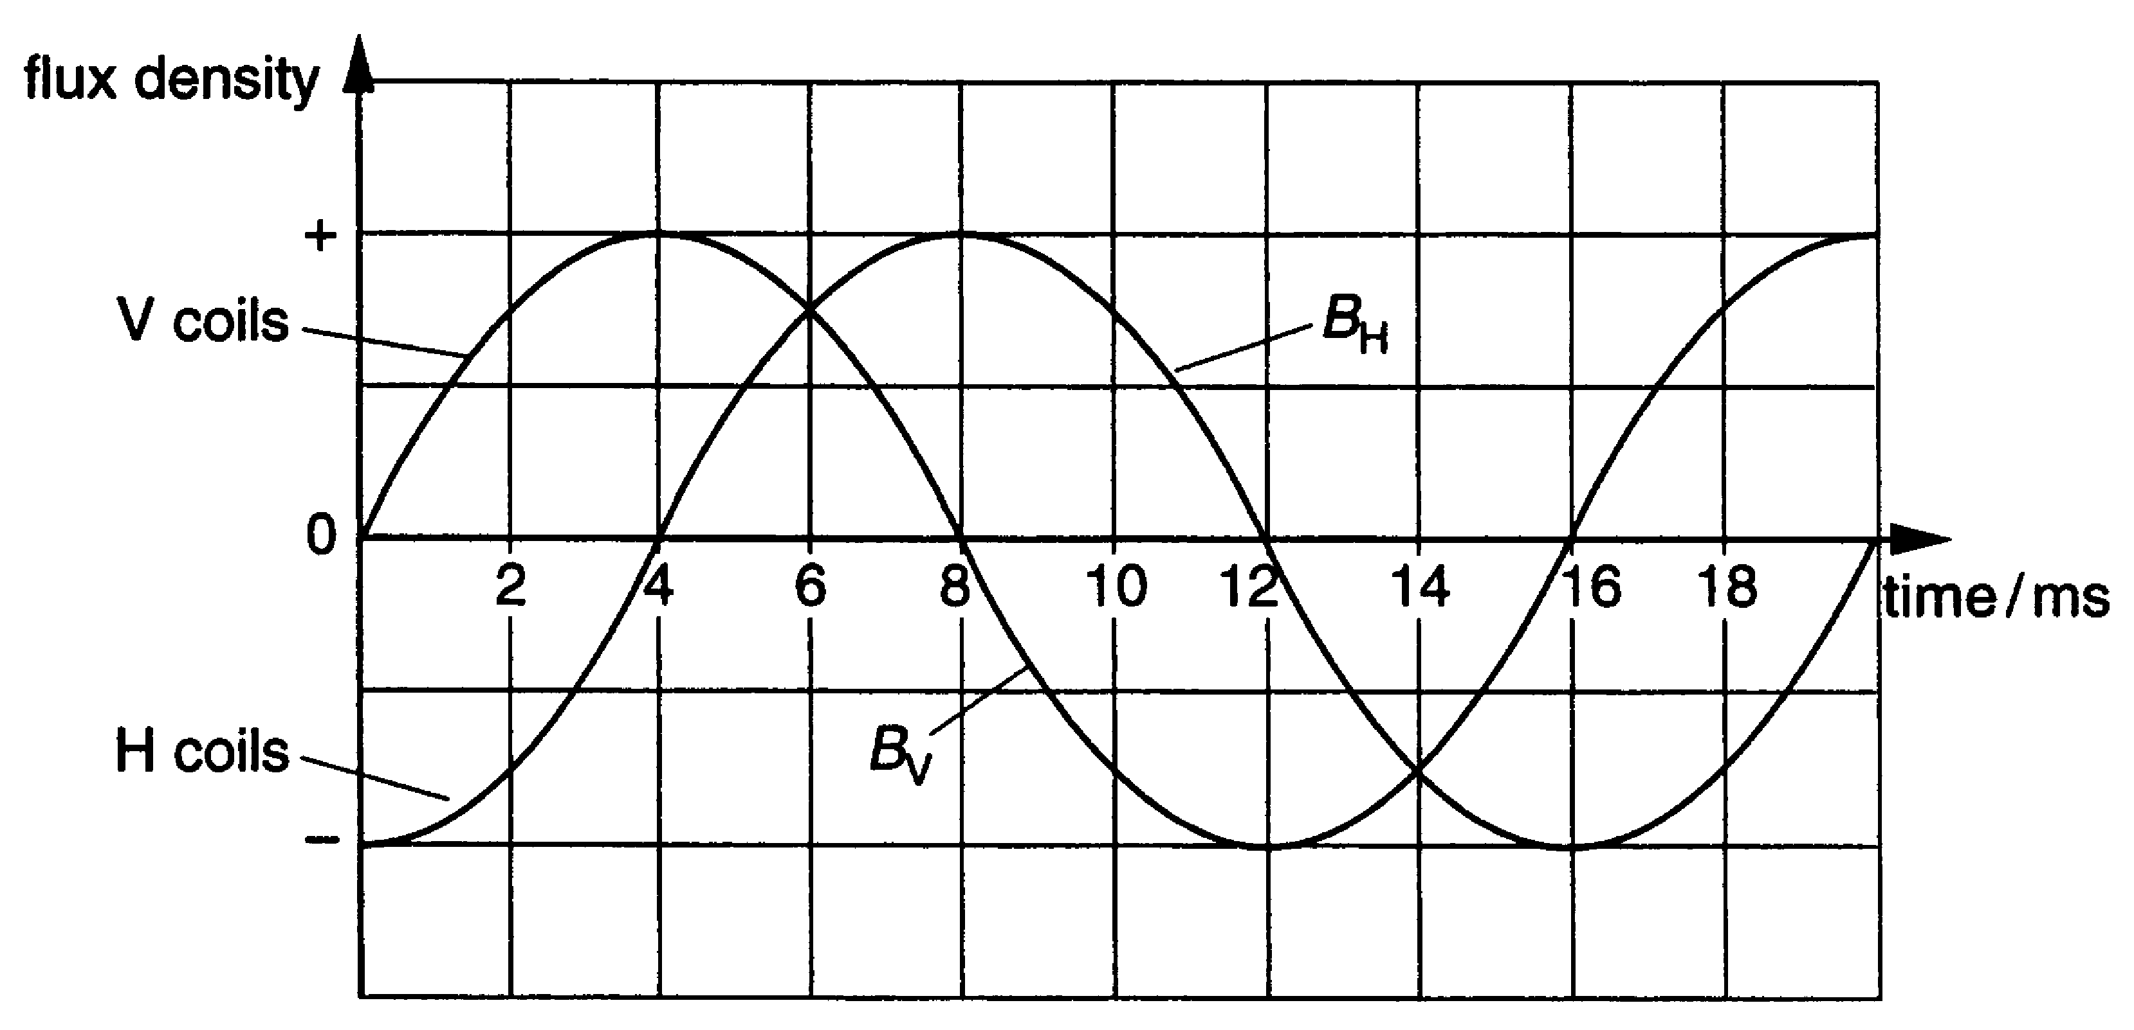

Fig. 6.3

- State the phase difference between the horizontal, B_{H}, and the vertical, B_{V}, magnetic fields.
phase difference = ....................... [1]

- The magnitude and direction of the horizontal and vertical magnetic fields through the rotor, at any instant, can be represented by vectors.
These two vectors at times of 5 ms, 6 ms, 9 ms and 10 ms are shown below.

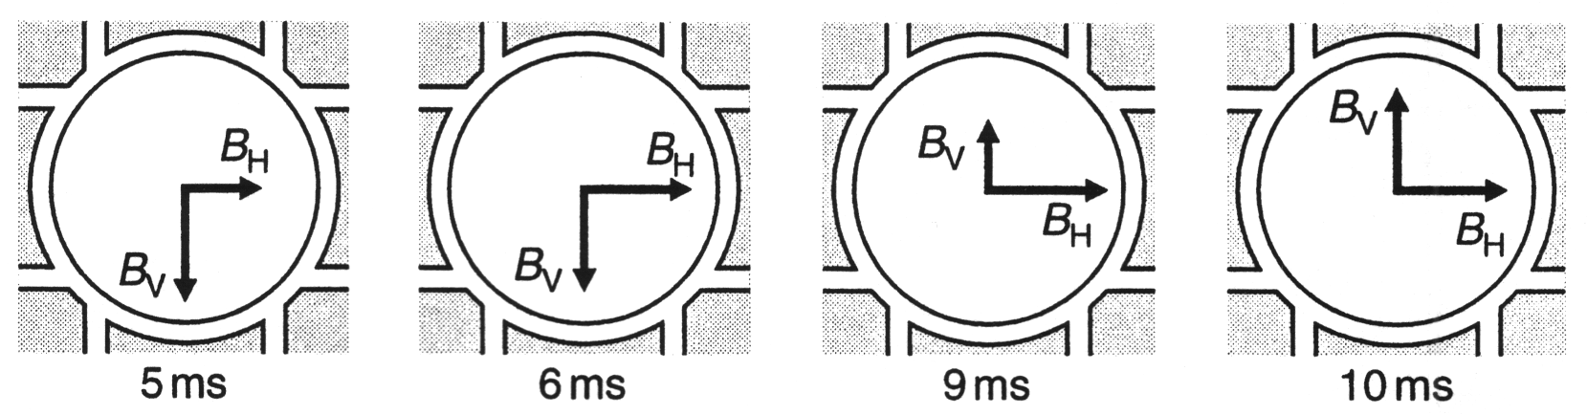

Complete each vector diagram to show the magnitude and direction of the resultant magnetic field at that instant.
[1]

- Describe how the direction of the resultant magnetic field changes with time.

[1]
- The rotor, as shown in Fig. 6.2, rotates continuously in an anticlockwise direction, as the alternating currents change.
Explain why this is so.

[2]

[Total: 6]
- The graph shows the variation of electric potential V with distance x from a charged particle.

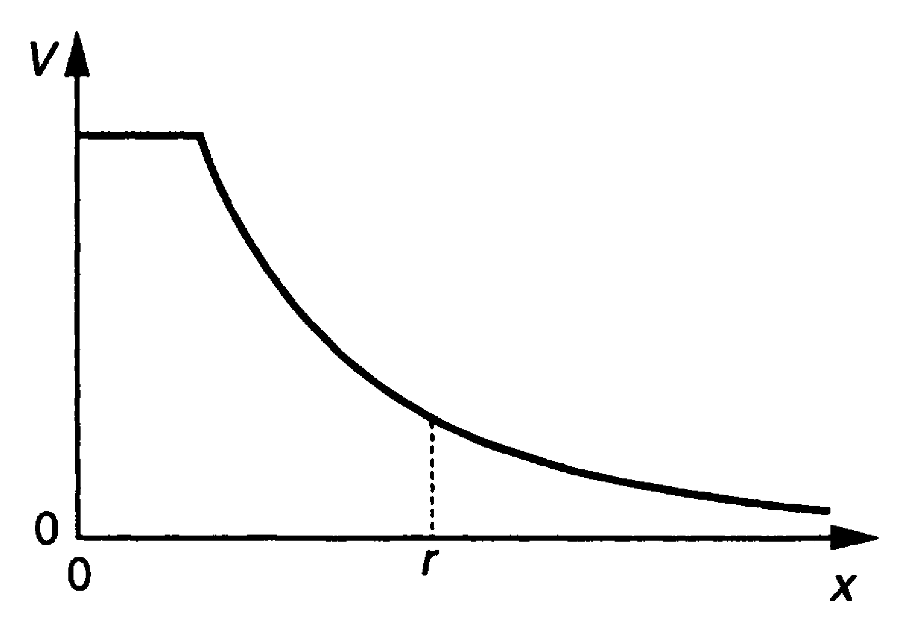

State the feature of the graph which could be used to calculate the magnitude of the electric field E at distance r.

[1]

- An alpha particle moving at 1.5 x 10⁷ m s^{–1} enters a magnetic field. The field has a strength of 0.25 T at right angles to the velocity of the alpha particle.
Calculate the force on the alpha particle in the field.
charge on alpha particle = 3.2 x 10^{–19} C

force = ....................... N [1]

- The graphs show how the electrical potential V around an object depends on the distance d from its centre.

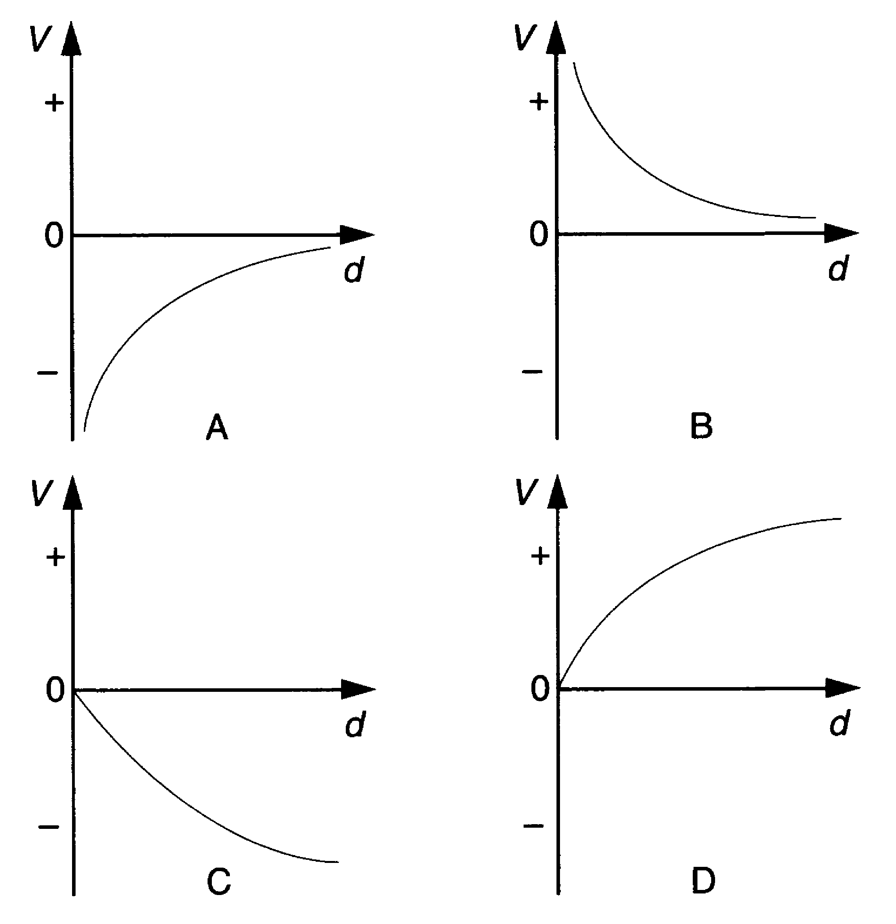

Which graph best shows the variation of potential with distance from a proton?

answer = .................. [1]

- A carbon-12 nucleus has a charge of +1.92 x 10^{–18} C.
Calculate the electric field strength at a distance of 5.0 x 10^{–11} m from the centre of the nucleus. State the unit with your answer.

electric field =.............................. unit..................[3]

- This question is about the motion of charged particles in magnetic fields.
Fig. 11.1 shows the path of a beam of ions in a vacuum as they pass through a magnetic field.

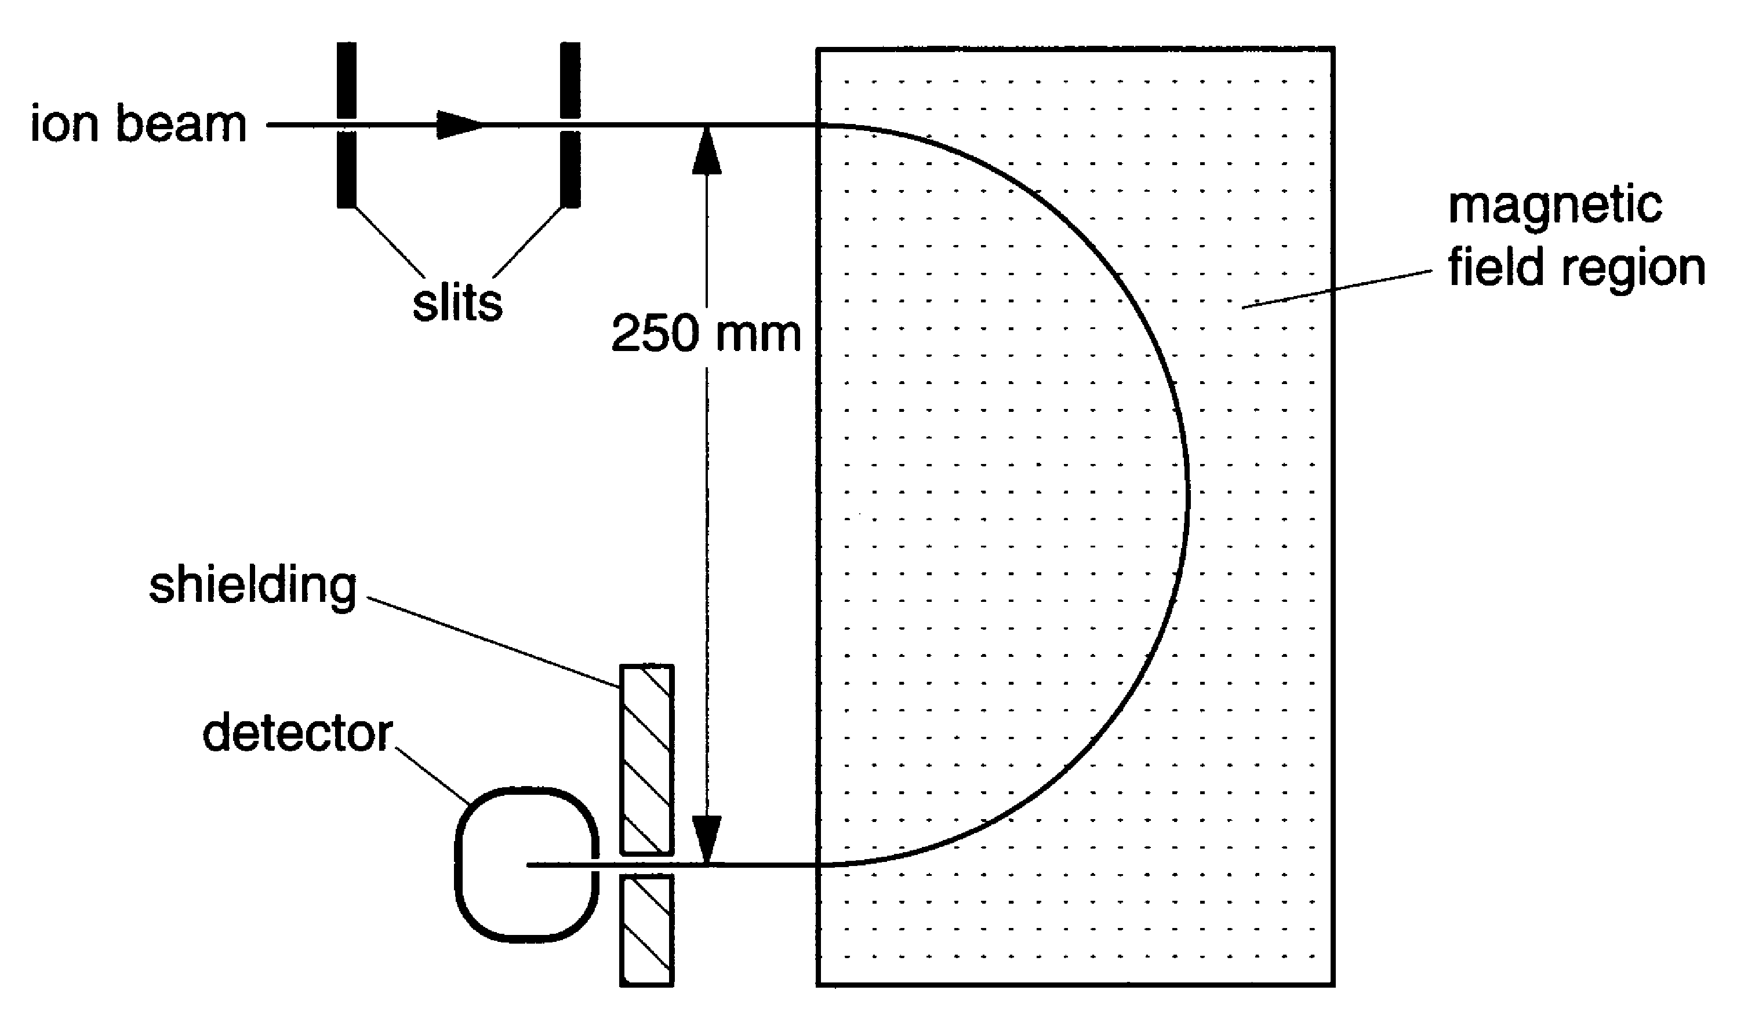

Fig. 11.1

The beam consists of singly ionised neon-20 atoms all with the same speed. After passing through a pair of slits to define the direction of the beam, the ions enter a region of uniform magnetic field at right angles to the plane of the diagram.

(a) Each ion is made by removing one electron from an atom. The beam current is 20 µA. How many neon ions enter the magnetic field region per second?
e = 1.6 x 10^{–19} C

number of ions = .................... s^{–1} [2]

(b) The ions are accelerated as they pass between the slits. The ions enter the first slit with a speed of 100 m s^{–1} and leave the second slit with a speed of 3.0 x 10⁵ m s^{–1}. The mass of a neon-20 atom is 3.32 x 10^{–26} kg.

- Calculate the increase of kinetic energy of a single ion as it passes between the slits.

kinetic energy increase = ..................... J
- Show that the potential difference between the slits must be greater than 5 kV.
e = 1.6 x 10^{–19} C

[3]

- As the beam passes through the magnetic field it follows a circular path of radius 0.125 m.

(i) Explain why the path is circular.

(ii) Each neon-20 ion has a speed of 3.0 x 10⁵ m s^{–1}.
Show that the centripetal force required on an ion of mass 3.32 x 10^{–26} kg is
2.4 x 10^{–14} N.

(iii) By considering the magnetic force on a neon-20 ion, calculate a value for the magnetic flux density.

magnetic flux density = .................... T [5]

- On one occasion the neon-20 beam is contaminated with a small amount of neon-22. However, none of the neon-22 ions arrive at the detector.
Explain why.

[1]

[Total: 11]
- This question is about the forces in electric fields.

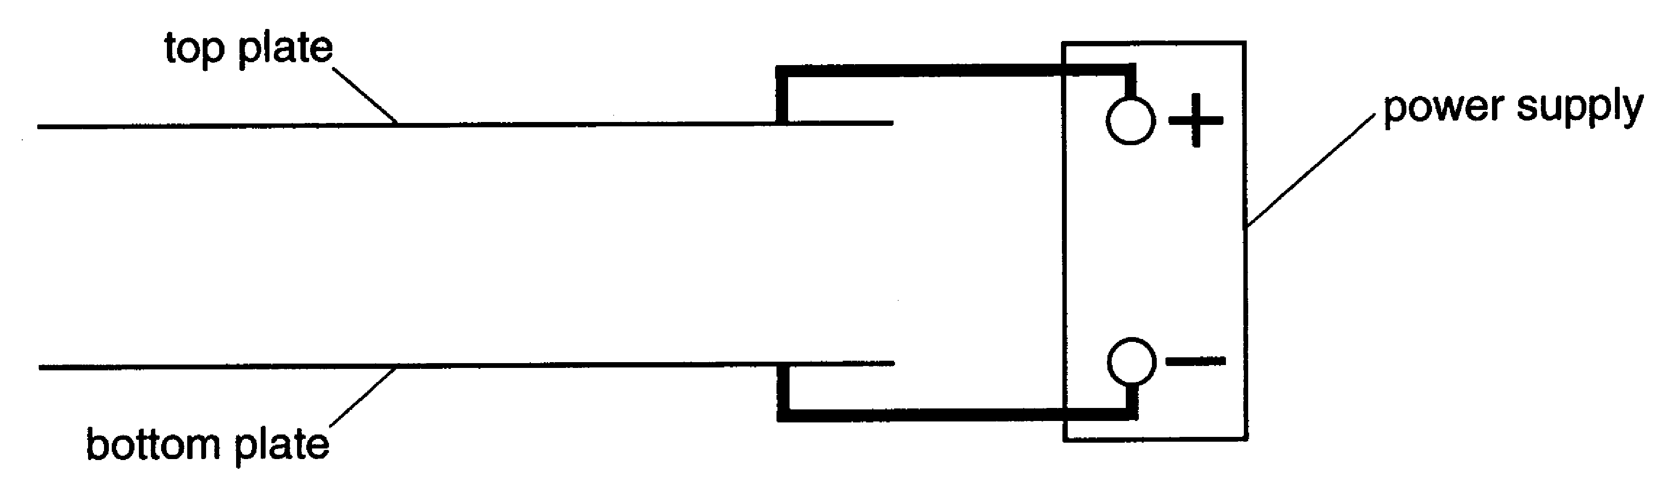

Fig. 12.1

- In Fig. 12.1, the plates are connected to a power supply.
Sketch five field lines in the gap between the plates.
[3]

A small metal sphere is place between the two horizontal plates, as shown in Fig. 12.2.

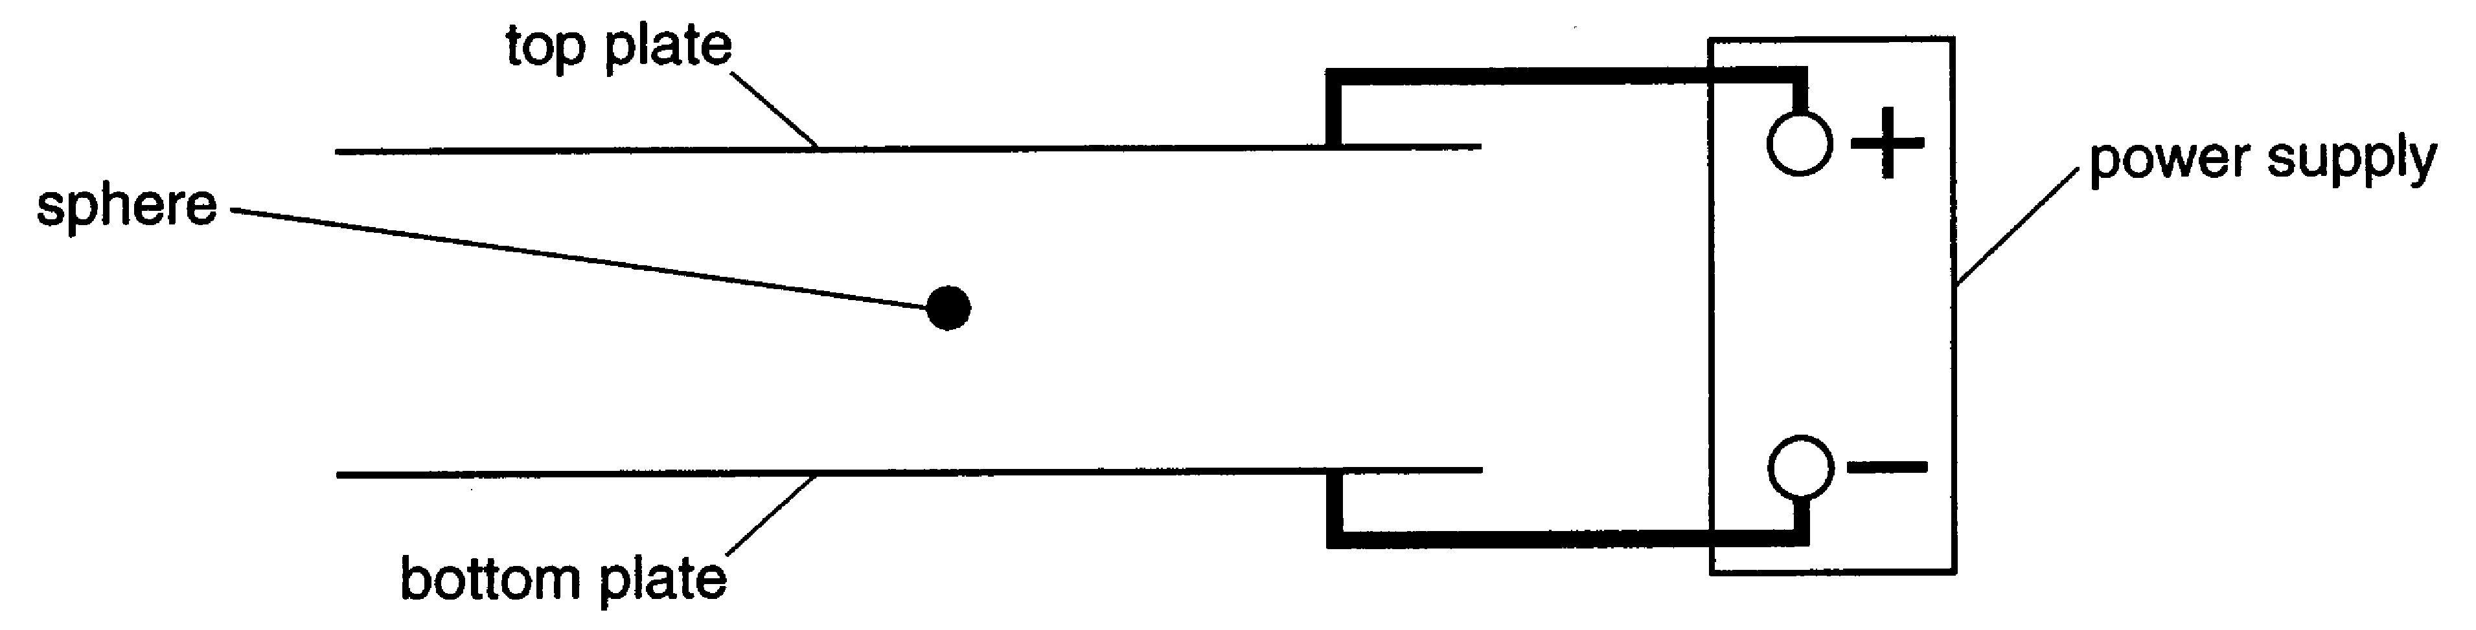

Fig. 12.2

The sphere is charged.
It does not move when the electric field is present.

- What sign of charge does the sphere have? Give reasons for your answer.

[2]
- The magnitude of the charge on the sphere is 4.8 x 10^{–14} C.
How many electrons had to be removed or added to give the sphere this charge?

number of electrons = ....................... [1]
- The mass of the sphere is 7.4 x 10^{–9} kg. The separation of the plates is 10 mm. For the sphere not to move,

(i) show that the electric field strength must be 1.5 x 10⁶ V m^{–1}.

[3]

(ii) calculate the potential difference required across the plates.

potential difference = ....................... V [1]

- The magnitude of the charge on the sphere can be changed by exposing the air between the plates to radiation from a beta source.
Explain how this can alter the charge on the sphere.

[3]

[Total: 13]

- The diagram shows the path followed by a 4 MeV proton as it almost collides head-on with a large nucleus.

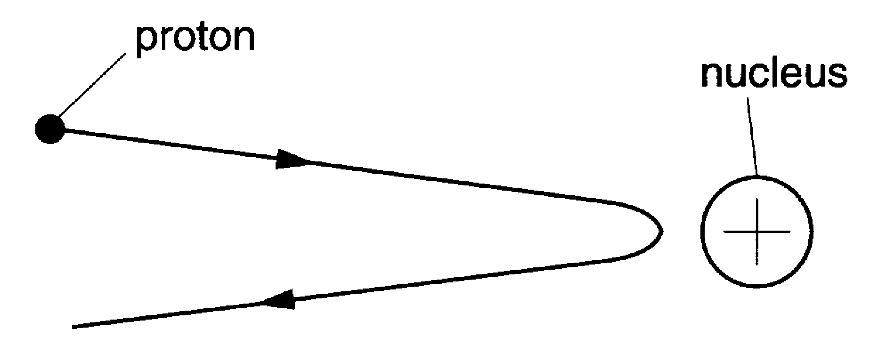

Another proton, with the same initial path, almost collides with the same nucleus. The proton has an energy of more than 4 MeV.
State and explain what difference this change would make to the distance of closest approach with the nucleus.

[2]

- The diagram shows part of the energy level diagram for an atom.

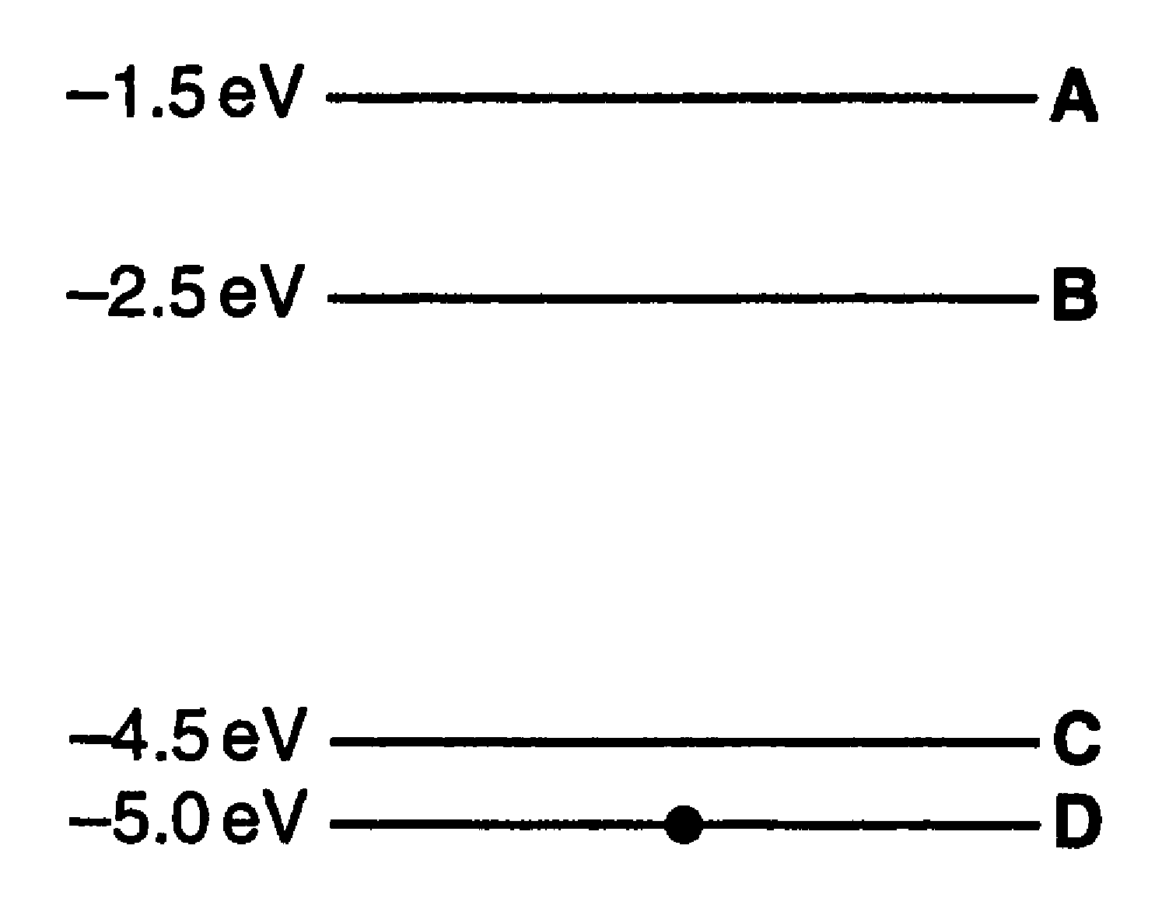

There are four energy levels, labelled A, B, C and D. The atom is initially in energy level D. An electron of energy 3.0 eV collides with the atom. This causes the atom to change energy level.

- If the collision raises the atom to energy level B, how much energy is the colliding electron left with?

energy = ....................... eV [1]

- Which energy level (A, B or C) will the atom definitely not be in after the collision?

energy level ....................... [1]

- This question is about the scattering of electrons from nuclei.

(a) The volume $\frac{4}{3}{πr}^{3}$of a nucleus of radius r is approximately proportional to the number of nucleons in it.

(i) Show that the radius r of a nucleus is given by the formula
r = r₀ A^{1/3}
where A is the atomic mass number and r₀ is a constant.

[4]
(ii) Show that the diameter of a neon-20 nucleus is about 7 × 10^{–15} m.
The constant r₀ = 1.2 x 10^{–15} m.

[2]
Electrons are directed towards a sample of neon-20 atoms, as shown in Fig. 15.1.

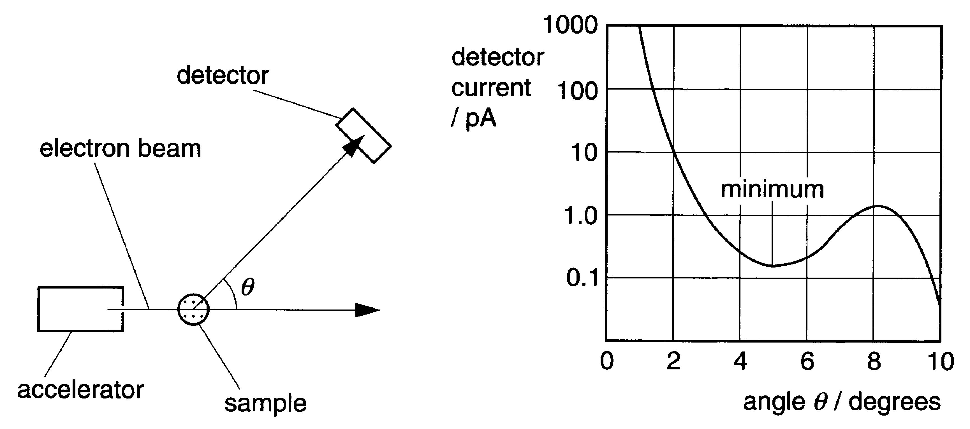

Fig. 15.1
(b) The graph of Fig. 15.1 shows the distribution of the electrons scattered elastically
from the sample. The graph shows a diffraction pattern.
By considering the possible paths of the electrons around a nucleus, explain why the graph has a minimum. No calculations are required.

[1]
- The angle θ for the first minimum of the diffraction of waves with wavelength λ around a circular object of diameter b is given by the formula
λ = 1.2 b sin θ
(i) Use the formula to show that the wavelength of the electrons in the beam is about 7 x 10^{–16} m.

(ii) Calculate the momentum of the electrons in the beam.
h = 6.63 x 10^{–34} J s

momentum = .................... N s [2]
- The neon-20 sample is replaced with a sample with the same number of argon-40 atoms. The graph of Fig. 15.2 shows what effect this has on the scattering of the electrons in the beam.

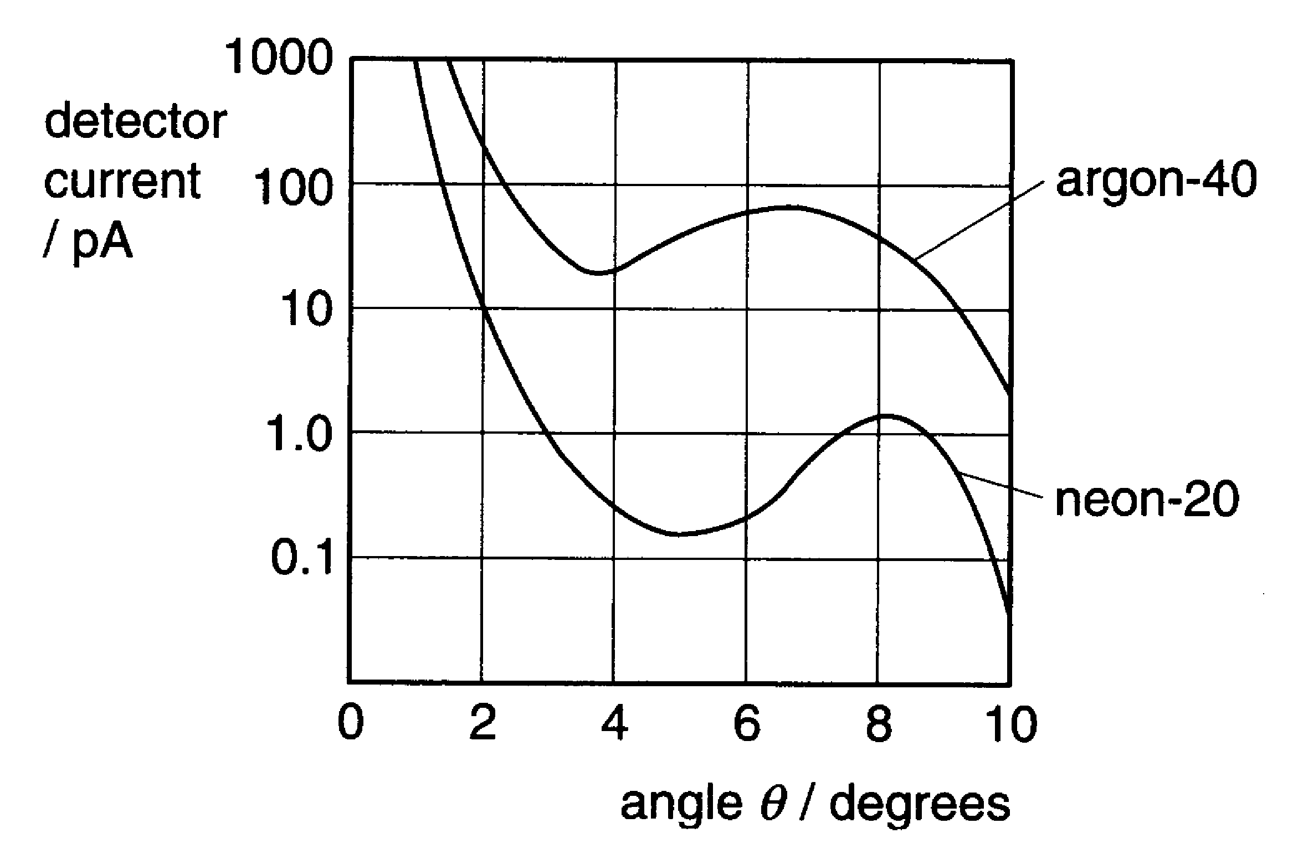

Fig. 15.2

Explain the differences between the two curves in the graph of Fig. 15.2. Both are produced by electron beams of the same energy.

[2]

[Total: 11]

- This question is about energy levels of atoms in a crystal.

(a) A beam of infrared radiation is passed through a crystal.
The graph of Fig. 16.1 shows the infrared absorption spectrum of the crystal.

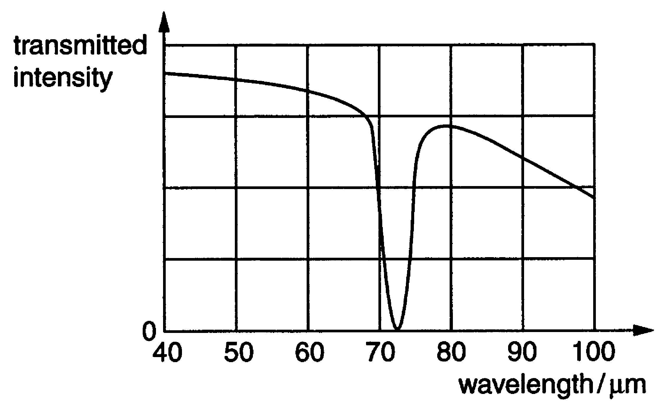

Fig. 16.1

- Show that the frequency of the infrared photons absorbed by atoms in the crystal is about 4 x 10¹² Hz.
c = 3.0 x 10⁸ m s^{–1}

[2]

(ii) The infrared absorption spectrum suggests that the energy levels of atoms in the crystal are evenly spaced, as shown in Fig. 16.2.

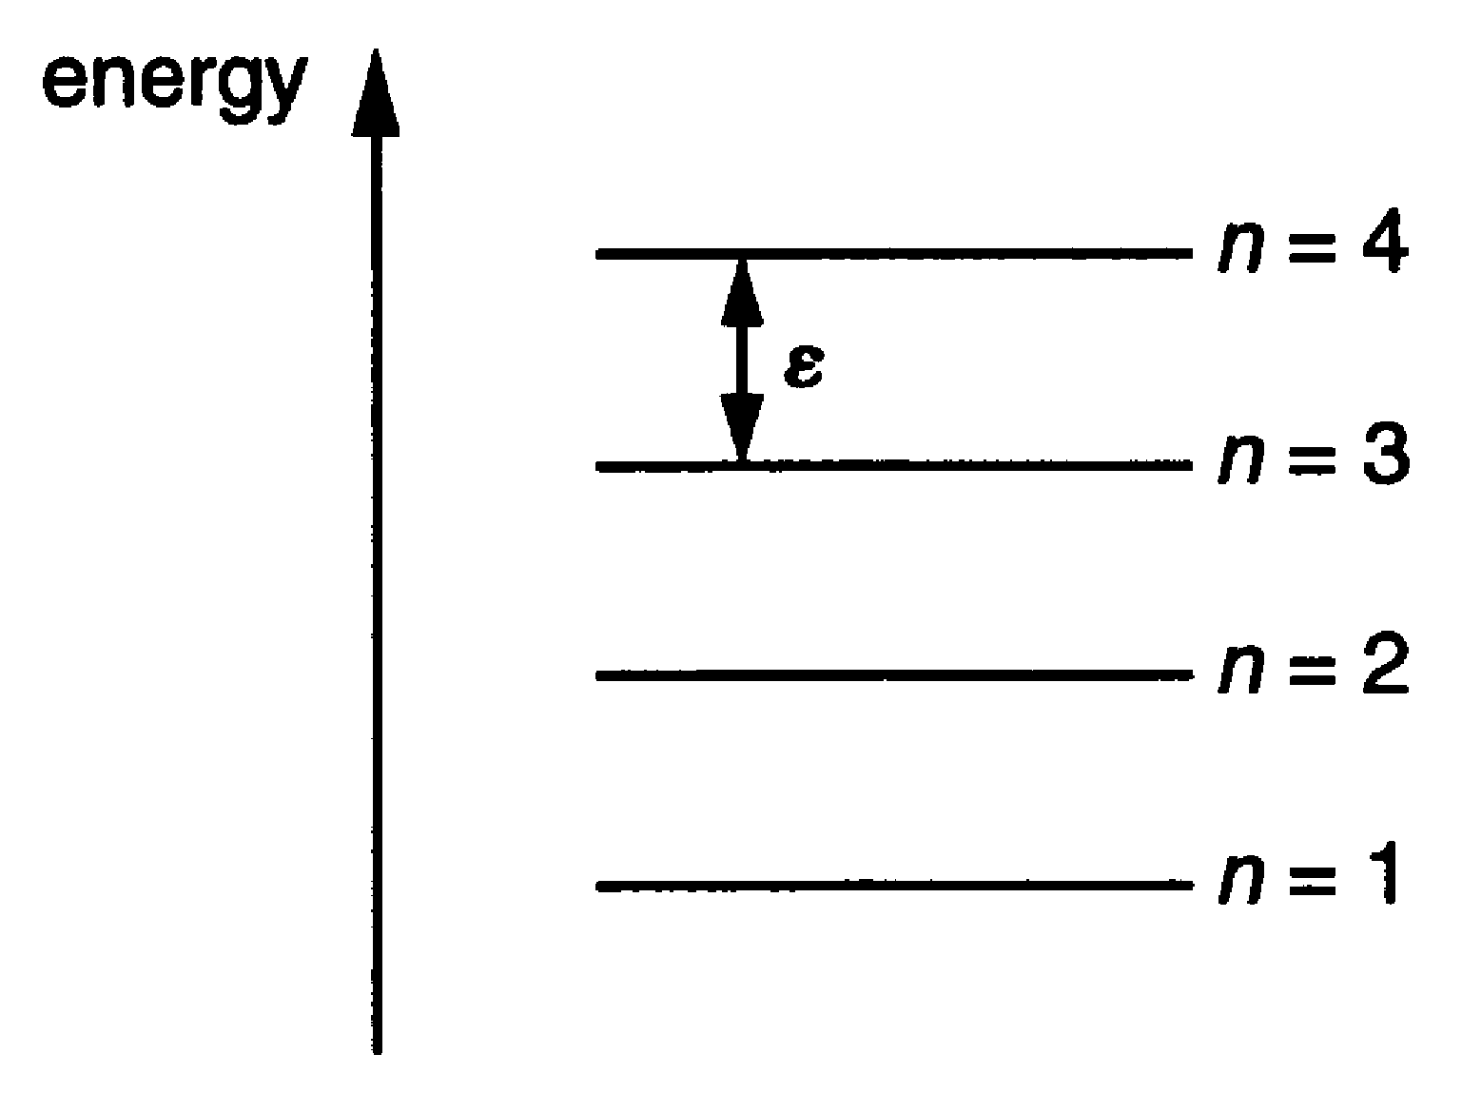

Fig. 16.2

The photons are absorbed when atoms move from one energy level to the next level.
On Fig. 16.2, draw an arrow to show the absorption of an infrared photon by the atom in the state n = 2.
[1]
(iii) Use your answer to (i) to calculate a value for ε, the separation of the energy levels.
h = 6.6 x 10^{–34} J s

ε = ......................... J [2]

(b) The oscillating motion of an atom in the crystal changes when it absorbs or emits an infrared photon. The bonds between each atom and its neighbours restrict its movement. This suggests a very simple model of a particle trapped in a box.
Fig. 16.3 shows a standing wave pattern for an atom in such a box when n = 3.

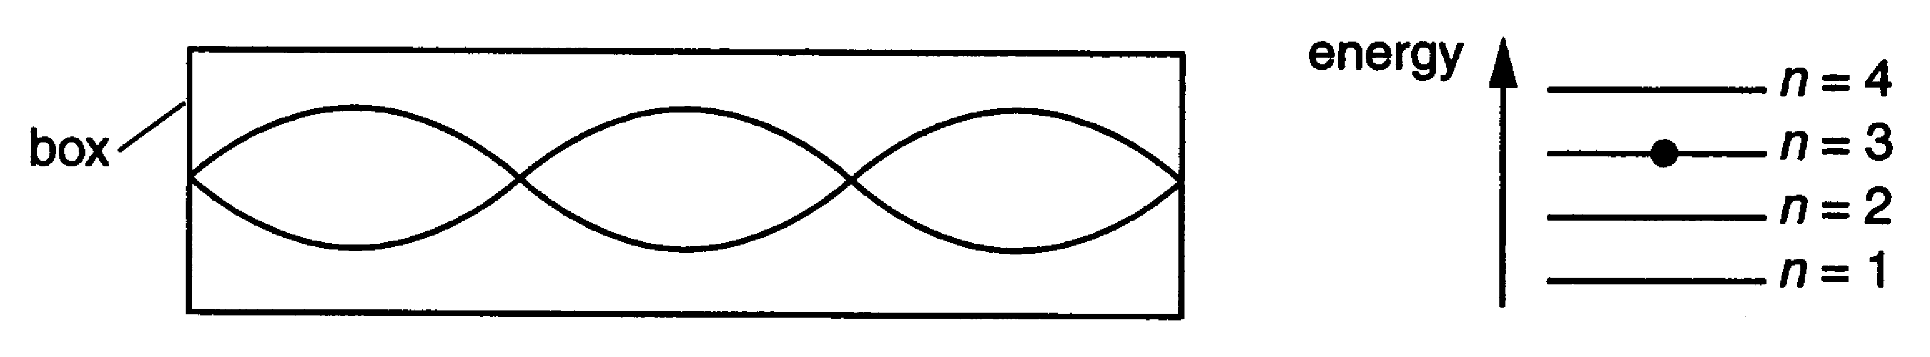

Fig. 16.3

(i) On Fig. 16.4 draw the standing wave for an atom when n =1.

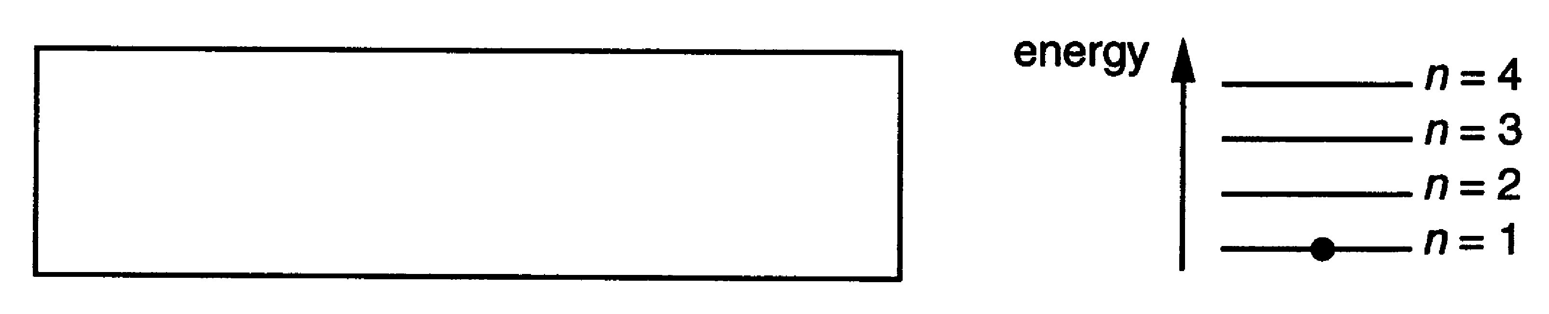

Fig. 16.4
[1]
(ii) The kinetic energy E of an atom of mass m with momentum p is given by the formula
$E=\frac{p^{2}}{2m}\text{.}$
Show that the de Broglie wavelength λ of the atom is given by
$λ=\sqrt{\frac{h^{2}}{2\text{mE}}}\text{.}$

[3]

(iii) When the atom is in its lowest energy state, the energy E is 1.35 x 10^{–21} J.
Calculate the de Broglie wavelength of the atom in its lowest energy state.
m = 5.1 x 10^{–26} kg

wavelength = ........................ m [1]

(c) (i) Use your answer to (b)(i) and (b)(iii) to estimate the length of the box which traps the particle when n =1.

length = ........................ m [1]

(ii) The model only predicts the correct energy levels if the length of the box trapping the particle increases with increasing energy.
Show this by calculating the length of the box for n = 3.

length = ........................ m [2]

[Total: 13]

- The equation shows a possible neutron-induced fission for a nucleus of plutonium-239.
${}_{\text{94}}^{\text{239}}{}\text{Pu} + {}_{0}^{1}{}n→{}_{\text{42}}^{\text{100}}{}\text{Mo} + {}_{\text{52}}^{\text{134}}{}\text{Te} + \text{neutrons}$
How many neutrons are emitted?

number of neutrons = ....................... [1]

- Silicon-31 is an emitter of beta particles. It has a half life of 9.4 x 10³ s.

(a) Show that its decay constant λ is about 7 x 10^{–5} s^{–1}.

[1]

(b) The activity of a radioactive source can be calculated with the relationship
$\frac{ΔN}{Δt}=−λN\text{.}$
Use the relationship to show that the decay constant has units of s^{–1}.

[1]

(c) Calculate the number of silicon-31 atoms needed to make a source of activity
3 x 10³ Bq.

number of atoms = ............................ [1]

- The typical dose equivalent for a chest X-ray is 2 x 10^{–4} Sv.
A dose equivalent of 1 Sv gives a person a 3% probability of developing cancer.
Calculate the probability of a person developing cancer from one chest X-ray per year for 25 years.

probability = ........................ % [2]

- Cobalt-60 is a radioisotope which emits gamma photons of energy 1.2 MeV.
Calculate the mass loss due to the emission of one gamma photon.

mass = ....................... kg [2]

- This question is about the fusion of hydrogen-2 nuclei.
The fusion of a pair of hydrogen-2 nuclei to make a nucleus of helium-3 and a neutron is given by this symbol equation.
${}_{1}^{2}{}H + {}_{1}^{2}{}H → {}_{2}^{3}{}\text{He} + {}_{0}^{1}{}n$
The table gives the masses of the particles in this equation.

particle | mass/u
neutron | 1.0087
hydrogen-2 | 2.0141
helium-3 | 3.0160

(a) The fusion reaction results in a transfer of rest energy to kinetic energy.

Calculate the kinetic energy produced.
1 u = 1.66 x 10^{–27} kg.

kinetic energy =.................... J [3]
(b) A proton bound in a nucleus can decay into a neutron by emitting a positron and a
neutrino.

(i) Write down a symbol equation to represent the decay of a proton.

(ii) Use the data in the table to calculate the change in mass when a proton decays to a neutron.

particle | mass/u
neutron | 1.0087
positron | 0.00055
proton | 1.0073

change of mass =.................... u

(iii) Use your answer to (b)(ii) to suggest why this decay is not possible for a free proton.

[4]

[Total: 7]

- This question is about the risks of ionising radiation.
A school purchases the three radioactive sources shown in the table.

source | emission | half-life/year
cobalt-60 | gamma photons | 5.3
strontium-90 | beta particles | 28.1
americium-241 | alpha particles | 458

- All three sources are delivered to the school with the same activity of 4.0 x 10⁴ Bq. This means that the alpha particle source contains the largest number of unstable nuclei. Explain this fact.

[2]

- The sources arrive in a lead-lined box. This absorbs all of the emissions from the alpha and beta sources, but not from the gamma source.

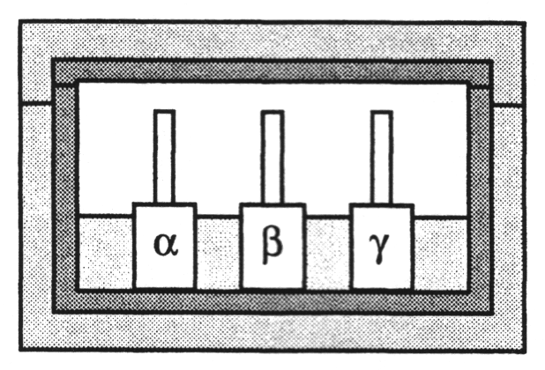

- 10 mm of lead absorbs half of the gamma photons incident on it.
Sketch a graph on the axes below to show how the transmission of the gamma photons through the lead depends on its thickness.

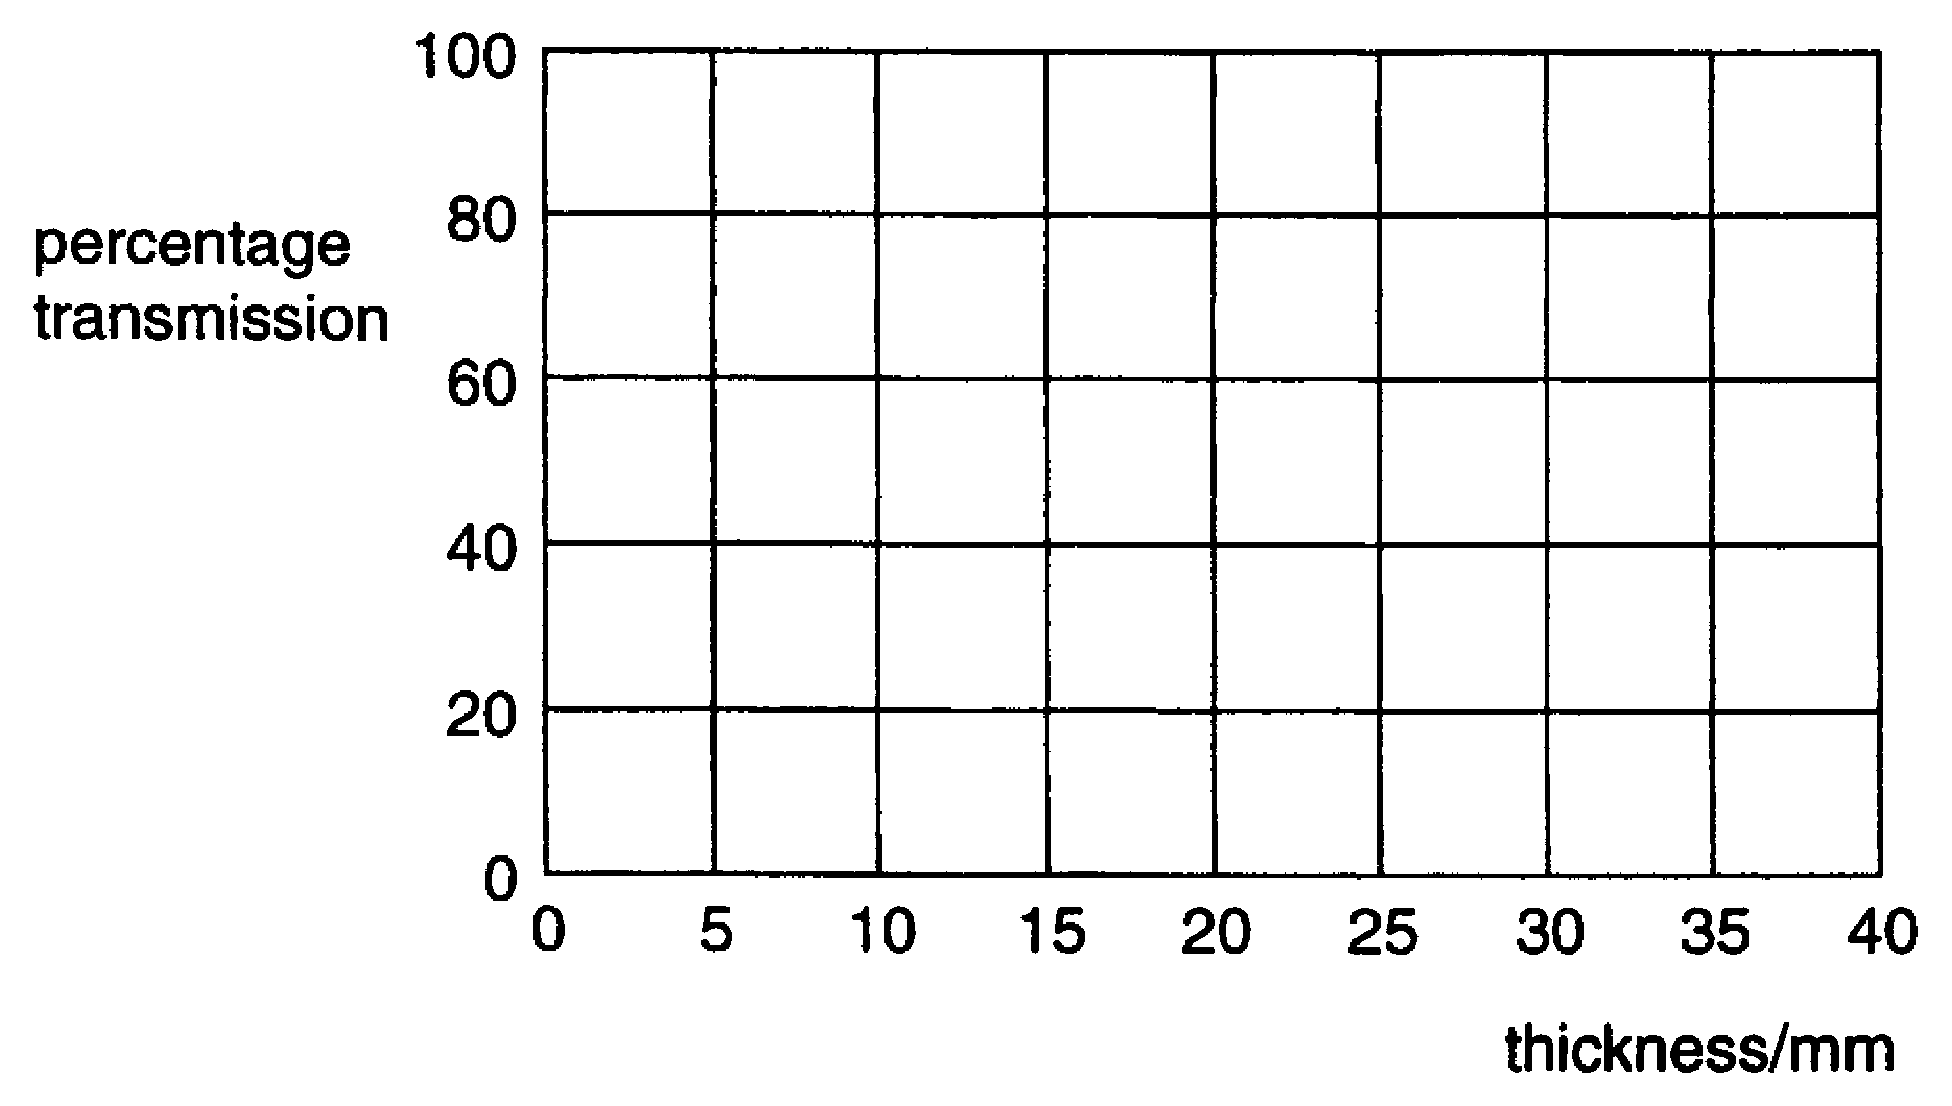
[2]

(ii) The lead of the box is 25 mm thick. The activity of the gamma photon source is 4 x 10⁴ Bq.

Use the graph to estimate the number of gamma photons escaping from the box per second.

number per second = ....................... s^{–1} [1]

- A student breaks the safety rules and keeps the beta particle source in his pocket for an hour before returning it to its box.

(i) Explain why the student can only absorb at most half of the particles emitted by the source when it is in his pocket.

[1]

(ii) The activity of the beta particle source is 4 x 10⁴ Bq.
The energy of each beta particle is 8.8 x 10^{–14} J.
Show that the maximum energy absorbed from the source by the student is about 6 µJ.

[2]
(iii) The student considers the risk that he has taken.
He assumes that the dose of 6 µJ is shared evenly over his mass of 60 kg. This gives a dose equivalent of 0.1 µSv.
The whole-body dose equivalent from background radiation is about 2 mSv per year, equivalent to 4 nSv per hour.
The student concludes wrongly that keeping the beta particle source in his pocket has increased his risk of cancer considerably.
Discuss the student's assumption and conclusion.
[2]

[Total: 10]

- This question is about an electric car.

(a) The car is driven by a dc electric motor. To avoid wasting energy when the car slows down, it is proposed to use the motor as a generator to recharge the batteries. Fig. 23.1 below is a simplified diagram of such a motor/generator.

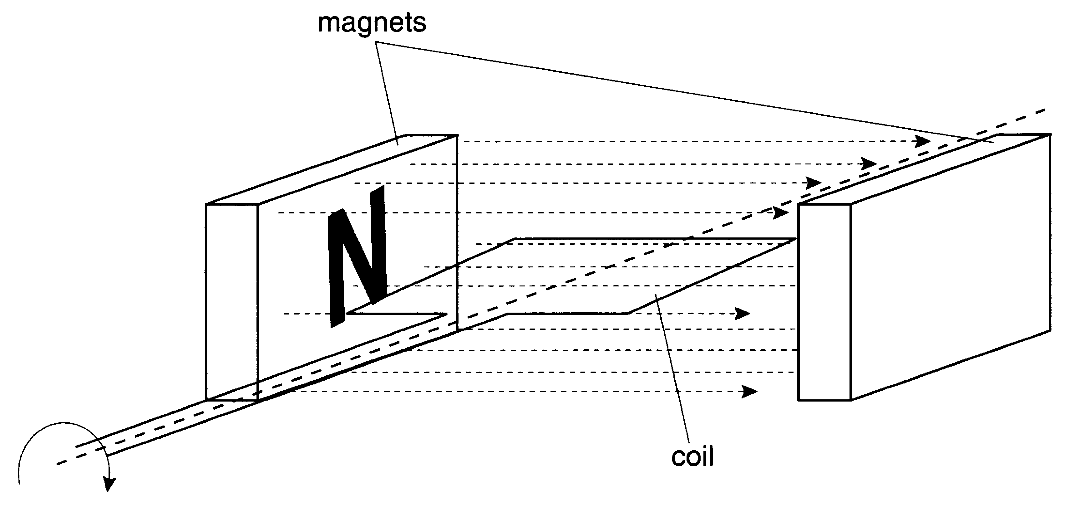

Fig. 23.1

(i) Explain, using the diagram of Fig. 23.1, how an emf is produced in this generator when the coil rotates.

(ii) The graphs A to D in Fig. 23.2 below show the average dc emf produced by the motor/generator as the car comes to a halt when using the motor to decelerate from its maximum speed. Choose the one of which best shows the emf during this time.

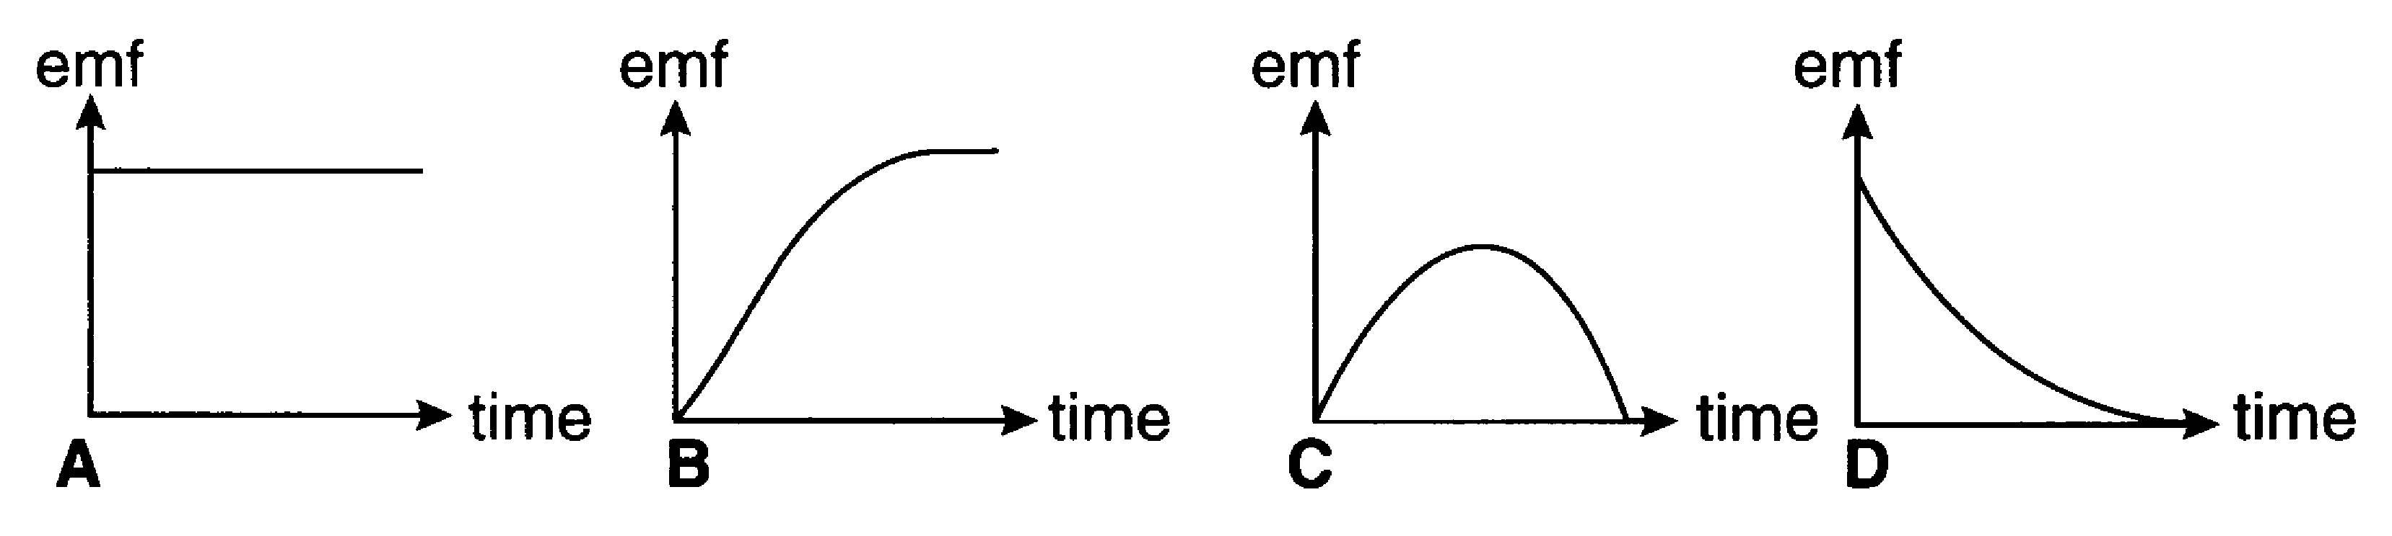

Fig. 23.2
The correct graph is...................... [2]

(b) Electric cars have the disadvantage of poor acceleration. Suggest and explain one reason for this.

[2]

- This question about nanomotors is based on an advanced notice article on ‘Nanotechnology’.

(a) The article states that good electromagnetic machines need to be large.
Fig. 24.1 shows two electromagnetic motors which differ only in size (one is twice as large as the other).

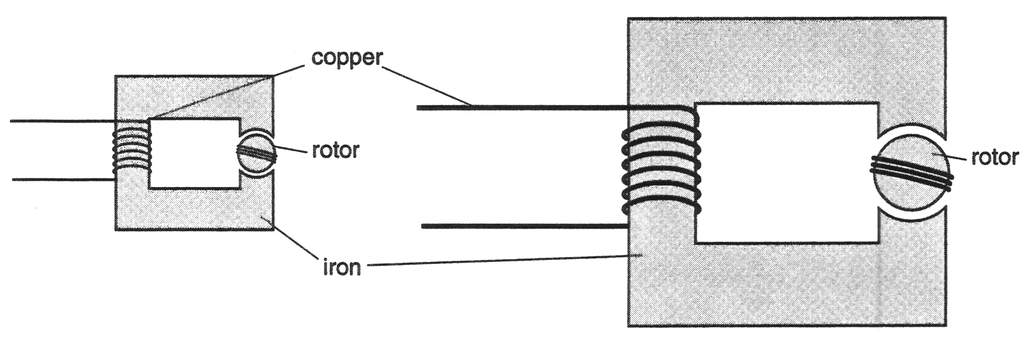

Fig. 24.1

- Considering the electrical circuit, explain why the larger machine can produce a larger flux in the rotor than the smaller one for the same p.d. across the copper coil.

[3]

- Considering the magnetic circuit, explain why the larger machine can produce a larger flux in the rotor than the smaller one for the same current in the copper coil.

[2]

(b) Centripetal forces are less of a problem for small motors.
Explain why centripetal forces can make rapidly-spinning motors break.

[2]
(c) Part of a simple electrostatic motor is shown in Fig. 24.2.

(i) On Fig. 24.2, draw a field line through X to show the electrical field produced by the two charged regions of the stator.
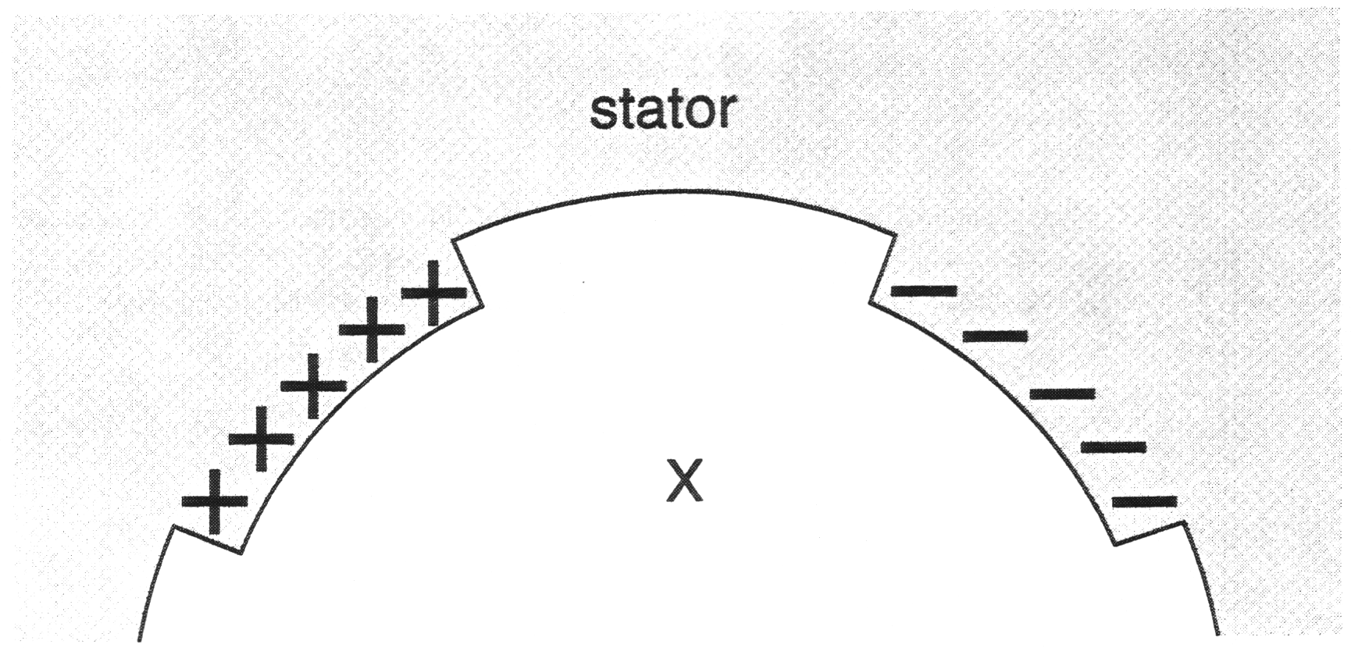

Fig. 24.2
[2]

(ii) Fig. 24.3 below shows a charged part of the rotor between the two conducting parts of the stator. Explain, in terms of the electric field, why the rotor rotates.

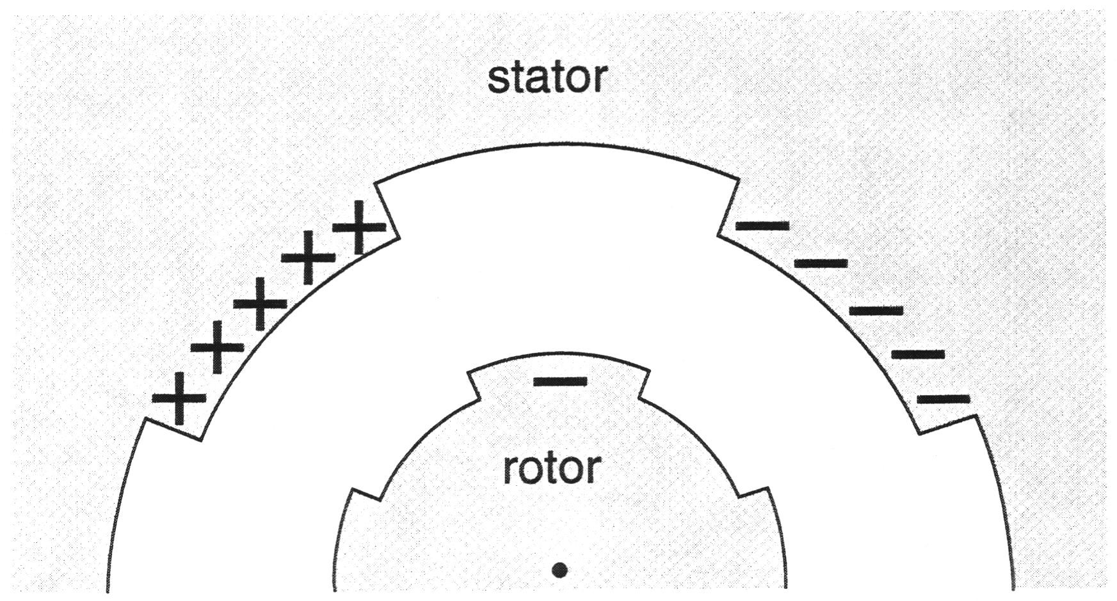

Fig. 24.3

[1]

[Total: 10]
- This question is about the photomultiplier tube in a gamma camera.

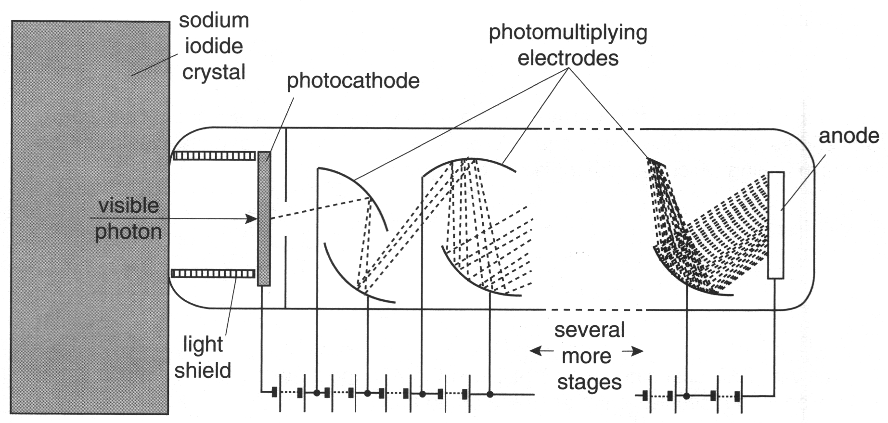

Fig. 25.1

- Explain why the photomultiplier tube needs the opaque light shield shown in Fig. 25.1.

[1]
- The graph of Fig. 25.2 shows the p.d. in the region between the photocathode and the first photomultiplying electrode. It is assumed that the electric field is constant in this region.

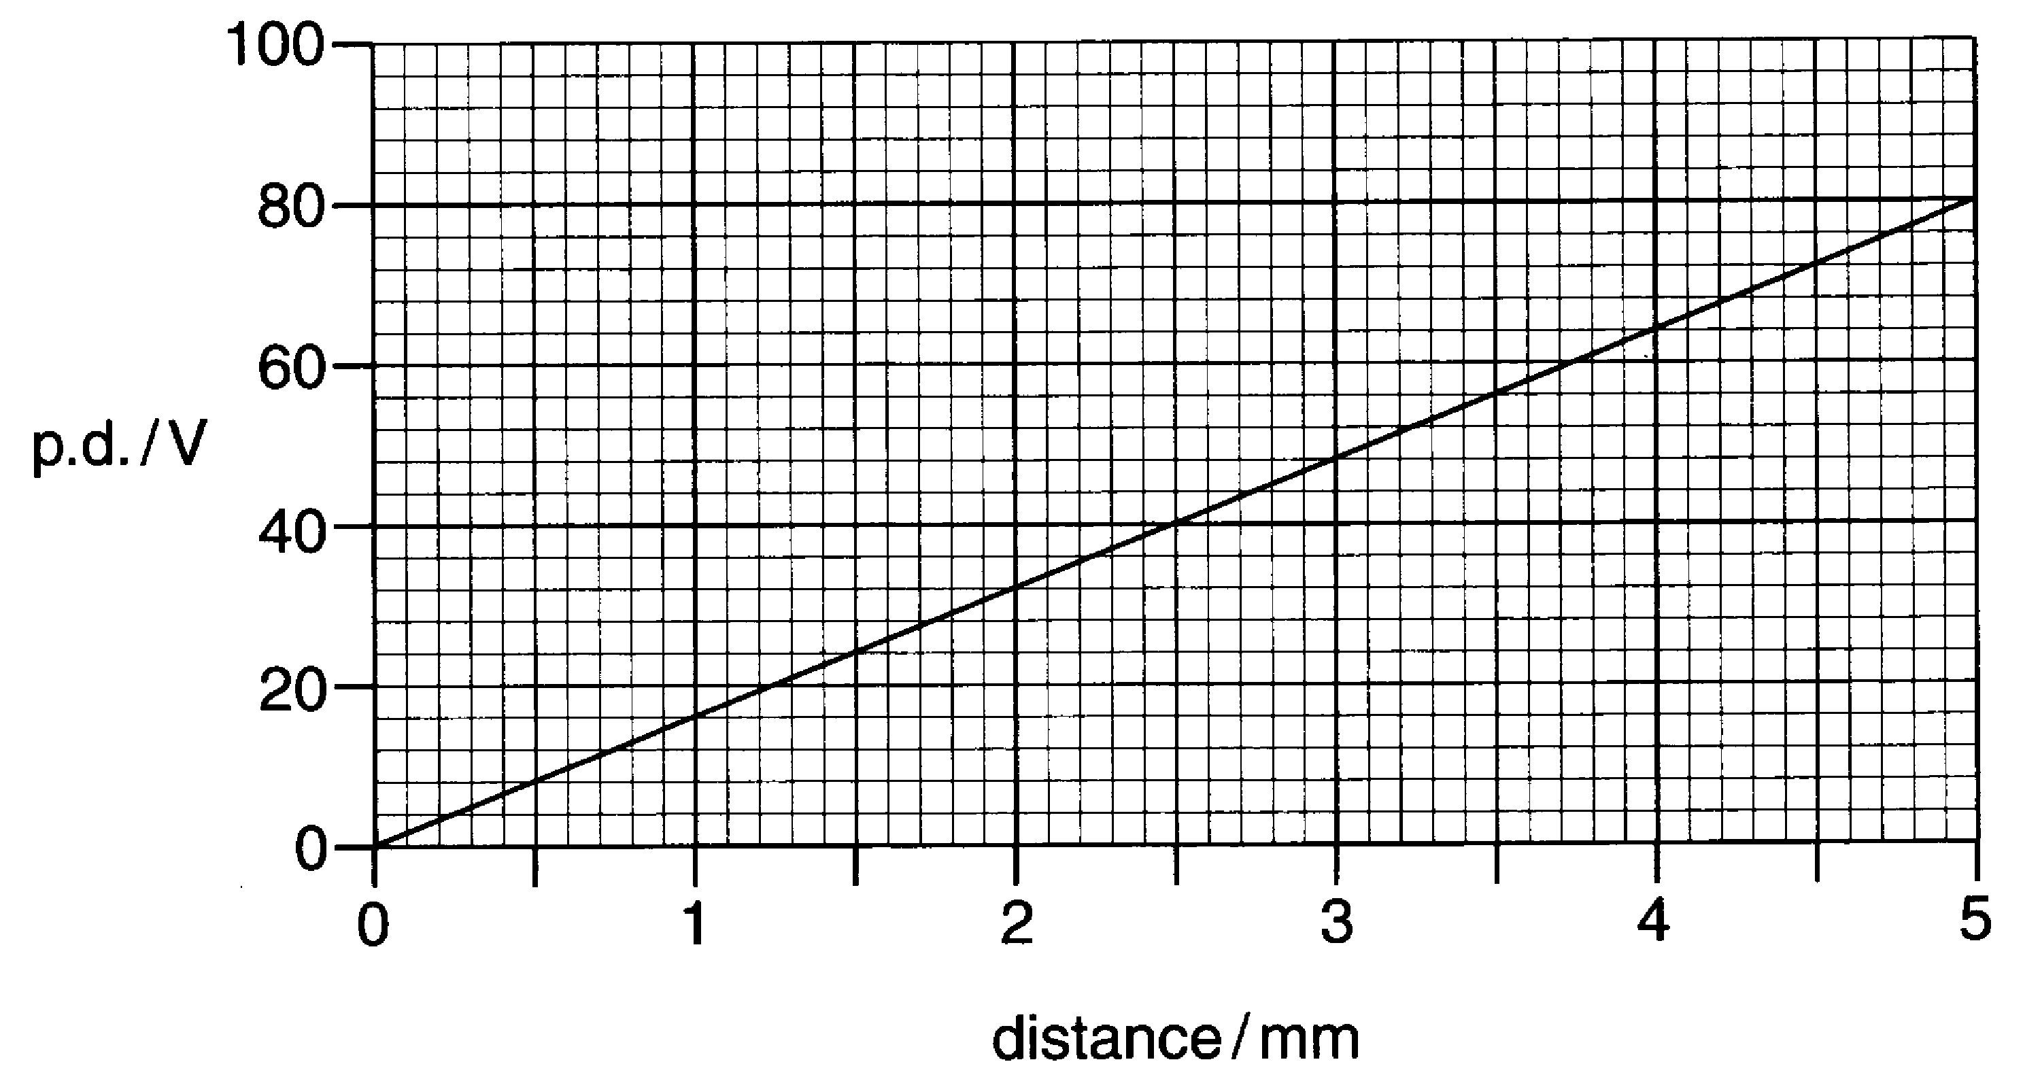

Fig. 25.2

- Explain how this graph shows that the electric field in this region is constant.

[1]

(ii) Show that the electric field in this region is 16 000 V m^{–1}.

[2]

(iii) Show that the force on an electron in this region is about 2.6 x 10^{–15} N.

[2]
(iv) Show that the acceleration of this electron is very much greater than g, the acceleration due to gravity on Earth.

[2]

[Total: 8]
- This question is about the fundamental particles called positrons, which have the same mass as electrons, but an opposite charge. Fig. 26.1 shows the type of paths that positrons can give in a cloud chamber, where they ionise air molecules.

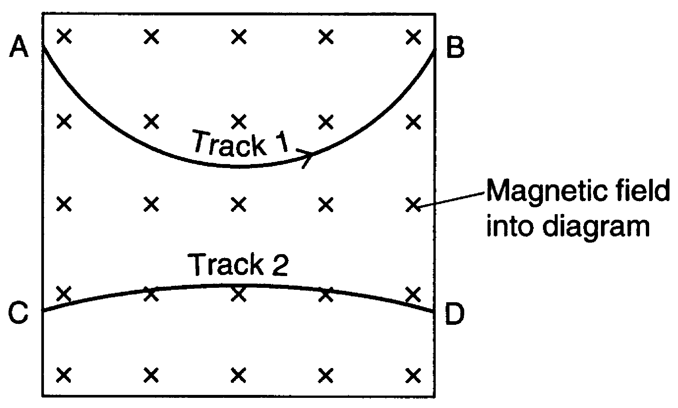
Fig. 26.1

Track 1 was produced by a high-speed positron travelling from A to B. A uniform magnetic field, perpendicular to the diagram, makes the positron travel in a curved path as shown.

- Track 2 was produced by a second positron. What two facts can you deduce about the positron that produced track 2? Explain your reason in each case.
Fact 1:
Explanation:
Fact 2:
Explanation:

[4]

A positron can be produced when a gamma photon (passing near a nucleus) creates an electron and a positron, and no other particles, in pair production as shown in the diagram below.
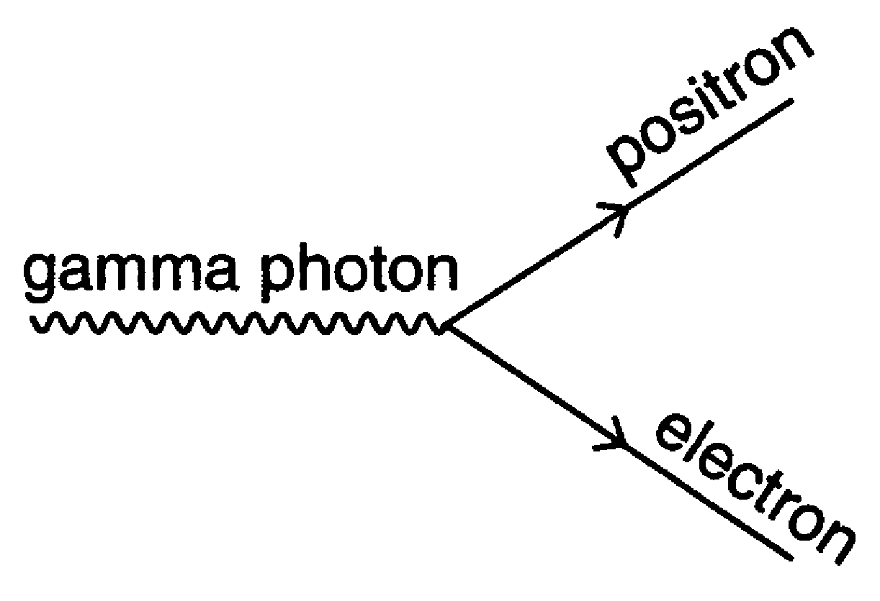
Fig. 26.2

- Explain why, if pair production is possible, the positron must have a charge equal and opposite to that of the electron.

[1]
When pair production occurs in a cloud chamber, Fig. 26.3 shows a typical pattern of the tracks obtained.

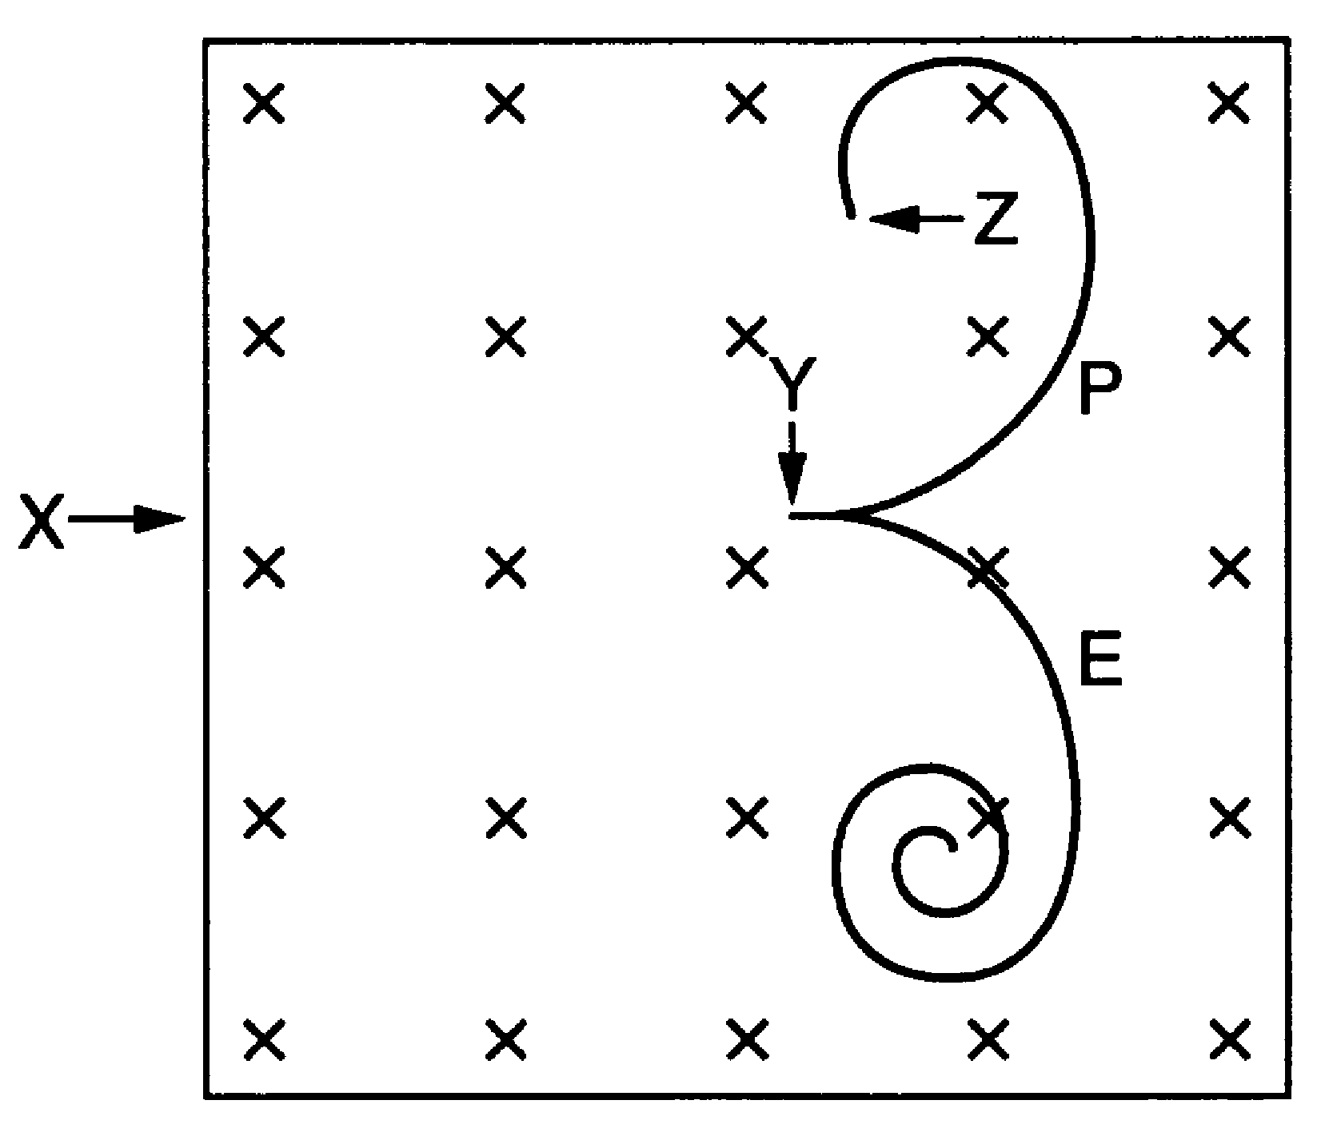

Fig 26.3

In Fig. 26.3, a gamma photon entered the chamber at X, and at Y it converted into a positron (P) and an electron (E).

- Suggest why the gamma photon leaves no track in the cloud chamber in Fig. 26.3.

[1]

- The electron and positron paths spiral inwards because the particles are slowing down. Explain why they are slowing down.

[2]

- The path of the positron suddenly stops at Z. Explain what happens at this point.

[2]

[Total :10]

- This question is about carbon-14 in the body.
All living matter contains carbon-14, which decays, following the equation:
${}_{6}^{\text{14}}{}C →{}_{7}^{\text{14}}{}N + X + \bar{ν}$

(a) Identify the particle X in this equation.

[1]
(b) The decay constant λ of carbon-14 is 3.8 x 10^{–12} s^{–1}.
Show that the half-life of carbon-14 is about 6000 years.
1 year = 3.2 x 10⁷ s

[2]
(c) A man of mass 65 kg contains about 1.3 x 10^{–11} kg of carbon-14.

Show that the activity of the carbon-14 in a 65 kg man is about 2 kBq.
u =1.7 x 10^{–27} kg

[3]
(d) When an organism dies, the carbon-14 stops being replaced and gradually decays
away.

(i) A preserved human body, about 65 kg in mass, was found in a glacier in the Alps. It is thought to be 5000 years old.
Explain why the activity of the carbon-14 in the body is about 1 kBq.

[1]

(ii) A measurable activity is about 10 Bq (significantly larger than the background count). Estimate the mass of tissue from the preserved body from the glacier which would have an activity of 10 Bq due to carbon-14, and explain why museums are reluctant to allow radiocarbon dating of this sort on their specimens.

[2]

(e) (i) A 65 kg man is constantly receiving a dose from the carbon-14 in his own body.
Each decay releases 2.5 x 10^{–14} J. If the activity of the carbon-14 in his body is
2 kBq, calculate the energy absorbed in the body each second. You can
assume that the body absorbs all the radiation emitted.

energy absorbed each second .................................. J [1]

(ii) Calculate the absorbed dose, in Gy, that a 65 kg man would expect to receive over a year from the carbon-14 in his body.

absorbed dose .................................. Gy [2]

(iii) Carbon-14 is not the only radionuclide in your body. Radioactive potassium-40 is also present. The dose you receive from your carbon-14 is much less than the dose you receive from your potassium-40.
Suggest reasons for this.

[2]

[Total: 14]

- (a) In a particle accelerator, protons are accelerated to within 0.1% of the speed of
light.

A student calculates the proton momentum and kinetic energy like this:
“0.1% of the speed of light is such a very small difference from c that I can write its velocity as 3.0 × 10⁸ m s^{–1}.
mass of proton = 1.7 × 10^{–27} kg
Therefore the momentum = mv = 1.7 × 10^{–27} kg × 3.0 × 10⁸ m s^{–1}
= 5.1 × 10^{–19} kg m s^{–1}
and the kinetic energy = ½mv² = 0.5 × 1.7 × 10^{–27} kg × (3.0 × 10⁸ m s^{–1})²
= 7.6 × 10^{–11} J”

- Explain why this is incorrect.

[1]

- Calculate the correct values of momentum and kinetic energy for these protons.
u = 1.7 × 10^{–27} kg

[4]

(b) Physicists are hunting a particle which is thought to have a mass (rest energy) of about 100 GeV.

It is hoped to create this particle in the LHC by colliding together protons and antiprotons of very high energy.

- Show that the relativistic constant γ for the protons and antiprotons will need to be about 50.
c = 3.0 × 10⁸ m s^{–1}
mass of proton = mass of antiproton = 940 MeV/c²

[3]

- Show that these particles must be travelling at about 99.98% of the speed of light.

[2]

[Total: 10]

This question is based on the advance notice article ‘Taming Nuclear Fusion’.

- This question is about population growth and energy demand (lines 4 – 9 in the article).

(a) Fig. 29.1 shows how the world population changed in the twentieth century.

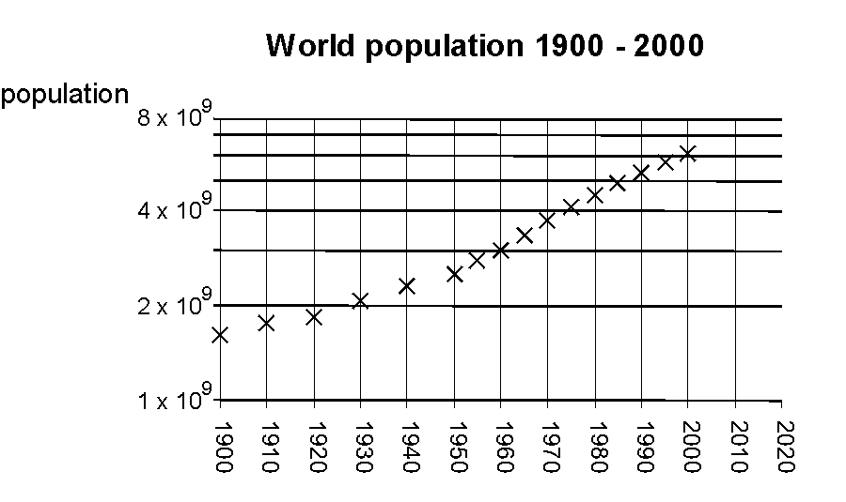

Fig. 29.1

- State how you can tell that the scale on the y-axis is logarithmic.

[1]

- Explain why a graph with a logarithmic scale on the y-axis is useful for testing for exponential change.

[2]

- Explain clearly how the graph shows that “…the rate of exponential growth suddenly increased significantly in the middle of the last century” (lines 4 and 5 in the article).

[2]

(b) (i) Assuming the annual energy consumption per capita remains at about 68 GJ
per person per year, use the graph to show that the total world consumption of energy in the year 2007 is likely to be about 5 × 10²⁰ J.

[2]

(ii) Use this value for the total world consumption of energy to estimate the maximum lifetime of the Earth’s fossil fuel resources, currently estimated at about 4 × 10²² J.

lifetime = …………………… years [1]

(iii) Suggest why the estimate of the lifetime may prove inaccurate.

[1]

[Total: 9]

This question is based on the advance notice article ‘Taming Nuclear Fusion’.

- This question is about the energy released in nuclear fusion (lines 17 – 34 in the article).
nucleon number, A
binding energy
per nucleon
/ MeV

Fig. 30.1

- On Fig. 30.1, ring the point corresponding to the nucleus ${}_{9}^{\text{19}}{}F$.

[1]

- Fig. 30.1 shows that hydrogen ${}_{1}^{1}{}H$has zero binding energy. State why this must be the case.

[1]

- Show that the graph gives a total binding energy for a ${}_{2}^{4}{}\text{He}$ nucleus of about
–28 MeV.

[2]
- The table shows the masses of different particles.

particle | mass/ 10^{–27} kg
proton | 1.6675
neutron | 1.6693
helium-4 nucleus | 6.6240

Use the data in the table to show that the total binding energy of the helium nucleus is about –4 × 10^{–12} J.
c = 3.0 × 10 ⁸ m s^{–1}

[2]

[Total: 6]

This question is based on the advance notice article ‘Taming Nuclear Fusion’.

- This question is about the conditions in the Sun’s core (lines 34 – 54 in the article).
The graph in Fig. 31.1 shows the potential energy of two protons as they approach each other.
potential energy
/ MeV
0
0
Fig. 31.1

- Use data from the graph to show that the potential energy is given by the equation.
$\text{potential energy}=\frac{\text{constant}}{r}$
Show your working clearly.

[2]

- (i) Fig 31.1 shows that 1.44 MeV is required to bring two protons to a separation
of 1 fm, where they can fuse.

Show that this requires each proton to have a kinetic energy of about
1 × 10^{–13} J.
e = 1.6 × 10^{–19} C

[1]
(ii) Calculate the value of kT for a proton in the core of the Sun.
k = 1.4 × 10^{–23} J K^{–1}
temperature of Sun’s core = 1.5 × 10⁷ K

kT = …………………….. J [1]

(iii) Use the answers to (i) and (ii) to explain why ‘the proportion of protons in the Sun’s core … with enough energy to approach this close is so tiny that fusion would be extremely unlikely to occur.’ (lines 44 – 45 in the article).

[2]

- Fig. 31.2 shows two protons heading towards each other at two different separations. On both diagrams, draw labelled arrows representing the magnitudes and directions of the forces acting on each proton. One arrow has been drawn for you.

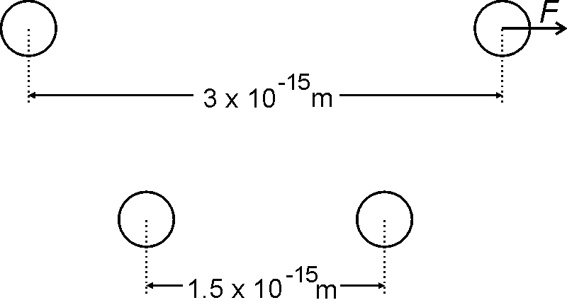

Fig. 31.2

[2]

- The pressure in the core of the Sun is 3.4 × 10¹⁶ Pa.
Calculate the mean separation of particles in the Sun’s core, assuming that the particles behave as an ideal gas.

Temperature of core = 1.5 × 10⁷ K
R = 8.3 J mol^{–1} K^{–1}
N_{A} = 6.0 × 10²³ mol^{–1}

separation = ………………………. m [4]

[Total: 12]

This question is based on the advance notice article ‘Taming Nuclear Fusion’.

- This question is about the magnetic field in a tokamak (lines 89 – 127 in the article).

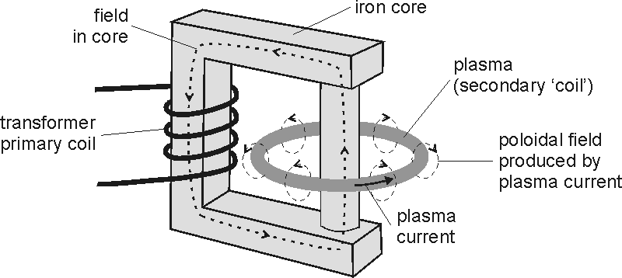

Fig. 32.1

- Explain in terms of magnetic circuits why a massive iron core is necessary to produce a large plasma current.

[1]

- Explain why a constant direct current in the primary coil would not generate a plasma current.

[2]
- The graph in Fig. 32.2 shows how the magnetic flux in the iron core changes at the start of a pulse.

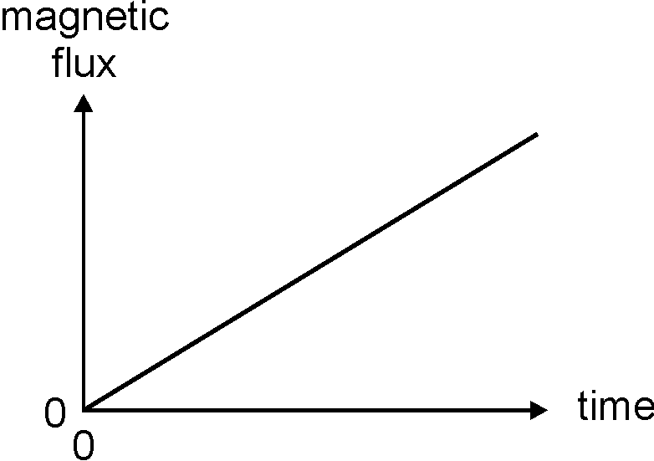

Fig. 32.2

Which one of the graphs A to D below shows the plasma current produced by the changing magnetic flux of Fig. 32.2?

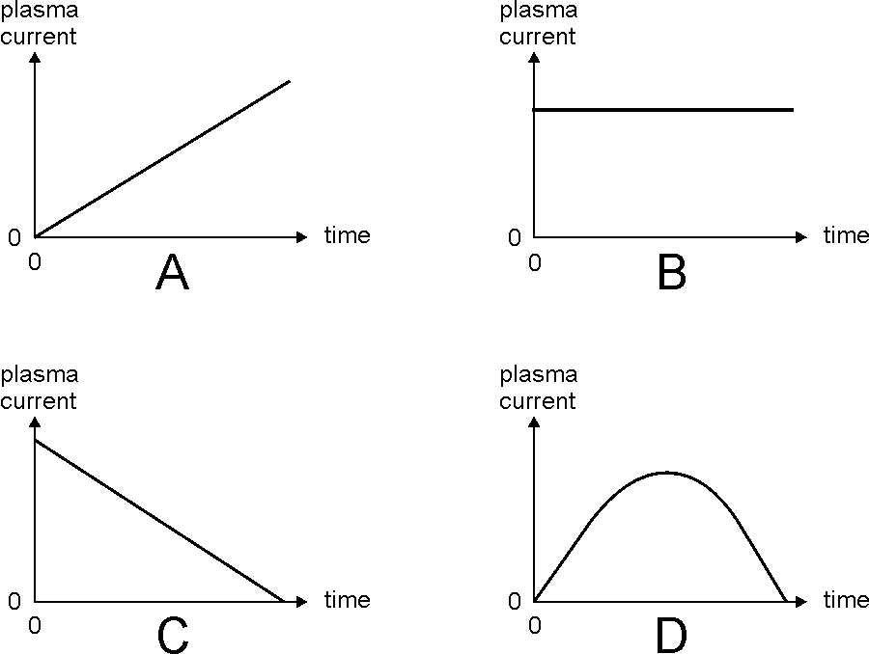

graph ………[1]

- The ions in the torus are moving in a complicated magnetic field pattern. State and explain how magnetic forces would affect ions travelling

- parallel to the lines of flux

- at right angles to the lines of flux.

[2]

[Total: 6]
This question is based on the advance notice article ‘Taming Nuclear Fusion’.

- This question is about the three methods of heating the plasma in a tokamak (lines 129 – 146 in the article).

(a) The plasma is heated by the plasma current.
(i) The resistance of the plasma is 5.0 × 10^{–7} Ω.
Show that the power dissipated as heat by a current of 3.0 × 10⁶ A is ‘at a rate of a few megawatts’ (line 134 in the article).

[2]

(ii) The plasma contains deuterium ${}_{1}^{2}{}H^{+}$ ions. Assuming that they contribute
1.0 × 10⁶ A to the total plasma current, calculate the number of deuterium ions per second passing any point in the torus.
e = 1.6 × 10^{–19} C

number of deuterium ions s^{–1} ………………………….. [2]

(b) The ions in the plasma spiral around the magnetic field lines (line 120 and Fig. 7 in the article).
The time taken for deuterium ${}_{1}^{2}{}H^{+}$ ions to spiral once around a magnetic field line is 4.0 × 10^{–8} s. This period resonates with electromagnetic radiation of the appropriate frequency.
Show that the article is correct in describing this resonant frequency as ‘in the radio frequency range’ (lines 135 and 137 in the article).

[1]
(c) The plasma is also heated by neutral beams of deuterium atoms (lines 138 – 146
in the article).
(i) The ${}_{1}^{2}{}H^{+}$ ions are accelerated by an electrical field to an energy of 60 keV.
State the p.d. required.

p.d…………………… V [1]

(ii) Explain why the ions must be neutralised before being injected into the plasma.

[1]

[Total: 7]

[Section C total: 40]

Advance notice article ‘Taming Nuclear Fusion’

The energy crisis and the population explosion
The world’s population has been growing faster than exponentially for some time, and the rate of exponential growth suddenly increased significantly in the middle of the last century. Even if the annual energy consumption per capita – the total global energy consumption divided by the total population – does not increase from the current value of about 68 GJ per person per year, it is clear that fossil fuel resources, currently estimated at 4 × 10²² J, are going to run out.
Nuclear fusion has received much attention since the 1950s. It offers the prospect of using a raw material which is abundant here on Earth, produces no greenhouse gases and leaves much less radioactive waste than nuclear fission. Unfortunately, at any stage since fusion research started, it seems as if the final product has always needed another thirty years to bring it to fruition. However, with the promising results from the JET fusion experiments, real success may be in sight.

Sliding down the fusion hill
In 1929, using the famous E = mc² relationship, Robert Atkinson and Fritz Houtermans suggested that the Sun’s energy output could be produced by the fusion of hydrogen nuclei. This can be explained in terms of binding energies, shown in Fig. 1.
nucleon number, A
$${}_{1}^{1}{}H$$
$${}_{2}^{4}{}\text{He}$$
binding energy
per nucleon
/ MeV
Fig. 1

The most tightly bound nucleus has the most negative binding energy per nucleon. This occurs where the nucleon number A is about 60. This corresponds to values typical of iron and its neighbours in the Periodic Table. For nucleon numbers up to 20 there is a sharp drop in binding energy per nucleon from hydrogen, with the most negative value, through the next few elements. By analogy with gravitational potential energy, this steep region of the graph could be called the ‘fusion hill’. There is a particularly big drop from hydrogen to helium, so significant amounts of energy are released by a series of nuclear reactions which turn protons into helium nuclei, summarised by
$4{}_{1}^{1}{}H→{}_{2}^{4}{}\text{He}+2{}_{1}^{0}{}e^{+}+2{}_{0}^{0}{}ν$.
Unfortunately, you need to get protons very close together if nuclear fusion is to happen. This is because the strong attractive nuclear force is a very short range force which becomes stronger than electrostatic forces of repulsion only for separations less than 1 fm
(1 × 10^{–15} m). At this distance, the electrical potential energy of a pair of protons is considerable, as Fig. 2 shows.

potential energy
/ MeV
0
0
Fig. 2 The electrical potential energy of two extremely close protons

The proportion of protons in the Sun’s core at 15 million K with enough energy to approach this close is so tiny that fusion would be extremely unlikely to occur. However, quantum mechanics does allow a finite probability for protons of lower energy to get as close as this. There is a small probability that two protons, heading directly towards each other, can ‘tunnel’ into contact from a substantially larger distance. They then have a further small probability of converting into a deuteron through the reaction
${}_{1}^{1}{}H+{}_{1}^{1}{}H→{}_{1}^{2}{}H+{}_{1}^{0}{}e^{+}+ν$.
The combination of these two small probabilities and the enormous number of protons in the Sun means not only that fusion in the Sun can take place, but also that it has been proceeding at a steady rate for about 5 billion years, rather than happening within a very short time.

The Sun and the hydrogen bomb
Fusion in the Sun is slow, even though the Sun is very massive. To achieve fusion on Earth using more modest numbers of nuclei, it is essential that a more rapid process is used.
Different nuclear reactions have different threshold energies, and proton-proton fusion is not the easiest reaction to accomplish. Most attention in fusion research has focused on fusion between deuterium (hydrogen-2) and tritium (hydrogen-3) to form helium-4 and a neutron.
$${}_{1}^{2}{}H+{}_{1}^{3}{}H→{}_{2}^{4}{}\text{He}+{}_{0}^{1}{}n$$
To get deuterium and tritium to react, it is not only necessary to reach high temperatures and pressures, but also to sustain these for long enough for fusion to take place. The conditions that are needed were summed up by John Lawson in 1957 in what is now called the Lawson criterion: any fusion process needs to have a minimum value of the product of the number density (the number of nuclei per cubic metre) and the confinement time (the time for which the reactants are kept together). The numerical value of the product also depends on the temperature, but at a temperature of one hundred million K, the Lawson criterion for the deuterium-tritium reaction is
(number density) × (confinement time) > 10²⁰ m^{–3} s
The only method that has successfully tapped fusion energy on Earth is the hydrogen bomb, developed by Edward Teller in the USA and Andrei Sakharov in the former Soviet Union. The high temperature, number density and confinement time were provided by a nuclear fission bomb, of the type which destroyed Hiroshima. The deuterium-tritium reactants were compressed by implosion from the fission bomb, keeping the reactants together until fusion occurred.
Research into harnessing this reaction to generate electricity has had to tackle the triple problem of the Lawson Criterion: the temperature must be very high, the deuterium and tritium nuclei must be packed closely together, and this arrangement must be maintained for long enough for the process to take place. The most promising research involves heating the deuterium-tritium mixture to produce a plasma of nuclei and electrons, and then compressing the plasma in the centre of a large torus (a doughnut shape) as shown in
Fig. 3.
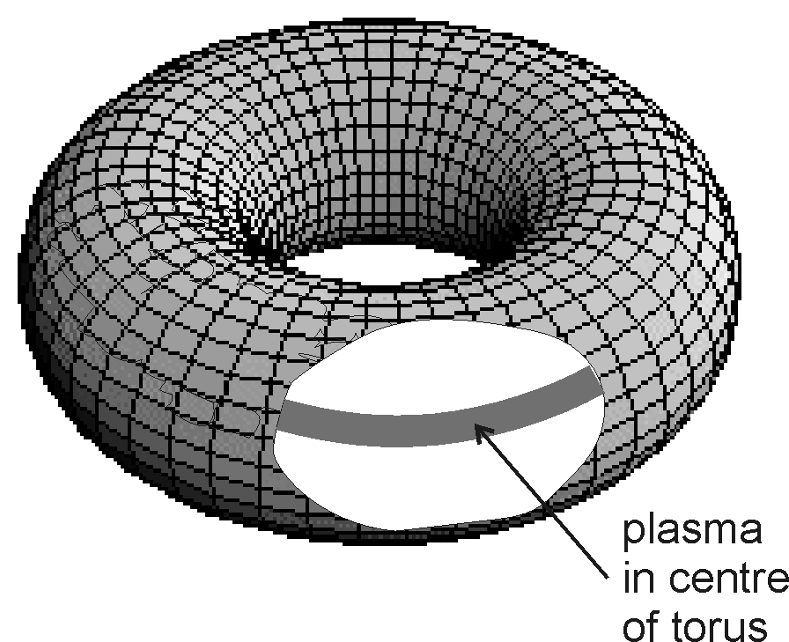

Fig. 3 A torus, cut away to show the central tube of plasma

Tokamaks
Tokamaks, from the Russian for ‘toroidal magnetic chamber’, were first developed by Andrei Sakharov, and remain the most promising design. This is the design that was used in the successful JET (Joint European Torus) experiment at Culham, near Oxford.
The entire torus, about 100 m³ in volume, contains only about one-tenth of a gram of plasma in the experiments at JET, and so would be only at a few times atmospheric pressure, even at the working temperature of 100 million K. Just as with a hot gas, random movement will cause it to expand into the available space, so it must be squeezed into a tiny region, while also being heated. To compress this plasma until fusion occurs, and to prevent it hitting the relatively cool walls of the torus, it is essential to compress it into the centre of the torus, as shown in Fig. 3.
The plasma is kept in the centre of the torus by a combination of magnetic fields. This is no easy task. It has been compared with trying to make a container for jelly from rubber bands. The entire structure is a gigantic transformer built around a massive iron core, with the plasma ions in the centre of the torus acting as the charge carriers in a single-turn secondary coil, as shown in Fig. 4.
Fig. 4

The moving ions generate magnetic flux, in a pattern described as poloidal, which is shown in Fig. 4. This poloidal field compresses or ‘pinches’ the ions into the centre of the torus in the same way as two conductors, carrying electric current in the same direction, experience attractive forces (Fig 5).
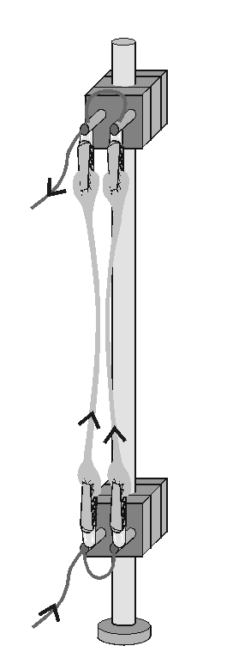
Fig. 5 Currents in the same direction attract one another

Although the poloidal field compresses the plasma, the arrangement is not stable. To increase stability, toroidal field coils are added. These toroidal coils produce flux through the torus in the same direction as the plasma current, as shown in Fig. 6.
The combination of the toroidal and poloidal field give rise to a field pattern in the shape of a helix, like the thread of a screw, as shown in Fig. 7. The Lorentz force (F = qvB) forces the moving particles to spiral around these helical field lines.
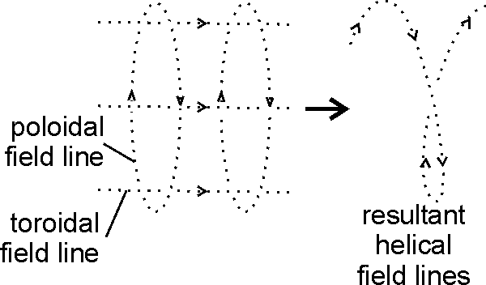
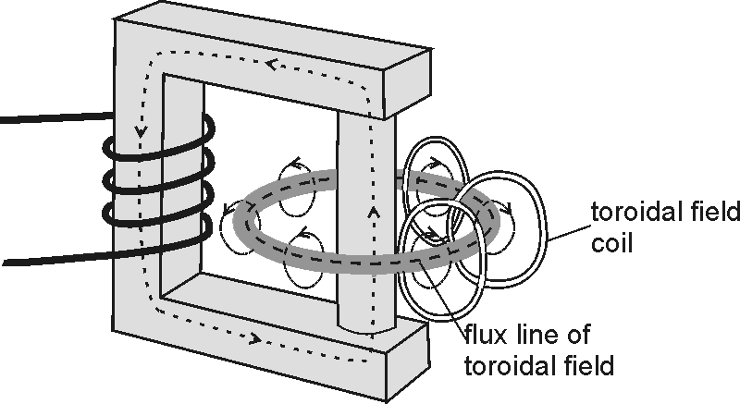

Fig. 6 Fig. 7

As it is a transformer, the primary current cannot be constant. However, to get the positive ions continuing in the direction shown in Fig. 4, there should not be an alternating flux in the core. This means that JET and other tokamaks operate in pulses.

Reaching 100 000 000 K
In JET, the plasma is heated in three ways.
The first method takes advantage of the high electric current formed by the plasma, which heats the plasma just like the current in a wire heats the wire. A relatively low induced voltage, of the order of one volt, produces a high electric current, about 3 million amps, which heats the plasma at a rate of a few megawatts.
The second method uses electromagnetic radiation. This radiation can be absorbed by the moving electrons and positive ions in the plasma, which have resonant frequencies in the radio frequency range.
The third method is to use neutral beam heating. A beam of fast-moving deuterium ${}_{1}^{2}{}H$ atoms is injected into the plasma. The atoms give up their energy as they collide with the background plasma ions. It is not possible to accelerate neutral particles to the speeds needed to raise the temperature of the plasma to the values required. ${}_{1}^{2}{}H^{+}$ ions are produced and accelerated to about 60 keV. An ion beam cannot be injected directly into the plasma, as strong magnetic fields would deflect the ions from their paths. The ion beam, travelling at high speed, is neutralised before entering the plasma. Should some of these neutral atoms, on collision with ions in the plasma, become ionised again, then they will merely add to the plasma rather than contaminating it.

END OF ARTICLE

