Sample Examination Questions
Contents
In the AS examination, Section C questions will be supported by Advance Notice material provided for the examination paper.

NB. Material covered by the AS papers may also appear in A2 papers.

Question number | Question type  (section A, B or C) | Question focus
1 | A | Probability is computed by combining amplitudes
2 | A | Production of standing waves
3 | B | Interference of waves from two slits
4 | B | Rotating phasors
5 | B | Diffraction by a grating
6 | B | Photons exchange energy in quanta
7 | B | Photoelectric effect
8 | A | Addition of vectors
9 | A | Addition of vectors
10 | A | Addition of vectors
11 | A | Kinematic equations
12 | B | Kinematic equations; F = ma
13 | B | Kinetic energy & gravitational potential energy; work done
14 | B | Interpreting graphs of accelerated motion
15 | A | Energy carried by photons
16 | B | Addition and resolution of vectors; F = ma
17 | B | Phasors and interference of waves
18 | C | Dot plot of data
19 | C | Systematic error and instrumental resolution
20 | C | Combining uncertainties in digital meters
21 | C | Energy changes in a rubber band

- In a double slit experiment an interference pattern is produced on a distant screen.
Photons from the source reach the screen at point X by the two possible paths shown in Fig. 1.1. The resultant phasor amplitude at X for these two paths is 2.0. Similarly, at another point Y on the same screen (Fig. 1.2) the resultant phasor amplitude is 0.5.

Fig. 1.1 Fig. 1.2

Calculate the ratio:

$$\frac{\text{probability} \text{of} \text{photons} \text{arriving} \text{at} \text{point} X}{\text{probability} \text{of} \text{photons} \text{arriving} \text{at} \text{point} Y}$$

ratio = ............................... [2]

- An organ pipe, closed at one end, and a flute, open at both ends, have the same length L. The fundamental standing wave in each is shown in Fig. 2.1.

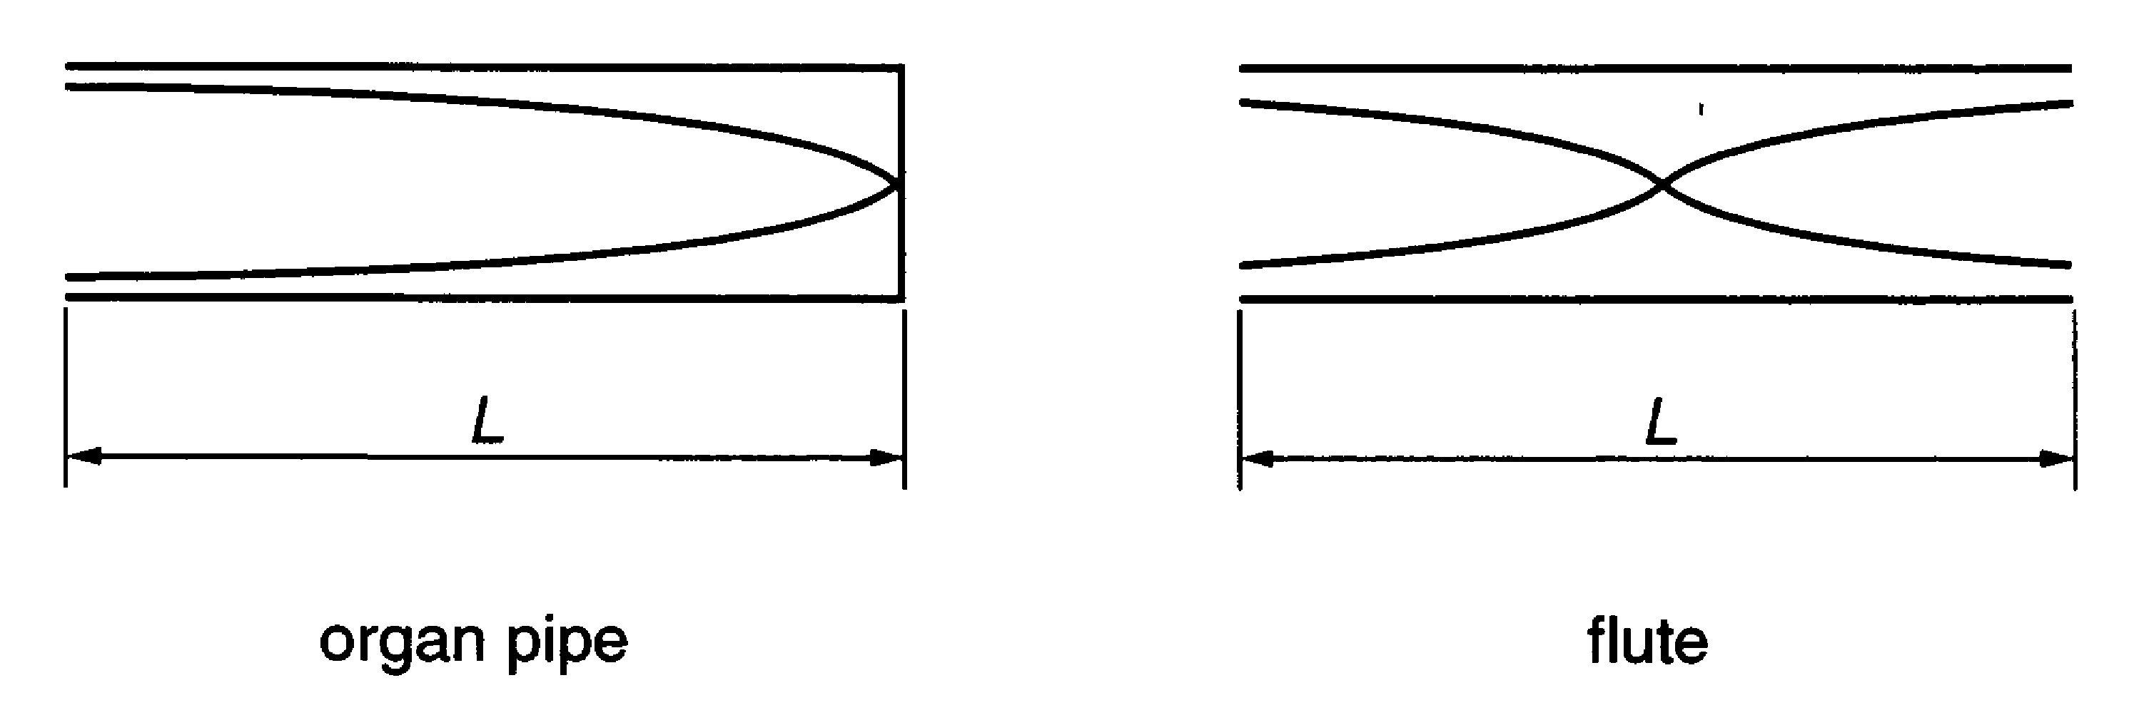

Fig. 2.1

- The organ pipe produces a fundamental note of frequency 130 Hz.
Explain why the frequency of the fundamental note produced by the flute is 260 Hz.

[2]

- The length L of the organ pipe is 0.65 m.
Show that the speed of sound in the air in the pipe is about 340 m s^{–1}.

[2]

- A parallel beam of light of a single wavelength falls on a double slit arrangement. Bright and dark fringes are observed on the screen at different angles θ shown in Fig. 3.1.

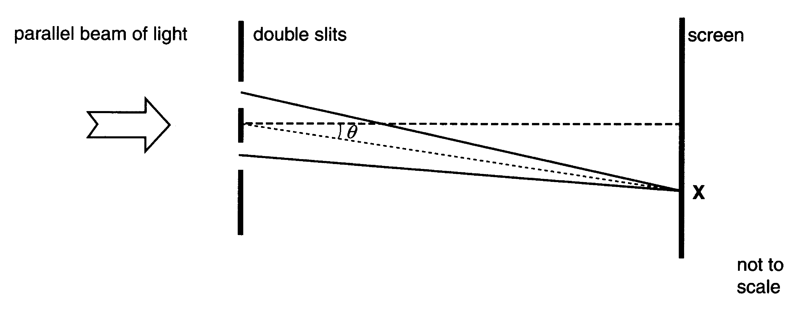

Fig. 3.1

- (i) What effect causes the bright and dark fringes?

...............................................................................................................................[1]

- Describe the condition necessary for a bright fringe to be produced at the place marked X on the screen.

[2]

- Explain why there is a dark fringe on either side of the bright fringe.

[2]
- Fig. 3.2 shows how the intensity, at different places on the screen, varies with sin θ in a particular experiment.

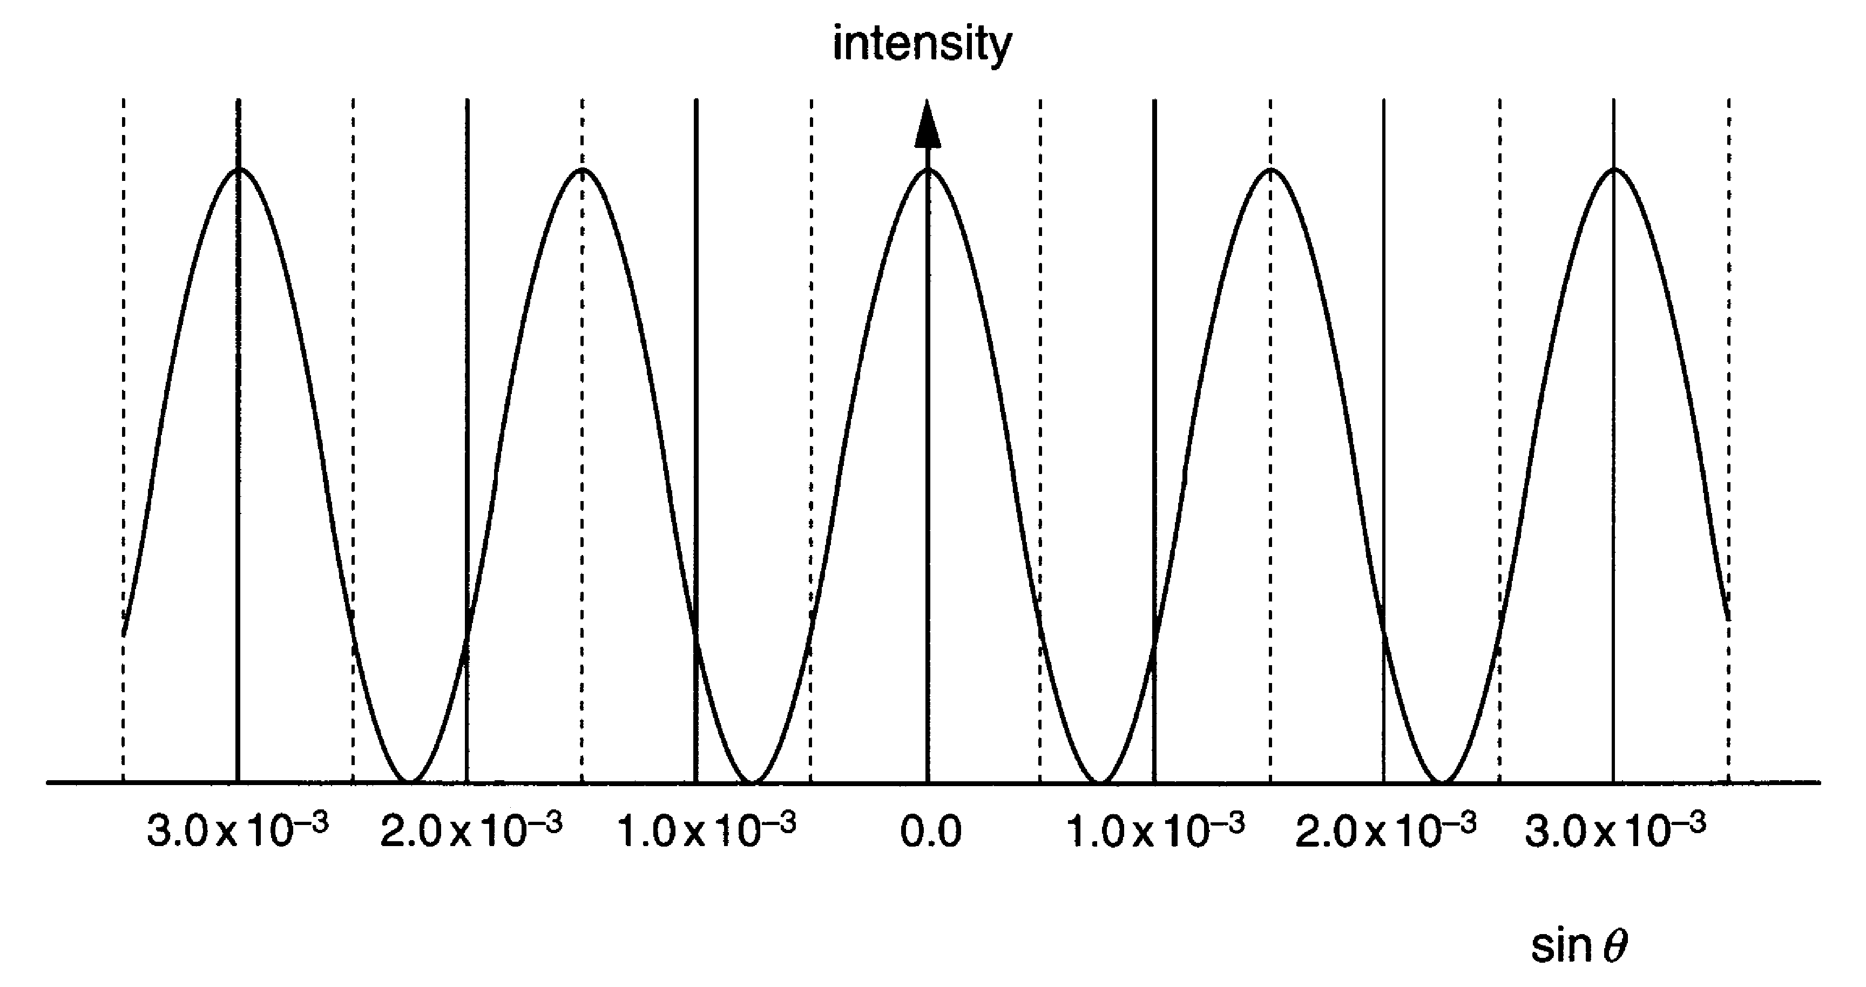

Fig. 3.2

Use the information given to show that the wavelength of the light used is about
600 nm. The separation of the slits is 0.4 mm in this experiment.

[3]

- The double slit arrangement is then replaced by a diffraction grating which has slits of the same width and spacing as previously used. Nothing else is altered.
State two ways in which the fringes formed by the diffraction grating differ from those formed by the double slits.

[2]

[Total: 10]

- This question is about using the idea of rotating phasors.
Light of a particular frequency passes through a diffraction grating on its way to a screen. The arrangement is shown in Fig. 4.1.



Fig. 4.1

- In travelling from the source to some point on the screen, a photon is supposed to have explored all possible paths available to it. The probability of arrival of the photon is determined by combining the phasors for the paths considered.

(i) Mark on Fig. 4.1 a point on the screen where photons may arrive. Label this point P.

(ii) Sketch on the diagram two of the possible paths that a photon would explore in arriving at P.

[2]

- In this question, select ideas from the following list to use in your answer.
rotating phasor frequency difference in path length
speed of photon angle between phasors
(i) Explain how the resultant phasor amplitude at P would be determined for the paths shown.

[3]
(ii) State how the probability of arrival of photons at P is related to the resultant phasor amplitude there.

[1]

- (i) Draw a diagram to represent the pattern that could be observed on the screen.
Label the important features using appropriate scientific terms.

[3]

(ii) Mark with the letter X on your diagram a place where the probability of arrival of photons is high.
[1]

[Total: 10]

- This question is about a diffraction grating.

(a) The diffraction grating is illuminated with a parallel beam of light. Diffracted beams are produced on the other side of the grating, as shown in Fig. 5.1. A regular pattern of bright and dark spots is observed on the screen.

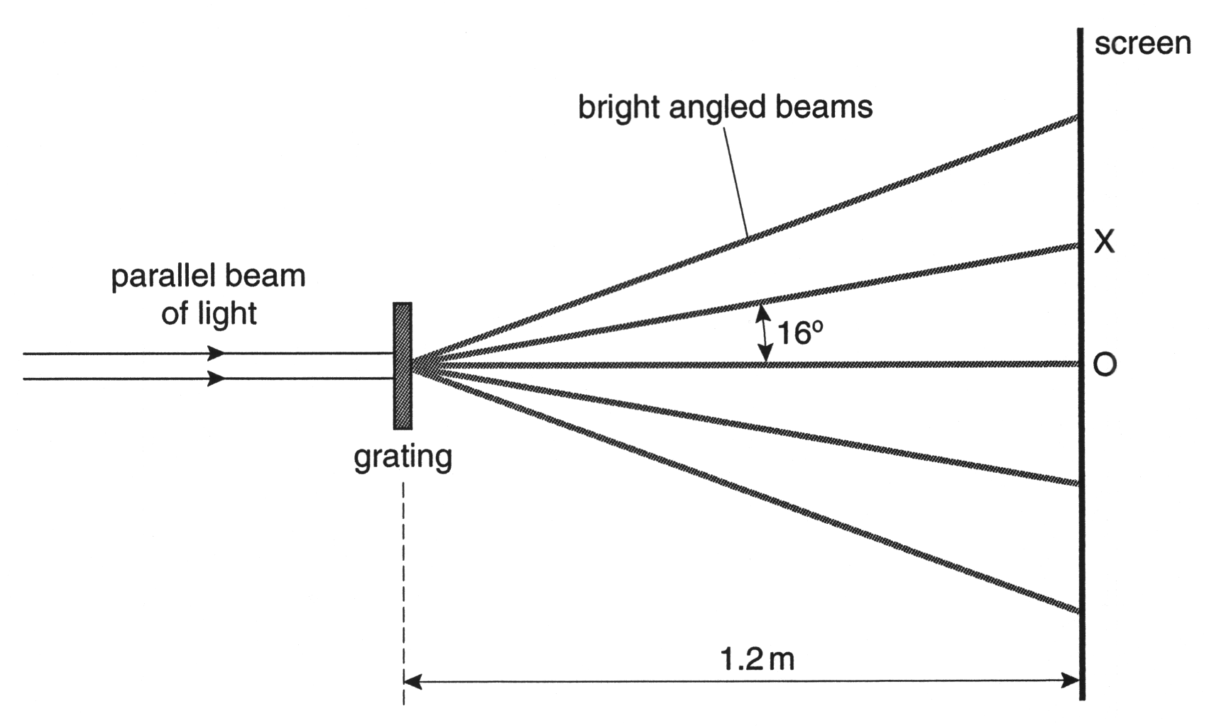

Fig. 5.1

- The angle between the first order diffracted beam and a line perpendicular to the grating is 16°, as shown.
Show that the spacing of the slits in the grating is 1.8 x 10^{–6} m.
The wavelength of the light λ = 5.0 x 10^{–7} m.

- The corresponding angle for the second order diffracted beam is 33.7°.
Show that the value for the spacing of the slits is confirmed by this result.

- Calculate the distance OX on the screen shown in Fig. 5.1.

[6]

(b) (i) Gratings are normally labelled with the number of lines per mm.

Calculate the number of lines per mm for this grating.
Express your answer to an appropriate number of significant figures.

lines per mm = ................................. .

(ii) Explain why the number of significant figures you have used in your answer to (b)(i) is appropriate in this case.

[4]

[Total: 10]
- This question is about photon energies.

(a) A powerful laser emits a single pulse of ultraviolet radiation lasting 5.0 x 10^{–9} s. The energy of each photon in the beam is 5.6 x 10^{–19} J.

- Calculate the frequency of an ultraviolet photon.
the Planck constant h = 6.6 x 10^{–34} J s

frequency = ....................... Hz [2]

- The energy in each pulse is 1.8 MJ.
Show that the pulse contains 3.2 x 10²⁴ photons.

[1]

- Calculate the power delivered by the laser pulse. Give a suitable unit for your answer.

power = ............................ unit ............................ [3]
(b) A photon of the laser light strikes the clean surface of a sheet of metal. This causes
an electron to be emitted from the metal surface.
The minimum energy required to release an electron from this surface is
4.8 x 10^{–19} J.

(i) Show that the maximum kinetic energy of the emitted electron is 8.0 x 10^{–20} J.

[1]

(ii) Show that the speed of an electron with this maximum energy is about
4 x 10⁵ m s^{–1}.
mass of electron = 9.1 x 10^{–31} kg

[2]

(iii) Electrons are quantum objects. The wavelength λ associated with an electron is given by the de Broglie equation

$$λ=\frac{h}{\text{mv}}$$

where m is the mass of the electron and v is the speed at which the electron is travelling.

Calculate the wavelength associated with the emitted electron.

[1]

[Total: 10]

- This question is about the emission of electrons from a metal surface.
A thin, square specimen of metal, dimensions 4.2 x 10^{–2} m x 4.2 x 10^{–2} m, is placed on the bench. The specimen is uniformly illuminated from above by a beam of electromagnetic radiation of frequency 6.0 x 10¹⁵ Hz, as shown in Fig. 7.1.

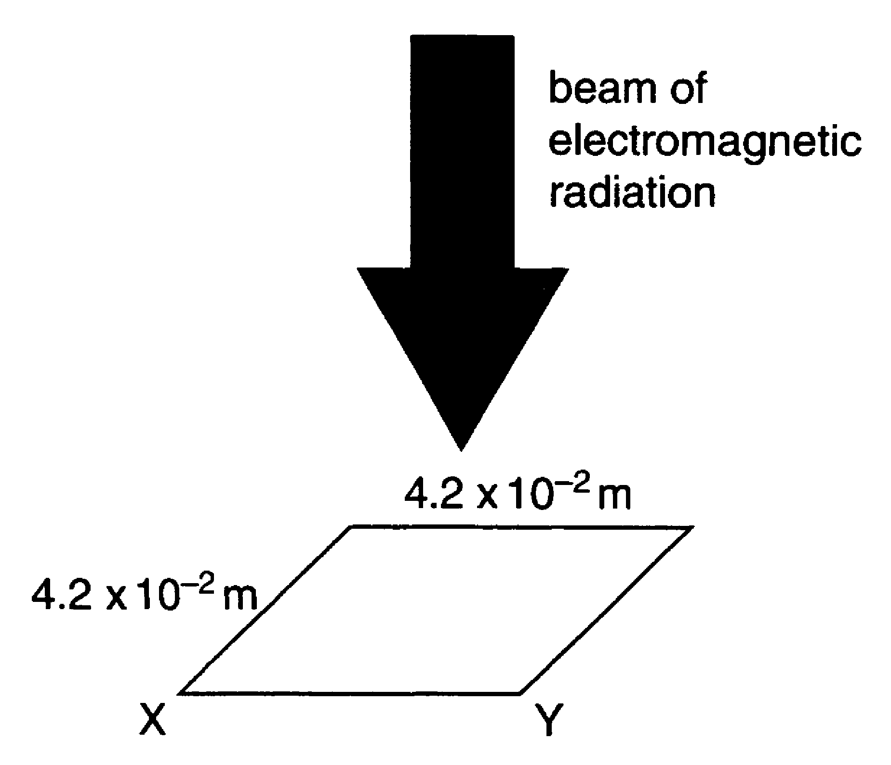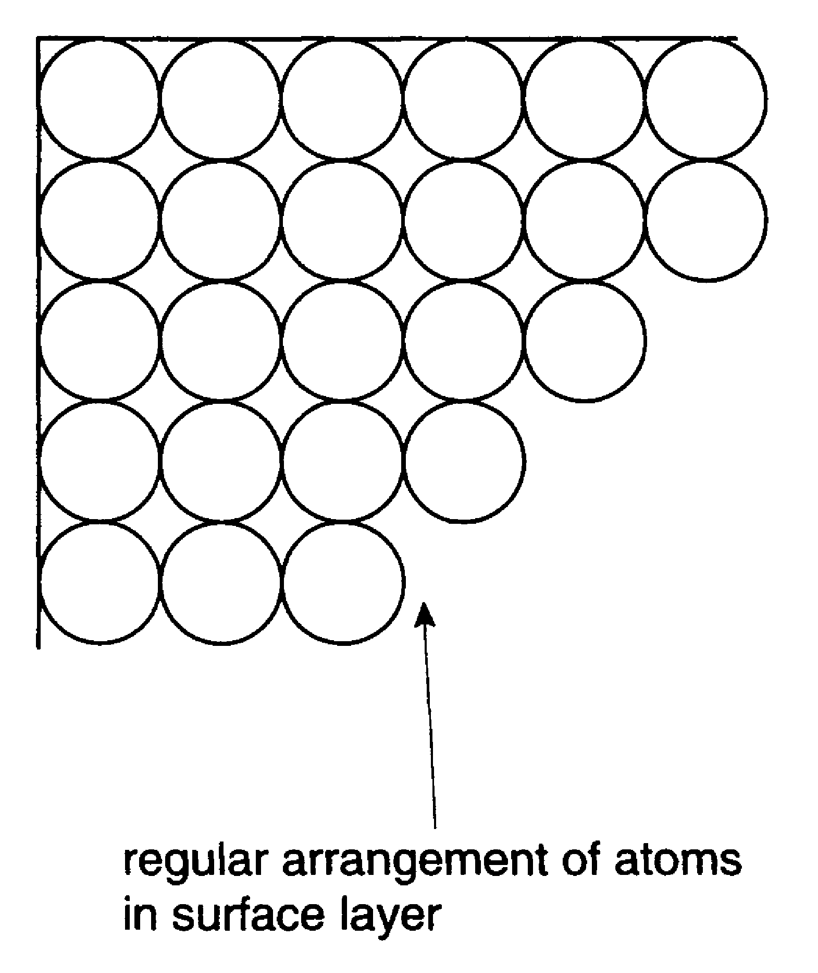

Fig. 7.1 Fig. 7.2

Assume that the atoms in the metal surface are in a simple regular arrangement, as shown in Fig. 7.2.

(a) (i) Show that there are 1.5 x 10⁸ atoms along the edge XY of the specimen in the
surface layer.
diameter of an atom = 2.8 x 10^{–10} m.

[2]

- Show that there are about 2.3 x 10¹⁶ atoms in the whole surface.

[2]
(b) (i) Every second, 9.0 x 10^{–7} J of energy is incident on the metal surface. Assume
the energy arrives continuously and is completely absorbed by the atoms in the surface layer. Show that, on average, the amount of energy absorbed every second by each atom in the metal surface is 4.0 x 10^{–23} J.

[2]

(ii) The energy required to remove an electron from an atom of the metal is known to be 3.2 x 10^{–18} J.

Calculate the time taken for an atom in the metal surface to absorb this energy from the electromagnetic radiation.

time = ............................ s [2]

The experimental result is quite different. When electromagnetic radiation falls on the metal surface, some electrons are emitted immediately from the surface. This is one crucial result that indicates that photoelectric emission cannot be explained if the energy is assumed to arrive continuously.

(c) The quantum theory assumes that electromagnetic radiation of frequency f is absorbed in discrete packets of energy (photons), each of energy E = hf.
Show that when a photon of electromagnetic radiation, frequency f = 6.0 x 10¹⁵ Hz, is absorbed by an atom of the metal, emission of an electron could occur.

[3]

[Total: 11]

- A vertical cylinder rotating in a horizontal stream of air has two perpendicular forces acting on it.
Fig. 8.1 shows the magnitudes and directions of the forces acting on the cylinder.

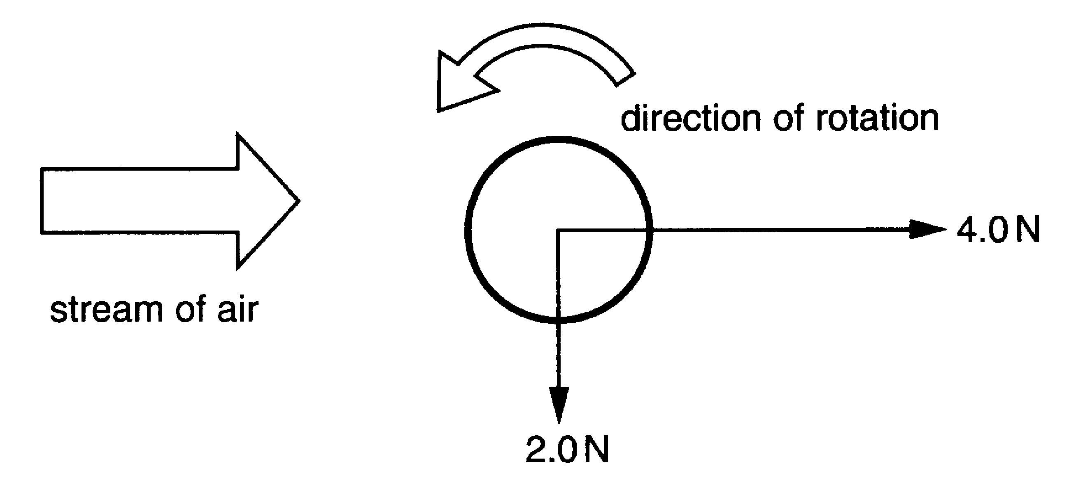

Fig. 8.1

Find by scale drawing, or by some other method,

- the magnitude of the resultant force acting on the cylinder

force = ......................... N [2]

- the angle that the resultant force makes with the direction of the air stream.

angle = .............. degrees [1]

- Two aircraft, A and B, are travelling towards each other in level flight along a common flight path, as shown in Fig. 9.1.

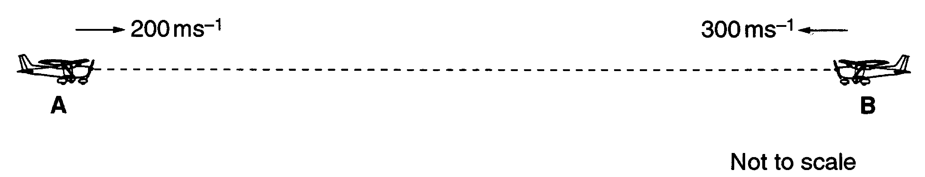

Fig. 9.1

The speeds of the two aircraft, relative to the ground, are 200 m s^{–1} and 300 m s^{–1} as shown.

- Calculate the magnitude of the relative velocity of approach of the two aircraft.

relative velocity = .........................m s^{–1} [1]

- Radar establishes that the two aircraft are 40 km apart. Calculate the time it would take for the aircraft to collide, if avoiding action is not taken.

time = ........................s [2]

- Fig. 10.1 shows a racing car fitted with a spoiler. When air flows over the spoiler a downward force is produced on the rear of the car.

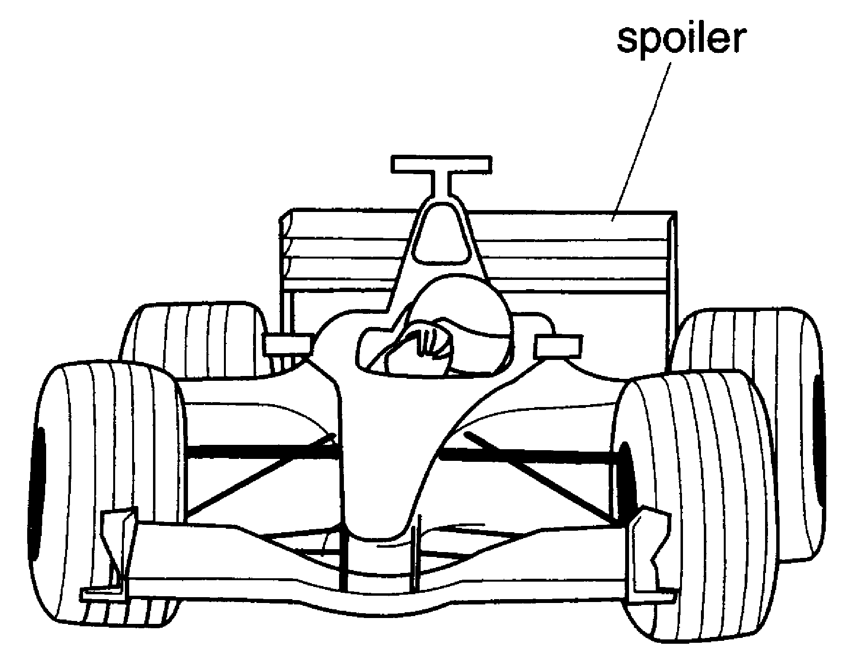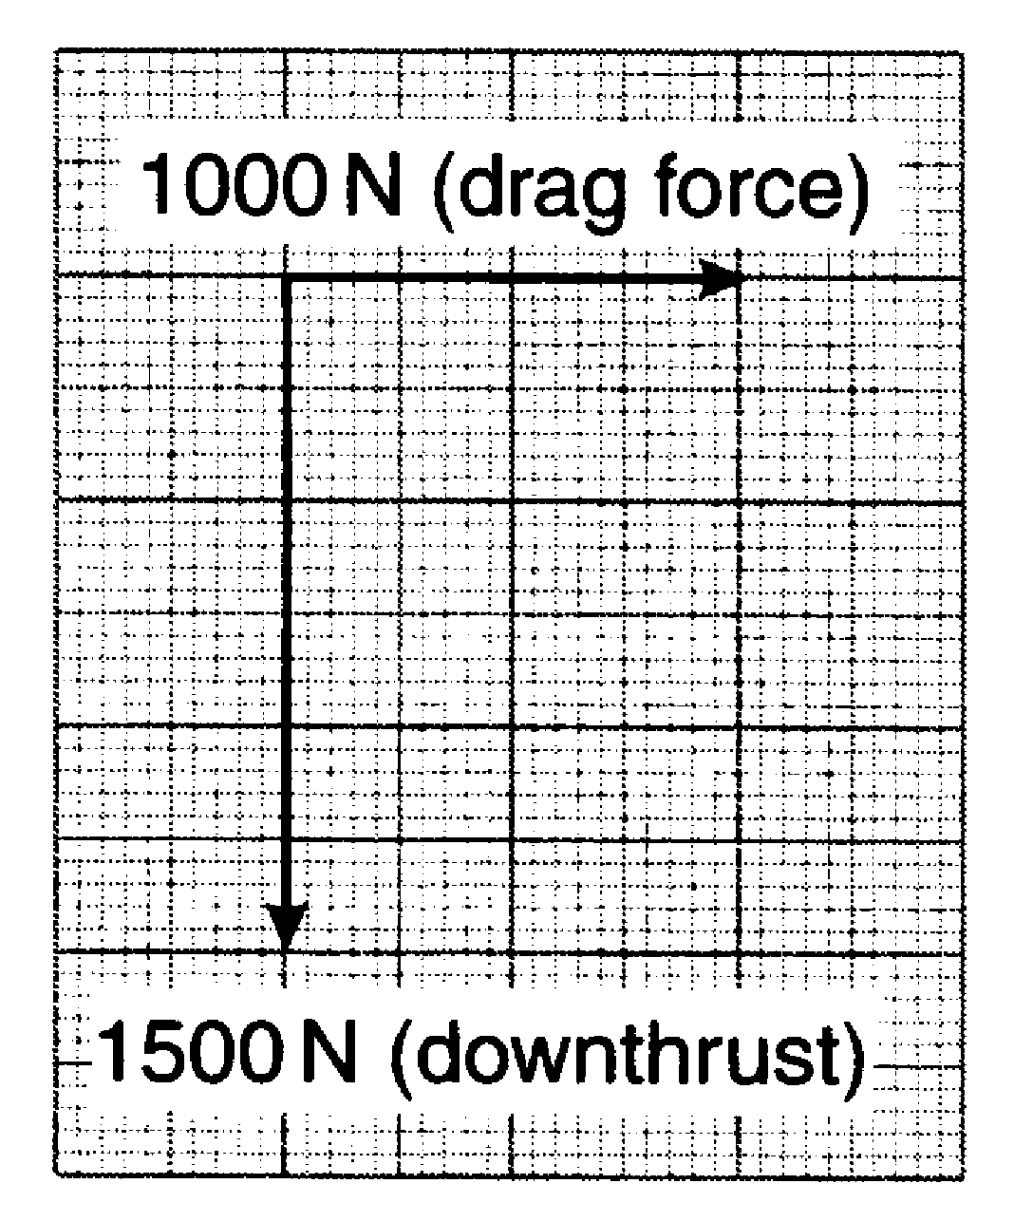

Fig. 10.1 Fig. 10.2

Fig. 10.2 shows the magnitude and direction of the forces acting on the spoiler when the car is travelling at speed. The forces are drawn to a scale of 1 cm to 500 N.
Find the magnitude of the resultant force acting on the spoiler. Show how you get your answer.

resultant force = ................................. N [2]

- A projectile is placed at the bottom of a vertical pipe of length 2.00 m as shown in Fig. 11.1. The pipe is closed at the lower end.

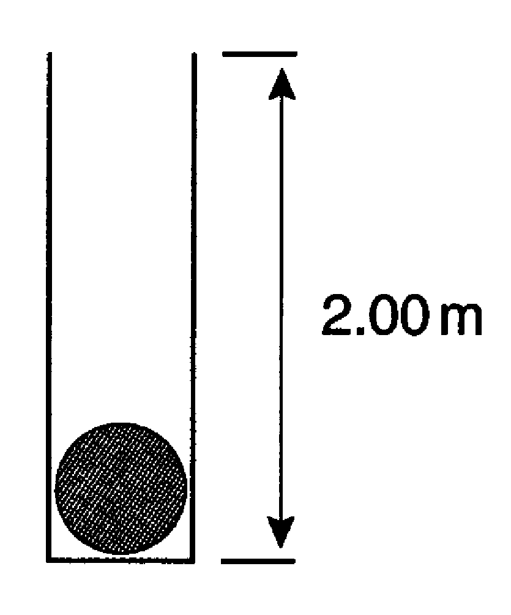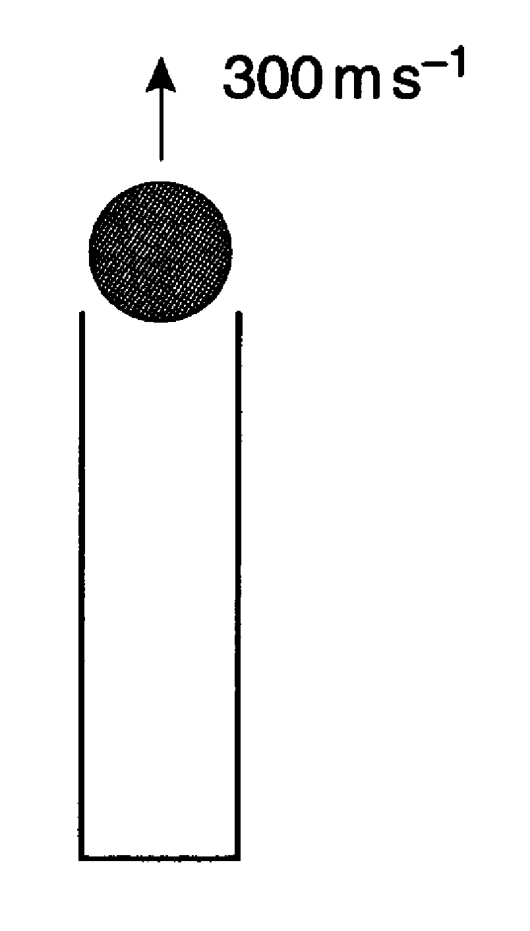

Fig. 11.1 Fig. 11.2

An explosive charge is detonated under the stationary projectile. It accelerates uniformly and leaves the pipe at a speed of 300 m s^{–1} (Fig. 11.2).
Show that the average acceleration of the projectile in the pipe is 2.25 x 10⁴ m s^{–2}.

[3]

- This question is about a simplified model of the braking of a car.
A car of mass 1200 kg is travelling at a constant speed of 20 m s^{–1} along a level road. The driver sees a hazard on the road ahead and applies the brakes as quickly as he can, bringing the car safely to a halt.

(a) Assume that it takes 0.5 s for the driver to react and apply the brakes after he sees the hazard. During this time the car travels forwards at constant speed.
Show that the car will travel 10 m in this time.

[1]

(b) Assume that the braking system of the car is designed to produce a constant decelerating force of 7.1 x 10³ N.

- Show that, when the brakes are applied
1. the deceleration of the car is 5.9 m s^{–2}

[1]

2. the car travels a further distance of about 34 m.

[2]

- Calculate the total stopping distance of this car travelling at an initial speed of 20 m s^{–1}.

[1]
- Fig. 12.1 shows how the measured stopping distance for this particular car and driver varies with the speed of the car in a road test.

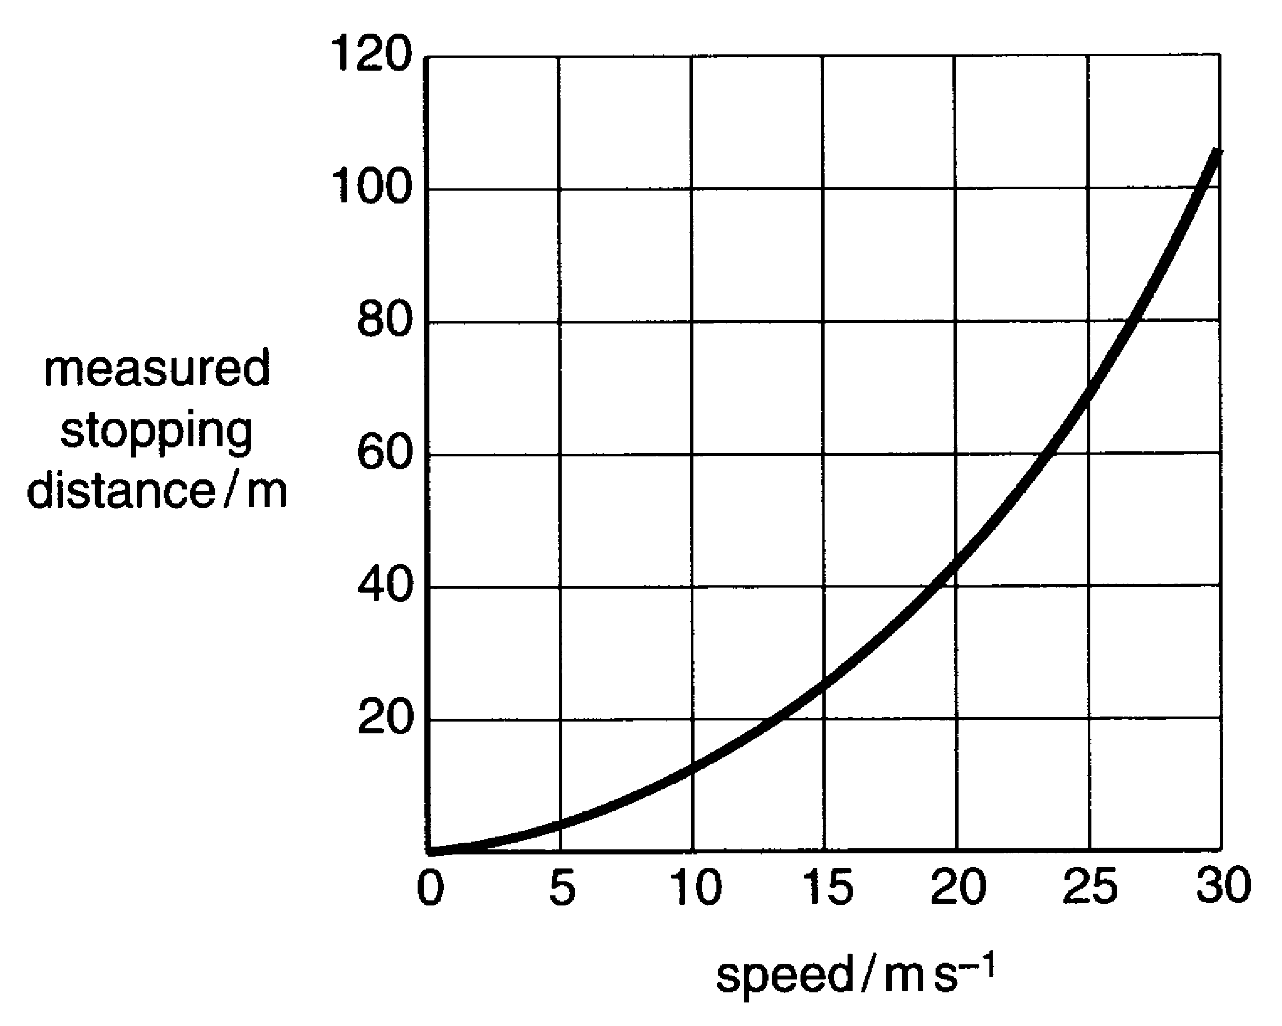

Fig. 12.1

By drawing suitable construction lines on Fig. 12.1

(i) show that for the car travelling at 20 m s^{–1} the measured stopping distance agrees with the calculated stopping distance

[1]

(ii) find the measured stopping distance for the car travelling at a speed of
30 m s^{–1}.

measured stopping distance = ........................ m [1]

- In the road test, the results at low speed seem to be consistent with the simple calculations. But at a higher speed of 30 m s^{–1} the calculated stopping distance is only about 91 m.
Suggest and explain one reason why the calculation may be oversimplified when applied to the car moving at higher speeds.

[2]

[Total: 9]
- This question is about driving poles into the ground.
Fig. 13.1 shows a 220 kg mass held in position 5.0 m above the top of a rigid, cylindrical pole. The lower end of the vertical pole is resting on the ground.

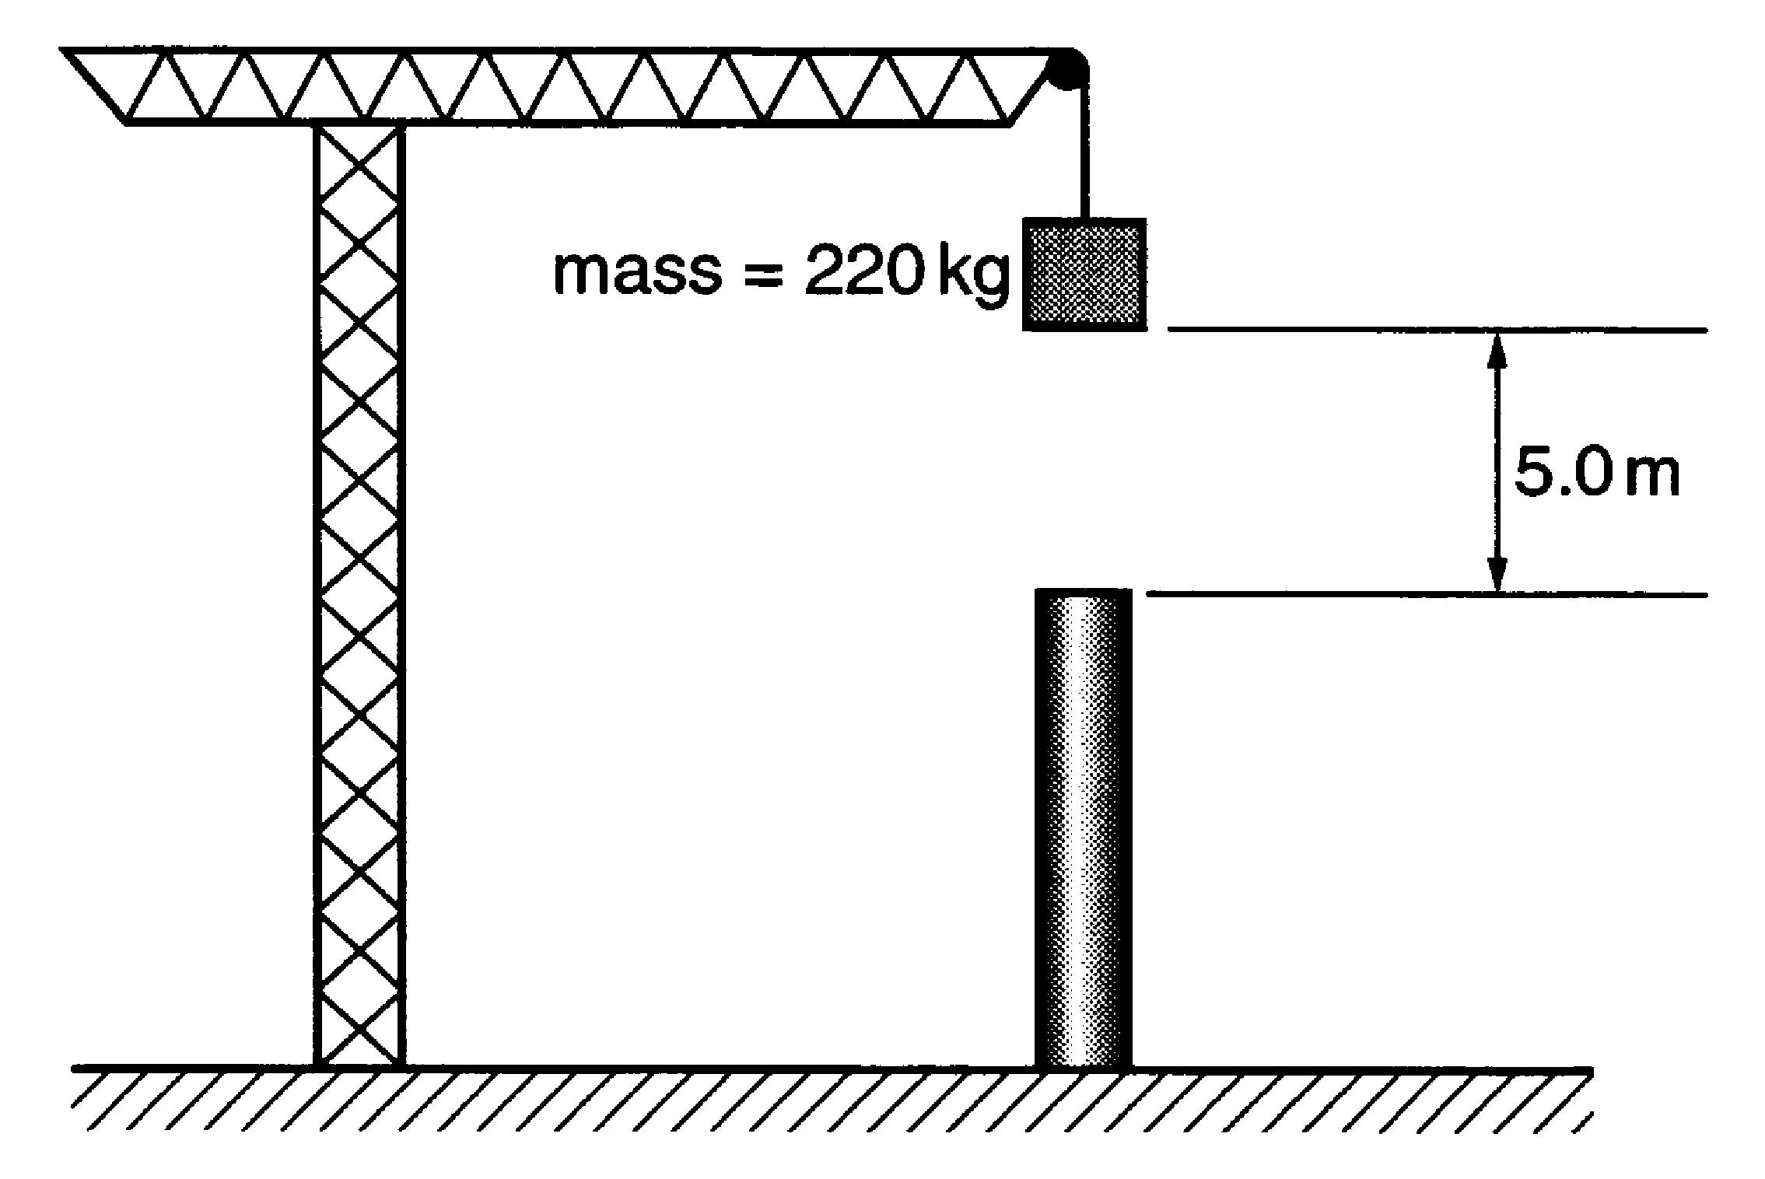

Fig. 13.1

- When released, the mass drops freely from rest under gravity and strikes the top of the pole.

(i) Describe the energy changes taking place from the moment the mass falls until it strikes the top of the pole.

[2]

- Show that the speed of the mass is about 10 m s^{–1} when it strikes the top of the pole.
g = 9.8 N kg^{–1}

[2]

- In bringing the moving mass to rest on top of the vertical pole, the pole is pushed down into the ground. The depth of penetration of the pole into the ground is 0.4 m.
Show that the average force exerted by the pole on the mass is about 29 kN.

[2]
- The process is repeated several times to drive the pole into the ground. Each time the mass is raised to a position 5.0 m above the top of the pole, and dropped onto it. For each successive drop, the extra depth of penetration achieved decreases.

(i) Suggest why this might be so.

[1]

The extra penetration achieved in the first and second drops of the mass is plotted on Fig. 13.2.

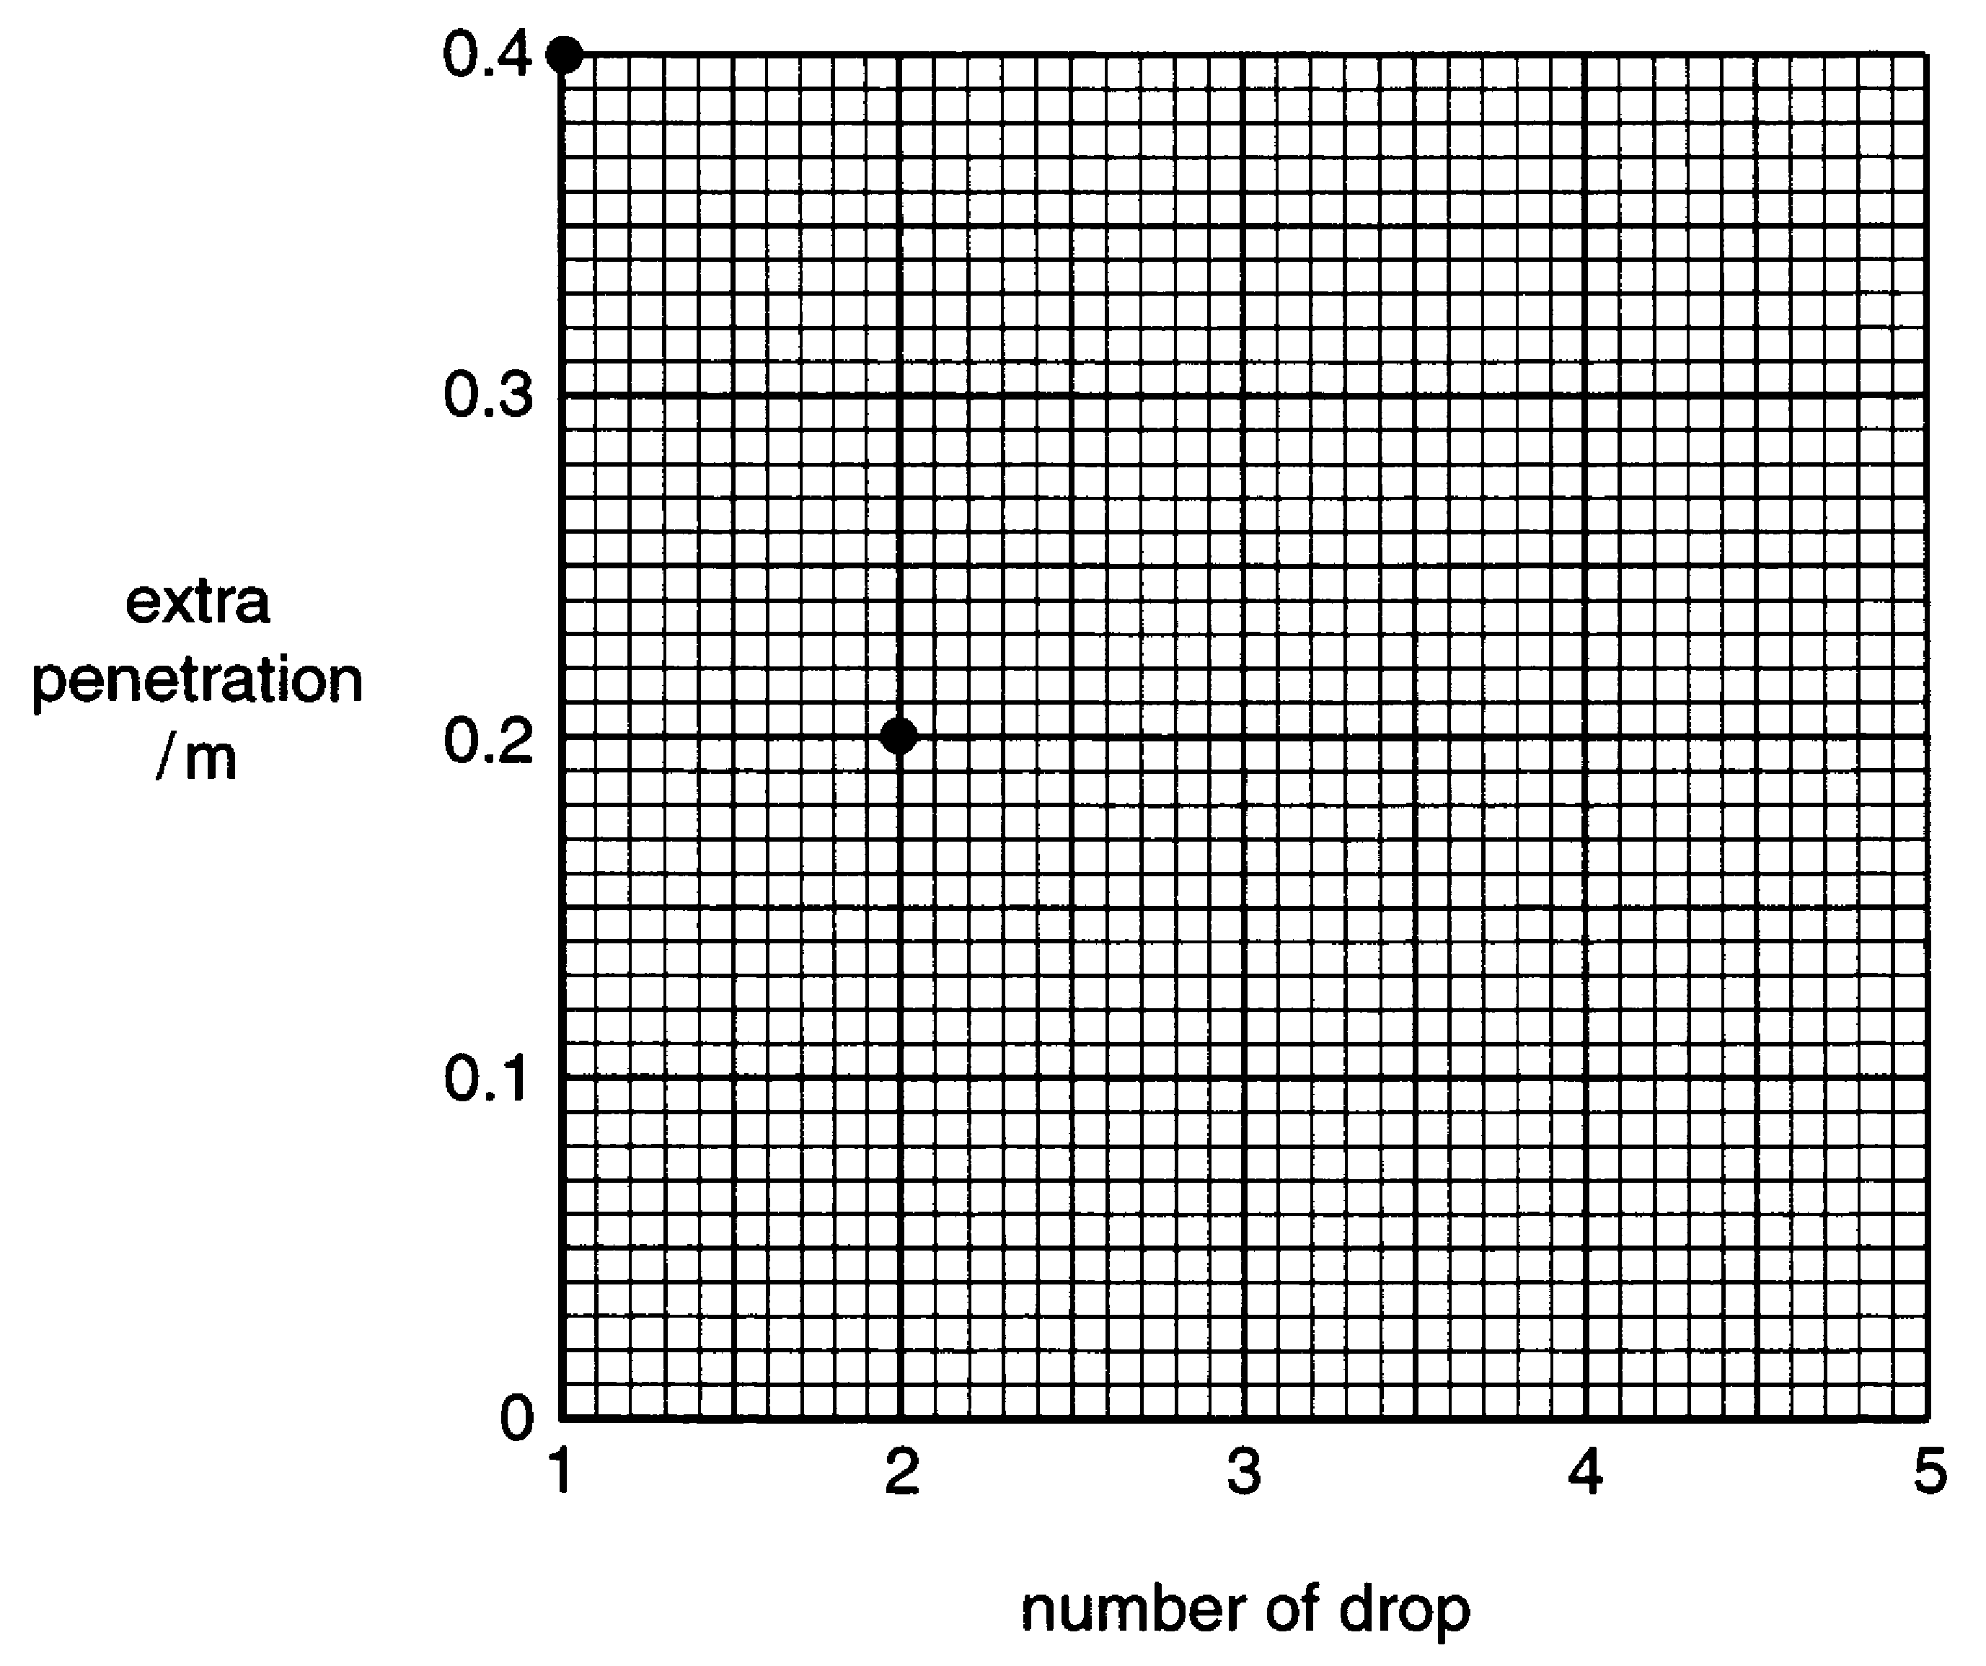

Fig. 13.2

The extra penetration at each successive drop is a constant fraction of the extra penetration achieved at the previous drop.

(ii) Complete Fig. 13.2 by marking on the graph the values of extra penetration achieved by the third, fourth and fifth drops. Show your reasoning below.

[3]

[Total: 10]
- This question is about the motion of a skateboarder on ramps of different shape.
Fig. 14.1 shows two ramps, A and B, which are used for skateboarding.
The ramps are the same length and 3.0 m high.

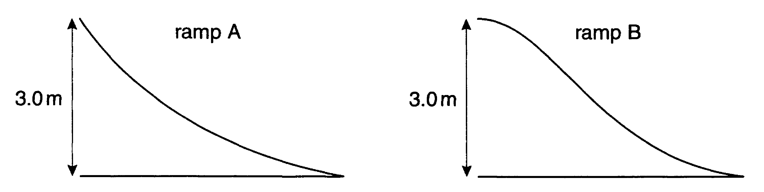

Fig. 14.1

- A skateboarder starts from rest at the top of each ramp.
Describe the motion of the skateboarder as he descends
ramp A
ramp B.

[4]
- The speed–time graphs for the motion down each ramp are shown in Fig. 14.2.

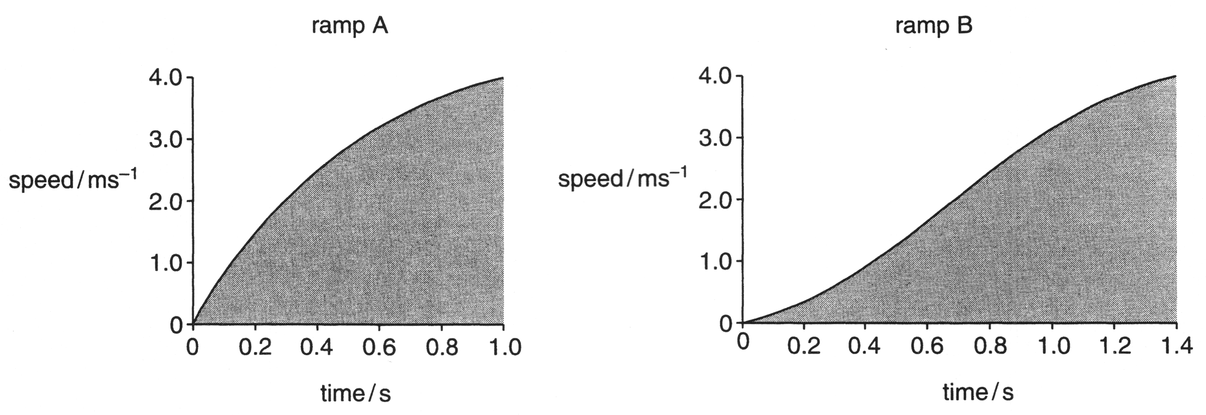

Fig. 14.2

Explain why

- the shaded areas under the two graphs must be equal

[2]

- the time taken to descend ramp B is greater than for ramp A.

[3]

[Total: 9]

- This question is about the gamma photons emitted in the decay of cobalt-60. The more energetic gamma photons emitted in this decay have an energy of 1.33 MeV.

(a) Show that the energy of a 1.33 MeV gamma photon is about 2 x 10^{–13}J.

[2]

(b) Calculate the frequency of a 1.33 MeV gamma photon.

[2]

(c) Gamma photons are emitted when a nucleus changes from an excited state to a lower energy level. Cobalt-60 produces both 1.33 MeV photons and 1.17 MeV photons.
Draw on the diagram below a simple energy level diagram showing the energy transitions which might produce photons of energies 1.17 MeV and 1.33 MeV. The nuclear ground state is labelled 0 MeV.

Ground state 0 MeV
[2]
- This question is about the forces needed to support and to accelerate the German Transrapid train, which is supported and propelled by magnetic fields.

(a) The fully laden Transrapid train has a mass of 200 tonnes (2.0 x 10⁵ kg). Show that a force of about 2 MN is needed to lift it.

[1]

(b) The forward force on the Transrapid train is produced by two magnetic forces F_{A} and F_{B}, equal in magnitude, as shown in Fig. 16.1.

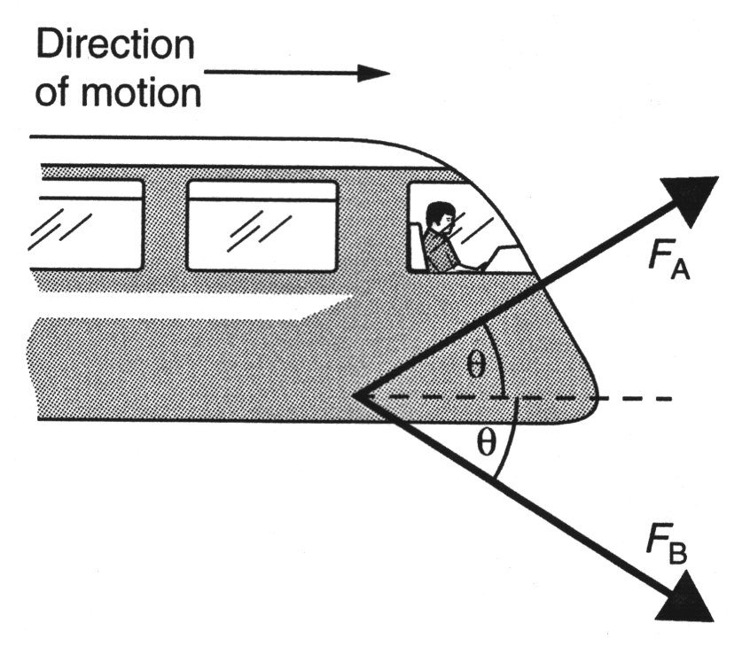

Fig. 16.1

Explain how the diagram shows that the resultant of these two forces will be horizontal.

[2]
- The angle θ is 30° and the magnitude of the force F_{A} is 1.7 x 10⁵ N. Show that the total horizontal force that F_{A} and F_{B} produce on the train is about 3.0 x 10⁵ N.

[3]
- Calculate the acceleration of the train produced by 3.0 x 10⁵ N, and suggest a reason why it is greater than the 0.67 m s^{–2} acceleration of the actual Transrapid Maglev train whose mass is also 200 tonnes.

[4]

[Total: 10]

- This question is about a radio-interferometer consisting of two detectors separated by a large distance.

Fig. 17.1 shows two detectors A and B receiving signals from a single distant radio star directly overhead.

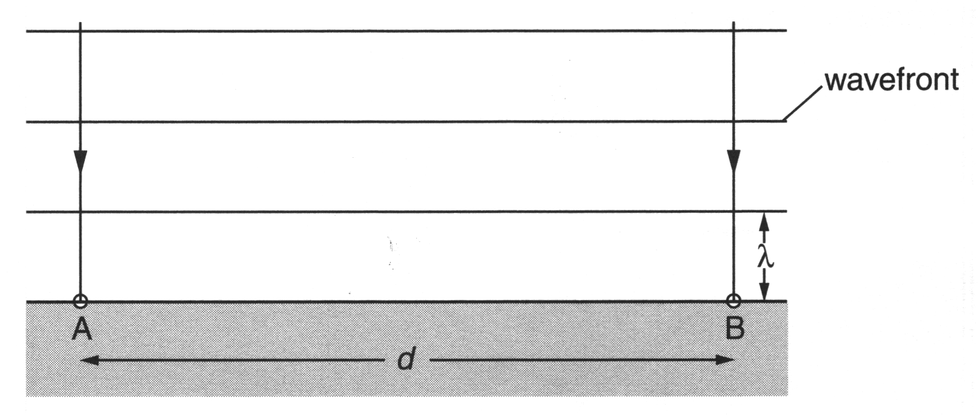
Fig. 17.1

- State how Fig. 17.1 shows that the star is very far off compared with the distance d.

[1]

- As the Earth rotates, the star is no longer directly overhead. Fig. 17.2 shows the detectors receiving signals from the star when the Earth has rotated through an angle θ.

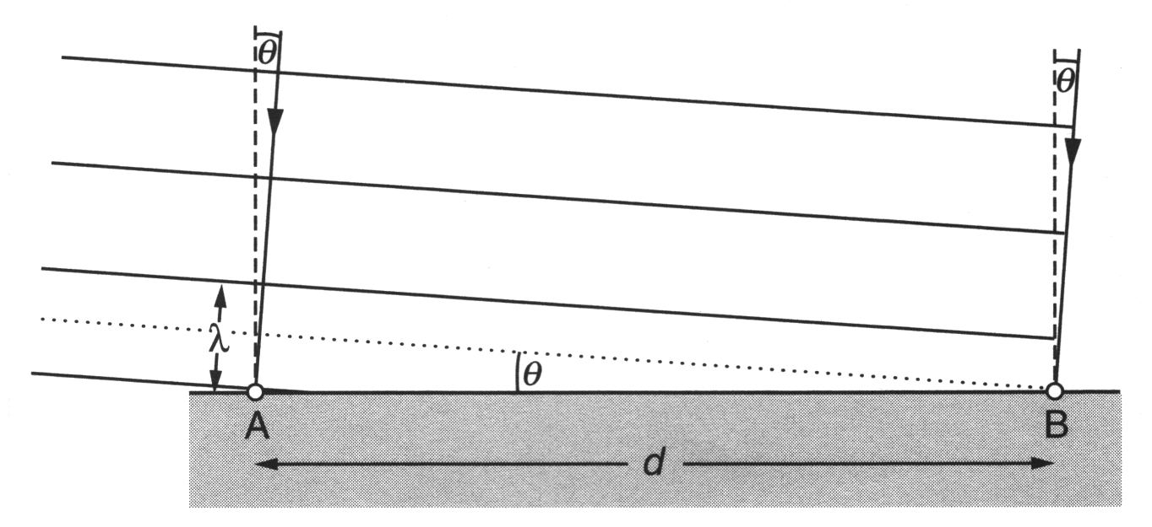
Fig. 17.2
- Complete Fig. 17.3 to show the phasor for the signal arriving at detector B in Fig. 17.2.

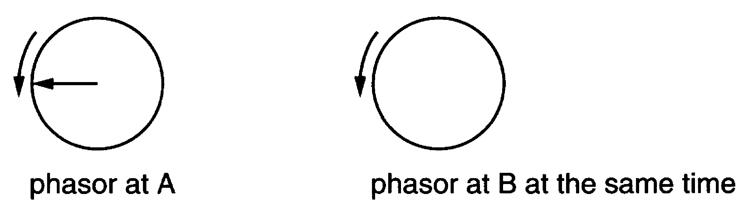
Fig. 17.3
[1]
- The signals received at A and B are added to give a resultant signal.
Explain why this resultant signal is smaller than that obtained when the same source is directly overhead as in Fig. 17.1.

[3]

- Use Fig. 17.2 to show that $\text{sin} θ=\frac{λ}{2d}\text{.}$

[1]

- Calculate the value of θ for two detectors of separation 50 m receiving radiation of wavelength 0.21 m.

[1]

[Total: 7]

- A student was finding the force needed to break a strip of newspaper 5 mm wide.
She tested 20 strips, and obtained these data:

breaking force /N: 3.0, 2.0, 3.0, 3.0, 3.5, 3.0, 3.5, 4.5, 4.0, 3.5, 7.5, 4.0, 4.5, 3.5, 3.0, 2.5, 3.5, 4.0, 4.0, 3.5.

- Make a dot plot of these data on this chart.

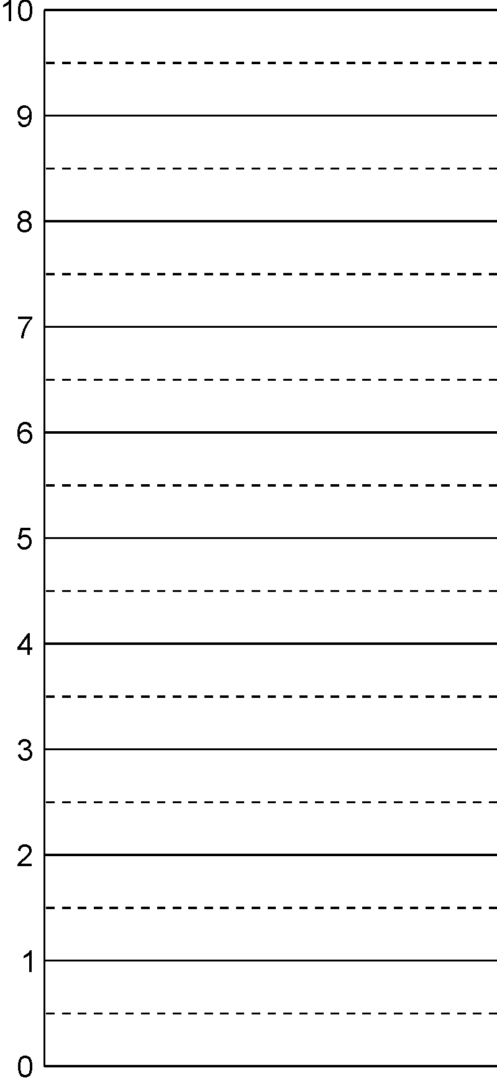
breaking force / N

[1]

Find the mean value and the spread of these data, identifying any values which seem to be outliers. Suggest possible reasons for any outliers.

[4]
- A metre rule, rather old and worn away at both ends, is used to measure the diameter of a 1 p coin, which is of the order of 1 cm in size.
Explain how the limitations of systematic error and instrumental resolution will affect this measurement, and suggest how the measurement could be improved.

[3]

- Digital meters can read only to the last digit of the display. If an ammeter reads to the nearest 0.01 A, for example, any current greater than 1.255 A and less than 1.265 A will register as 1.26 A. This means that the uncertainty in each reading is ± 0.005 A.

A digital ammeter and a digital voltmeter are used to get quick values of the resistance and conductance of a resistor.

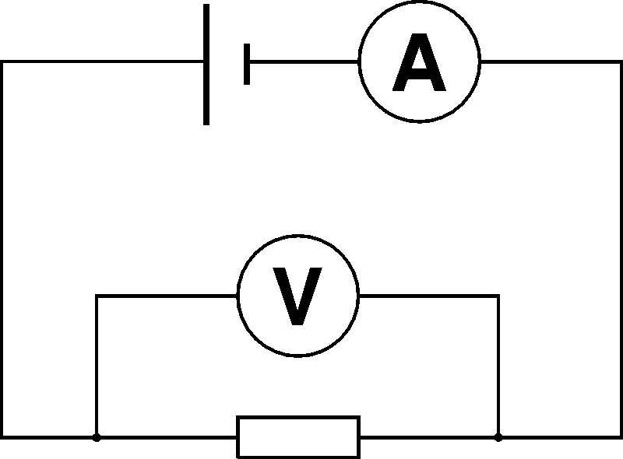

- If the readings on the digital meters are 1.46 V and 0.08 A, write down the minimum and maximum values of p.d. and current.

V_{min} = ……………V V_{max} = ……..…… V I_{min} = ………..… A I_{max} = ………..… A

[1]

- Use values from (a) to calculate the minimum and maximum values of resistance of the resistor.

minimum resistance = ………..… Ω maximum resistance = ………..… Ω
[3]

- Write your answer to (b) in the form R ± ΔR.

R = (………..… ± ………..…) Ω
[1]

- Write the conductance G in the same way as in (c).

G = (………..… ± ………..…) S
[1]

- Calculate the percentage uncertainties in resistance and conductance.

Percentage uncertainty in resistance = ……………%

Percentage uncertainty in conductance = ……………%
[2]

- If you could replace one of the meters with one which read to three decimal places instead of to two, which would you choose? Explain your answer.

[2]

[Total: 10]

- In an experiment to investigate energy changes when a rubber band is stretched, two students stretched a rubber band by different amounts, and then ‘fired’ the band into the air, measuring the height h it reached. They repeated each reading 5 times. They also measured the force needed to stretch the rubber band by each of the amounts chosen. Any outliers they obtained were checked, and repeated if necessary.

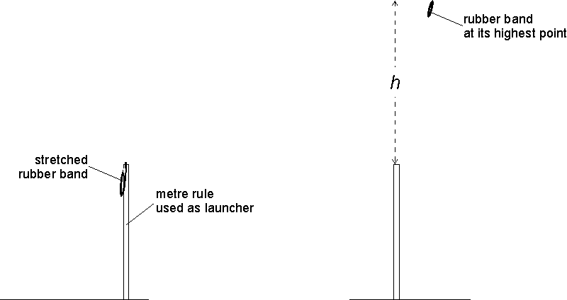

The data they obtained are given in the table:

extension of band Δx /m | force F /N | height h reached by rubber band /m
extension of band Δx /m | force F /N | 1 | 2 | 3 | 4 | 5 | mean | spread
0.010 | 1.9 | 0.06 | 0.06 | 0.08 | 0.05 | 0.05 | 0.06 | 0.02
0.020 | 3.4 | 0.20 | 0.28 | 0.23 | 0.21 | 0.22 | 0.23 | 0.04
0.030 | 5.2 | 0.47 | 0.63 | 0.59 | 0.56 | 0.55
0.040 | 7.0 | 1.12 | 0.89 | 0.96 | 0.84 | 0.98
0.050 | 8.6 | 1.31 | 1.68 | 1.53 | 1.45 | 1.42

- Complete the last two columns of this table, and plot a graph of height h (y-axis) against extension Δx (x-axis) to display the results.

[6]

- The work done when a rubber band is stretched by an extension Δx under a force F is given by

work done = average force × Δx.

The average force during the extension is half the final value, so work done = ½FΔx.

Use the data from the table above to complete the following table of work done and gravitational energy gained by the rubber band (mgh). The first row has been done for you. Note that the energies are tabulated in millijoules.
You will need to assume that a rubber band behaves in the same way as a spring.

mass of rubber band = 4.5 g = 0.0045 kg
gravitational field strength, g = 9.8 N kg^{–1}

extension of band Δx /m | force F /N | mean height h /m | work done in stretching /mJ | gravitational energy gained /mJ
0.010 | 1.9 | 0.06 | 9.5 | 2.6
0.020 | 3.4 | 0.23 | 34 | 10.1
0.030 | 5.2
0.040 | 7.0
0.050 | 8.6

[5]

- If all the energy stored in the stretched rubber band goes into gravitational potential energy, a graph of gravitational energy gained (y-axis) against work done (x-axis) should be show direct proportion, and should have a gradient of 1.

Plot a graph to test this, and comment on the results.

[4]

[Total: 15]

