Worked Solutions for Sample Examination Questions
Question 1

Probability is proportional to (amplitude)².

Thus the probability of photons arriving at X ∝ 2² = 4 and at Y ∝ 0.5² = 0.25
so the ratio

$$\frac{\text{probability} \text{of} \text{photons} \text{arriving} \text{at} X}{\text{probability} \text{of} \text{photons} \text{arriving} \text{at} Y}=\frac{4}{0\text{.}\text{25}}=\text{16}\text{.}$$

Question 2

(a) The key fact to bear in mind is that the speed of the sound waves is the same for both instruments:

v = f λ so f λ is a constant.
By inspection the wavelength of the fundamental in the organ = 4L, but for the flute it is 2L. Because f λ is a constant, halving λ requires doubling f:

2 x 130 Hz = 260 Hz.

(b) If L = 0.65 m, then λ = 4 x 0.65 m = 2.6 m.

v = f λ = 130 Hz x 2.6 m = 338 m s^{–1} ≈ 340 m s^{–1} (to 2 significant figures).

Question 3

(a)(i) The parallel beam incident on the double slits is diffracted at each slit. Where the diffracted beams from the two slits overlap constructive and destructive superposition (interference) takes place.

(a)(ii) Equivalent descriptions are:
- the two paths differ by an integral number of wavelengths
- when the diffracted waves from each slit arrive at X they are in phase
- the phasors of the two waves line up
- the waves from each slit superpose constructively.

(a)(iii) Equivalent descriptions are:
- the path difference is not a whole number of wavelengths but have an extra half-wavelength difference
- the diffracted waves from each slit are completely out of phase
- the phasors of the two waves tend to cancel
- the waves from each slit superpose destructively.

(b) Using the Young’s two-slit /diffraction grating relationship

n λ = d sin θ

the graph shows that for n = 1 (the first maximum to either side of the central maximum) sin θ = 1.5 x 10^{–3} so

λ = (0.4 x 10^{–3} m) x (1.5 x 10^{–3}) = 0.6 x 10^{–6} m = 6 x 10^{–7} m.

(c) The two most obvious differences are that the fringes are brighter and sharper. More subtle effects are ‘missing orders’ and a greater variation in brightness across the fringe pattern.

Question 4

(a)(i)
(a)(ii)
Any two unbroken paths from the source that go through a slit in the grating and intersect on the screen at the point P are a correct answer. The paths do not have to be straight lines.

(b)(i) The phasors rotate at the frequency of the light f. The speed of the photon and the difference in path length give the angle between the phasors for the two paths. The phasors are combined ‘tip to tail’ to give the resultant.

(b)(ii) The probability of arrival is proportional to the (resultant amplitude)².

(c)(i)

(c)(ii) see diagram for (c)(i)
Any peak could be labelled with the X.

Question 5

(a)(i) The grating relationship is

d sin θ = n λ

for first order n = 1

$$d=\frac{5\text{.}0×{\text{10}}^{−7} m}{\text{sin} \text{16}°}=1\text{.}\text{814}×{\text{10}}^{−6} m$$
which is 1.8 x 10^{–6} m to 2 significant figures (the same as the data given).

(a)(ii)

$$d=\frac{2×(5\text{.}0×{\text{10}}^{−7} m)}{\text{sin} \text{33}\text{.}7°}=1\text{.}\text{802}×{\text{10}}^{−6} m$$
which is 1.8 x 10^{–6} m (to 2 significant figures).

(a)(iii) The distance OX is the fringe separation:

$$\text{tan} \text{16}\text{°=}\frac{\text{OX}}{1\text{.}2 m}$$

thus OX = 0.34 m.

(b)(i) If the spacing of the lines (slits) is d metres, then the number
of slits per metre = 1 / d.

From (a)(i) d = 1.814 x 10^{–6} m, so the number of slits per metre = 5.513 x 10⁵ slit m^{–1}.
Thus the number of lines per mm = 5.5 x 10² slit mm^{–1}, or 550 slit mm^{–1} to 2 significant figures.

(b)(ii) Two significant figures are used because that is the least number of significant figures in the data used to do the calculation. (The calculation needs to be carried out with numbers with more than 2 significant figures, and the final answer rounded down to 2 significant figures. Observe that if 1.8 x 10^{–6} m had been used for d, which is quite acceptable in an examination, then the lines per mm comes out as 560.)

Question 6

(a)(i) E = h f, thus

f = E / h = (5.6 x 10^{–19} J) / (6.6 x 10^{–34} J s) = 8.5 x 10¹⁴ Hz.

(a)(ii)

$$\begin{aligned}\frac{\text{Pulse} \text{energy}}{\text{Photon} \text{energy}}=\frac{1\text{.}8×{\text{10}}^{6} J {\text{pulse}}^{−1}}{5\text{.}6×{\text{10}}^{−\text{19}} J {\text{photon}}^{−1}} \\ 3\text{.}\text{214}×{\text{10}}^{\text{24}} \text{photon} {\text{pulse}}^{−1}\end{aligned}$$

i.e. approximately 3.2 x 10²⁴ photons in the pulse.

(a)(iii)

$$\begin{aligned}\text{Power}=\frac{\text{energy} \text{transferred}}{\text{time} \text{taken}} \\ =\frac{1\text{.}8×{\text{10}}^{6} J {\text{pulse}}^{−1}}{5\text{.}0×{\text{10}}^{−9} s {\text{pulse}}^{−1}} \\ 3\text{.}6×{\text{10}}^{\text{14}} \text{watt} (W)\text{.}\end{aligned}$$

(b)(i)
(NB: the photoelectric effect is being described.)

Maximum kinetic energy = photon energy – minimum energy for release (‘the work function’)
= (5.6 x 10^{–19} J) – (4.8 x 10^{–19} J) = 8.0 x 10^{–20} J.

(b)(ii)

$$\text{Kinetic} \text{energy}=\frac{{\text{mv}}^{2}}{2}=8\text{.}0×{\text{10}}^{−\text{20}} J\text{.}$$

Solving for

$$\begin{aligned}v^{2}=\frac{2×8\text{.}0×{\text{10}}^{−\text{20}} J}{m} \\ \frac{1\text{.}6×{\text{10}}^{−\text{19}} J}{9\text{.}1×{\text{10}}^{−\text{31}} \text{kg}} \\ 1\text{.}\text{758}×{\text{10}}^{\text{11}} J {\text{kg}}^{−1} (\text{equivalent} \text{to} m^{2} s^{−2})\end{aligned}$$

thus

$$v=\sqrt{1\text{.}\text{758}×{\text{10}}^{\text{11}} (m s^{−1})^{2}} =4\text{.}2×{\text{10}}^{5} m s^{−1}\text{.}$$

(b)(iii)

$$\begin{aligned}λ=\frac{6\text{.}6×{\text{10}}^{−\text{34}} J s}{(9\text{.}1×{\text{10}}^{−\text{31}} \text{kg})×(4\text{.}2×{\text{10}}^{5} m s^{−1})} \\ 1\text{.}7×{\text{10}}^{−9} m\text{.}\end{aligned}$$
(Using v = 4 × 10⁵ m s^{–1}, given in part (b)(ii), gives λ = 1.8 × 10^{–9} m)

Question 7

(a)(i) Number of atoms along an edge is:

$$\frac{\text{length} \text{of} \text{edge}}{\text{diameter} \text{of} \text{an} \text{atom}}=\frac{4\text{.}2×{\text{10}}^{−2} m}{2\text{.}8×{\text{10}}^{−\text{10}} m {\text{atom}}^{−1}}=1\text{.}5×{\text{10}}^{8} \text{atoms}\text{.}$$

(a)(ii) (1.5 x 10⁸)² = 2.25 x 10¹⁶ ≈ 2.3 x 10¹⁶ atoms.

(b)(i) Each second, 9.0 x 10^{–7} J of energy is absorbed by 2.25 x 10¹⁶ atoms, thus the energy absorbed per atom per second is

$$\frac{9\text{.}0×{\text{10}}^{−7} J s^{−1}}{2\text{.}\text{25}×{\text{10}}^{\text{16}} \text{atom}}=4\text{.}0×{\text{10}}^{−\text{23}} J s^{−1} {\text{atom}}^{−1}\text{.}$$

(b)(ii) Time to accumulate 3.2 x 10^{–18} J at 4.0 x 10^{–23} J s^{–1} is

$$\frac{3\text{.}2×{\text{10}}^{−\text{18}} J}{4\text{.}0×{\text{10}}^{−\text{23}} J s^{−1}}=8\text{.}0×{\text{10}}^{4} s\text{.}$$
(This is nearly a day)

(c)

E = h f = (6.6 x 10^{–34} J s) x (6.0 x 10¹⁵ Hz)

= 4.0 x 10^{–18} J

This is greater than 3.2 x 10^{–18} J, so photoemission is possible.

Question 8

(a) Note that you only want the magnitude of the resultant force. Measuring the distance between the vector arrow tips on a scale drawing with 1.0 cm representing 1.0 N gives 4.5 cm, equivalent to a force of 4.5 N.
‘Some other method’ would use trigonometry applying Pythagoras’s theorem:

(resultant)² = 4² + 2² = 20

so the length of the resultant represents √20 = 4.47 N = 4.5 N to two significant figures.

(b) The angle with the air stream = tan^{–1} (2 / 4) = 27 degrees.

Question 9

(a) You want the velocity of A as seen by B, which considers an observer at rest with respect to B. To do this we need to superpose a velocity of 300 m s^{–1} to the right on the situation. Thus the velocity of A as seen by B is 200 m s^{–1} + 300 m s^{–1} =
500 m s^{–1} to the right.
(From A’s point of view the relative velocity of B is 500 m s^{–1} to the left.)

(b) To cover 40 km at a speed of 500 m s^{–1} takes (40 x 10³ m) / 500 m s^{–1} = 80 s to collide.

Question 10

Either: measure the diagonal of the resultant triangle of forces = 3.6 cm.
Scale = 1 cm = 500 N, thus 3.6 cm ≈ 1800 N.
Or, using Pythagoras’s theorem

(resultant)² = (1000 N)² + (1500 N)² = 3 250 000 N²

thus the resultant = $\sqrt{3 \text{250} \text{000} N^{2}}$ = 1800 N.

Question 11

The following information is given:
- initial speed u = 0 m s^{–1}
- final speed v = 300 m s^{–1}
- distance s over which projectile is accelerated = 2.00 m

v² = u² + 2 a s = 2 a s

thus

$$a=\frac{v^{2}}{2s}=\frac{(\text{300} m s^{−1})^{2}}{2×2\text{.}\text{00} m}=\text{22}\text{500} m s^{−2}\text{.}$$

Question 12

(a) s = u t = 20 m s^{–1} x 0.5 s = 10 m (= ‘thinking distance’)

(b)(i)
(1) F = m a, thus a = F / m = 7.1 x 10³ N / 1200 kg = 5.9 m s^{–2} deceleration.

(2) v² = u² + 2 a s

when stopped, u = 0, so

s = v² / 2 a = (20 m s^{–1})² / (2 x 5.9 m s^{–2}) = 33.89 m ≈ 34 m.

(b)(ii) Total stopping distance = thinking distance + stopping distance
= 10 m + 34 m = 44 m.

(c)(i)

The vertical scale on the graph is 1 cm = 20 m.
At 20 m s^{–1} the stopping distance is ‘2.2 cm’, equivalent to 2.2 x 20 = 44 m, which is consistent with the answer in part (b)(ii).

(c)(ii) At 30 m s^{–1}, stopping distance is ‘5.3 cm’, equivalent to 5.3 x 20 = 106 m.

(d) Possible reasons:
- Braking friction could decrease as the brakes get hot, so that it takes longer to stop.
- Tyres could slip at higher speeds, reducing the effective deceleration.
- Air drag has been ignored in the calculation (but that would tend to reduce the calculated stopping distance!).

Question 13

(a)(i) While falling the kinetic energy increases at the expense of gravitational potential energy. Because of the air drag the internal energy of the mass and the air increases.

(a)(ii) Assuming the effects of air drag are negligible

$$\text{mgh}=\frac{{\text{mv}}^{2}}{2}$$

thus

v² = 2 g h

so

$$\begin{aligned}v=\sqrt{2\text{gh}} \\ =\sqrt{2×9\text{.}8 m s^{−1}×5\text{.}0 m} \\ 9\text{.}\text{899} m s^{−1} \\ \text{10} m s^{−1}\text{.}\end{aligned}$$

(a)(iii) If the pole is driven 0.4 m into the ground the total distance the 220 kg mass has fallen is 5.0 m + 0.4 m = 5.4 m.
The work done driving the pole into the ground = the average F x distance
= 0.4 m x F.
By conservation of energy (ignoring the potential energy the pole loses as it sinks 0.4 m)

0.4 m x F = m g h = 220 kg x 9.8 N kg^{–1} x 5.4 m

thus

F = 29 106 N ≈ 29 kN.

(b)(i) The resistive force increases with depth because more surface area of the pole is in contact with the earth and it is harder to push the earth at the lower end of the pole out of the way. You could also argue that the earth is getting more compacted, and so resists the pole more; or you could suggest that the ground gets denser as you go deeper, due to more stony material beneath the surface soil.

(b)(ii) The two given points on the graph show that the second drop achieved only half the original penetration, so the constant fraction is ½. Thus drops 3, 4 and 5 should be plotted at 0.1 m, 0.05 m and 0.025 m.

Question 14

(a) Ramp A: high initial acceleration which decreases smoothly (or noting that part (b) of the question gives speed time/graphs; the speed increases rapidly, then more slowly).

Ramp B: the acceleration is low at first, then higher, then gets less again
(or in terms of speed; speed increases slowly, then faster, then more slowly).

(b)(i) The area under the graph represents the distance travelled which, since both ramps have the same length, must therefore be equal. (NB: it is nothing to do with the fact that the vertical drops are the same.)

(b)(ii) (NB: for both ramps the skateboarder is accelerating all the way to the bottom, and have the same speed of 4 m s^{–1} at the bottom.)
There are several equivalent ways this can be accounted for:
- average acceleration for B is less than for A
- until they reach the bottom of the ramp, at all times the speed of B is less than the speed of A
- the slope of each speed–time graph represents the acceleration, for B this is less than A.

Question 15

(a) 1.33 MeV = 1.33 x 10⁶ eV

= (1.33 x 10⁶ eV) x (1.6 x 10^{–19} J (eV)^{–1})

= 2.128 x 10^{–13} J ≈ 2.0 x 10^{–13} J.

(b) E = h f

so

f = E / h = 2.13 x 10^{–13} J / 6.63 x 10^{–34} J s

= 3.2 x 10²⁰ Hz.

(c)
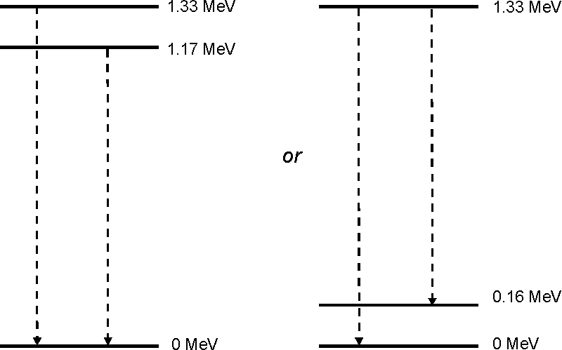

Question 16

(a) Weight = m g = 2.0 x 10⁵ kg x 9.8 N kg^{–1} = 1.96 x 10⁶ N ≈ 2 MN.

(b) F_{A} and F_{B} are the same size and at the same angle above and below the horizontal, so their vertical components will be equal and opposite, giving a zero vertical resultant. Thus the resultant must be horizontal.

(c) Horizontal component of F_{A} = F_{A} cos 30°.
Horizontal component of F_{B} = F_{B} cos 30° = F_{A} cos 30° (because F_{B} = F_{A}).
Resultant = 2 x F_{A} cos 30° = 2 x (1.7 x 10⁵ N) x 0.866 = 2.94 x 10⁵ N ≈ 3.0 x 10⁵ N.

(d) F = ma, so:

$$a=\frac{F}{m}=\frac{3\text{.}0×{\text{10}}^{5} N}{\text{200}×{\text{10}}^{3} \text{kg}}=1\text{.}5 m s^{−2}\text{.}$$

This is greater than the actual acceleration of Transrapid, because drag has been ignored.

Question 17

(a) The wavefronts are parallel, so come from a very distant centre of curvature.

(b)(i)

Phasors rotate anti-clockwise (with the frequency of the wave they represent). The wave front arrives at B at an earlier time than at A. The diagram shows that the equivalent point on a wave front arrives at B half a wavelength before arriving at A. Half a wavelength corresponds to 180 degrees (or π) phase difference, which is half a revolution of the phasor. So the arrow should point to 3 o’clock.

(b)(ii) For the source overhead (Fig. 17.1) the two signals are in phase and superpose constructively. In Fig. 17.2 the signals are in antiphase and will superpose destructively.

(b)(iii) Consider the triangle with base AB. Because λ / 2 << d, θ is a small angle so

sin θ ≈ tan θ = ½ λ / d = λ / 2 d.

(b)(iv) Substituting the data into the equation given in (b)(iii)

sin θ = 0.21 m / (2 x 50 m) = 0.0021

θ = sin^{–1} (0.0021) = 0.12 degree.
Question 18

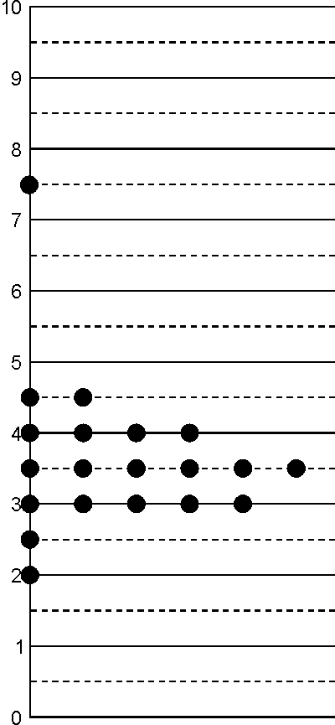
breaking force / N

The value at 7.5 N looks like an outlier.

Procedure: find the mean and spread of the remaining data to investigate further whether it is an outlier.

The mean of the remaining 19 readings is 3.5 N,
and their spread = ½ × range = (4.5 – 2)/2 = 1.25 N.
The uncertainty cannot be quoted to more significant figures than the data, so it must be rounded to the nearest 0.5 N. This should be rounded up (to 1.5 N) rather than down (to 1.0 N), as it is safer to overestimate uncertainties slightly than to underestimate them.

The reading of 7.5 is 4.0 N greater than the mean value of the rest. As this is more than twice the spread of 1.5 N, it is probably an outlier, so the best estimate of the mean and spread are

breaking force = 3.5 N ± 1.5 N.

However, this does not mean the high reading was definitely wrong: there could be an explanation for it – perhaps the strip was cut slightly wider than 5 mm, or the strip was not cut in the same direction along the paper, as newspaper is often weaker in one direction than the other.

Question 19
The metre rule has a zero error, because the rule starts at some point after 0. This means that there will be a systematic error whereby all readings are too small. The systematic error could be removed by measuring from a different point on the ruler, not the end, e.g. by starting measuring at the 1 cm mark (providing that you remember to subtract 1 cm from each reading). In this case, this is unlikely to be significant, as the sensitivity of the rule is to the nearest millimetre, and it would have to be a very worn metre rule indeed for it to be a whole millimetre out.

The resolution of a metre rule, measuring to the nearest millimetre only, is ± 0.5 mm.

For a coin of diameter about 10 mm,

percentage uncertainty ≈ ± $\frac{0\text{.}5\text{mm}×\text{100}\text{\%}}{\text{10}\text{mm}}$= ± (100 × 0.5mm/10mm)% = ± 5%.

This resolution could be improved if an instrument of smaller graduations were used (e.g. a ruler graduated to the nearest 0.5 mm, reducing the uncertainty to about ± 2.5%; or vernier callipers, which will measure to the nearest 0.1 mm, reducing the uncertainty to about ± 0.5%; or a micrometer, measuring to the nearest 0.01 mm, reducing the uncertainty to ± 0.05%). Another method, applicable in a case like this where a number of very similar coins are readily available, would be to measure the length of a large number of them lined up along the metre rule. It would not be prohibitively expensive to line up fifty 1 p coins, which would give a reading of about (500 ± 0.5) mm, or an uncertainty of ± 0.1%.

One possible procedure would be to fit the ruler against a rectangular block aligned with (for example) the 10 cm mark, line up the N pennies against it with each touching its neighbour(s) and the ruler, and to slide another rectangular block along the ruler until it touched the far end of the chain of pennies. The edge of this second block could then be read off the ruler, and the difference between the readings gives the combined diameters of N pennies.

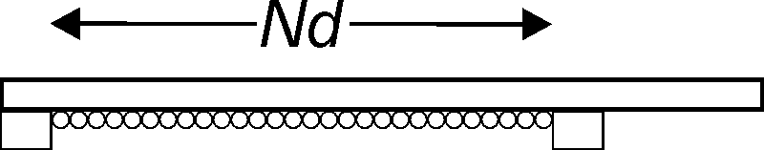

Question 20
(a)(i) V_{min} = 1.455 V, V_{max} = 1.465 V

(a)(ii) I_{min} = 0.075 A, I_{max} = 0.085 A

(b) R_{min} = 1.455 V/0.085 A = 17.1 Ω; R_{max} = 1.465 V/0.075 A = 19.5 Ω

(c) mean =(17.1 Ω + 19.5 Ω)/2 = 18.3 Ω; uncertainty = 19.5 Ω − 18.3 Ω = 1.2 Ω
resistance R = (18.3 ± 1.2) Ω

Uncertainties should be expressed to only 1 significant figure, which is to the nearest 1 Ω. This limit will then apply to the mean value as well: so resistance = (18 ± 1) Ω

(d) G_{min} = 0.075 A/1.465 V ( or = 1/R_{max}) = 0.0512 S;
G_{max} = 0.085 A/1.455 V ( or = 1/R_{min}) = 0.0584 S
conductance G = (0.0548 ± 0.0036) S = (0.055 ± 0.004) S

(e) Percentage uncertainty in R = (ΔR / R) × 100 = (1/18) × 100 = 6%
Percentage uncertainty in G = (ΔG / G) × 100 = (0.004/0.055) × 100 = 7%

(f) The least precise reading is the current, so this is the one to improve. The
uncertainty in current with a meter which reads to three decimal places would be 0.0005 A. If this produced a reading of (for example) 0.082 A, then a repeat of the above calculation gives
R = (17.8 ± 0.2) Ω with a percentage uncertainty of 1%
G = (0.0562 ± 0.0005) S with a percentage uncertainty of 1%

Question 21

(a)

extension of band Δx /m | force F /N | height h reached by rubber band /m
extension of band Δx /m | force F /N | 1 | 2 | 3 | 4 | 5 | mean | spread
0.010 | 1.9 | 0.06 | 0.06 | 0.08 | 0.05 | 0.05 | 0.06 | 0.02
0.020 | 3.4 | 0.20 | 0.28 | 0.23 | 0.21 | 0.22 | 0.23 | 0.04
0.030 | 5.2 | 0.47 | 0.63 | 0.59 | 0.56 | 0.55 | 0.56 | 0.08
0.040 | 7.0 | 1.12 | 0.89 | 0.96 | 0.84 | 0.98 | 1.0 | 0.1
0.050 | 8.6 | 1.31 | 1.68 | 1.53 | 1.45 | 1.42 | 1.5 | 0.2

Note that the spread (uncertainty) is to one significant figure, and this limits the number of significant figures of the mean.

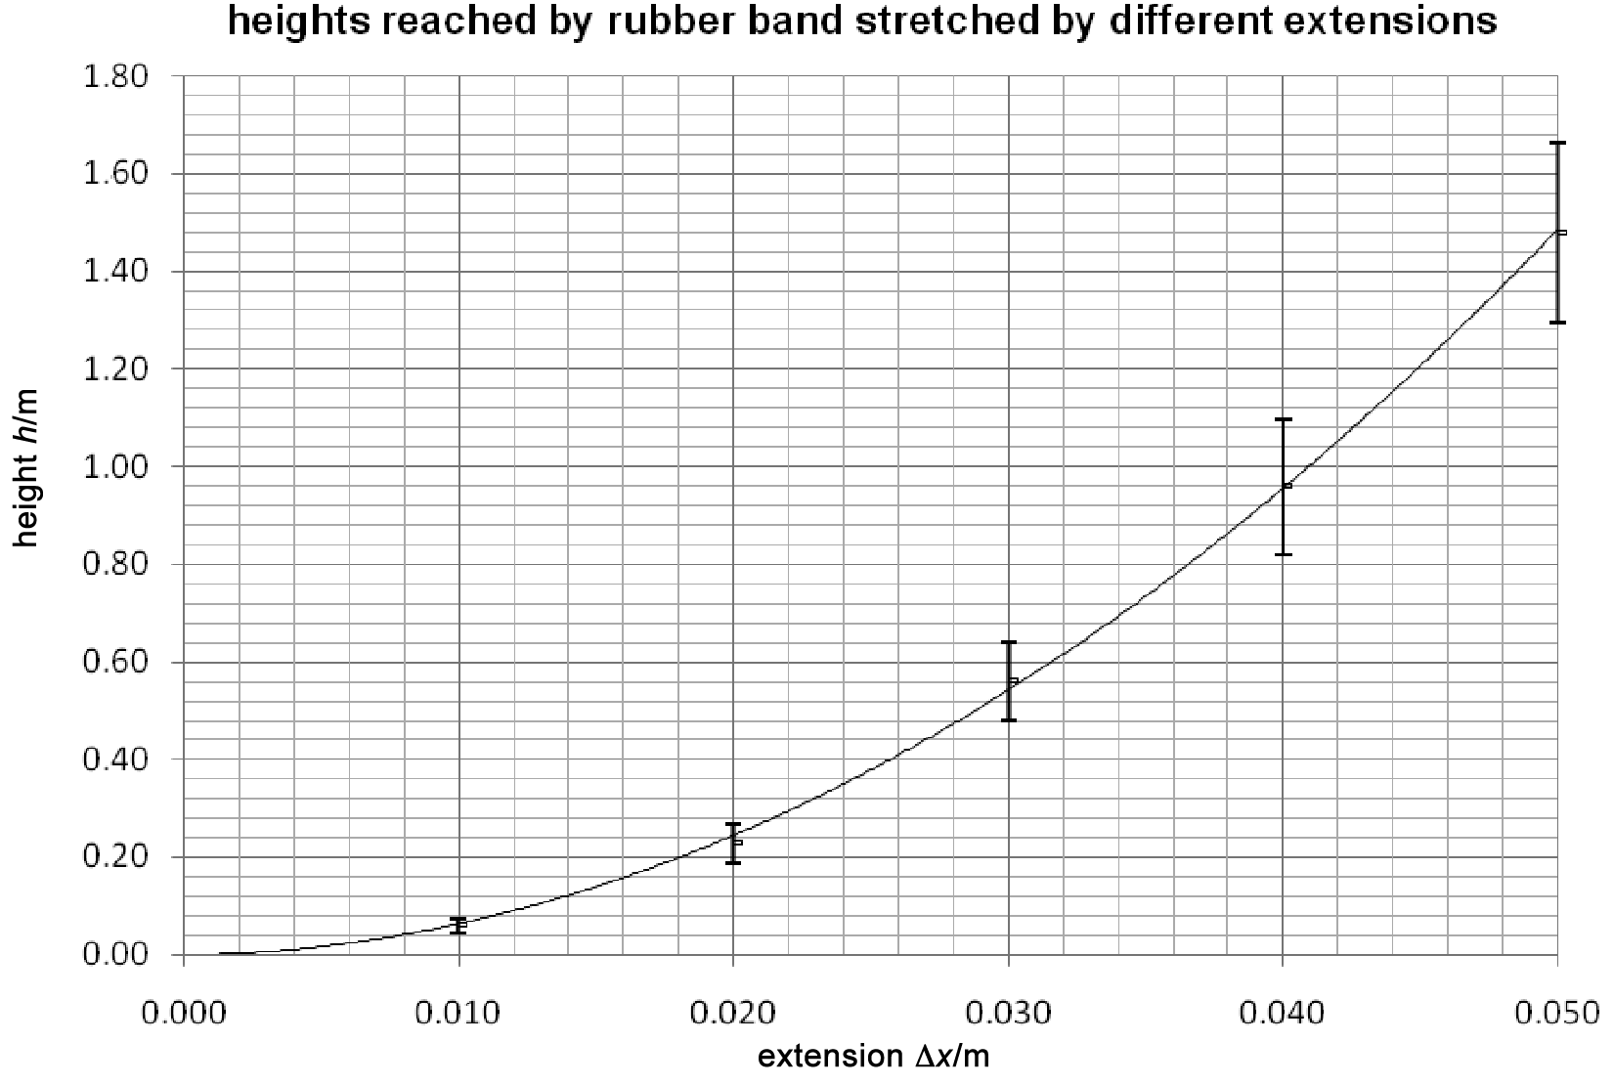

Note that this graph is not a straight line.

It is reasonable to extrapolate (continue back) to the origin, as a rubber band which has not been stretched will not rise into the air at all, so h = 0 when Δx = 0.

[In an examination you would expect more of the table to be completed for you, and several of the points of the graph, with their uncertainty bars, to be plotted. This is because you would not have time, in an examination, to do all the above. The same applies to parts (b) and (c).]

(b)

extension of band Δx /m | force F /N | mean height h /m | work done in stretching /mJ | gravitational energy gained /mJ
0.010 | 1.9 | 0.06 | 9.5 | 2.6
0.020 | 3.4 | 0.23 | 34 | 10.1
0.030 | 5.2 | 0.56 | 78 | 24.7
0.040 | 7.0 | 1.0 | 140 | 44.1
0.050 | 8.6 | 1.5 | 215 | 66.2

(c)
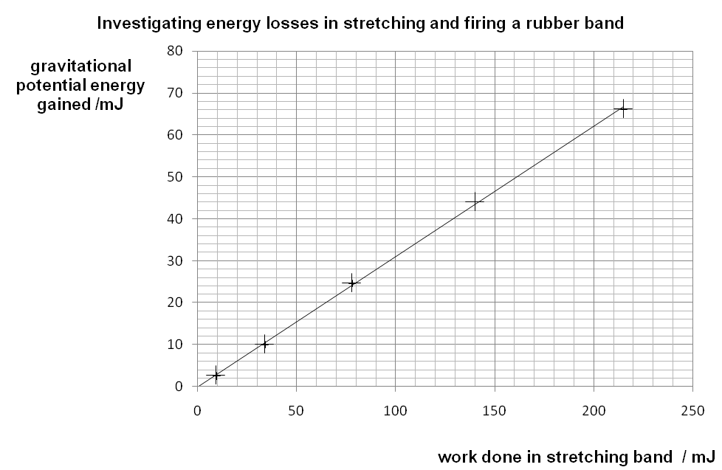

The best fit straight line does go through the origin, so the potential energy gained is directly proportional to the work done in stretching the rubber band.

Gradient = 62 mJ/200 mJ = 0.31

This is not 1, as predicted in the question.

This means that only 31% of the energy put into the rubber band ends up as gravitational potential energy. The rest is clearly lost due to work done against other forces. You should be able to suggest at least one of these.

The two forces here are air resistance as it rises and – much greater in effect – energy losses in the rubber itself as it is stretched. This is due to the movement of the polymer chains in the rubber. The rubber does get hotter as a consequence; you can check this by stretching and relaxing a rubber band several times, and then holding it against your lip – you will notice that it has become warmer.

