Revision Guide for Chapter 16
Contents
Student’s Checklist

Revision Notes
Uniform electric field 5
Electric field 5
Electric potential 7
Force on a moving charge 8
Electron volt 10

Summary Diagrams (OHTs)
Electric forces and field 11
Field strength and potential gradient 12
Field lines and equipotentials 14
Deflection by electric field 15
Force, field and potential 16
Radial field and potential 17
Millikan’s experiment 19
Student's Checklist
Back to list of Contents

I can show my understanding of effects, ideas and relationships by describing and explaining cases involving:
a uniform electric field E = V/d (measured in volts per metre)

Revision Notes: Uniform electric field
Summary Diagrams: Electric forces and field; Field strength and potential gradient; Field lines and equipotentials
the electric field of a charged body; the force on a small charged body in an electric field; the inverse square law for the field due to a small (point or spherical) charged object

Revision Notes: Electric field and inverse square law
Summary Diagrams: Deflection by electric field
electrical potential energy and electric potential due to a point charge and the 1/r relationship for electric potential due to a point charge

Revision Notes: Electric potential
Summary Diagrams: Force, field and potential; Radial field and potential
evidence for the discreteness of the charge on an electron

Summary Diagrams: Millikan’s experiment
the force on a moving charged particle due to a magnetic field

Revision Notes: Force on a moving charge

I can use the following words and phrases accurately when describing effects and observations:
electric field; electric potential (J C–1) and electrical potential energy (J)

Revision Notes: Uniform electric field; Electric field and inverse square law; Electric potential
Summary Diagrams: Force, field and potential
electron and the electron volt used as a unit of energy

Revision Notes: Electron volt

I can sketch and interpret:
• graphs of electric field versus distance, knowing that the area under the curve between two points gives the electric potential difference between the points

• graphs of electric potential and electrical potential energy versus distance, knowing that the tangent to the potential versus distance graph at a point gives the value of the electric field at that point

Summary Diagrams: Radial field and potential
diagrams illustrating electric fields (e.g. uniform and radial) and the corresponding equipotential surfaces

Revision Notes: Uniform electric field; Electric field and inverse square law
Summary Diagrams: Field strength and potential gradient; Field lines and equipotentials

I can make calculations and estimates making use of:
electric permittivity ε0 and the electric force constant
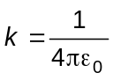
as used in the equations:
electric force due to a charge
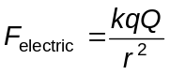
electric field
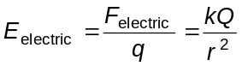

Revision Notes: Electric field and inverse square law
Summary Diagrams: Force, field and potential
electric field related to electric potential difference
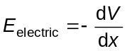
and
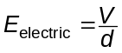
for a uniform field

Revision Notes: Uniform electric field
Summary Diagrams: Force, field and potential
electric potential at a point distance r from a point charge:
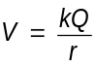

Revision Notes: Electric potential
Summary Diagrams: Force, field and potential
the force F on a charge q moving at a velocity v perpendicular to a magnetic field B
F = q v B

Revision Notes: Force on a moving charge

Revision Notes
Back to list of Contents

Uniform electric field
The electric field strength E at a point in an electric field is the force per unit charge acting on a small positive charge at that point. Electric field strength is a vector quantity in the direction of the force on a positive charge.
The SI unit of electric field strength is the newton per coulomb (N C–1) or (equivalently) the volt per metre (V m–1).

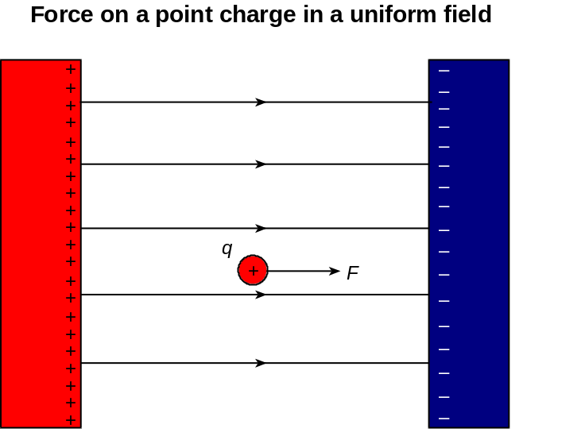

A uniform electric field exists between two oppositely charged parallel conducting plates a distance d apart. The lines of force are parallel to each other and at right angles to the plates. Because the field is uniform, its strength is the same in magnitude and direction everywhere. The potential increases uniformly from the negative to the positive plate along a line of force. Between the plates, the potential gradient is constant and equal to V / d, where V is the potential difference between the plates. The electric field strength therefore has magnitude E = V / d.

A point charge q at any point in the field experiences a force q E = q V / d at any position between the plates.

Back to Student’s Checklist

Electric field
An electric field occupies the space around a charged object, such that a force acts on any other charged object in that space.

The lines of force of an electric field trace the direction of the force on a small positive charge.

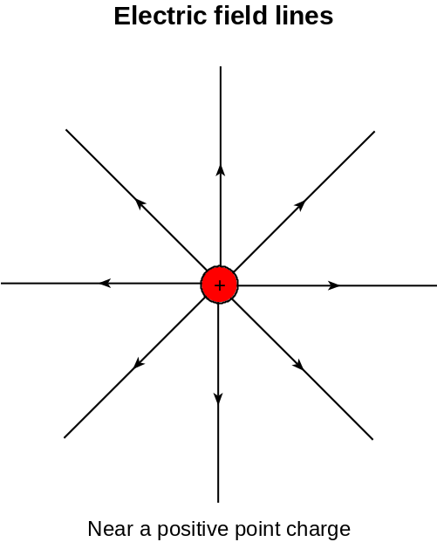

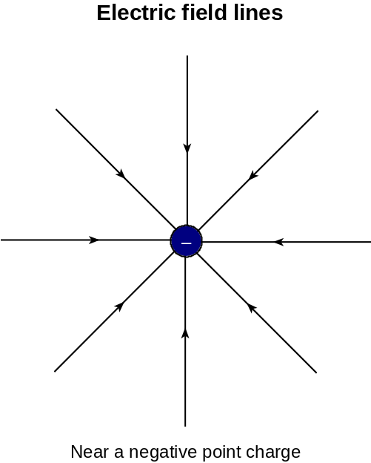

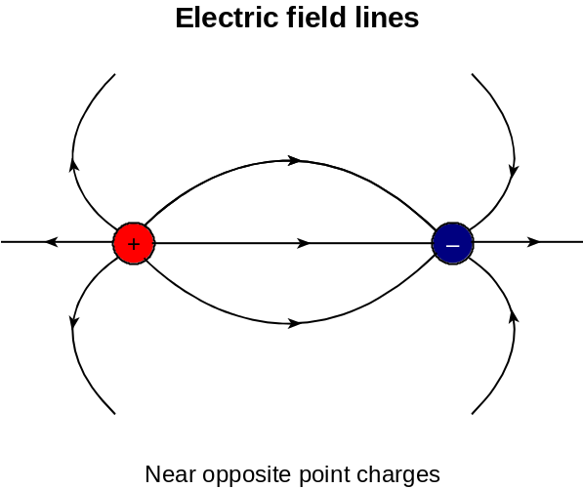

Electric field strength is the force per unit charge on a small positive point charge on a test object.

The electric field is the negative gradient of the electric potential.
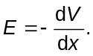

The direction of the electric field is down the potential gradient (just as gravitational forces point downhill). A strong field is indicated by a concentration of lines of force or by equipotential surfaces close together.

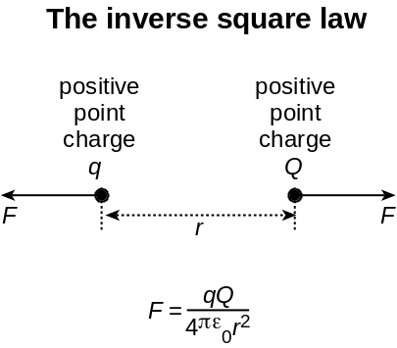

A radial electric field surrounds a point charge. Point charges q and Q at separation r in a vacuum exert equal and opposite forces on each other given by Coulomb's law
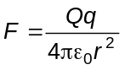
where ε0 is the permittivity of free space.

The electric field F/q at a distance r from a point charge Q is
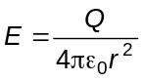

The force and the electric field vary with distance according to the inverse of the square of the distance apart.

Back to Student’s Checklist

Electric potential
The electric potential at a point is the potential energy per unit charge of a small positive test charge placed at that point. This is the same as the work done per unit positive charge to move a small positive charge from infinity to that point.

The potential energy of a point charge q is Ep = q V, where V is the potential at that point.
The unit of electric potential is the volt (V), equal to 1 joule per coulomb. Electric potential is a scalar quantity.

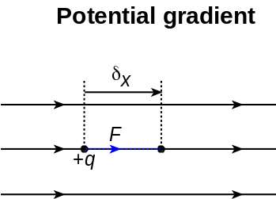

The potential gradient, dV / dx, at a point in an electric field is the rate of change of potential with distance in a certain direction. The electric field strength at a point in an electric field is the negative of the potential gradient at that point:
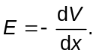

In the radial field at distance r from a point charge Q the potential V is:
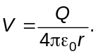

The corresponding electric field strength is:

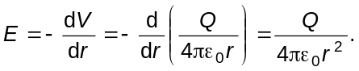

Back to Student’s Checklist

Force on a moving charge

The force F on a charged particle moving at speed v in a uniform magnetic field is F = B q v sinθ, where q is the charge of the particle and θ is the angle between its direction of motion and the lines of force of the magnetic field.

The direction of the force is perpendicular to both the direction of motion and the direction of the field. The forces on positively and negatively charged particles are opposite in direction.

A beam of charged particles in a vacuum moving at speed v in a direction perpendicular to the lines of a uniform magnetic field is forced along a circular path because the magnetic force B q v on each particle is always perpendicular to the direction of motion of the particle.

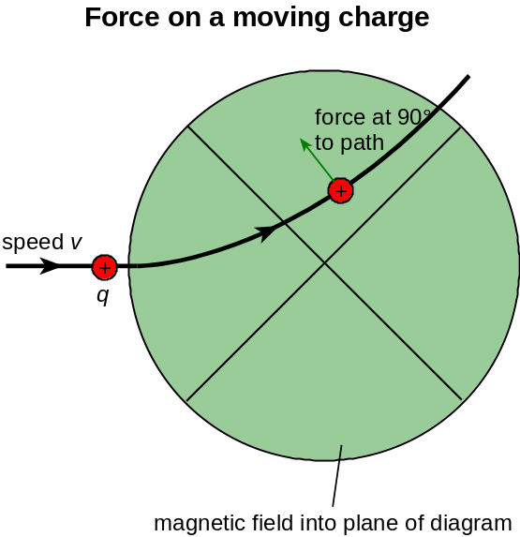

The radius of curvature of the path of the beam
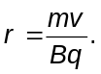
This is because the magnetic force causes a centripetal acceleration
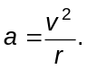

Using F = ma gives
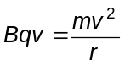
and hence 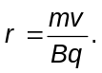

Note that writing the momentum mv as p, the relationship r = p / B q remains correct even for velocities approaching that of light, when the momentum p becomes larger than the Newtonian value m v.

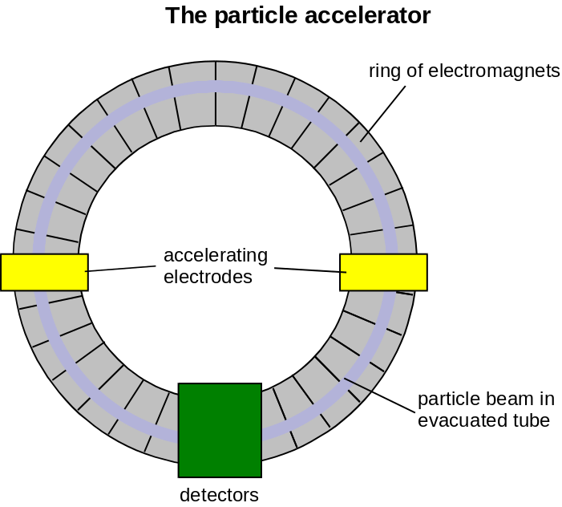

In a particle accelerator or collider, a ring of electromagnets is used to guide high-energy charged particles on a closed circular path. Accelerating electrodes along the path of the beam increase the energy of the particles. The magnetic field strength of the electromagnets is increased as the momentum of the particles increases, keeping the radius of curvature constant.

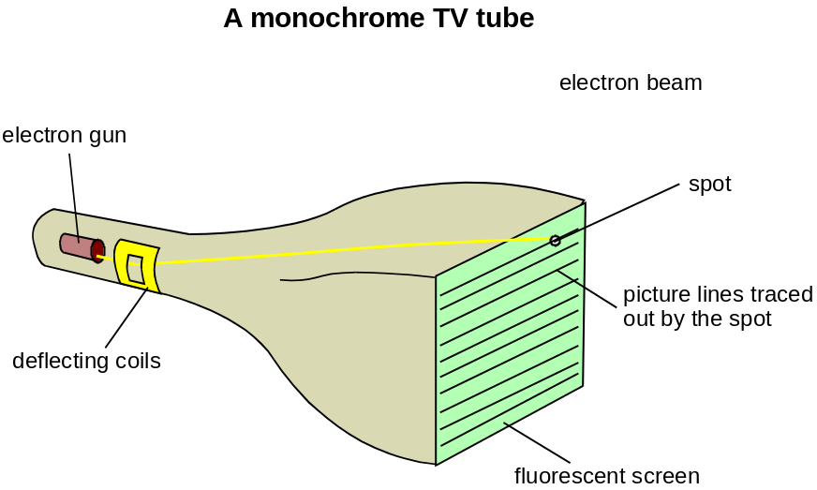

In a TV tube, an electron beam is deflected by magnetic coils at the neck of the tube. One set of coils makes the spot move horizontally and a different set of coils makes it move vertically so it traces out a raster of descending horizontal lines once for each image.

In a mass spectrometer, a velocity selector is used to ensure that all the particles in the beam have the same speed. An electric field E at right angles to the beam provides a sideways deflecting force Eq on each particle. A magnetic field B (at right angles to the electric field) is used to provide a sideways deflecting force Bqv in the opposite direction to that from the electric field. The two forces are equal and sum to zero for just the velocity v given by E q = Bqv, or v = E / B. Only particles with this velocity remain undeflected.

Back to Student’s Checklist

Electron volt
The charge of the electron e = –1.60 × 10–19 C. The charge e on the electron was measured in 1915 by Robert Millikan, who invented a method of measuring the charge on individual charged oil droplets. Millikan discovered that the charge on an oil droplet was always a whole number multiple of 1.6 × 10–19 C.

Physicists often measure the energy of charged particles in the unit electron volt (eV). This is the work done when an electron is moved through a potential difference of 1 volt. Since the charge of the electron is 1.6 × 10–19 C, then 1 eV = 1.6 × 10–19 J. The energy needed to ionise an atom is of the order of 10 eV. X-rays are produced when electrons with energy of the order 10 keV or more strike a target. The energy of particles from radioactive decay can be of the order 1 MeV.

Back to Student’s Checklist

Summary Diagrams (OHTs)
Back to list of Contents

Electric forces and field
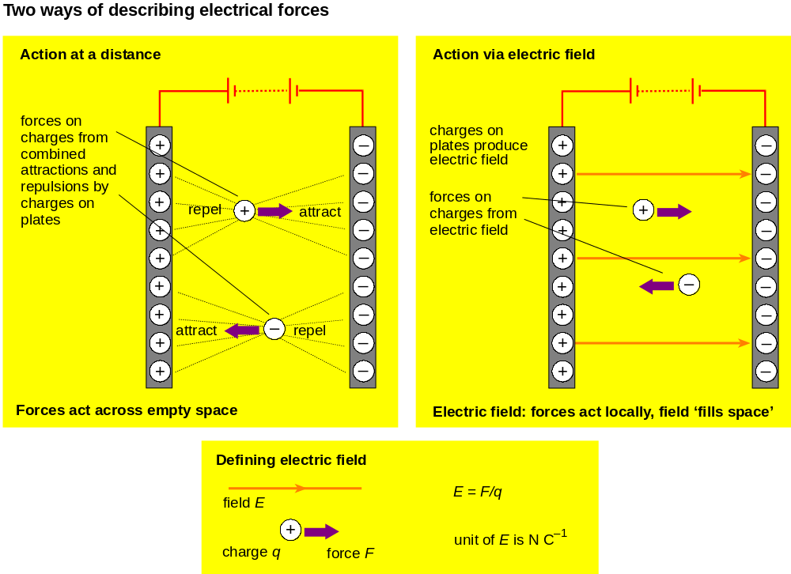

Back to Student’s Checklist

Field strength and potential gradient

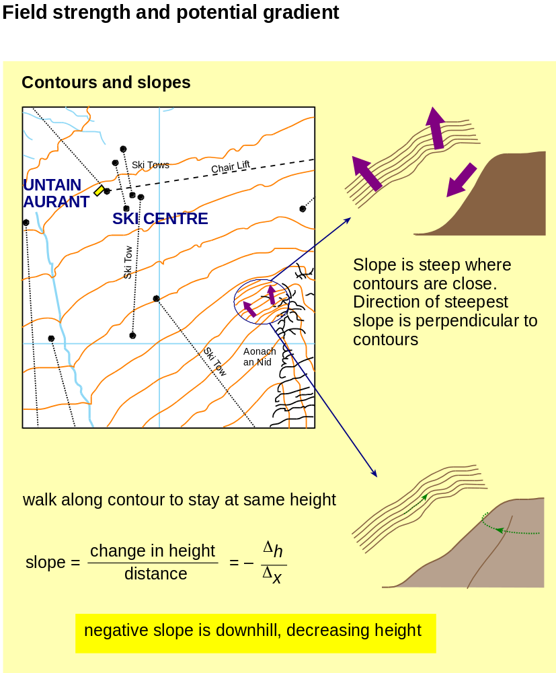
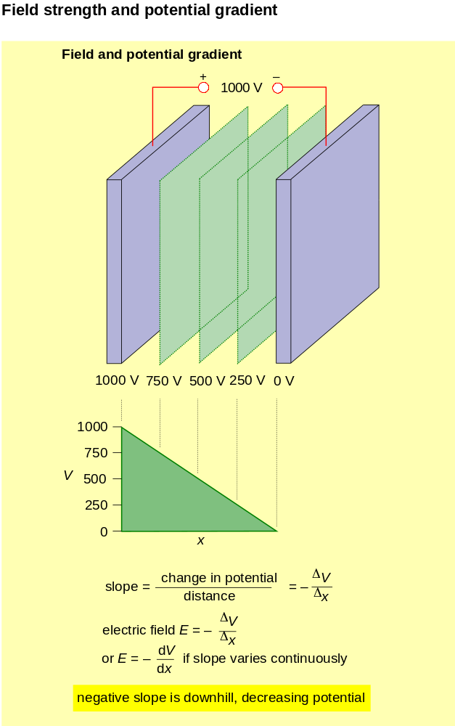
Back to Student’s Checklist

Field lines and equipotentials

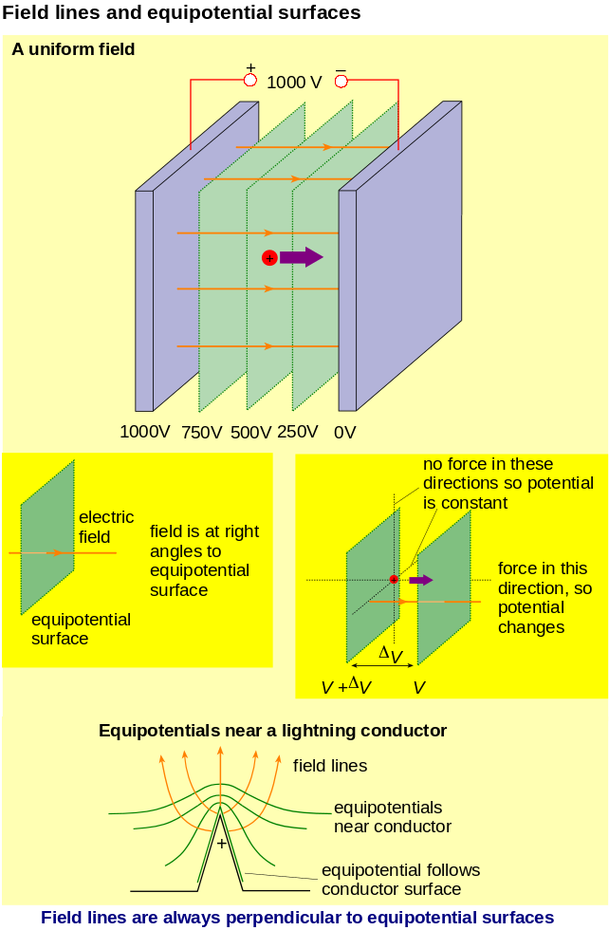

Back to Student’s Checklist

Deflection by electric field

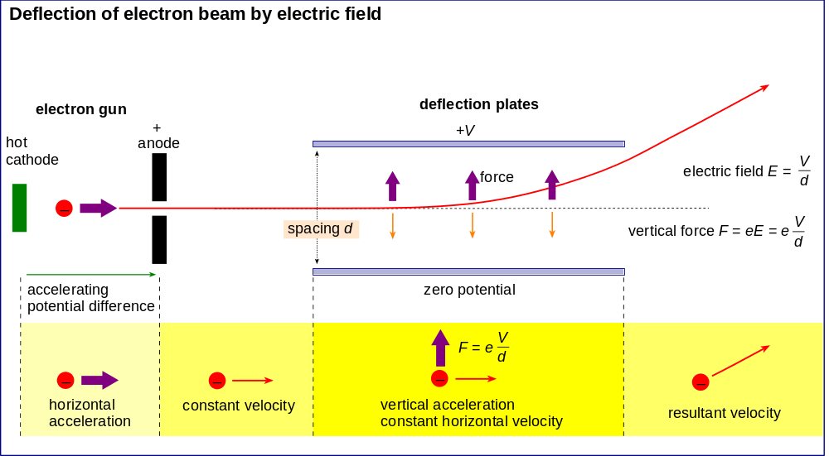

Back to Student’s Checklist

Force, field and potential

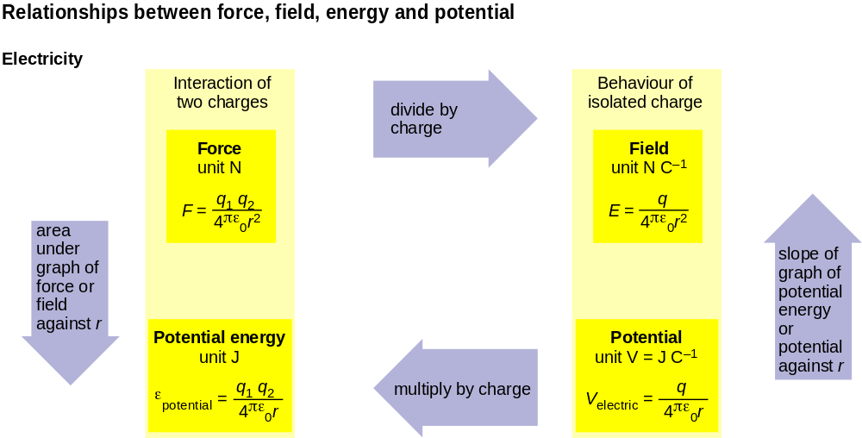

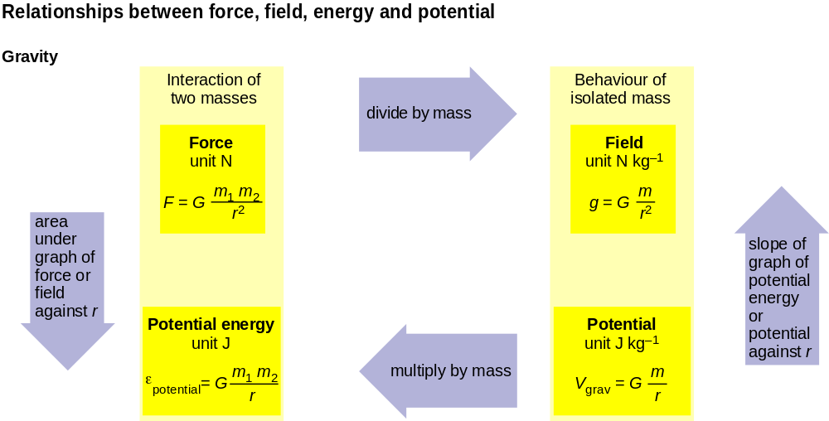

Back to Student’s Checklist

Radial field and potential

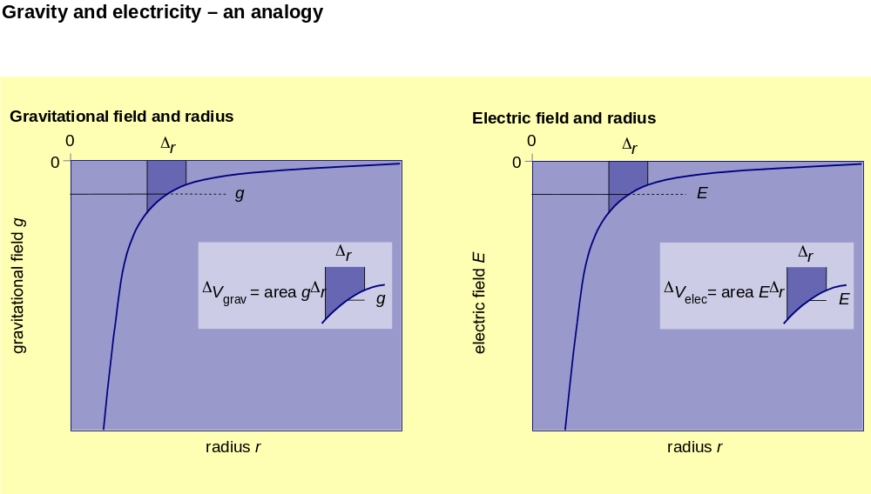

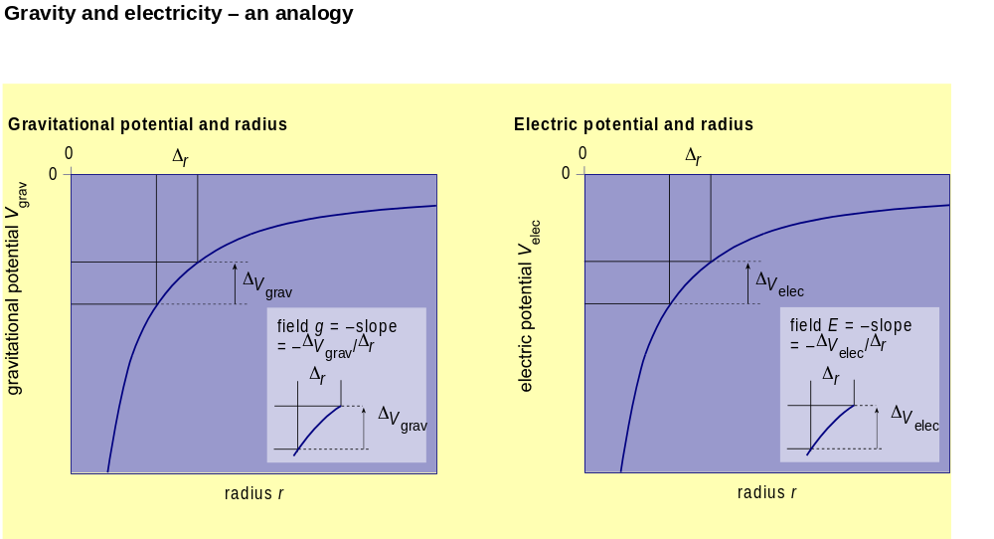

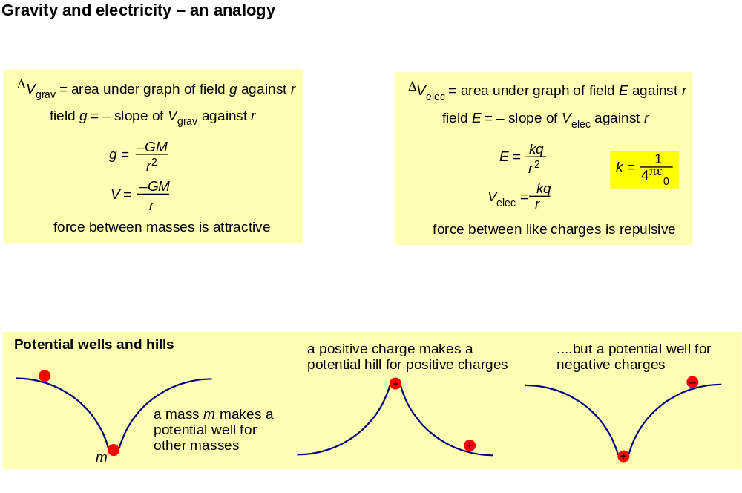

Back to Student’s Checklist

Millikan’s experiment

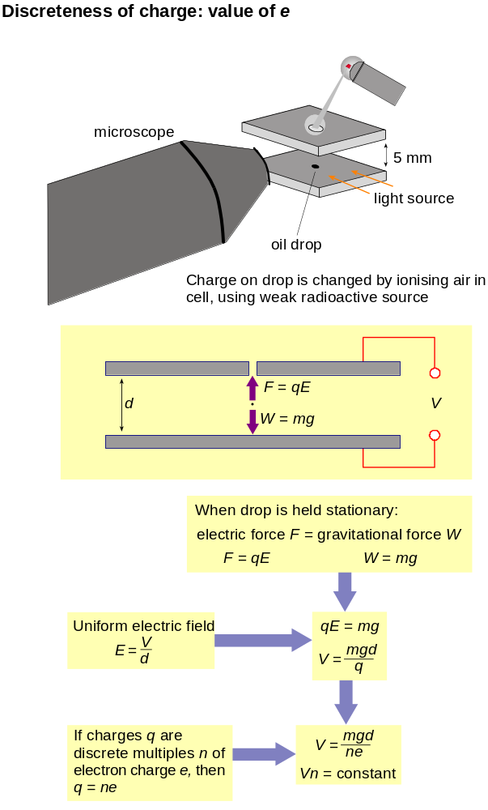
Back to Student’s Checklist

