Revision Guide for Chapter 14
Contents
Student’s Checklist

Revision Notes
Boltzmann factor 4
Thermal activation processes 4
Values of the energy kT 6

Summary Diagrams (OHTs)
Climbing a ladder by chance 7
Temperature and average energy per particle 8
Average energy per particle for various processes 9
Variation of Boltzmann factor with temperature 10
Examples of activation processes 12
Student's Checklist
Back to list of Contents

I can show my understanding of effects, ideas and relationships by describing and explaining cases involving:
the ratio of the numbers of particles in a body that exist in states at different energy, and the change in the ratio when the temperature changes

Revision Notes: Boltzmann factor
Summary Diagrams: Climbing a ladder by chance; Temperature and average energy per particle; Average energy per particle for various processes; Variation of Boltzmann factor with temperature
the idea of activation energy, and link this idea to what happens in various processes when the temperature changes (e.g. changes of state, thermionic emission, ionisation, conduction in semiconductors)

Revision Notes: Activation processes
Summary Diagrams: Variation of Boltzmann factor with temperature; Examples of activation processes

I can use the following words and phrases accurately when describing effects and observations:
Boltzmann factor

Revision Notes: Boltzmann factor
activation energy

Revision Notes: Activation processes
Summary Diagrams: Examples of activation processes

I can sketch, plot and interpret:
graphs showing how the Boltzmann factor varies with energy and temperature

Revision Notes: Activation processes
Summary Diagrams: Average energy per particle for various processes; Variation of Boltzmann factor with temperature

I can make calculations and estimates involving:
ratios of characteristic energies (energies of a particle at which changes might occur) to the approximate mean energy per particle kT

Revision Notes: Values of the energy kT
Summary Diagrams: Temperature and average energy per particle; Average energy per particle for various processes
the Boltzmann factor exp(– ε / kT)

Revision Notes: Boltzmann factor; Activation processes
Summary Diagrams: Variation of Boltzmann factor with temperature; Examples of activation processes

Revision Notes
Back to list of Contents

Boltzmann factor
For a large number of particles in thermal equilibrium at temperature T, the ratio of numbers of particles occupying distinct states which differ by energy ε is given by the Boltzmann factor e– ε /kT , where k is the Boltzmann constant.

The value of the Boltzmann constant is k = 1.38 × 10–23 J mol–1 K–1.

The Boltzmann factor is important in cases where particles require a large amount of energy for a process to occur. The Boltzmann factor gives an approximate estimate of the fraction of particles with an excess of energy of at least ε. Thus the value of the Boltzmann factor plays an important role in determining the rate of many physical processes.

Typically, processes proceed at an appreciable rate when the ratio ε/kT is about 20 to 30. The value of e– ε /kT , for ε/kT = 20 is about 10⁻⁹. That is, about 1 particle in 10⁹ has energy ε or greater. Since a particle in a gas collides with another about 10⁹ times per second, a reaction in a gas may proceed on a time scale of seconds when ε/kT is about 20.

Back to Student’s Checklist

Thermal activation processes
The random thermal energy of a particle is a small multiple of the energy kT. As the temperature increases more particles can cross the energy gap characteristic of activation processes.

Thermal activation processes include:
- The decrease of resistance of a semiconductor with temperature.
- The increase of pressure of a vapour with temperature.
- The increase in the rate of a chemical reaction with temperature.
- Thermionic emission of electrons.
- Viscous flow of some liquids.

Many processes require particles to have sufficient energy to cross an energy barrier if the process is to occur. For example, molecules in a liquid can escape from the surface to enter the vapour state by breaking apart from other liquid molecules. Particles with sufficient energy can overcome the barrier. Such a process is known as an activation process. The energy needed to cross the gap or barrier is referred to as the activation energy.

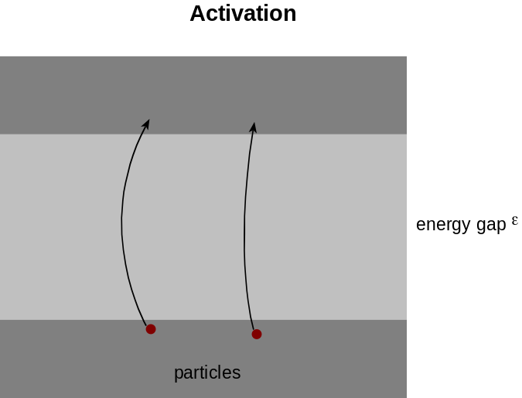

The Boltzmann factor e – ε / kT is an approximation to the fraction of particles in a large system at temperature T having a larger than average energy of at least ε. If the temperature is increased, the number of energetic particles increases, and the process occurs more rapidly.

Thermionic emission
To escape from a metal surface, a conduction electron must cross an energy barrier: the work function of the surface. The number of electrons with energy in excess of the work function φ is approximately proportional to 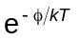. If the temperature increases, then increases and more electrons per second are emitted from the surface. This is the process of thermionic emission. Typically, φ is of the order of 10⁻¹⁹ J or about 1 eV, which gives a negligible value for at T = 300 K (φ is 40 or 50 times kT ). However, at 3000 K, is larger and there is significant thermionic emission.
Evaporation
To escape from a liquid, a molecule must have enough energy to overcome the attraction of the other molecules in the surface. The fraction of molecules on the surface that have sufficient energy to escape is approximately proportional to the Boltzmann factor e–ε / kT, where ε is the energy needed by a molecule to escape. Thus at temperature T, the number of molecules in the vapour state is approximately proportional to e–ε / kT. The vapour pressure varies as p = p0 e–ε / kT. Thus a graph of ln p against 1/T will be a straight line of gradient
-ε / k.
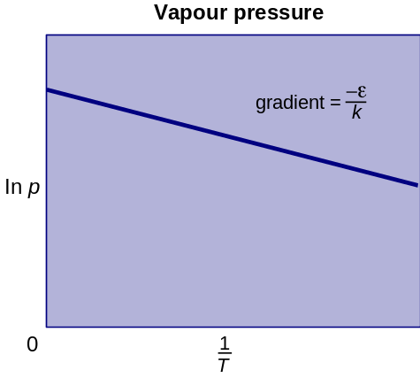
Intrinsic semiconductors
Conduction in an intrinsic semiconductor is due to electrons which have broken free from the atoms and move about inside the semiconductor. The higher the temperature, the greater the number of free electrons. At temperature T, the number of free electrons is approximately proportional to the Boltzmann factor e–ε / kT, where ε is the energy needed to free an electron. Hence the conductivity σ of an intrinsic semiconductor is approximately proportional to e–ε / kT:
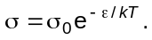

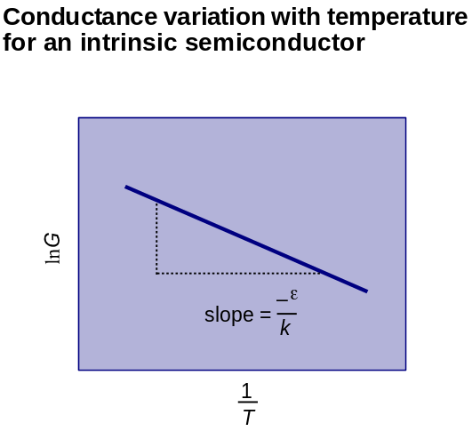

Back to Student’s Checklist

Values of the energy kT
The average energy of a particle in matter at absolute temperature T is often of the order of magnitude kT, where k is the Boltzmann constant.
A table of order of magnitude values of temperature, energy kT and photon wavelength
Temperature  T / K | Energy  kT / eV | Energy  kT / kJ mol–1 | photon wavelength for  E = hf = kT
1 | 0.0001 | 0.01 | 10 mm
10 | 0.001 | 0.1 | 1 mm
100 | 0.01 | 1 | 0.1 mm
1000 | 0.1 | 10 | 0.01 mm
10 000 | 1 | 100 | 1 μm
100 000 | 10 | 1000 | 100 nm
1 million | 100 | 10 000 | 10 nm
10 million | 1000 | 100 000 | 1 nm

These values involve two large approximations, each of about 20%. So the values are an order of magnitude guide only. The row in bold may be worth memorising. Other values can then be got by multiplying or dividing by 10.

Back to Student’s Checklist

Summary Diagrams (OHTs)
Back to list of Contents

Climbing a ladder by chance
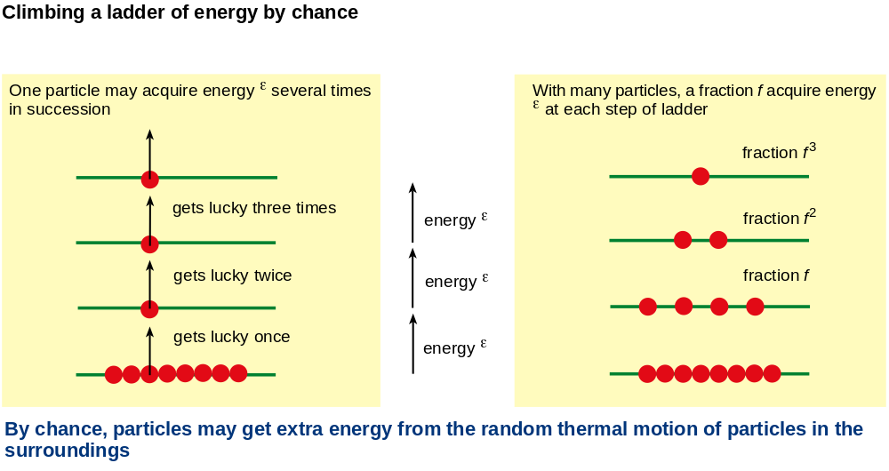
This diagram shows why only a small fraction of particles acquire energy much larger than average, through random collisions.

Back to Student’s Checklist

Temperature and average energy per particle
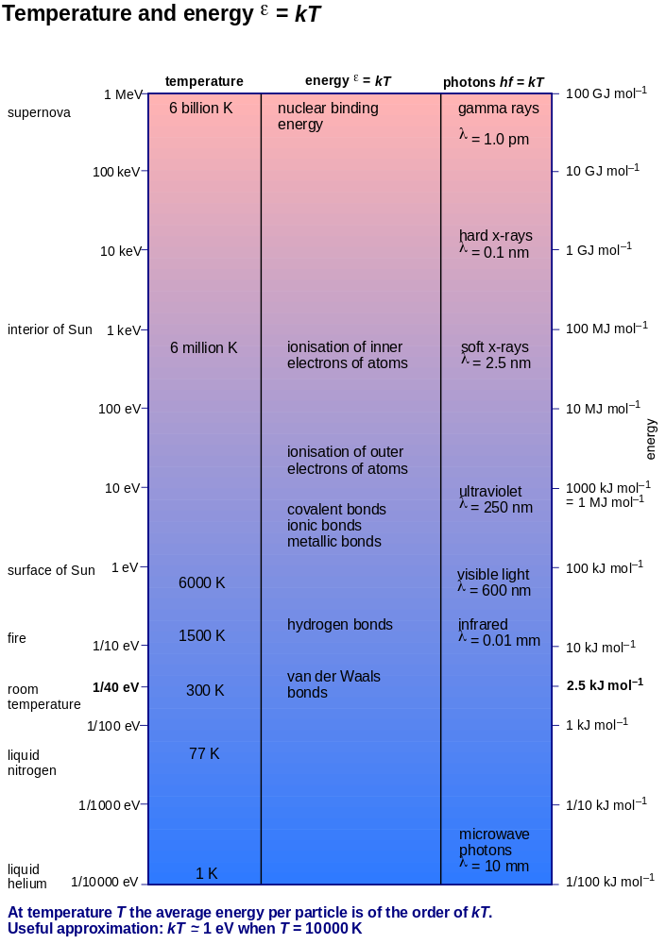

This diagram shows how temperature and the average energy per particle are related, across a very wide range of temperatures.

Back to Student’s Checklist

Average energy per particle for various processes
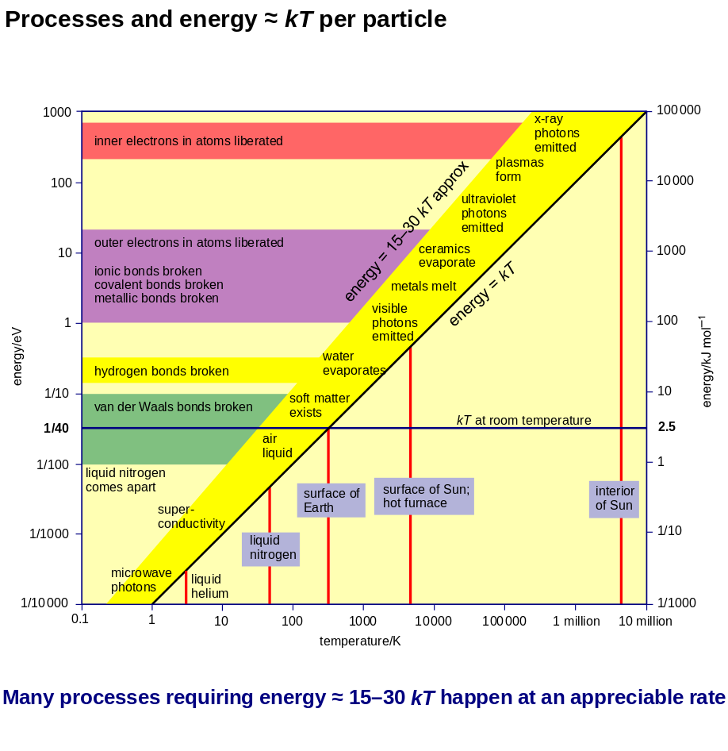
This diagram emphasises the range 15–30 times kT, where the average energy per particle is enough for a process to begin to happen at an appreciable rate.

Back to Student’s Checklist

Variation of Boltzmann factor with temperature
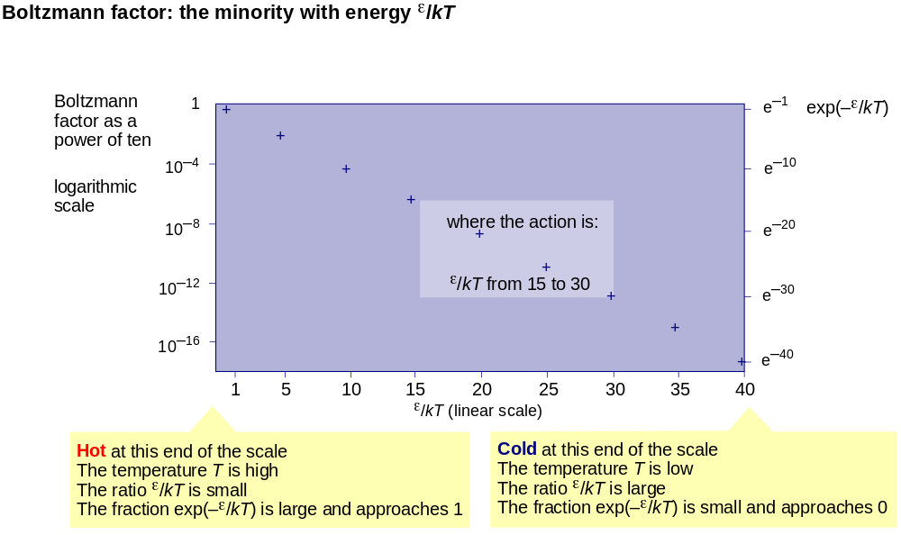
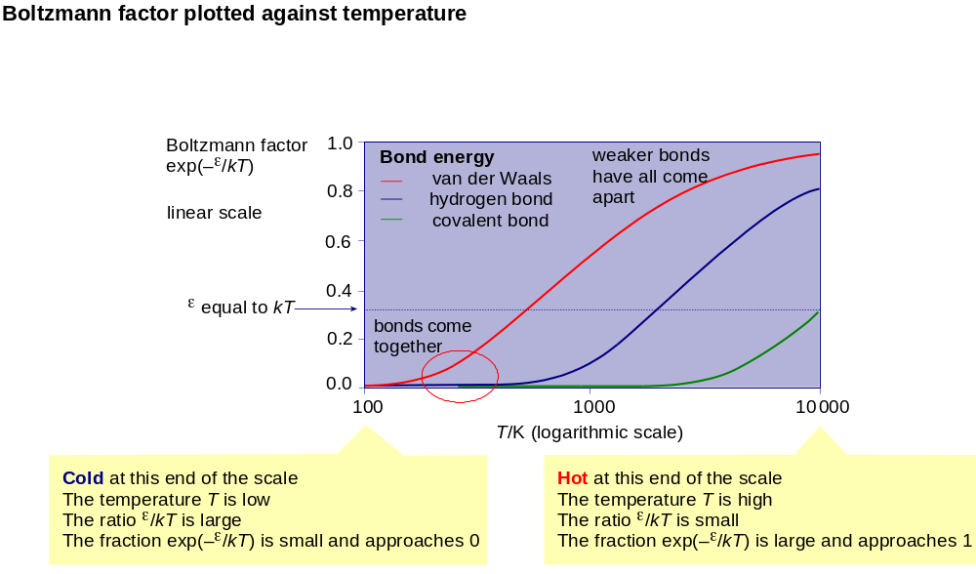
The Boltzmann factor is the ratio of numbers of particles in states separated by energy ε. It depends on temperature and the energy needed to get from one state to the other.

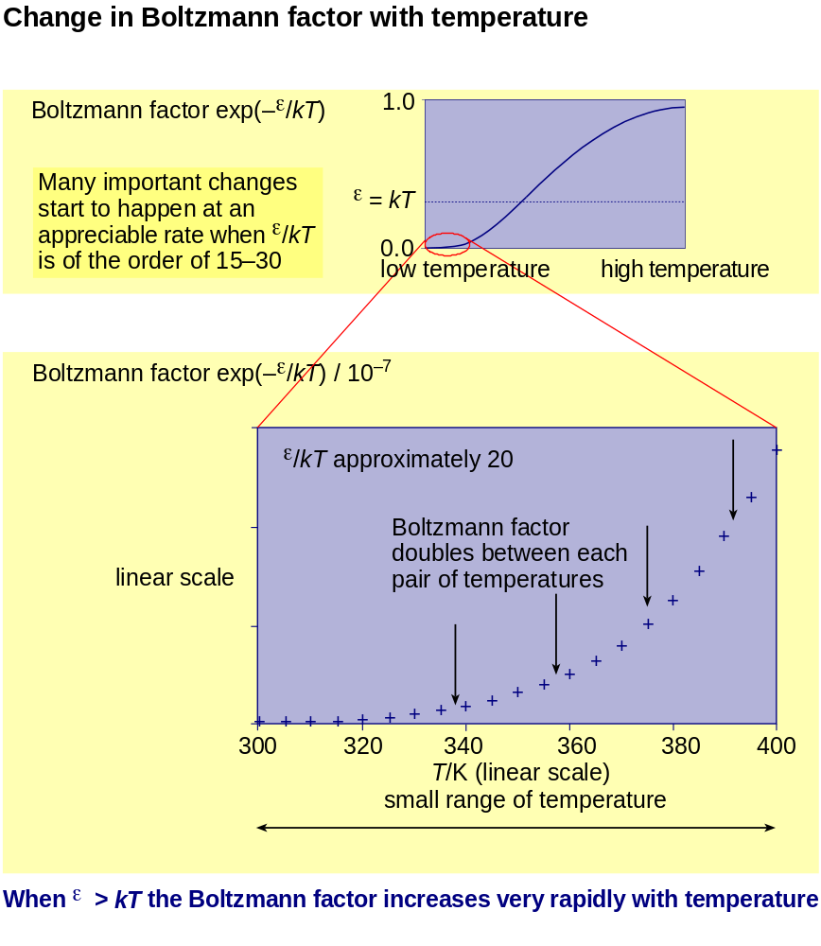
The Boltzmann factor changes very rapidly with temperature. This is why the rates at which various processes proceed often increase very rapidly with temperature.

Back to Student’s Checklist

Examples of activation processes
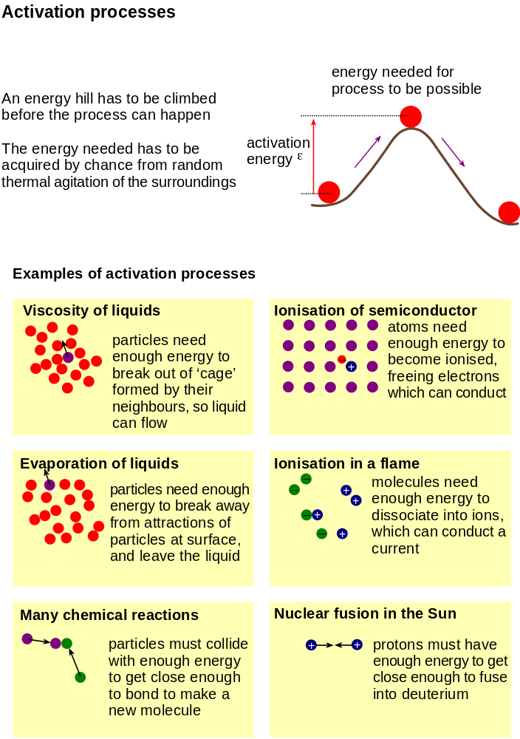
An activation process is one in which the particles have to overcome an energy barrier before the reaction or change can occur.

Back to Student’s Checklist

