Revision Guide for Chapter 12
Contents
Student’s Checklist

Revision Notes
The speed of light 4
Doppler effect 4
Expansion of the Universe 5
Microwave background radiation 5
Galaxy 6

Summary Diagrams (OHTs)
Distance and velocity by radar ranging 7
Distances in light travel time 8
Relative velocity by radar 9
Radar Doppler shift 10
Cosmological red-shift 11
The age of the Universe 12
Microwave background radiation in pictures 13
History of the Universe 15
Measuring astronomical distances 16
Student's Checklist
Back to list of Contents

I can show my understanding of effects, ideas and relationships by describing and explaining:
how radar-type measurements are used to measure distances in the solar system
how distance is measured in time units (e.g. light-seconds, light-years)

Summary Diagrams: Distance and velocity by radar ranging; Distances in light travel time
that we see distant astronomical objects as they were a long time ago, depending on how far they are away in light-years

Revision Notes: The speed of light
Summary Diagrams: Distances in light travel time
how relative velocities are measured using radar techniques
e.g. using a simple pulse technique

Revision Notes: Doppler effect
Summary Diagrams: Relative velocity by radar; Radar Doppler shift
the evidence supporting the Hot Big Bang model of the origin of the Universe:
• cosmological red-shifts and the Hubble Law;
• cosmological microwave background radiation

Revision Notes: Expansion of the Universe; Microwave background radiation
Summary Diagrams: Cosmological red-shift; Age of Universe; Microwave background radiation in pictures

I can use the following words and phrases accurately when describing astronomical and cosmological effects and observations:
microwave background, red-shift, galaxy

Revision Notes: Expansion of the Universe; Microwave background radiation; Galaxy

I can interpret:
charts, graphs and diagrams which use logarithmic ('times') scales to display data, such as distance, size, mass, time, energy, power and brightness

Summary Diagrams: Distances in light travel time; History of the Universe

I can calculate:
distances and ages of astronomical objects

Summary Diagrams: Distances in light travel time; History of the Universe; Measuring astronomical distances
distances and relative velocities using data from radar-type observations
e.g. using time-of-flight

Revision Notes: Doppler effect
Summary Diagrams: Distance and velocity by radar ranging; Relative velocity by radar; Radar Doppler shift

Revision Notes
Back to list of Contents

The speed of light
Light travels at the same speed in empty space relative to any object, no matter how the object is moving relative to other objects.

Light and all electromagnetic waves travel at a speed of nearly 300 000 km s–1, which is found to be the same by all observers, no matter how they are moving relative to one another. Ultimately this is because the speed of light is the constant conversion factor between measures of space and time, the same for all observers. It is often useful to think of the speed of light as simply unity – as 1 second of time per light-second of distance, for example.

The invariance of the speed of light is assumed in making radar measurements of the scale of the solar system. The invariance of the speed of light is one of the postulates of Einstein's theory of special relativity.

The reason why ‘nothing goes faster than light’ is that if it did, it would arrive before it left. Effect would precede cause.

The ‘ultimate speed’ c is not a kind of barrier. It is a fundamental quantity linking measurements of space and time.

Back to Student’s Checklist

Doppler effect
The Doppler effect is the change of frequency of waves from a source due to relative motion between the source and the observer.

The Doppler shift for sound, which travels through a medium such as air, is slightly different according to whether the source or receiver of the sound is moving relative to the air. However, for velocities v low compared with the speed of sound c, the result is the same:
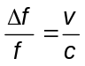
where Δ f is the change in frequency f. The frequency increases if source and receiver are coming together and decreases if they are moving apart.

For electromagnetic waves, including radar, which travel through empty space, the Doppler effect depends only on the relative velocity v of source and receiver. No meaning can be attached to their absolute movement. But again, for relative velocities small compared with the speed of light the ratio v / c gives the fractional change in frequency or in wavelength.

For light from receding objects, the shift to longer wavelengths is towards the red end of the visible spectrum and is called a red-shift.

Back to Student’s Checklist

Expansion of the Universe
Evidence for the expansion of the Universe from a hot dense initial state comes from:
- observations of the cosmic microwave background radiation, showing that the Universe has cooled as it expanded,
- observations of the speed of recession of galaxies, from red-shifts of their spectra.

The Big Bang theory of the Universe is that the Universe was created in a massive explosion from a point when space, time and matter were created. This event is thought to have occurred about 14 billion years ago. As the Universe expanded and cooled, first nucleons, then nuclei, atoms, molecules and eventually galaxies formed.

The Big Bang theory originated from the discovery by the American astronomer Edwin Hubble that the distant galaxies are receding from us at speeds in proportion to their distances. Hubble's law states that a galaxy at distance d is receding at speed v = H d, where H is a constant of proportionality known as the Hubble constant.

Estimates of the value of the Hubble constant have varied considerably over the years, mainly because of the difficulty of establishing a good distance scale.

Relationships
Red-shift z = change in wavelength / wavelength emitted = 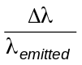
Thus wavelength observed / wavelength emitted = 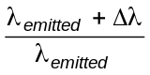 = 1 + z
scale of Universe at time of observation / scale of Universe at time of emission = 1 + z

Back to Student’s Checklist

Microwave background radiation
The detection of microwave background radiation was one piece of evidence that led to the acceptance of the Big Bang theory of the expansion of the Universe.

Arno Penzias and Robert Wilson discovered the cosmic microwave background radiation. It is understood as the cooled-down relic of hot radiation which once filled the Universe.

The Cosmic Background Explorer satellite launched in 1989 very accurately mapped out the microwave background radiation. The measurements confirmed it to be black body radiation at a temperature of 2.7 K.

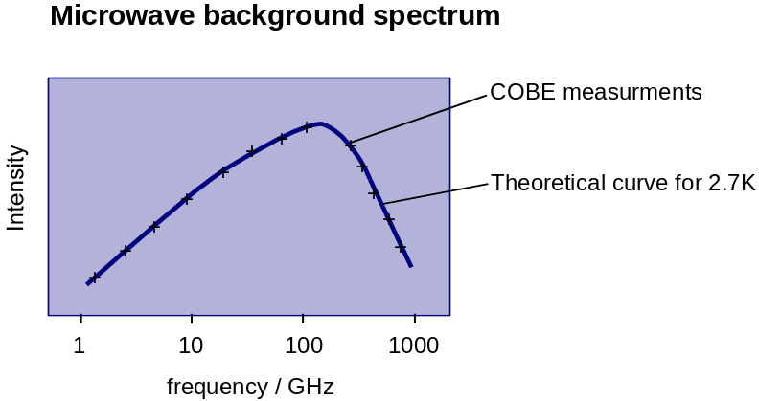

When the Universe became cool enough, electrons and ions combined to form neutral atoms, the Universe became transparent and photons existing at that time could then travel long distances through the Universe. This change is thought to have occurred when the Universe was about a hundred thousand years old, about a thousandth of its present size and at a temperature of about 3000 K. As a result of the expansion of the Universe, the photons now detected have stretched in wavelength by this factor of about a thousand, so that they are now in the microwave range of the electromagnetic spectrum, at a temperature of the order of 3 K.

Back to Student’s Checklist

Galaxy
A galaxy is an assembly of millions of millions of stars, held together by their mutual gravitational attraction.

The Sun is one of about 1011 stars in the Milky Way galaxy, our home galaxy, which is over 100 000 light-years in diameter. In comparison, the nearest star to the Sun is just a few light-years away.

Astronomers reckon the Universe contains about 1011 galaxies. The average distance between two neighbouring galaxies is of the order of ten times the diameter of an average galaxy.

Deep space photographs reveal that galaxies group together in clusters, each containing thousands of galaxies, and that clusters link together to form superclusters of galaxies separated by vast empty regions or voids.

Back to Student’s Checklist

Summary Diagrams (OHTs)
Back to list of Contents

Distance and velocity by radar ranging
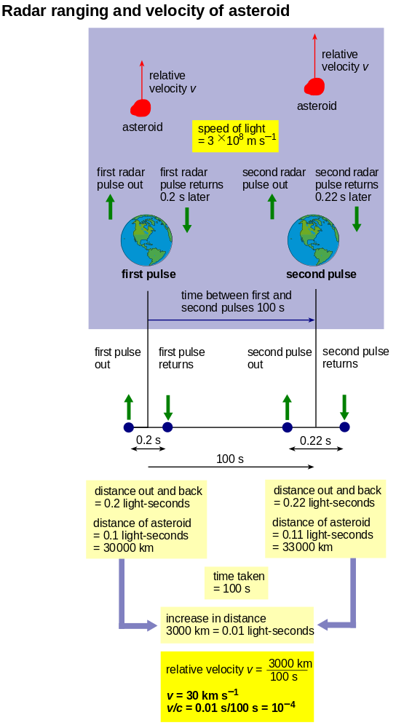
Back to Student’s Checklist

Distances in light travel time
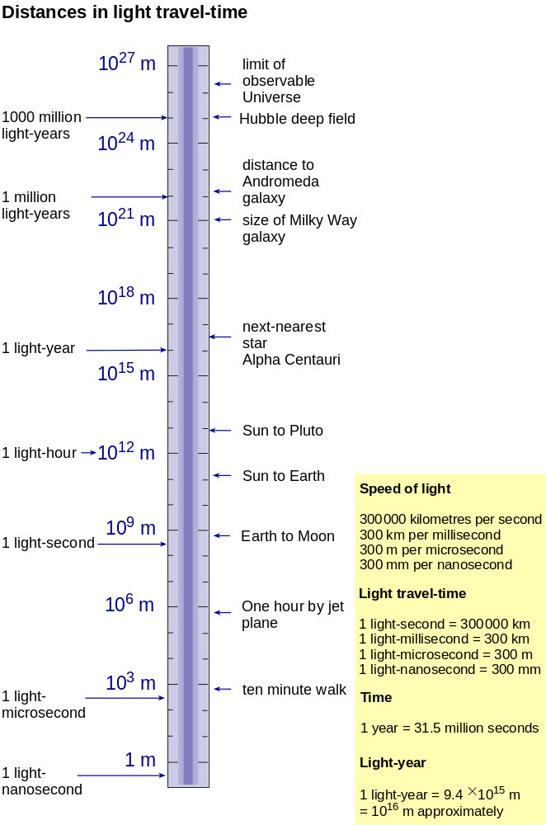
Back to Student’s Checklist

Relative velocity by radar
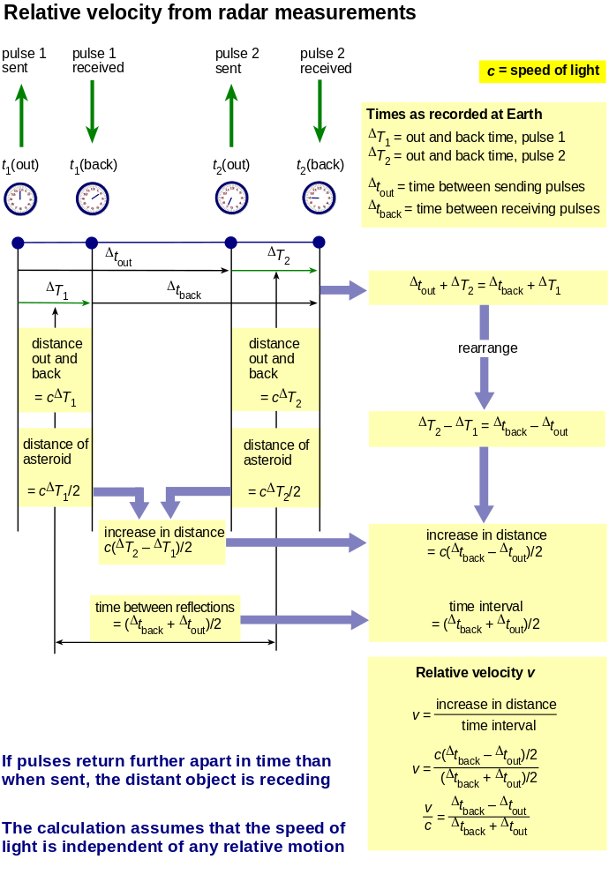
Back to Student’s Checklist

Radar Doppler shift
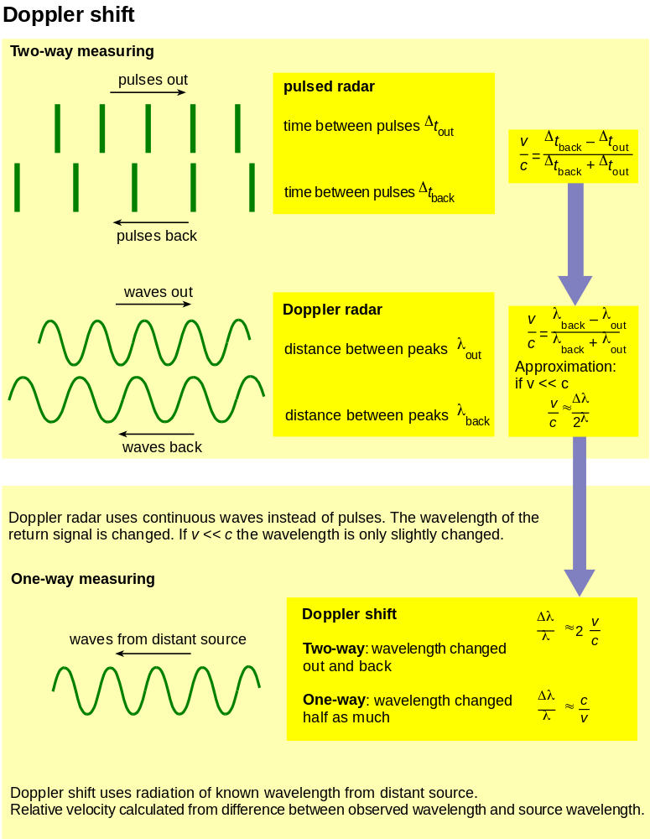
Back to Student’s Checklist

Cosmological red-shift
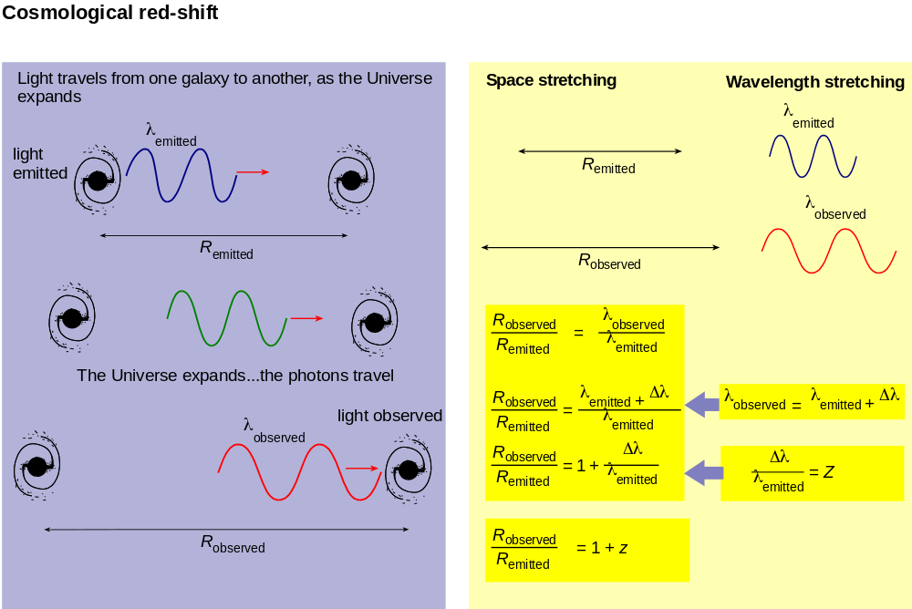

Back to Student’s Checklist

The age of the Universe
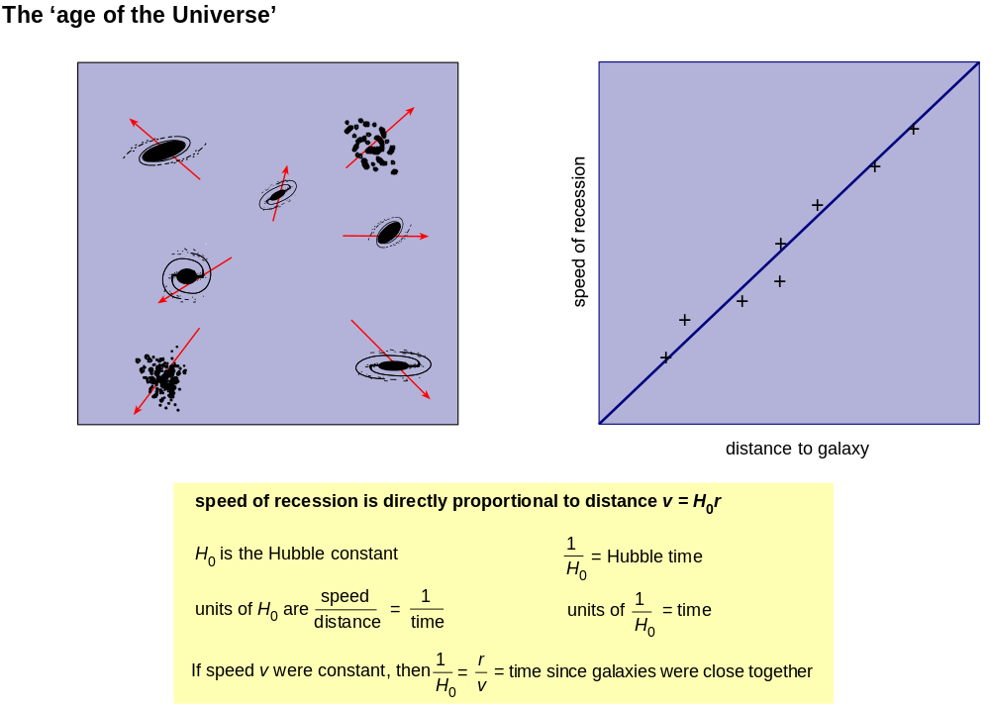

Back to Student’s Checklist

Microwave background radiation in pictures
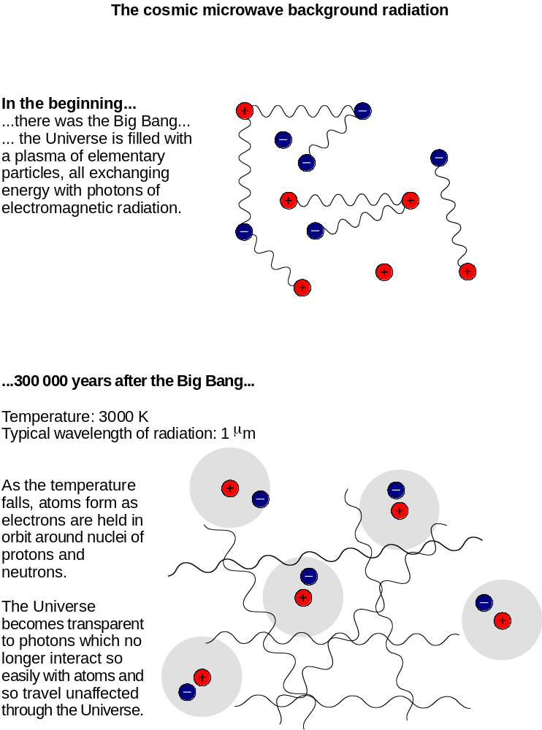
The decoupling of the radiation – the Universe becomes transparent to electromagnetic radiation.
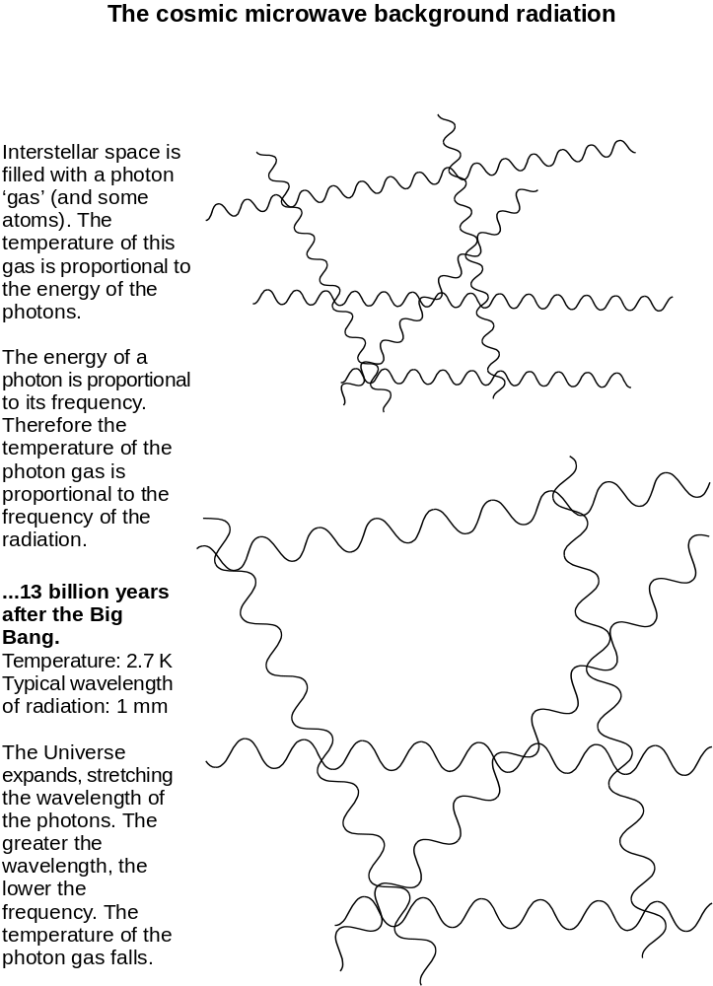
The expansion of the Universe stretches the wavelength of the radiation, decreasing its frequency and therefore reducing the energy density and lowering the temperature.

Back to Student’s Checklist

History of the Universe
A spiral timeline showing the history of the Universe on a logarithmic scale
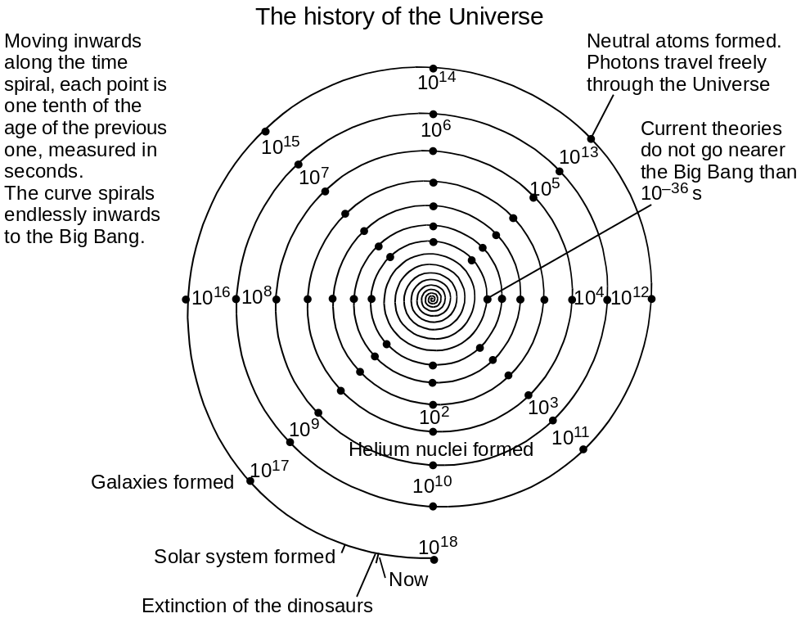
Back to Student’s Checklist

Measuring astronomical distances

Here are some techniques for measuring distance, arranged to show how they overlap.

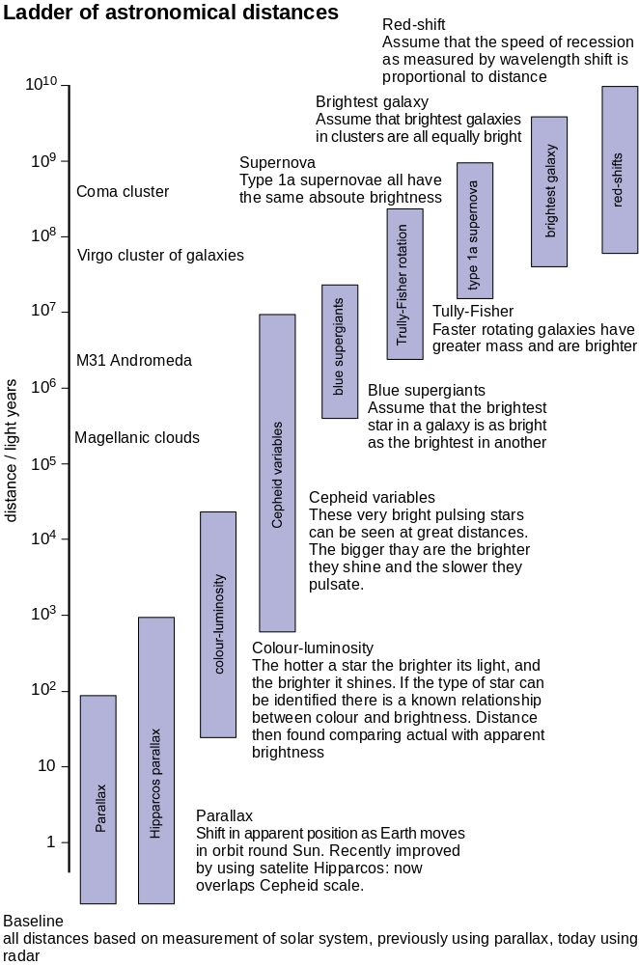
Back to Student’s Checklist

