Revision Guide for Chapter 10
Contents
Student’s Checklist

Revision Notes
Capacitance 5
Exponential decay processes 5
Simple harmonic motion 6
Damping and resonance 6

Summary Diagrams (OHTs)
Energy stored on a capacitor 8
Exponential decay of charge 9
Radioactive decay 10
Half-life and time constant 11
Describing oscillations 12
Motion of a simple harmonic oscillator 13
Graphs of simple harmonic motion 14
Computing oscillator motion step by step 15
Elastic potential energy 17
Energy flows in an oscillator 18
Resonance 19
Student's Checklist
Back to list of Contents

I can show my understanding of effects, ideas and relationships by describing and explaining cases involving:
capacitance as the ratio C = Q/V
the energy stored on a capacitor 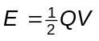

Revision Notes: Capacitance
Summary Diagrams: Energy stored on a capacitor
decay of charge on a capacitor modelled as an exponential relationship between charge and time; with the rate of removal of charge proportional to the quantity of charge remaining

Revision Notes: Exponential decay processes
Summary Diagrams: Exponential decay of charge
radioactive decay modelled as an exponential relationship between the number of undecayed atoms, with a fixed probability of random decay per atom per unit time

Revision Notes: Exponential decay processes
Summary Diagrams: Radioactive decay; Half-life and time constant
simple harmonic motion of a mass m subject to a restoring force 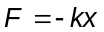 proportional to the displacement

Revision Notes: Simple harmonic motion
Summary Diagrams: Describing oscillations; Motion of simple harmonic oscillator; Graphs of SHM; Computing oscillator motion step by step
changes of kinetic energy 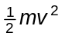 and potential energy 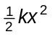 during simple harmonic motion

Summary Diagrams: Elastic potential energy; Energy flows in an oscillator
free and forced vibrations (oscillations) of an object
damping of oscillations
resonance (i.e. when natural frequency of vibration matches the driving frequency)

Revision Notes: Damping and resonance
Summary Diagrams: Resonance

I can use the following words and phrases accurately when describing effects and observations:
for capacitors: half-life, time constant
for radioactivity: half-life, decay constant, random, probability

Revision Notes: Exponential decay processes
simple harmonic motion, amplitude, frequency, period, resonance

Revision Notes: Simple harmonic motion; Damping and resonance
Summary Diagrams: Describing oscillations; Resonance
relationships of the form dx/dt = –kx , i.e. where a rate of change is proportional to the amount present

Revision Notes: Exponential decay processes

I can sketch, plot and interpret graphs of:
radioactive decay against time (plotted both directly and logarithmically)

Summary Diagrams: Radioactive decay; Half-life and time constant
decay of charge, current or potential difference with time for a capacitor (plotted both directly and logarithmically)

Summary Diagrams: Exponential decay of charge
charge against voltage for a capacitor as both change, and know that the area under the curve gives the corresponding energy change

Summary Diagrams: Energy stored on a capacitor
displacement–time, velocity–time and acceleration–time for simple harmonic motion (showing phase differences and damping where appropriate)

Summary Diagrams: Graphs of SHM
variation of potential and kinetic energy in simple harmonic motion

Summary Diagrams: Energy flows in an oscillator
variation in amplitude of a resonating system as the driving frequency changes

Summary Diagrams: Resonance

I can make calculations and estimates making use of:
small difference methods to build a numerical model of a decay equation
small difference methods to build a model of simple harmonic motion

Revision Notes: Exponential decay processes
Summary diagrams: Computing oscillator motion step by step
data to calculate the time constant τ = RC of a capacitor circuit
data to calculate the half-life of a radioactive source

Revision Notes: Exponential decay processes
Summary Diagrams: Exponential decay of charge; Half-life and time constant
the relationships for capacitors:
C = Q/V
I = ΔQ/Δt
E = (1/2) QV = (1/2) CV2

Revision Notes: Capacitance
Summary Diagrams: Energy stored on a capacitor
the basic relationship for simple harmonic motion
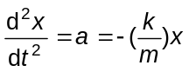
the relationships x = A sin2πft and x = A cos2πft for harmonic oscillations
the period of simple harmonic motion:
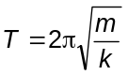
and the relationship F = -kx

Revision Notes: Simple harmonic motion
Summary Diagrams: Describing oscillations; Motion of simple harmonic oscillator; Graphs of SHM; Computing oscillator motion step by step
the conservation of energy in undamped simple harmonic motion:
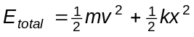

Summary Diagrams: Energy flows in an oscillator

Revision Notes
Back to list of Contents

Capacitance
Capacitance is charge stored / potential difference, C = Q/V.
The SI unit of capacitance is the farad (symbol F).

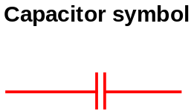
One farad is the capacitance of a capacitor that stores a charge of one coulomb when the potential difference across its terminals is one volt. This unit is inconveniently large. Thus capacitance values are often expressed in microfarads (μF) where 1 μF = 10–6 F.

Relationships
For a capacitor of capacitance C charged to a potential difference V:
Charge stored Q = C V.
Energy stored in a charged capacitor E = 1/2 Q V = 1/2 C V2.

Back to Student’s Checklist

Exponential decay processes
In an exponential decay process the rate of decrease of a quantity is proportional to the quantity remaining.

Capacitor discharge
For capacitor discharge through a fixed resistor, the current I at any time is given by I = V / R, where V = Q / C. Hence I = Q /RC.

Thus the rate of flow of charge from the capacitor is
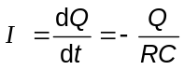
where the minus sign represents the decrease of charge on the capacitor with increasing time.

The solution of this equation is

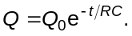

The time constant of the discharge is RC.

Radioactive decay
The disintegration of an unstable nucleus is a random process. The number of nuclei δ N that disintegrate in a given short time δ t is proportional to the number N present:
δ N = – λ N δ t, where λ is the decay constant. Thus:
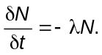

If there are a very large number of nuclei, the model of the differential equation
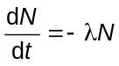
can be used. The solution of this equation is
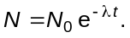

The time constant is 1 / λ. The half-life is T1/2 = ln 2 / λ.

Step by step computation
Both kinds of exponential decay can be approximated by a step-by-step numerical computation.
- Using the present value of the quantity (e.g. of charge or number of nuclei), compute the rate of change.
- Having chosen a small time interval dt, multiply the rate of change by dt, to get the change in the quantity in time dt.
- Subtract the change from the present quantity, to get the quantity after the interval dt.
- Go to step 1 and repeat for the next interval dt.

Back to Student’s Checklist

Simple harmonic motion
Simple harmonic motion is the oscillating motion of an object in which the acceleration of the object at any instant is proportional to the displacement of the object from equilibrium at that instant, and is always directed towards the centre of oscillation.

The oscillating object is acted on by a restoring force which acts in the opposite direction to the displacement from equilibrium, slowing the object down as it moves away from equilibrium and speeding it up as it moves towards equilibrium.

The acceleration a = F/m, where F = - ks is the restoring force at displacement s. Thus the acceleration is given by:
a = –(k/m)s,

The solution of this equation takes the form
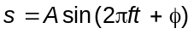where the frequency f is given by 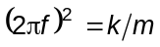, and φ is a phase angle.

Back to Student’s Checklist

Damping and resonance
In any oscillating system, energy is passed back and forth between parts of the system:

- If no damping is present, the total energy of an oscillating system is constant. In the mechanical case, this total energy is the sum of its kinetic and potential energy at any instant.
- If damping is present, the total energy of the system decreases as energy is passed to the surroundings.

If the damping is light, the oscillations gradually die away as the amplitude decreases.

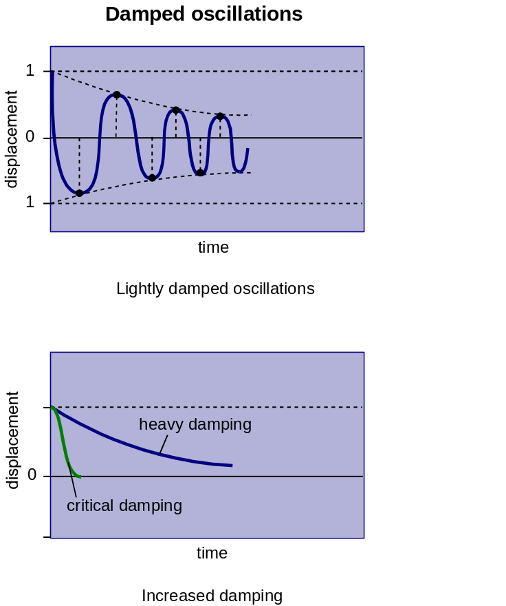

Forced oscillations are oscillations produced when a periodic force is applied to an oscillating system. The response of a resonant system depends on the frequency f of the driving force in relation to the system's own natural frequency, f0. The frequency at which the amplitude is greatest is called the resonant frequency and is equal to f0 for light damping. The system is then said to be in resonance. The graph below shows a typical response curve.

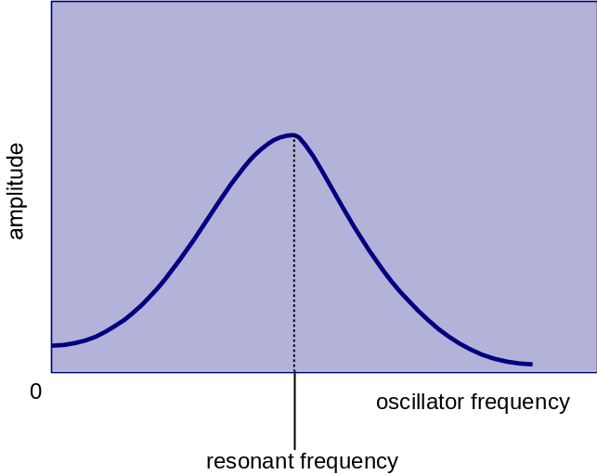

Back to Student’s Checklist

Summary Diagrams (OHTs)
Back to list of Contents

Energy stored on a capacitor

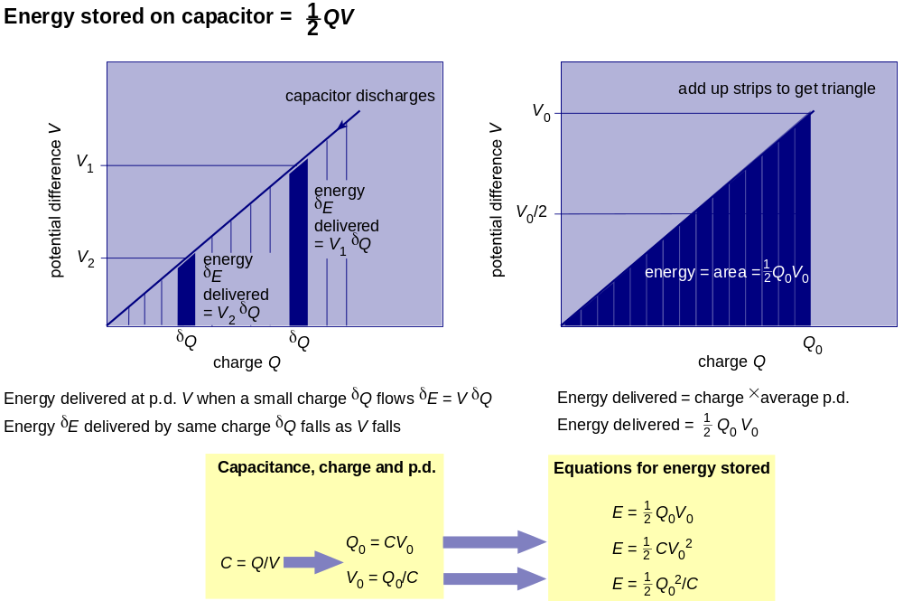

Back to Student’s Checklist

Exponential decay of charge

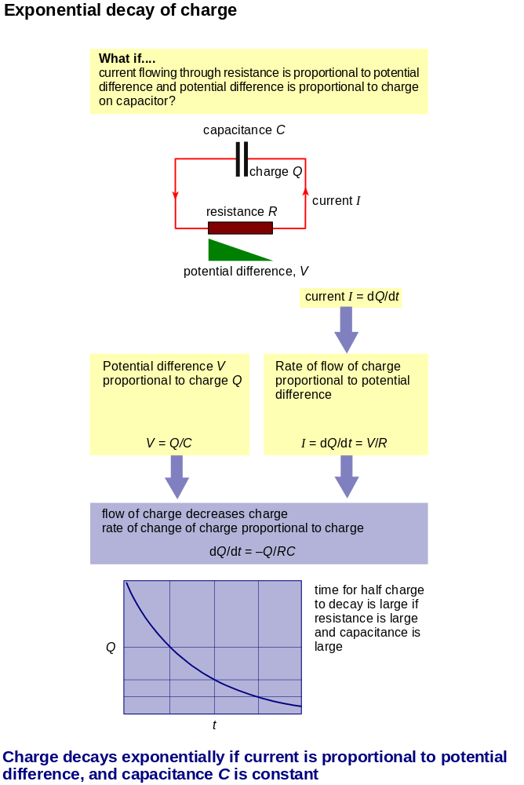

Back to Student’s Checklist

Radioactive decay

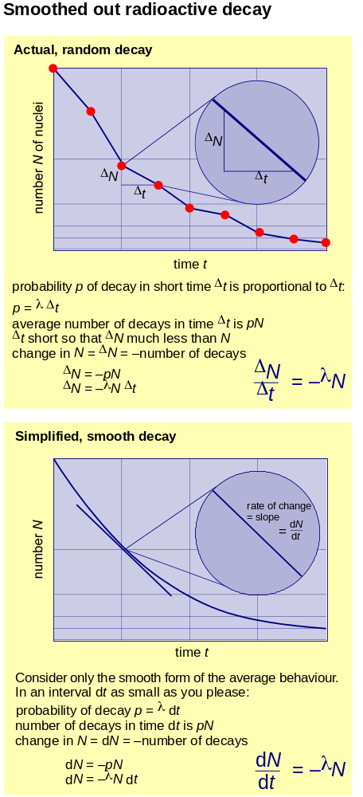
Back to Student’s Checklist

Half-life and time constant

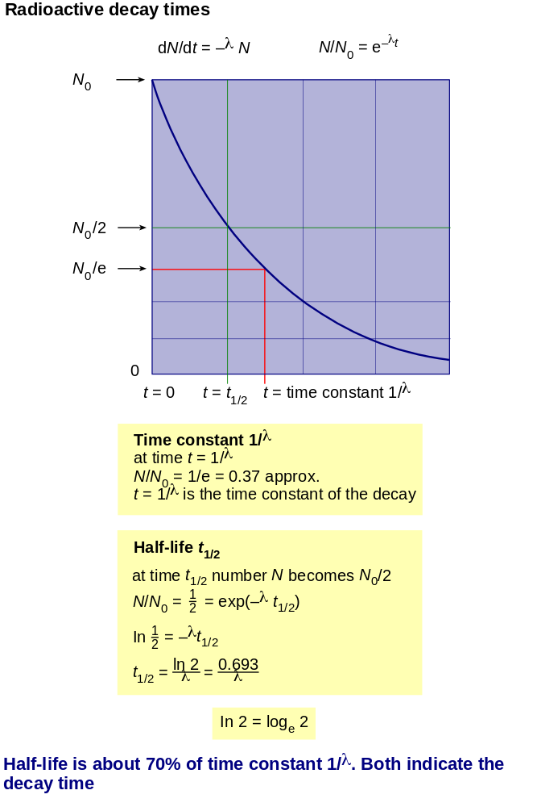

Back to Student’s Checklist

Describing oscillations

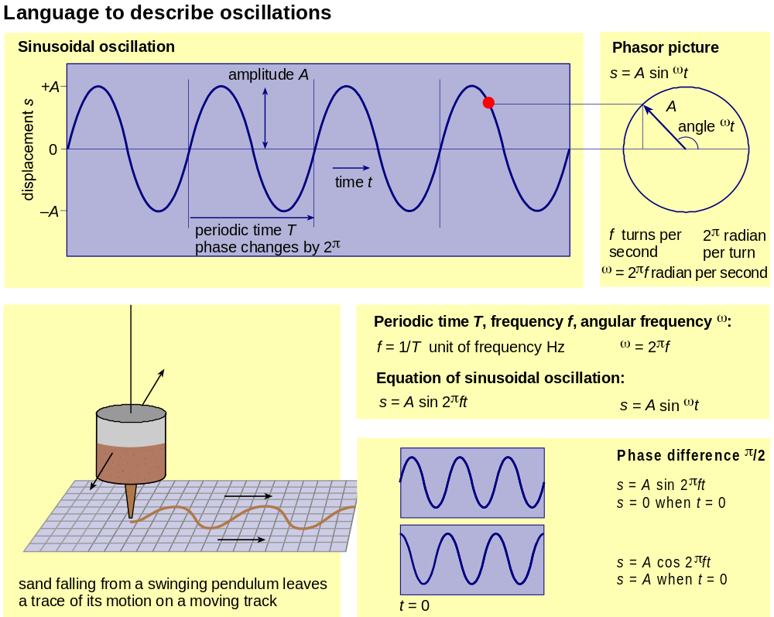

Back to Student’s Checklist

Motion of a simple harmonic oscillator

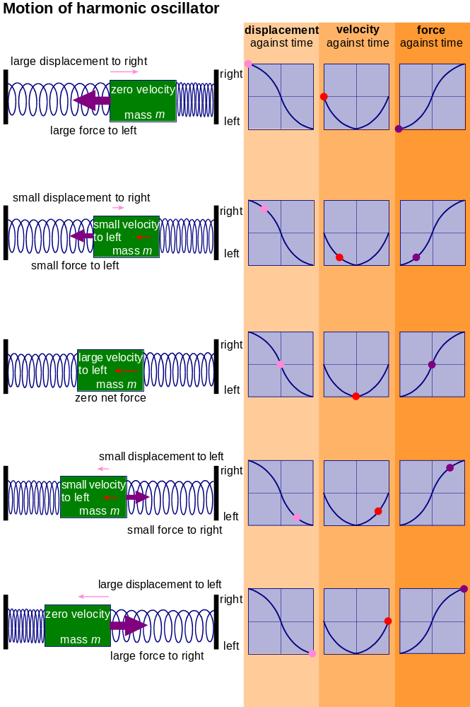
Back to Student’s Checklist

Graphs of simple harmonic motion

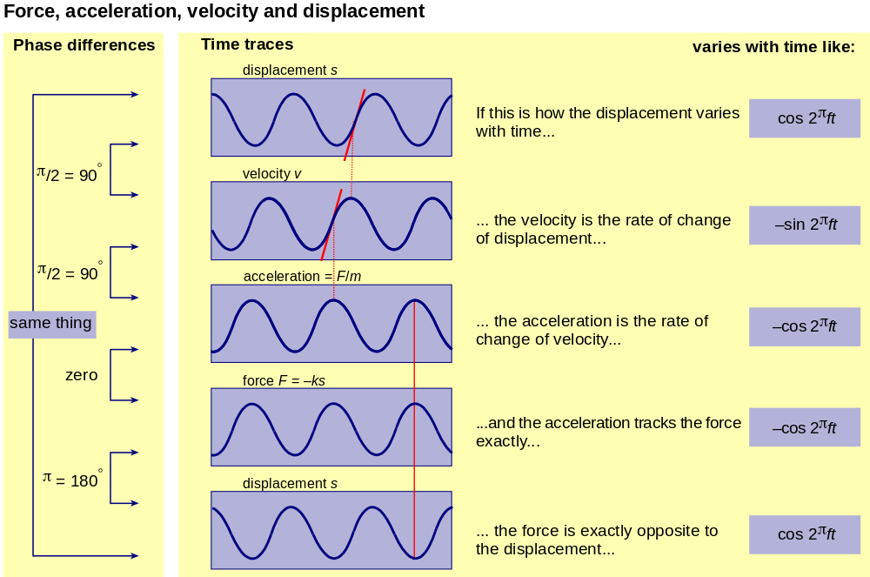

Back to Student’s Checklist

Computing oscillator motion step by step
These two diagrams show the computational steps in solving the equation for a harmonic oscillator.

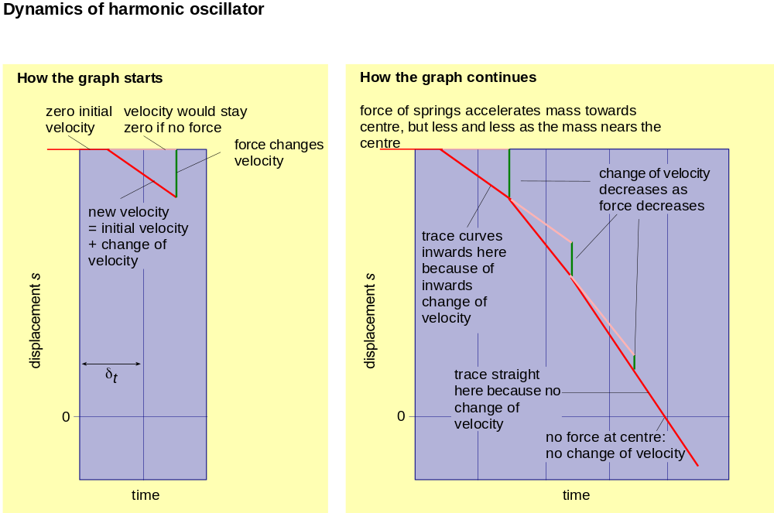

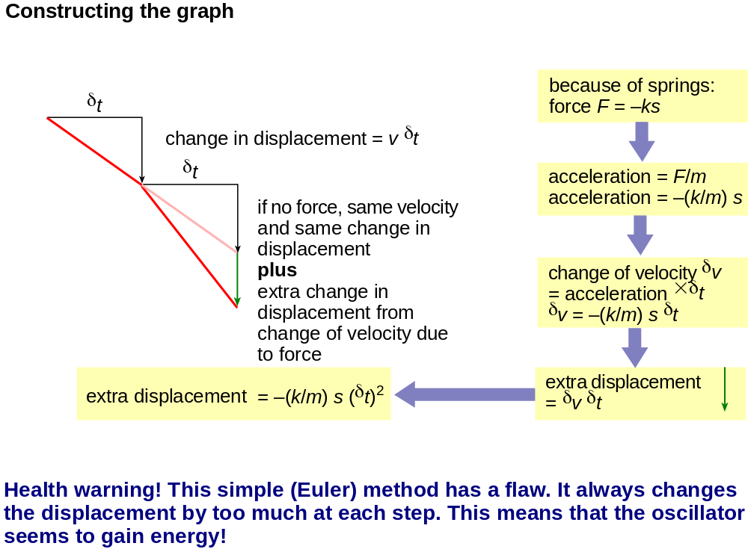
Back to Student’s Checklist

Elastic potential energy
The relationship between the force to extend a spring and the extension determines the energy stored.

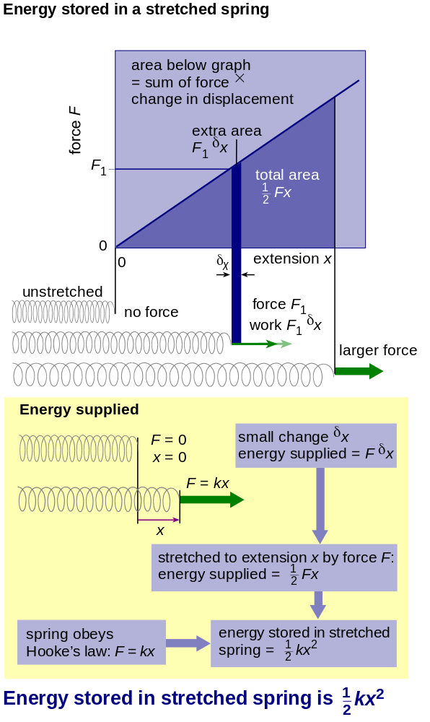

Back to Student’s Checklist

Energy flows in an oscillator
The energy sloshes back and forth between being stored in a spring and carried by the motion of the mass.

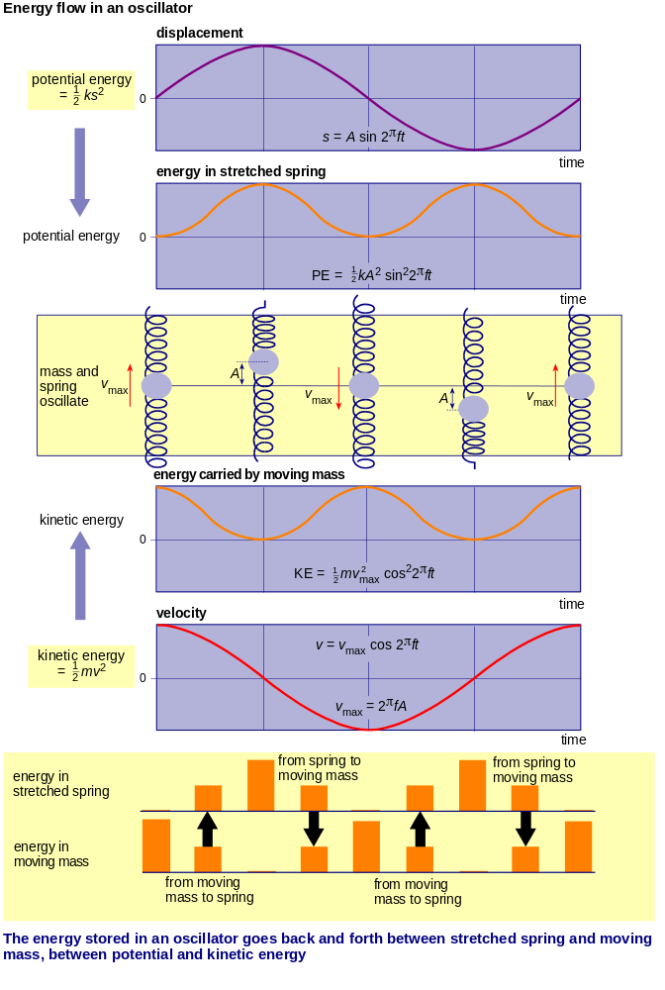

Back to Student’s Checklist

Resonance
Resonance occurs when driving frequency is equal to natural frequency. The amplitude at resonance, and just away from resonance, is affected by the damping.

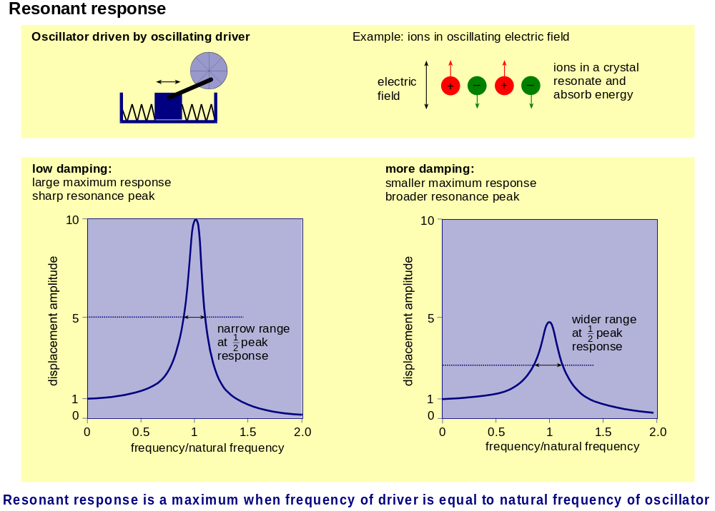

Back to Student’s Checklist

