Revision Guide for Chapter 7
Contents
Student’s Checklist

Revision Notes
Path of least time 4
Interference of photons 5
Quantum behaviour 5
Photons 6
Electron diffraction 7
Probability 8

Summary Diagrams (OHTs)
A path contributes an arrow 9
Finding probabilities 10
Mirror: contributions from different paths 11
Photons and refraction 12
Focusing photons 13
Diffraction of photons 14
Evidence for photons 15
Student's Checklist
Back to list of Contents

I can show my understanding of effects, ideas and relationships by describing and explaining:
how phasor arrows come to line up for photon paths near the path that takes the least time

Revision Notes: Path of least time
Summary Diagrams: A path contributes an arrow; Finding probabilities
how phasor arrows 'lining up' and 'curling up' account for straight-line propagation, reflection, refraction, focusing, diffraction and interference of light

Revision Notes: Path of least time; Interference of photons;
Summary Diagrams: Mirror: contribution of different paths; Photons and refraction; Focusing photons; Diffraction of photons
that the probability of arrival of a quantum is determined by graphical addition of arrows representing the phase and amplitude associated with each possible path

Revision Notes: Quantum behaviour; Photons;
Summary Diagrams: A path contributes an arrow; Finding probabilities
evidence for random arrival of photons

Revision Notes: Photons
evidence for the relationship E = hf

Revision Notes: Evidence for photons
evidence from electron diffraction that electrons show quantum behaviour

Revision Notes: Electron diffraction

I can use the following words and phrases accurately when describing effects and observations:
frequency, energy, amplitude, phase, superposition, intensity, probability

Revision Notes: Probability; See also Revision Guide for Chapter 6
path difference, interference, diffraction

See Revision Guide for Chapter 6

I can interpret:
diagrams illustrating how paths contribute to an amplitude

Summary Diagrams: A path contributes an arrow; Finding probabilities; Mirror: contribution of different paths; Photons and refraction; Focusing photons; Diffraction of photons

I can calculate:
the energy of a photon using the relationship E = hf

Revision Notes: Evidence for photons

I can give and explain an example of:
a phenomenon or application where quantum effects are important
e.g. the photoelectric effect; the production of line spectra; the quantum interference of photons; electron diffraction

Revision Notes: Photons; Evidence for photons; Interference of photons; Electron diffraction

Revision Notes
Back to list of Contents

Path of least time
Fermat had the idea that light always takes the ‘quickest path’ – the path of least time. You see below a number of paths close to the straight line path from source to detector. A graph of the time for each path has a minimum at the straight line path.

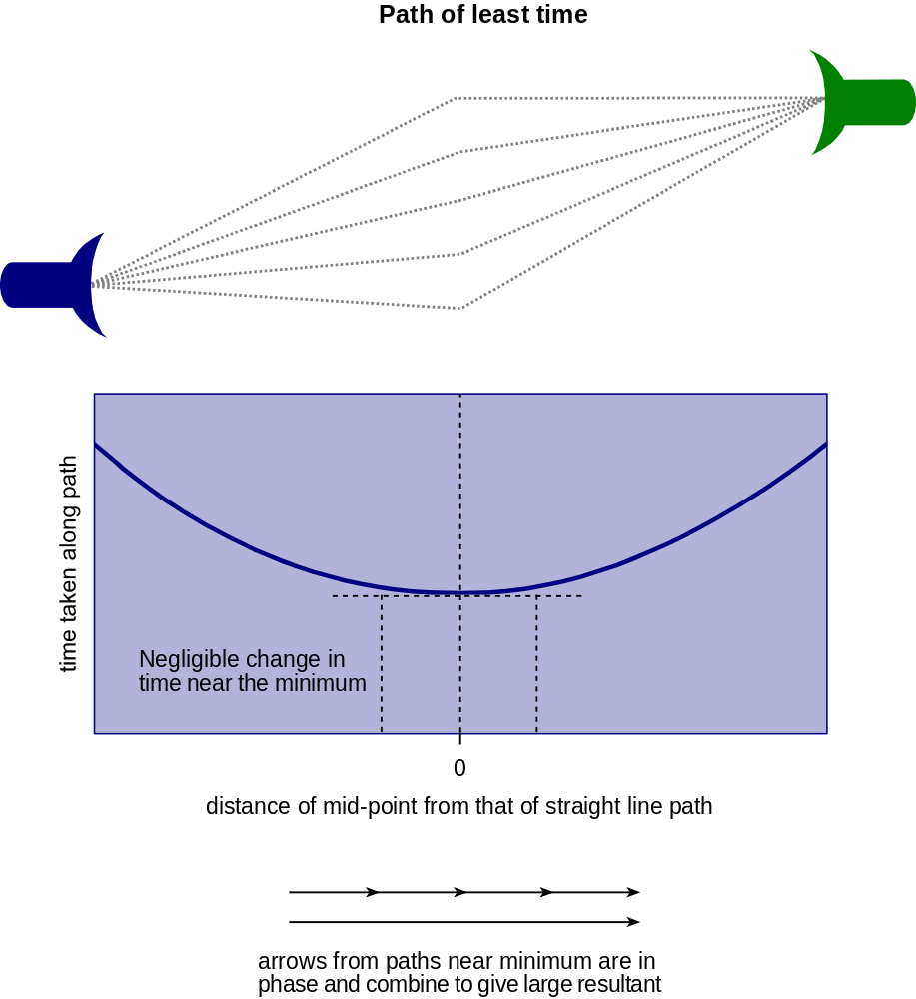

Near the minimum the graph is almost flat. This is a general property of any minimum (or maximum). That is, near the minimum the times are all almost the same.

The amount by which a photon phasor turns along a path is proportional to the time taken along the path. Thus, for paths near the minimum all the phasors have turned by the same amount. They are therefore all nearly in phase with one another. They ‘line up’, giving a large resultant amplitude.

This is the reason why Fermat’s idea works. Only for paths very close to the path of least time is there a large probability for photons to arrive. The photons try all paths, but all except the paths close to the least-time path contribute very little to the probability to arrive.

The idea explains photon propagation in a straight line, reflection and refraction.

Back to Student’s Checklist

Interference of photons
If light from a narrow source is passed through a pair of closely spaced slits onto a screen, a pattern of interference fringes is seen on the screen. Photons have two paths to the screen, and must be thought of as trying both. There is a phasor quantity (amplitude and phase) associated with each path. Since the paths are nearly equal in length the magnitude of the amplitudes for each path is similar, but the phases differ.

The phasor for a path rotates at the frequency of the light. The phase difference between two paths is proportional to the path difference.

At points on the screen where the phasors have a phase difference of half a turn, that is 180°, dark fringes are observed because the phasors added 'tip to tail' give zero resultant. Where the phasors are in phase (zero or an integer number of turns difference) there are bright fringes. The intensity on the screen is proportional to the square of the resultant phasor.

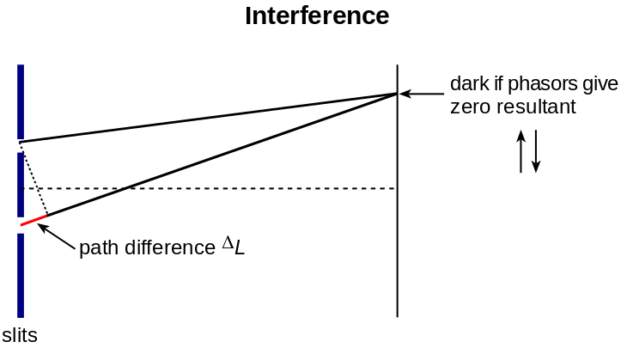

Back to Student’s Checklist

Quantum behaviour
Quantum behaviour can be described as follows:

- Particles are emitted and absorbed at distinct space-time events.
- Between these events there are in general many space-time paths.
- The presence of all possible space-time paths influences the probability of the passage of a particle from emission to absorption.
- Each path has an associated amplitude and phase, representable by a rotating phasor arrow.
- The phasor arrows for all possible paths combine by adding 'tip to tail', thus taking account of amplitude and phase.
- The square of the amplitude of the resultant phasor is proportional to the probability of the emission event followed by the absorption event.

A photon, although always exchanging energy in discrete quanta, cannot be thought of as travelling as a discrete 'lump' of anything. Photons (or electrons) arriving at well-defined places and times (space-time events) are observable. But their paths between emission and detection are not well-defined. Photons are not localised in time and space between emission and absorption. They must be thought of as trying all possible paths, all at once.

In the propagation of photons from source to detector across an empty space, the probability of arrival of photons anywhere but close to the straight line from source to detector is very low. This is because, not in spite of, the many other possible paths. The quantum amplitudes for all these paths add to nearly zero everywhere except close to the straight line direction.

As soon as the space through which the light must go is restricted, by putting a narrow slit in the way, the probability for photons to go far from the direction of straight line propagation increases. This is because the cancelling effect of other paths has been removed.

The net effect is that the narrower one attempts to make the light beam, the wider it spreads.

Back to Student’s Checklist

Photons
Electromagnetic waves of frequency f are emitted and absorbed in quanta of energy E = h f, called photons.

Photons are quantum objects, exhibiting quantum behaviour. They are emitted and absorbed at random. Their intensity is given by the probability of arrival. But this probability is the square of a phasor amplitude found by combining phasor arrows for all possible paths from emission to detection. In this sense, the photon cannot be thought of as localised on any particular path from emitter to detector. Rather, photons 'try all paths'.

For a point source of photons emitting energy at a rate W, the number of photons per second emitted by the source = W / h f since each photon carries energy h f.

Random arrival of photons
The random nature of the arrival of photons is most easily seen using high energy gamma ray photons, which can be heard arriving randomly in a Geiger counter.

The pictures below illustrate the random arrival of photons. They are constructed as if made by collecting more and more photons to build up the picture. Where the picture is bright the probability of arrival of a photon is high. Where it is dark, the probability is low. You can see how the random arrival, governed by these probabilities, builds up the final picture.

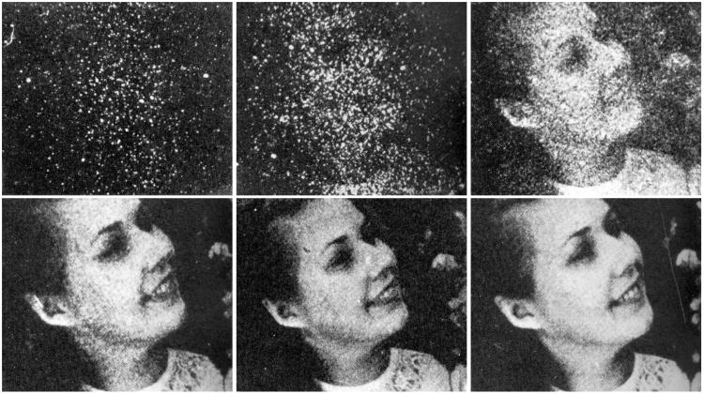

Emission of photons from atoms
When an electron moves from a higher to a lower energy level in an atom, it loses energy which can be released as a photon of electromagnetic energy. Since the energy of a photon = h f, then if an electron transfers from an energy level E1 to a lower energy level E2, the energy of the photon released = h f = E1 – E2.

In this way, the existence of sharp energy levels in atoms gives rise to sharp line spectra of the light they emit.

Back to Student’s Checklist

Electron diffraction
Electron diffraction is the diffraction of a beam of electrons by a regular arrangement of atoms.

Possible paths for electrons being scattered by successive layers of atoms differ in length, and so in the phase of the associated phasor. The phasors for paths going via successive layers of atoms only combine to give a large amplitude in certain directions.

The frequency of rotation of the phasor representing a possible path of a free electron is given by
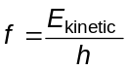
where h is the Planck constant. If the quantum behaviour of a free electron is thought of as associated with a wave motion, the wavelength of the waves is the de Broglie wavelength
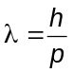
where p is the momentum of the electron.

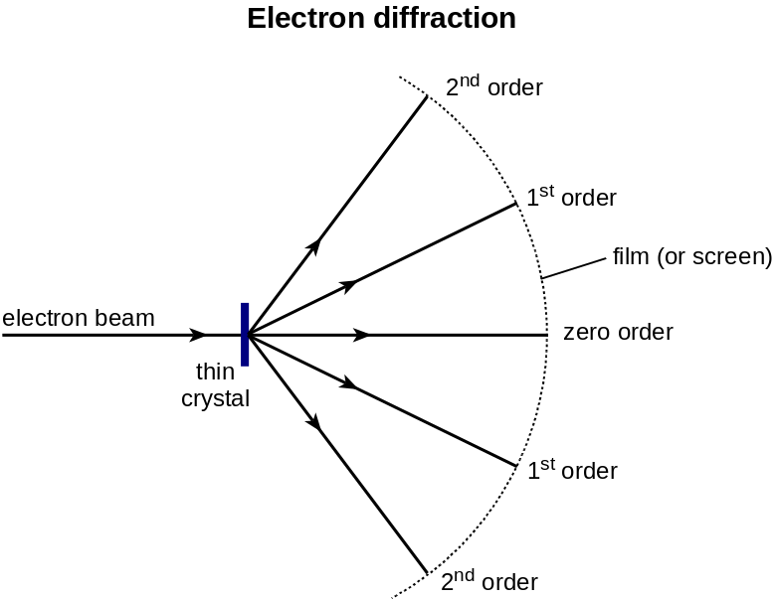

Back to Student’s Checklist

Probability
Probability has to do with uncertainty, with randomness and with quantum effects. Probability is a measure of the chance of one of a number of possible things happening.

Random events, such as the emission of an alpha particle from a radioactive nucleus, are more, or are less, likely to happen. The probability of emission in a short time interval can be estimated from the number of emissions taken over a long period of time.

The probability of the random arrival of a photon at a point in a beam of light is proportional to the intensity of the light. The intensity is proportional to the square of the classical wave amplitude, or in quantum theory, to the square of the resultant phasor amplitude for all possible paths.

Back to Student’s Checklist

Summary Diagrams (OHTs)
Back to list of Contents

A path contributes an arrow

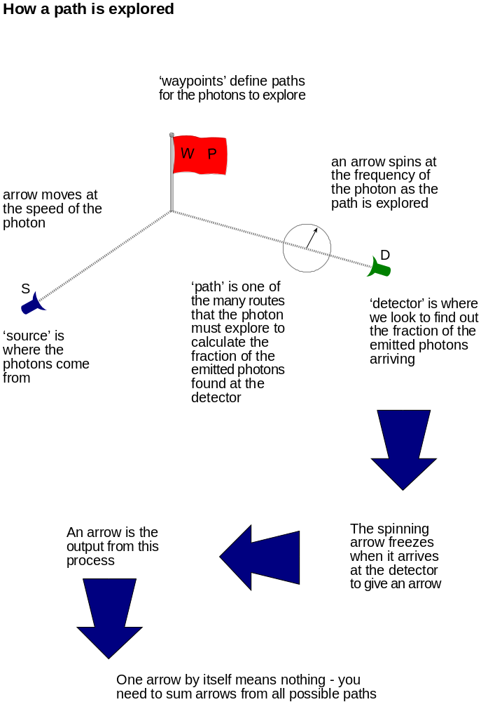

Back to Student’s Checklist

Finding probabilities
Many path arrows can be summed to give an amplitude. The square of the amplitude gives a probability.

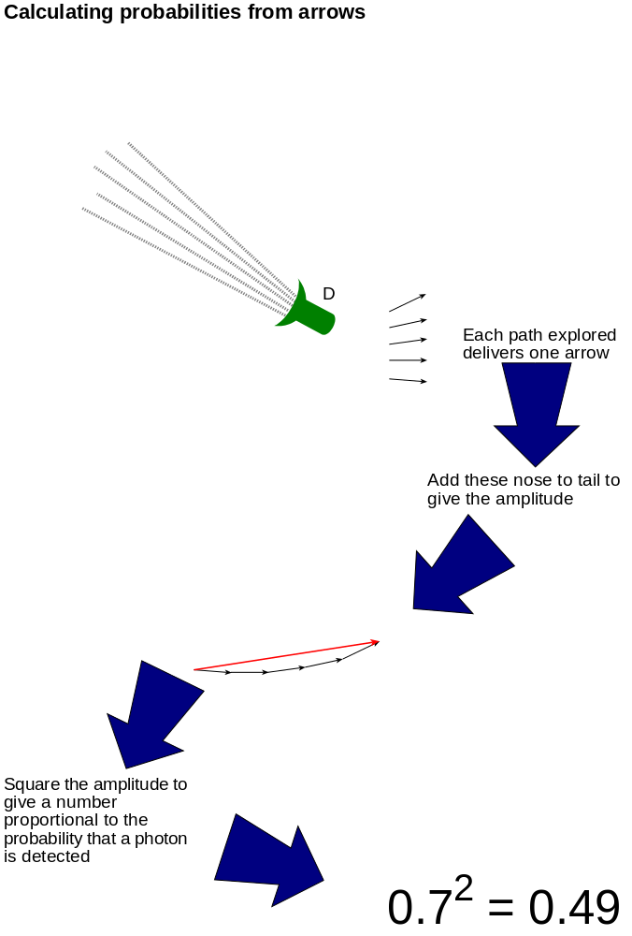

Back to Student’s Checklist

Mirror: contributions from different paths
Phasors for paths near the middle of the mirror line up. Phasors for paths away from the middle curl up.

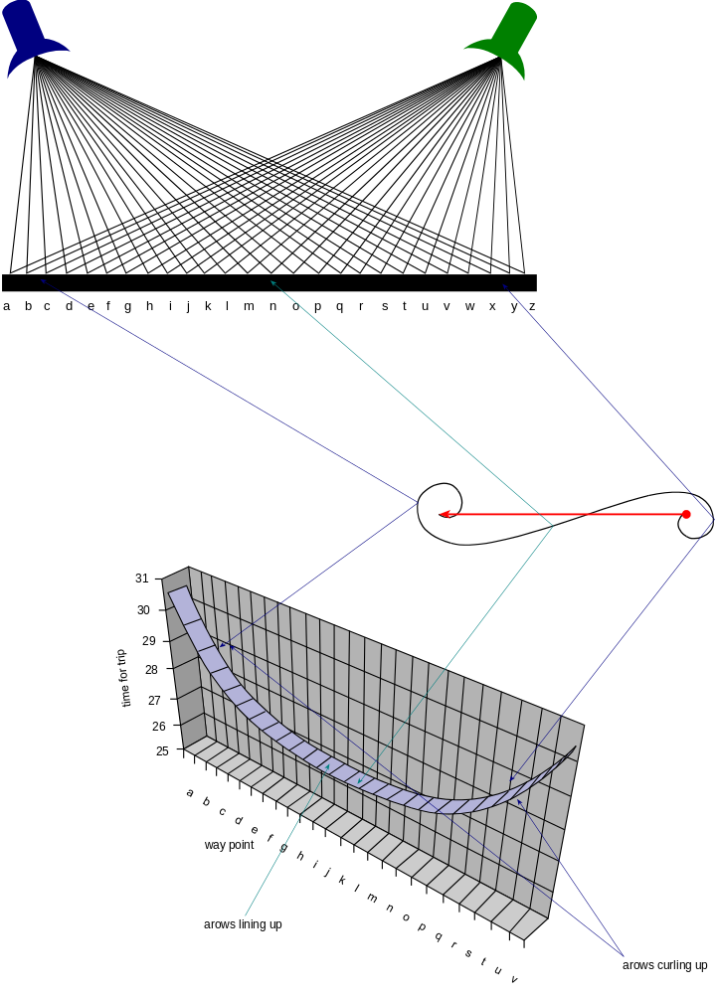

Back to Student’s Checklist

Photons and refraction
Light refracted at a surface takes the path of least time.

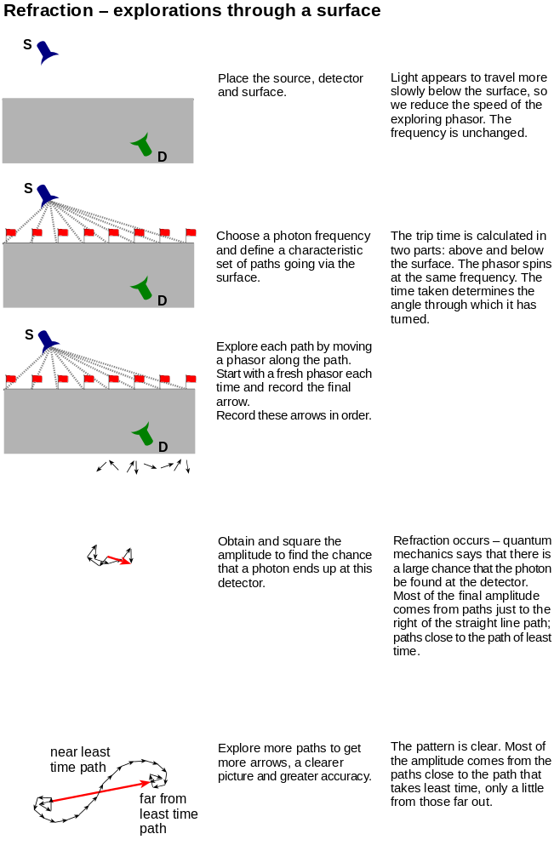

Back to Student’s Checklist

Focusing photons
Curving a mirror shortens paths going via the edges. When all paths to the focus take the same time, photons are very likely to arrive there.

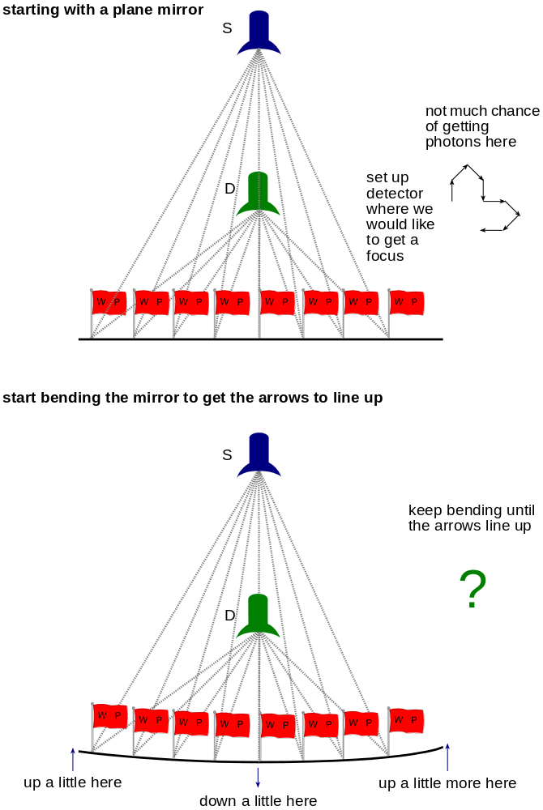

Back to Student’s Checklist

Diffraction of photons

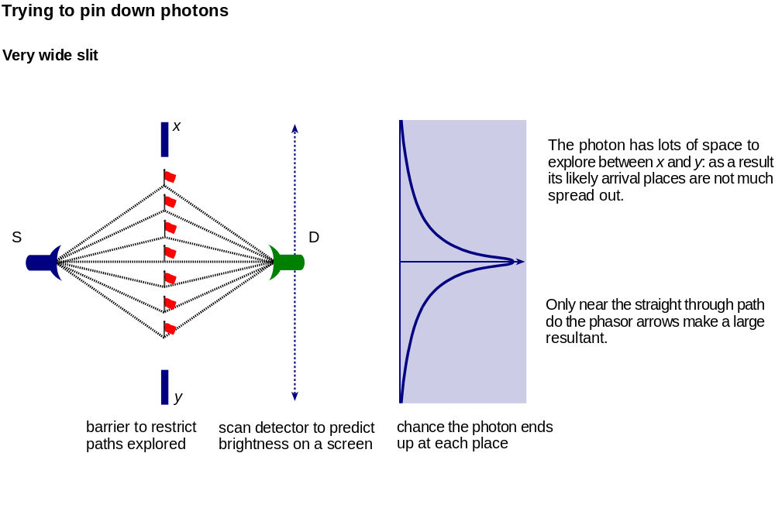

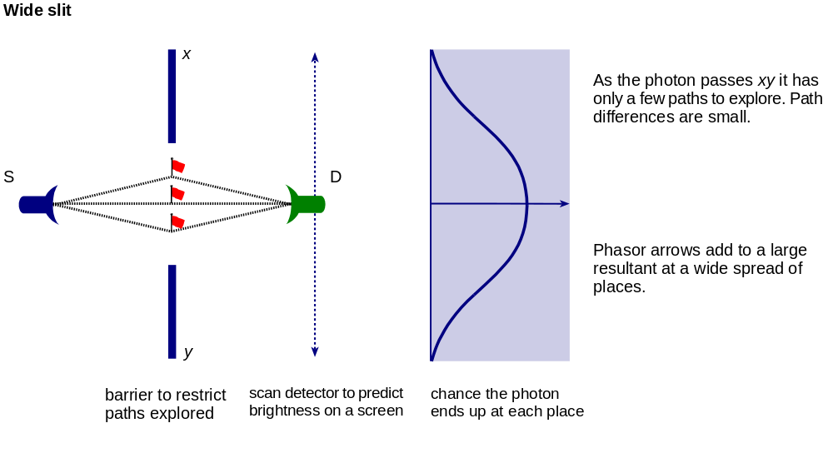

Back to Student’s Checklist

Evidence for photons
Here are three pieces of evidence, each supporting the view that light carries energy in certain sized packets.
Light emitted by LEDs
The frequency of the emitted light is compared with the potential difference needed to emit light of that colour.

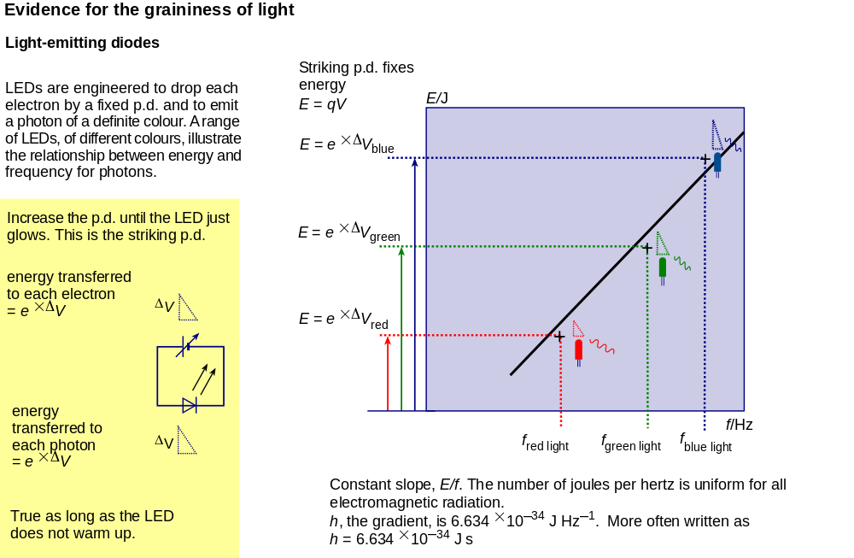

Light ejecting electrons from metals
The frequency of the absorbed light is compared with the potential difference needed to stop electrons emitted from clean metal surfaces.

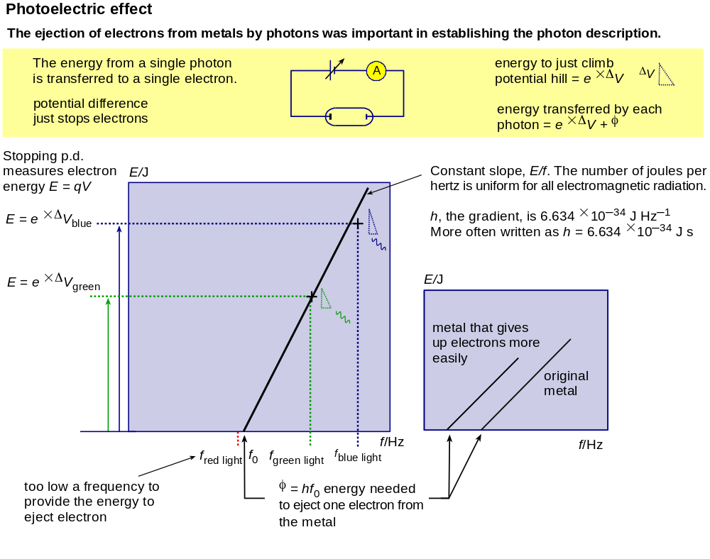

Light emitted or absorbed by atoms
The frequency of the light is compared with the possible energy levels within atoms.

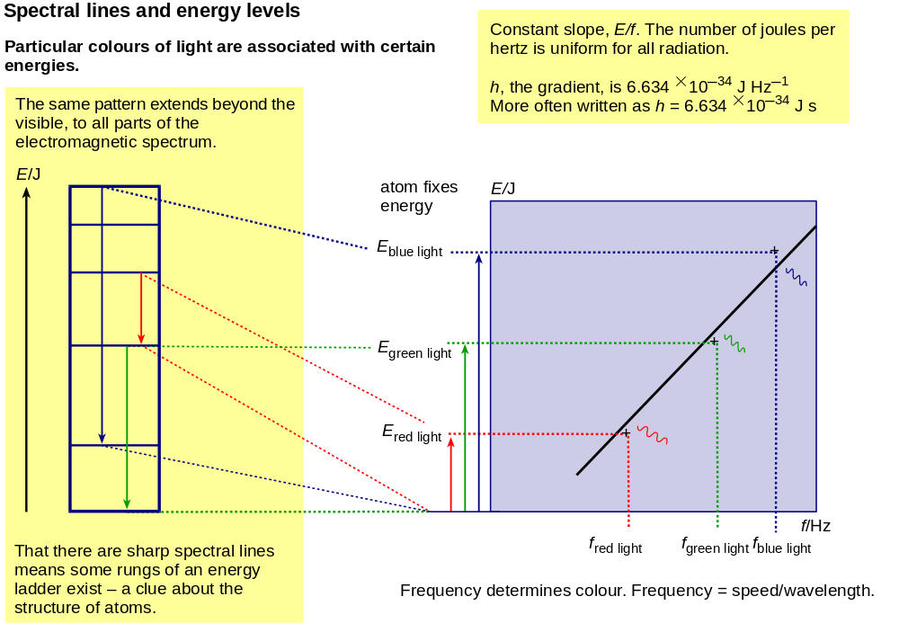

Back to Student’s Checklist

