Revision Guide for Chapter 4
Contents
Student’s Checklist

Revision Notes
Materials: properties and uses 5
Materials selection charts 5
Refraction 8
Total internal reflection 9
Conductors and insulators 10
Semiconductors 11
Mechanical characteristics of materials 11
Stress and strain 12
Stretching and breaking 12
Electrical conductivity and resistivity 14

Summary Diagrams (OHTs)
Refraction: ray and wave points of view 15
The Young modulus 17
Conductivity and resistivity 18
Stress–strain graph for mild steel 19
Range of values of conductivity 20
Student's Checklist
Back to list of Contents

I can show my understanding of effects, ideas and relationships by describing and explaining:
how the optical, electrical and mechanical properties of materials are linked to how they are used

Revision Notes: Materials: properties and uses; Materials selection charts
what refraction is

Revision Notes: Refraction
Summary Diagrams: Refraction: ray and wave points of view
what total internal reflection is, and why it occurs

Revision Notes: Total internal reflection
the differences between metals, semiconductors and insulators

Revision Notes: Conductors and insulators; Semiconductors

I can use the following words and phrases accurately when describing the properties of materials:
Mechanical properties:
stiff, elastic, plastic, ductile, hard, brittle, tough
stress, strain, Young modulus, fracture stress, yield stress

Revision Notes: Mechanical characteristics of materials; Stress and strain; Stretching and breaking
Summary Diagrams: The Young modulus
Optical properties:
refraction, refractive index, total internal reflection, critical angle

Revision Notes: Refraction; Total internal reflection
Summary Diagrams: Refraction: ray and wave points of view
Electrical properties:
resistivity, conductivity

Revision Notes: Electrical conductivity and resistivity
Summary Diagrams: Conductivity and resistivity

I can sketch and interpret:
stress–strain graphs to identify the quantities yield stress, fracture stress, Young modulus, and relate them to how materials are used

Revision Notes: Stretching and breaking
Summary Diagrams: Stress-strain graph
tables and diagrams comparing materials by properties and relating them to how materials are used, e.g. strength–density and stiffness–density diagrams

Revision Notes: Materials selection charts
plots on a logarithmic scale of quantities such as resistivity and conductivity

Summary Diagrams: Values of conductivity

I can calculate:
the refractive index of a material using the equation
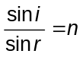
and rearrange the equation to calculate the other quantities

Revision Notes: Refraction
the resistance of a conductor using the equation
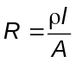
and rearrange the equation to calculate the other quantities

Revision Notes: Electrical conductivity and resistivity
Summary Diagrams: Conductivity and resistivity
the conductance of a conductor using the equations
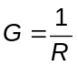
and
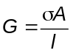
and rearrange the equations to calculate the other quantities

Revision Notes: Electrical conductivity and resistivity
Summary Diagrams: Conductivity and resistivity
tensile stress using the relationship stress = force / area
tensile strain using the relationship strain = extension (or compression) / original length
the Young modulus E using the relationship E = stress / strain

Revision Notes: Stress and strain; Stretching and breaking
Summary Diagrams: The Young modulus;

I can show understanding of and their applications by giving and explaining my own examples of:
how the properties of a material determine how it is used

Revision Notes: Mechanical characteristics of materials; Materials selection charts

Revision Notes
Back to list of Contents

Materials: properties and uses
Here are some examples of how the properties of materials help to decide the choice of material for various uses.

An aeroplane wing must not bend much under load, so must be made of a stiff material. The wing must not break suddenly, so the material must be tough, not brittle. The wing must be light, so the material must not be dense. If the wing surface has to be pressed into shape the material must be malleable. The commonest choice of material for the wings of commercial aircraft is an aluminium alloy, though for certain parts (e.g. the rudder) carbon-fibre reinforced plastic has been used. Cost: civil aircraft normally use cheaper materials than do military aircraft.

The material for spectacle lenses must be transparent, and have a high refractive index so that the lenses need not be too thick and thus heavy. The surface should be hard, so as not to scratch easily. The material needs to be stiff, so that the lenses do not deform, and strong so that they do not break if dropped. The material chosen used to be glass, but increasingly transparent plastic materials are used. It is generally the case that the materials available are brittle, so that spectacle lenses do shatter if they break. The cost of shaping the lenses is much greater than the cost of the raw material.

Long distance electricity cables for the National Grid must be very good conductors of electricity. They must be strong, and not too dense, since the cables have to support their own weight in between pylons. The material must be tough so that the cables will not suddenly fracture. Cost is important because the cables use a lot of material. A common choice is an aluminium core, for lightness and high conductivity, with a steel wire sheath for strength, toughness and cheapness.

The outer sleeve of a cartridge fuse in a domestic electrical power plug must clearly be a very good electrical insulator. It must not melt or char when the fuse inside ‘blows’, so the material needs a high melting point and to be chemically stable. A ceramic material is often chosen. Millions are made and sold, so cost matters. Such ceramic materials are usually stiff and strong, making them equally suitable for the insulators of electricity cables, where they must support the weight of the cables.

Back to Student’s Checklist

Materials selection charts
Materials selection charts are a graphical way of presenting data about properties of materials. Most mechanical properties extend over several orders of magnitude, so logarithmic scales are used. A 2D plot of a pair of properties is used. Below is Young modulus plotted against density. From this chart you can see:
- the range of values typical of materials in a given class (metals, ceramics, polymers etc)
- the values of Young modulus and density for different particular materials.

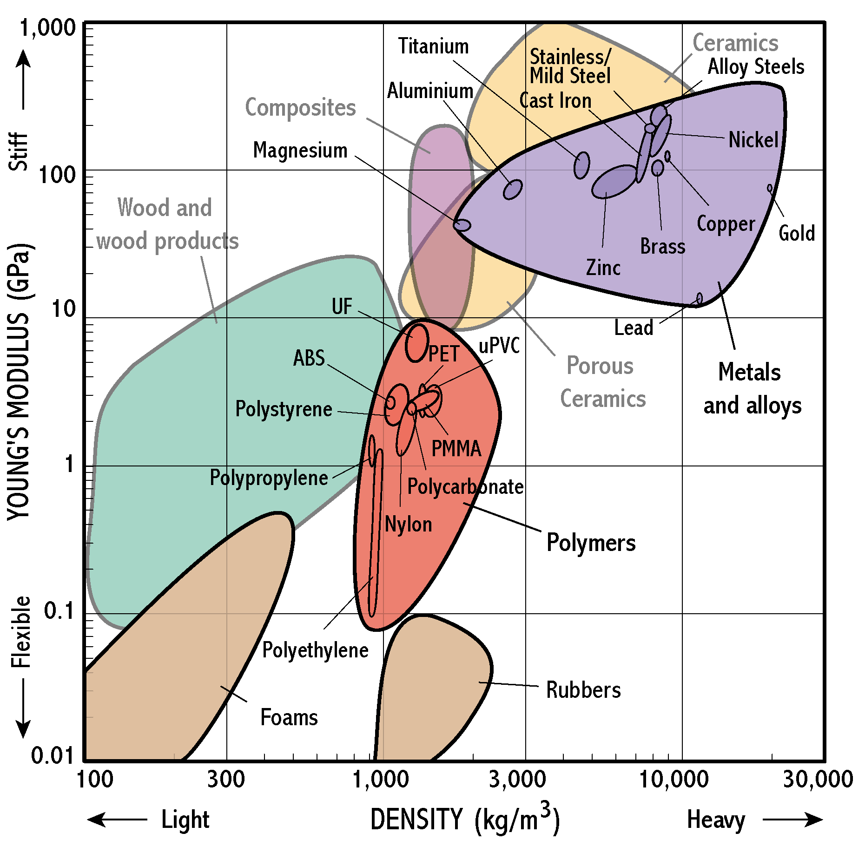

Designers have a challenging task in choosing materials for products, as they usually have to consider many competing objectives and constraints at once – light and stiff, strong and cheap, tough and recyclable (or maybe all of these at once!). Materials selection in design is therefore a matter of assessing trade-offs between several competing requirements.

For example – what materials might be used for a light, stiff bike frame? Notice that most of the metals are stiff, but rather heavy. Strength and toughness also matter. Look at the strength–toughness chart below, with a selection of metals illustrated. Note that in general the toughness of a type of alloy falls as its strength is increased.

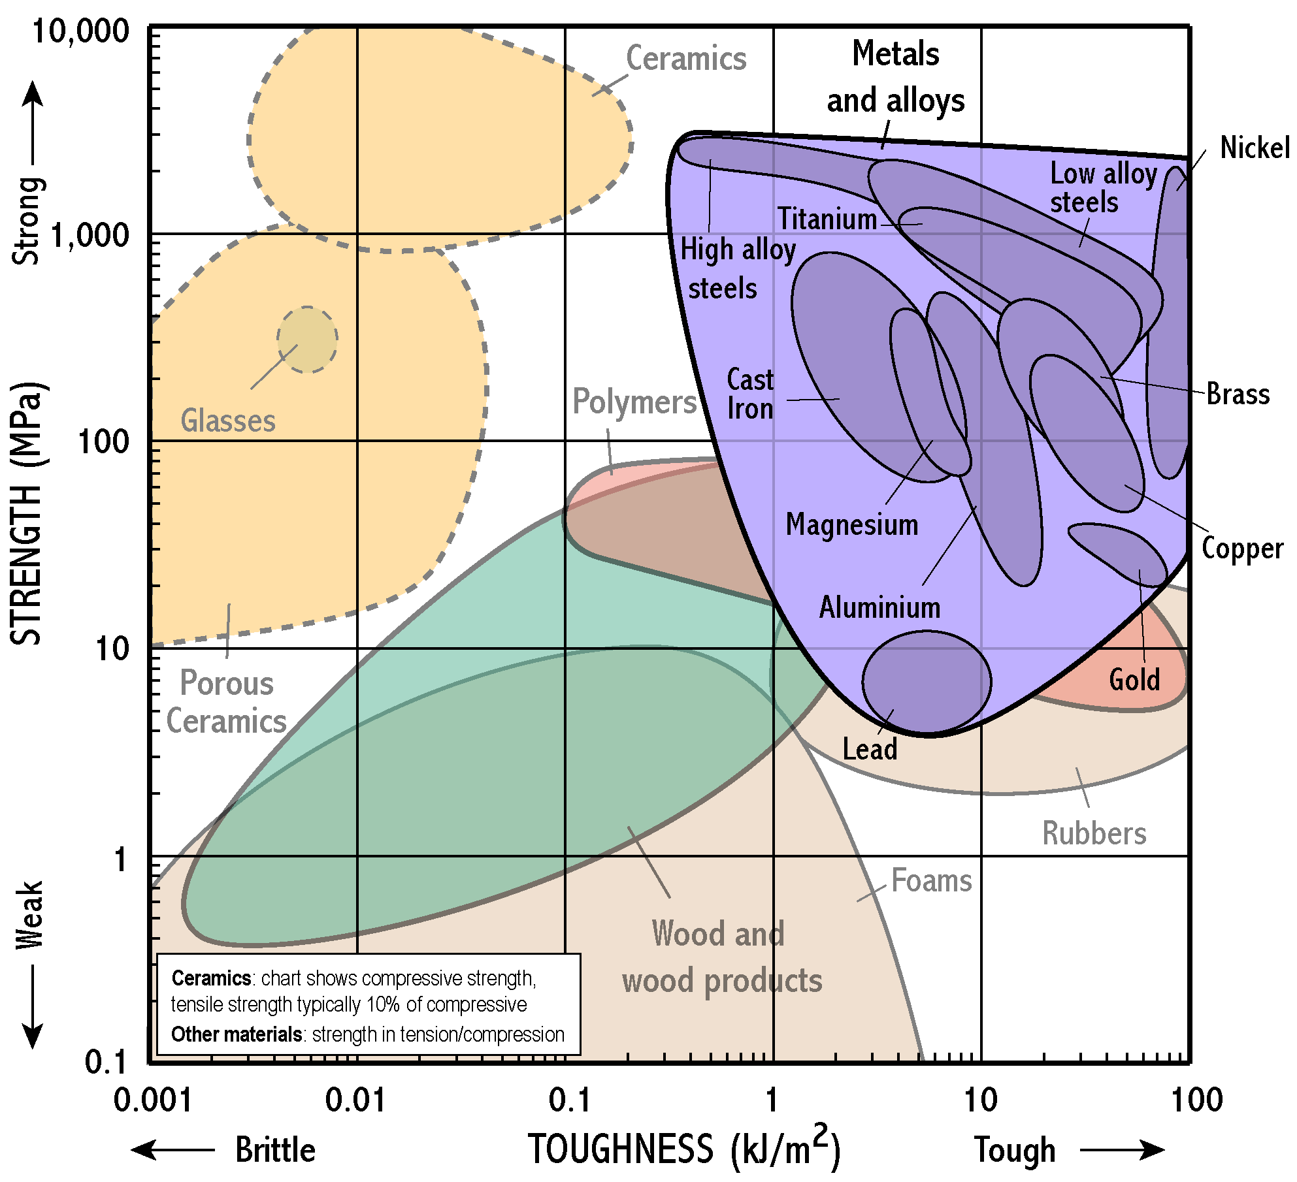

Electrical Properties
The next chart shows electrical resistivity plotted against cost per cubic metre of material. In engineering design, cost is almost always important, so selection charts often show this on one axis.

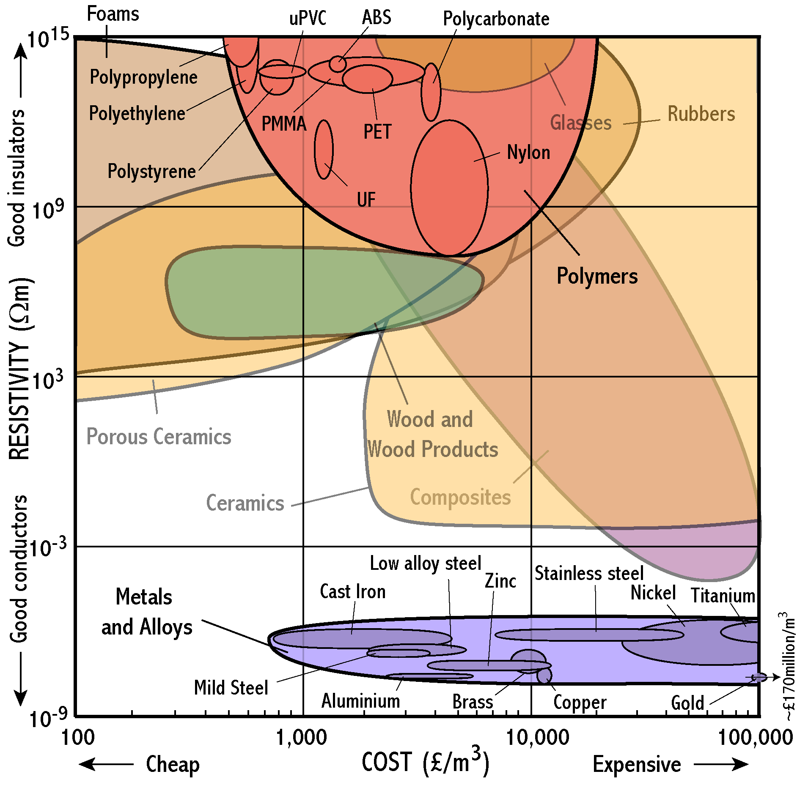

This chart shows that metals have much lower resistivity than almost all other materials. Polymers and ceramics fall at the top of the chart, being insulators. The range of values of resistivity is huge – the diagram covers 24 orders of magnitude. Gold is an excellent conductor, but it is so expensive that it is even off the scale of the chart. Despite this, it is used for electrical contacts in microcircuits.

Back to Student’s Checklist

Refraction
Refraction is the bending of light caused by a change in its speed as light passes from one region to another. If the wave slows down on crossing the boundary, the direction of travel of the wavefront becomes nearer to the normal to the boundary (unless the wave is travelling along the normal). If the wave speeds up on crossing the boundary, either the direction of travel of the wavefront becomes further from the normal or total internal reflection occurs.

Refraction occurs with any kind of wave. For example, waves from the sea may travel more slowly as they enter shallow water near a beach.

For light, the refractive index n = c0 / c, where c0 is the wave speed in a vacuum and c is the wave speed in the substance. Refractive index is a pure ratio and has no units. The speed of light in a vacuum is greater than the speed of light in any transparent substance so the refractive index is greater than 1.

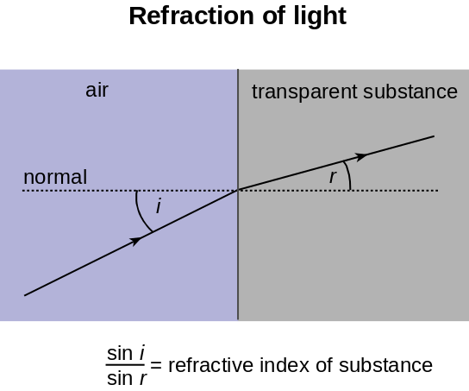

Snell's law of refraction states that sin i / sin r = constant, where i is the angle between the incident direction and the normal, and r is the angle between the refracted direction and the normal. The constant is equal to the ratio of the incident wave speed ci to the wave speed cr in the refracting medium. It is called the refractive index.
Relationships
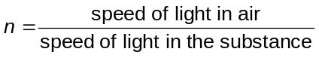
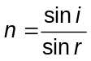

Back to Student’s Checklist

Total internal reflection
Total internal reflection is when a wave is reflected totally at a boundary between two substances.

Total internal reflection can occur if the speed of the incident wave in the first medium is less than the speed of the refracted wave in the second medium.

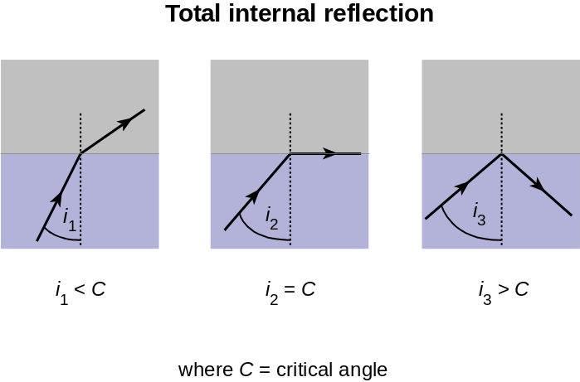

If the angle of incidence is less than the critical angle C, the wave is refracted away from the normal. If the angle of incidence exceeds C, the wave is totally internally reflected. The critical angle is the angle of incidence for which the angle of refraction is 90º.

Applications of total internal reflection include thick optical fibres used in medicine. Total internal reflection of light occurs in the optical fibre every time a light ray inside the fibre reaches the boundary, provided the fibre is not bent too much.
Relationships
In general, Snell’s law may be written:
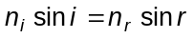
Thus if i = C and r = 90º then since sin 90º = 1
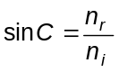 or 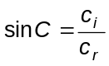,
where ci is the speed of the incident wave in the first medium and cr is the speed of the refracted wave in the second medium.
For light passing into air from a refractive medium of refractive index n, the equation for the critical angle is simply:
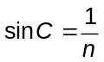

Back to Student’s Checklist

Conductors and insulators
A conductor is any object that easily allows an electric current through it when it is in a circuit.

Materials can be grouped into conductors or insulators, or in-between as semiconductors, as indicated in the table below:

Classification | Conductivity / S m–1 | Resistivity / Ω m | Carrier density / m3 | Example
Conductor | About 106 or more | About 10–6 or less | About 1025 or more | Any metal, graphite
Insulator | About 10–6 or less | About 106 or more | Less than 1010 | Polythene
Semiconductor at room temperature | About 103 | About 10–3 | About 1020 | Silicon, germanium

Metals are generally very good conductors.

An electrical insulator is a very poor conductor of electricity.

The resistivity of an insulator is of the order of a million million times greater than that of a metal. Insulators such as polythene and nylon are used to insulate wires and metal terminals in electrical fittings and appliances.

Back to Student’s Checklist

Semiconductors
Semiconductors are used to make a wide range of electronic devices including electronic chips, light-emitting diodes and solid state lasers.

Semiconductors have conductivities in between the very high conductivity of metals and the very low conductivities of insulators. There are various types of semiconductor, including metal oxides as well as elements like silicon and germanium.

In insulators, essentially all the electrons are tightly bound to atoms or ions, and none are free to move under an external electric field. In effect, these materials do not conduct electricity at all. In metallic conductors, essentially all the atoms are ionised, providing free electrons which can move freely through the ions.

Semiconductors differ from both insulators and metallic conductors. Only a small proportion of atoms are ionised, so that conduction electrons are relatively few in number. Thus a semiconductor does conduct, but not well. The conductivity is increased and controlled by ‘doping’ with traces of other elements.

Back to Student’s Checklist

Mechanical characteristics of materials
The mechanical characteristics of a material have to do with its behaviour when subjected to forces which try to stretch, compress, bend or twist it.

The mechanical characteristics of a material include its stiffness, its strength, its flexibility or brittleness and its toughness. Other characteristics include its density, whether or not it is elastic or plastic and whether or not it is ductile and malleable.

A material is:
dense if it has a large mass per unit volume. Solid materials vary in density mainly because elements have different atomic masses. Lead is much more dense than aluminium, mainly because lead atoms are much heavier than aluminium atoms.
stiff if it is difficult to stretch or bend the material (e.g. a metal sheet is stiffer than a polythene sheet of the same dimensions). The stiffness is indicated by the Young modulus.
hard if it is difficult to dent the surface of the material (e.g. a steel knife is much harder than a plastic knife). Hardness is tested by machines that indent the surface. Many ceramics are very hard.
brittle if it breaks by snapping cleanly. The brittleness of glass is a consequence of defects such as fine surface cracks, which propagate easily through the material.
tough if the material does not break by snapping cleanly. A tough material is resistant to the propagation of cracks. Toughness is the opposite of brittleness. Metals are tough, and break by plastic flow. There is no one simple measure of toughness, but a tough material will dissipate a large amount of energy per unit area of new fracture surface.
elastic if it regains its shape after stretching (e.g. a rubber band regains its original length when released). When a metal or ceramic stretches elastically, the bonds between neighbouring atoms extend very slightly. In a polymer the atoms rotate about their bonds.
plastic if it undergoes large permanent stretching or distortion before it breaks (e.g. a polythene strip stretches permanently if pulled).
ductile if it is easy to draw a material into a wire (e.g. copper is easier to draw into a wire than tungsten). Metals are ductile because the non-directional metallic bonds allow ions to slide past one another.
malleable if it is easy it is to hammer or press a sheet of material into a required shape (e.g. a lead sheet is easier to fit on a roof than a steel sheet).

Back to Student’s Checklist

Stress and strain
Tensile stress and compressive stress are the force per unit area acting at right angles to a surface.

Tensile strain is the change of length per unit length. Strain is a ratio of two lengths and therefore has no unit.

The SI unit of stress is the pascal (Pa), equal to 1 N m–2.

If the solid is a bar of uniform cross-sectional area made from a single material, the stress at any point is the same, equal to the applied force divided by the area of cross section. If the cross section of the solid is non-uniform, the stress is greatest where the area of cross section is least.

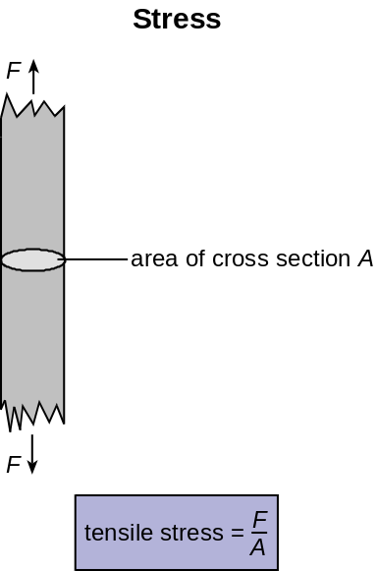

Back to Student’s Checklist

Stretching and breaking
The (engineering) breaking stress of a material = F / A where F is the force needed to break the material by stretching it and A is the initial area of cross section of the material. The actual stress in the material at this point will usually be rather larger, since the area of cross section will be somewhat reduced.
The Young modulus E of a material = tensile stress / tensile strain provided the limit of elasticity of the material is not exceeded.

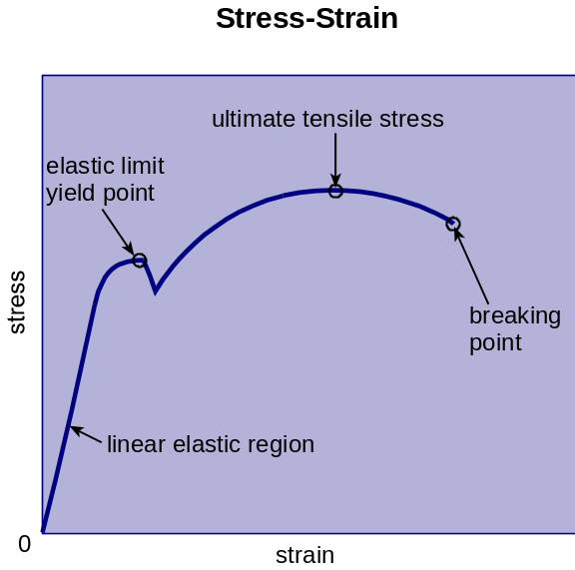

A graph of stress against strain for a metal has these features:
- Strain is proportional to stress, up to a limit. This is the initial straight section of the graph. In this part of the graph, the ratio stress / strain is constant and equal to the Young modulus of the material. Here the material behaves elastically.
- The elastic limit is the point beyond which a material does not regain its initial shape when the tension is removed. It is also called the yield point.
- When a material is stretched beyond its elastic limit, and is stretched beyond the yield point, it behaves plastically, suffering permanent deformation. The yield stress is the stress at the yield point.
- As the tension is increased beyond the yield point, the strain increases and a neck forms. Further stretching causes the stress to concentrate at the neck until it breaks. The (engineering) breaking stress is equal to F / A where F is the force needed to break the material by stretching it and A is the initial area of cross section of the material. The breaking stress is also called the tensile strength of the material.

The fracture energy required to break a material can be defined in several ways. One is the energy needed to create the extra fractured surface area.
Relationships
Consider a length l of material of uniform cross-sectional area A. When under tension T , the material extends to a length l + e, where e is the extension of the material.
- The tensile stress in the material = F / A where F is the tension and A the area of cross section.
The SI unit of tensile stress is the pascal (Pa) which is equal to 1 N m–2.
- The strain in the material = e / l, where e is the extension and l the initial length.
- The Young modulus of elasticity E of a material is equal to tensile stress / tensile strain
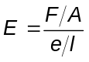
The SI unit of E is the pascal (Pa) which is equal to 1 N m–2.

Back to Student’s Checklist

Electrical conductivity and resistivity
The conductivity measures how easily a material conducts electricity.

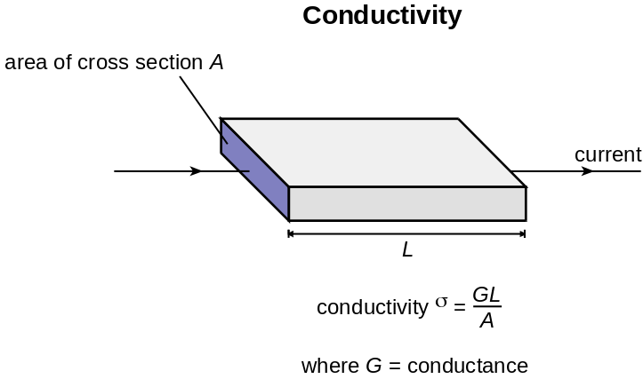

For a conductor of uniform cross-sectional area A and length l, the conductance G is:
The conductivity σ of the material can be calculated from the measured conductance G using:
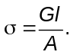
The SI unit of conductivity is the siemens per metre (S m–1). The siemens is the same as the reciprocal of the ohm (i.e. Ω–1).

The conductivity of a material depends on the number of charge carriers per unit volume in the material and also on how free those charge carriers are to move.

The resistivity ρ can be calculated from the resistance of a sample, and the length and cross-sectional area of the sample using:
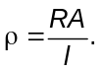
The SI unit of resistivity is the ohm metre (Ω m). Conductivity and resistivity are each the reciprocal of the other:

Summary of relationships

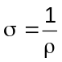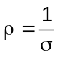
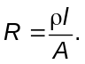

Back to Student’s Checklist

Summary Diagrams (OHTs)
Back to list of Contents

Refraction: ray and wave points of view
These diagrams show refraction from the ray point of view and from the wave point of view.

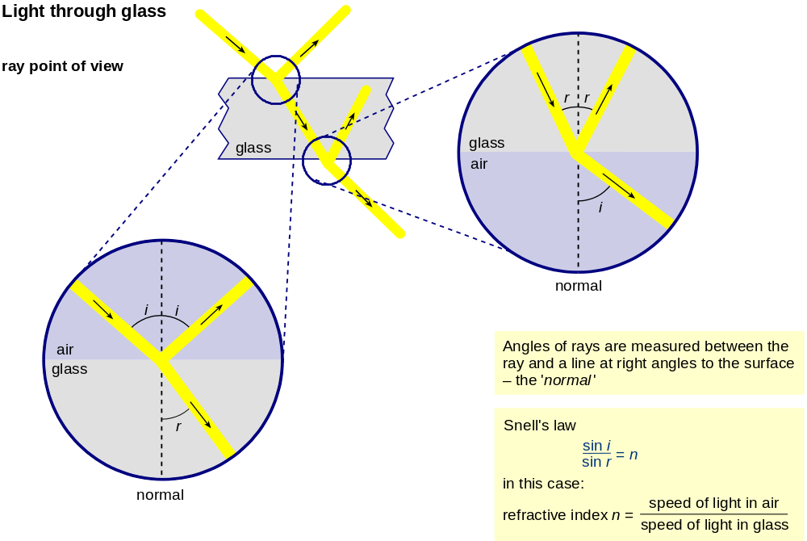

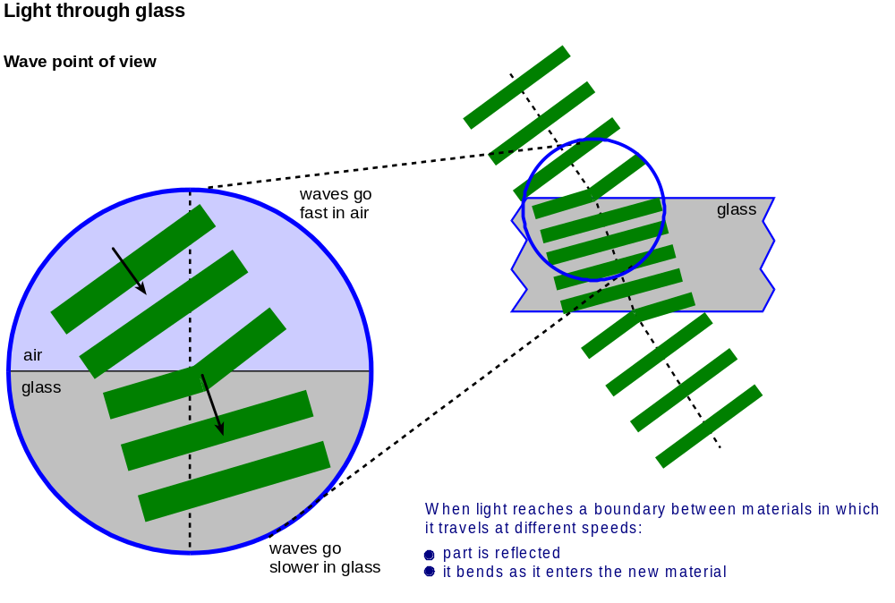

Back to Student’s Checklist

The Young modulus
The Young modulus tells you how a material behaves under stress.

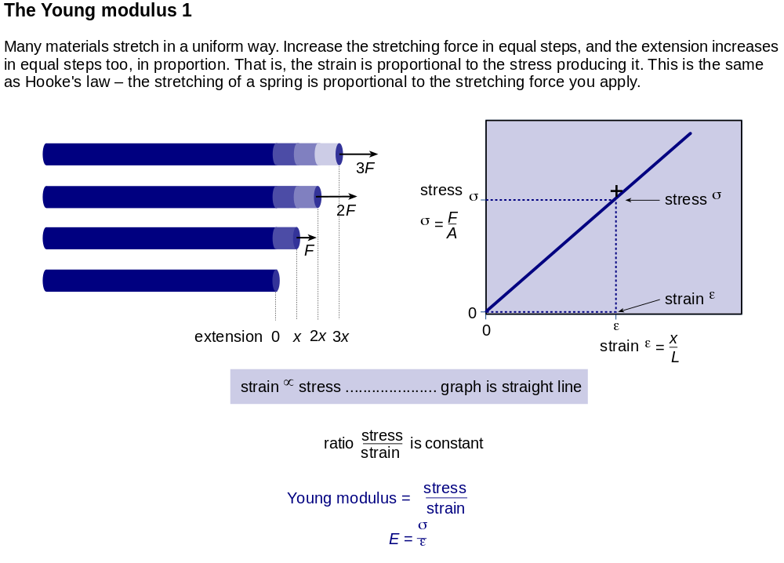

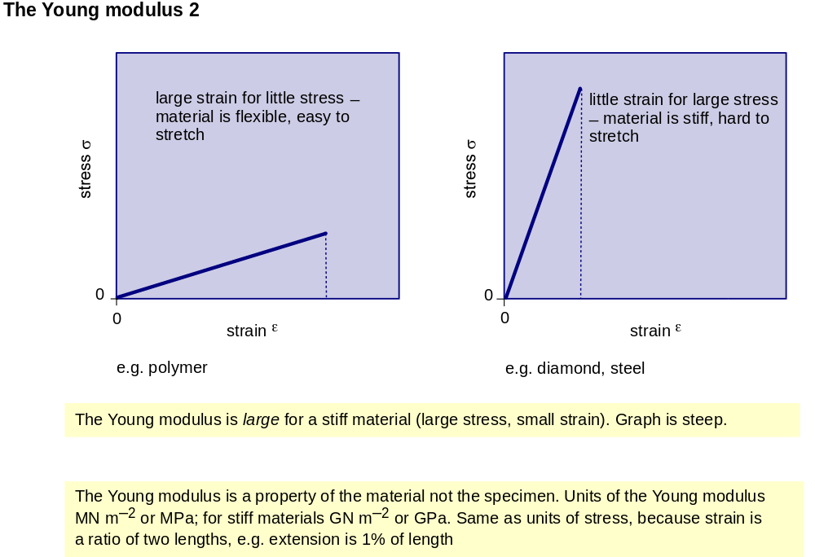

Back to Student’s Checklist

Conductivity and resistivity
These diagrams show the relationships between conductance and resistance for samples of different sizes, and how to calculate them from the conductivity or resistivity.

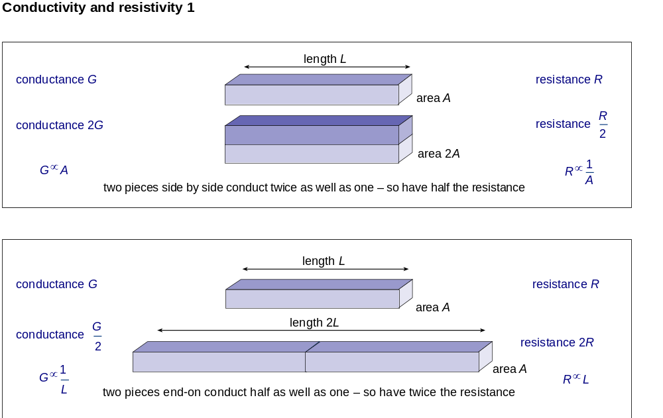

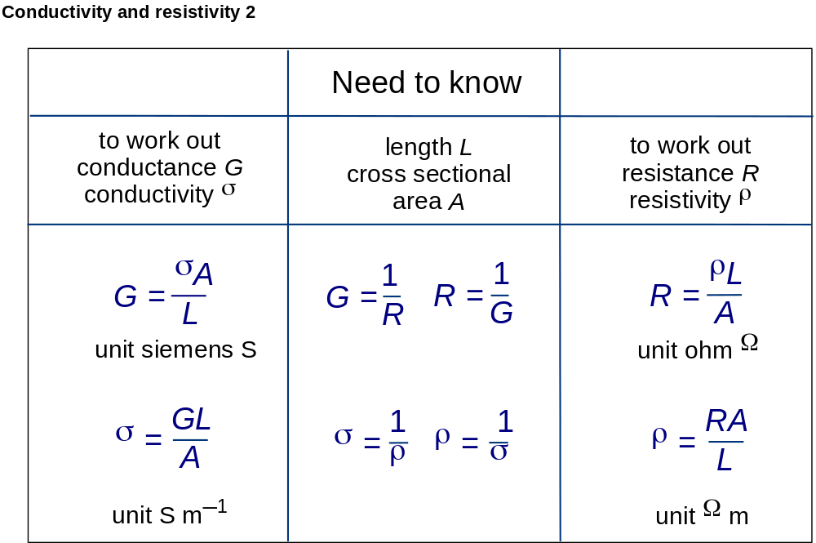

Back to Student’s Checklist

Stress–strain graph for mild steel
The graph shows how the behaviour of mild steel changes as the stress increases.

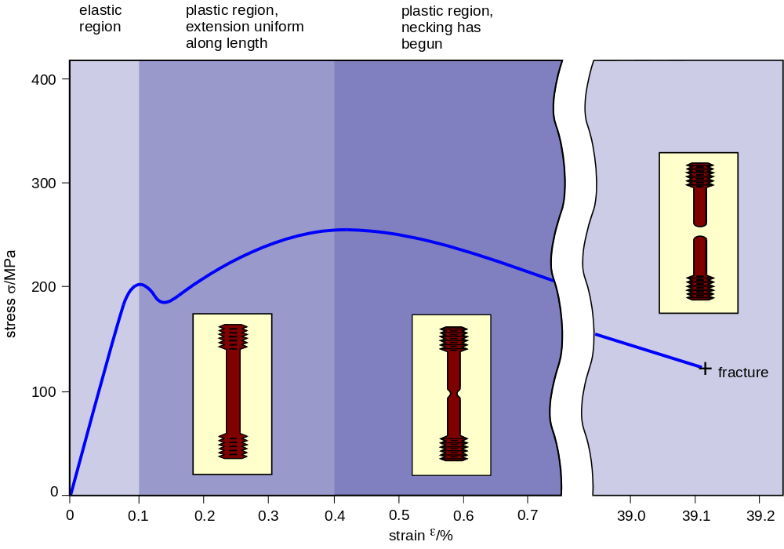

Back to Student’s Checklist

Range of values of conductivity
The conductivity of the best conductor shown below (silver) is 1024 times greater than the conductivity of the best insulator (polystyrene).

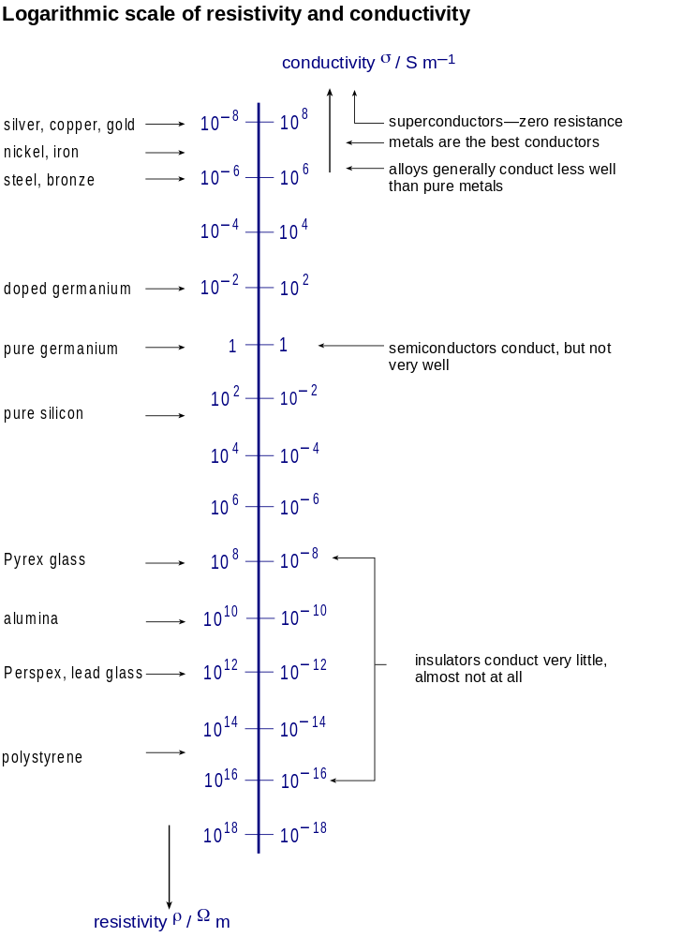

Back to Student’s Checklist

