Sample Examination Questions
Contents
NB. Material covered by the AS papers may also appear in A2 papers.

Question number | Question type  (section A or B) | Question focus
1 | A | Ideal transformer
2 | A | Induced EMF
3 | A | Magnetic flux linkage
4 | A | Units for magnetic quantities
5 | A | Dynamo
6 | B | Motor
7 | A | Electric field and potential
8 | A | Force on a moving electric charge due to a magnetic field
9 | A | Electric potential
10 | A | Electric field of a charge
11 | B | Force on a moving electric charge due to a magnetic field
12 | B | Force on a charge in an electric field
13 | A | Kinetic and potential energy of a scattered particle
14 | A | Discrete energy levels in atoms
15 | B | Structure of the nucleus
16 | B | Discrete energy levels
17 | A | Decay of a nucleus
18 | A | Decay of a nucleus
19 | A | Risk
20 | A | Energy change from a nuclear transformation
21 | B | Energy change from a nuclear transformation
22 | B | Activity; absorbed dose; dose equivalent
23 | Synoptic Paper B | Motor
24 | Synoptic Paper A | Motor
25 | Synoptic Paper A | Electric field and potential
26 | Synoptic Paper B | Force on a moving electric charge due to a magnetic field; ionising radiation
27 | Synoptic Paper B | Transformation of nuclei; radioactive decay; absorbed dose

- Fig. 1.1 shows the construction of a commercial transformer.

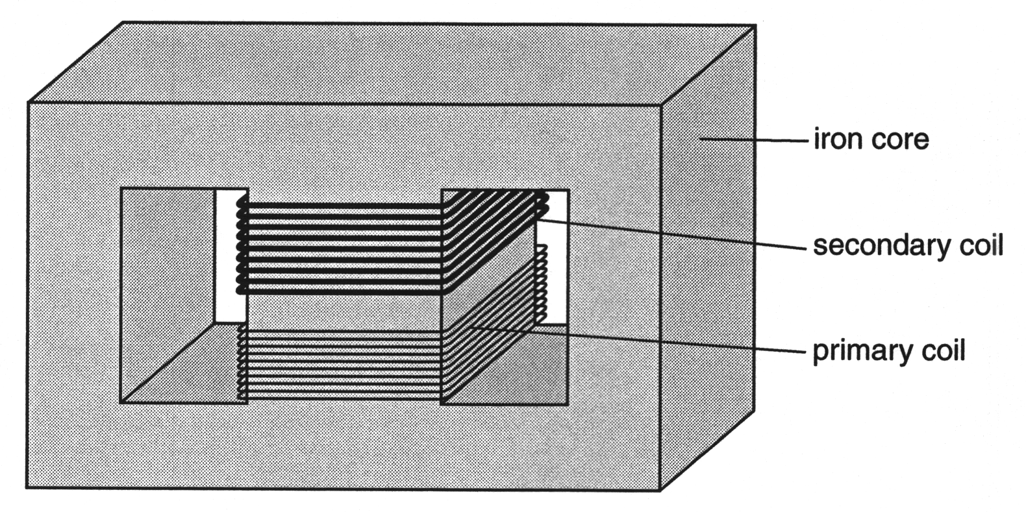

Fig. 1.1

- Here are some facts about the construction of the transformer.
A Both coils are wound on the same part of the core.
B The wire in the secondary coil is thicker than the wire in the primary coil.
C The iron core is made from thin sheets.
Which one of these facts ensures that the rate of change of magnetic flux in the primary coil is equal to that in the secondary coil?

answer ................................. [1]

- The primary coil of the transformer has 1000 turns and the secondary coil has 200 turns. The primary coil is connected to a 400 V, 50 Hz supply.
Calculate the voltage across the secondary coil, and state its frequency.

voltage = ............................... V
frequency =.............................. Hz
[3]

- The magnetic flux linkage of a coil of wire increases steadily by 90 mWb in a time of 450 µs.

(a) Show that the rate of change of magnetic flux linkage is 200 Wb s^{–1}.

(b) State the emf induced across the coil by the rate of change of magnetic flux linkage.

emf = ...................... V [3]

- An iron rod has 400 turns of wire coiled around it. There is a current in the coil. The rod has a cross-sectional area of 1.25 x 10^{–5} m².

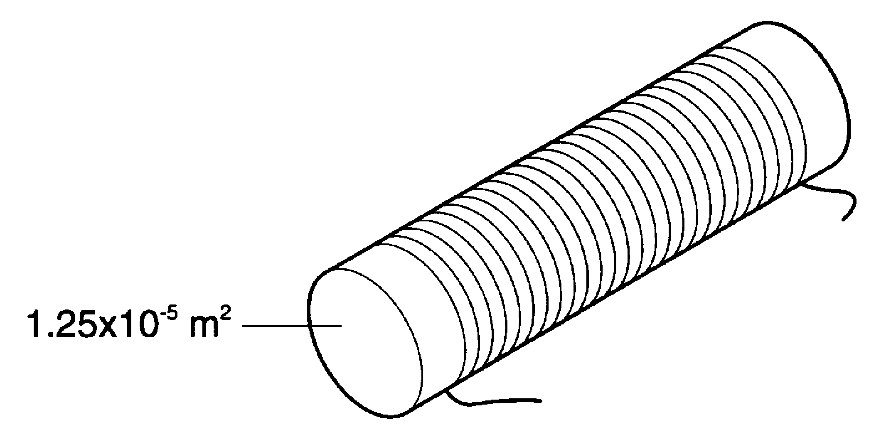

The flux linkage of the coil is 4.0 x 10^{–4} Wb.

- Calculate the flux linking one turn of the coil.

flux = .................... Wb [1]

- Calculate the flux density in the iron.

flux density =.................... T [2]

- Here is a list of units.

ampere (A)
tesla (T)
volt (V)
weber (Wb)

Which unit from the list is the correct choice for

(a) magnetic flux, ......................

(b) magnetic flux density, ......................

(c) rate of change of magnetic flux linkage? ......................
[3]

- Fig. 5.1 shows a simple dynamo.

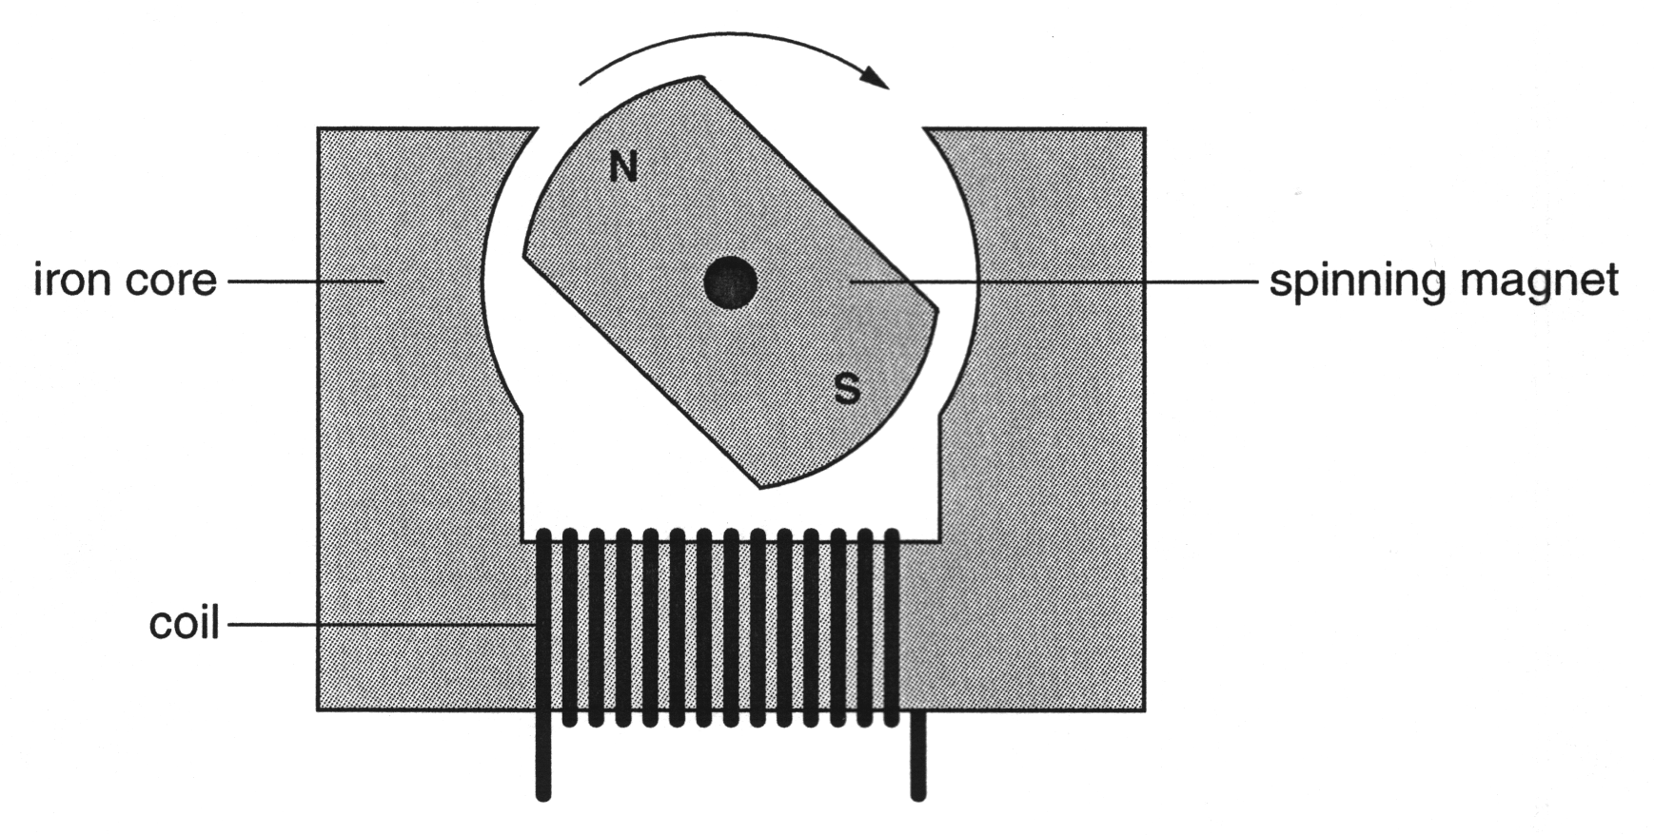

Fig. 5.1

When the magnet is rotated, the emf induced across the coil is 4 V at 10 Hz.
The magnet is now rotated twice as fast.
Which of the following is the new emf induced across the coil?
A 8 V at 10 Hz
B 4 V at 20 Hz
C 8 V at 20 Hz

answer ....................... [1]

- This question is about an induction motor. Part of the induction motor is shown in Fig. 6.1.
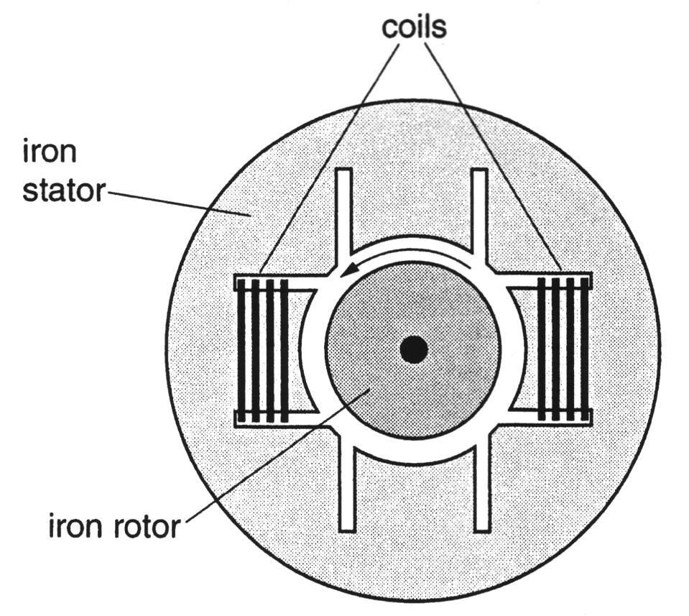

Fig. 6.1

- One pair of coils is shown in Fig. 6.1. At one instant, there is a current in these coils. This current produces a horizontal magnetic field of strength B_{H} in the rotor. (NB: by ‘horizontal’ the question means ‘in the plane of the page and parallel to the top edge’.) On Fig. 6.1, sketch one complete line of flux in the motor due to this current.
[1]

- In fact, the motor has two pairs of coils, as shown in Fig. 6.2.
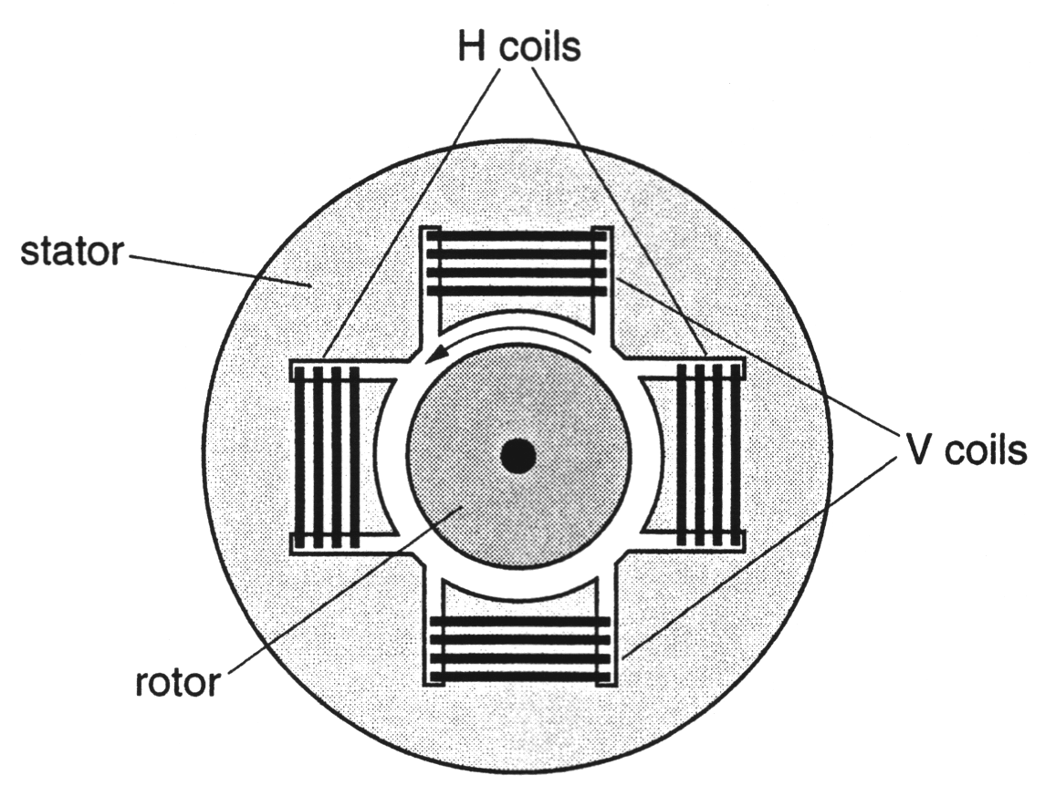

Fig. 6.2

The pair of coils labelled H produce a horizontal magnetic field through the rotor. The pair of coils labelled V produce a vertical magnetic field through the rotor. There is an alternating current in each pair of coils, but there is a phase difference between these currents. This results in horizontal and vertical magnetic fields, B_{H} and B_{V} respectively which vary with time, as shown in Fig. 6.3. (NB: by ‘vertical’ the question means ‘in the plane of the paper parallel to the long side edges.)
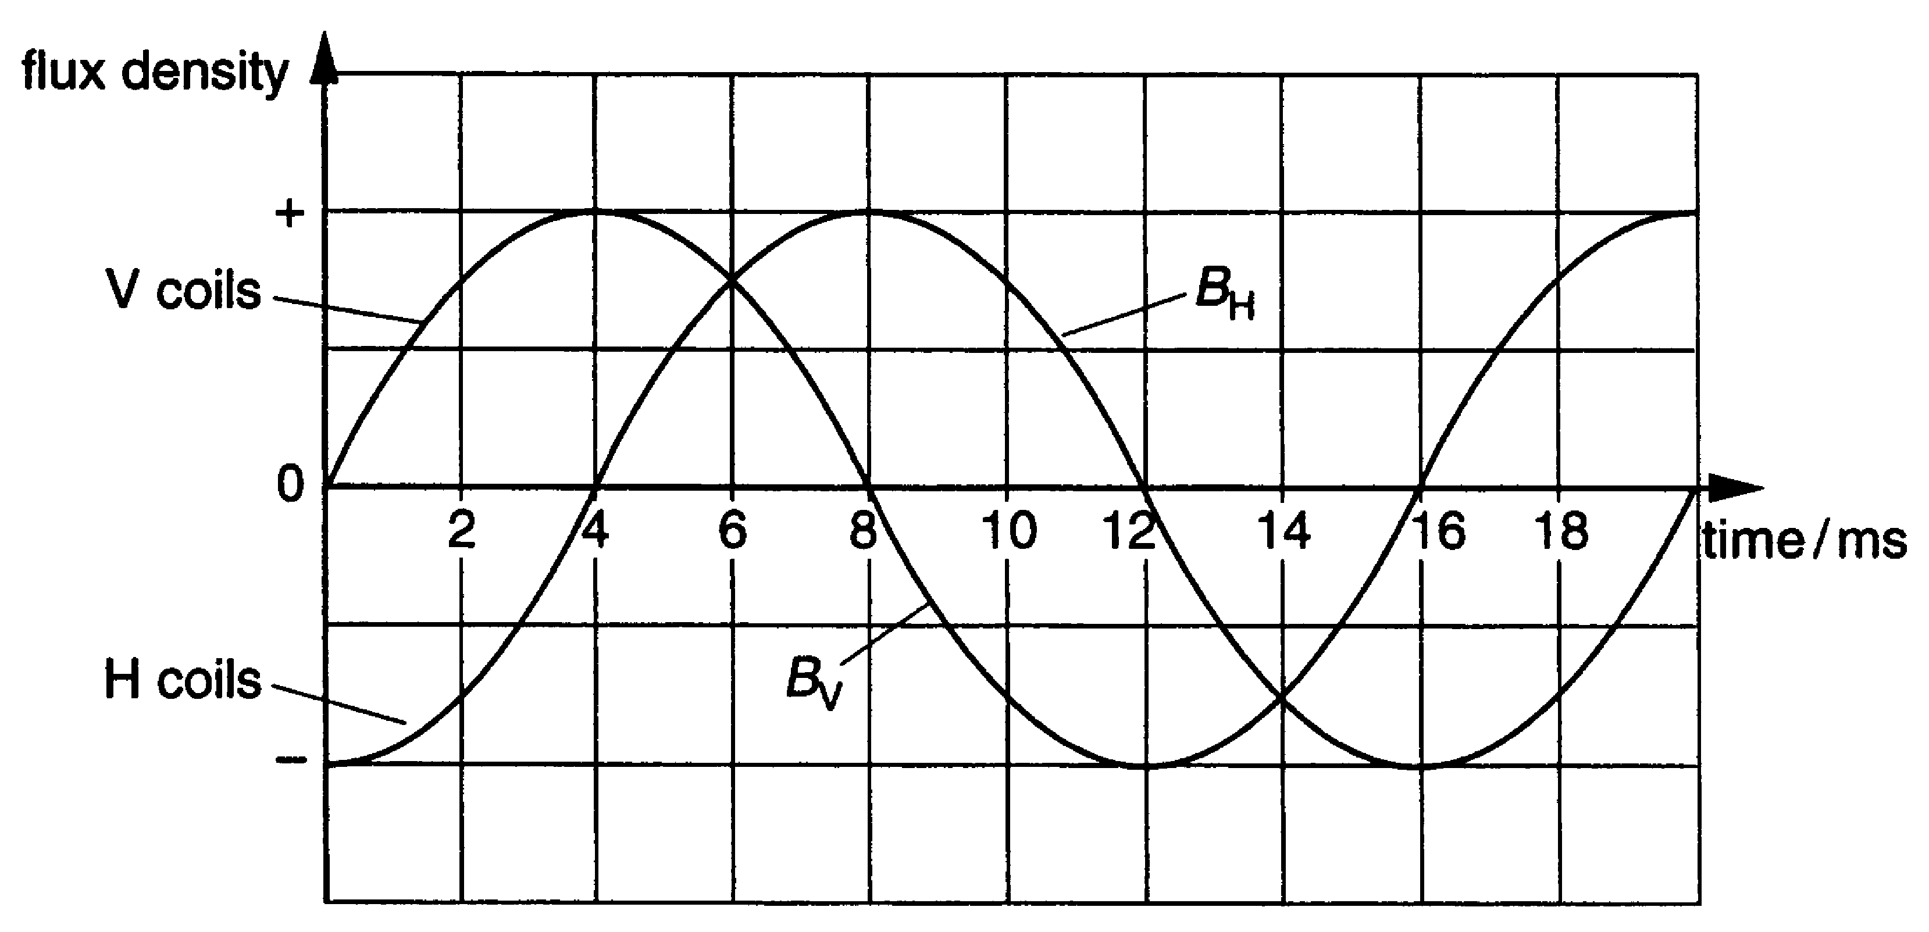

Fig. 6.3

- State the phase difference between the horizontal, B_{H}, and the vertical, B_{V}, magnetic fields.
phase difference = ....................... [1]

- The magnitude and direction of the horizontal and vertical magnetic fields through the rotor, at any instant, can be represented by vectors.
These two vectors at times of 5 ms, 6 ms, 9 ms and 10 ms are shown below.

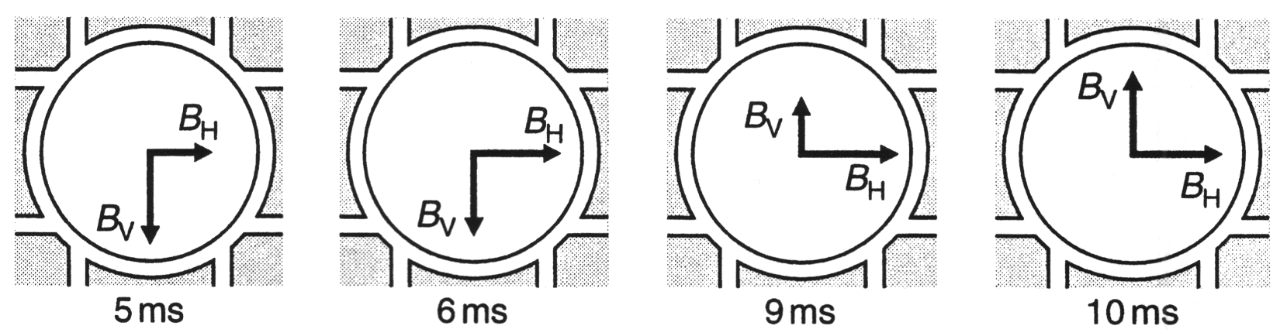

Complete each vector diagram to show the magnitude and direction of the resultant magnetic field at that instant.
[1]

- Describe how the direction of the resultant magnetic field changes with time.

[1]
- The rotor, as shown in Fig. 6.2, rotates continuously in an anticlockwise direction, as the alternating currents change.
Explain why this is so.

[3]
[Total: 7]

- The graph shows the variation of electric potential V with distance x from a charged particle.

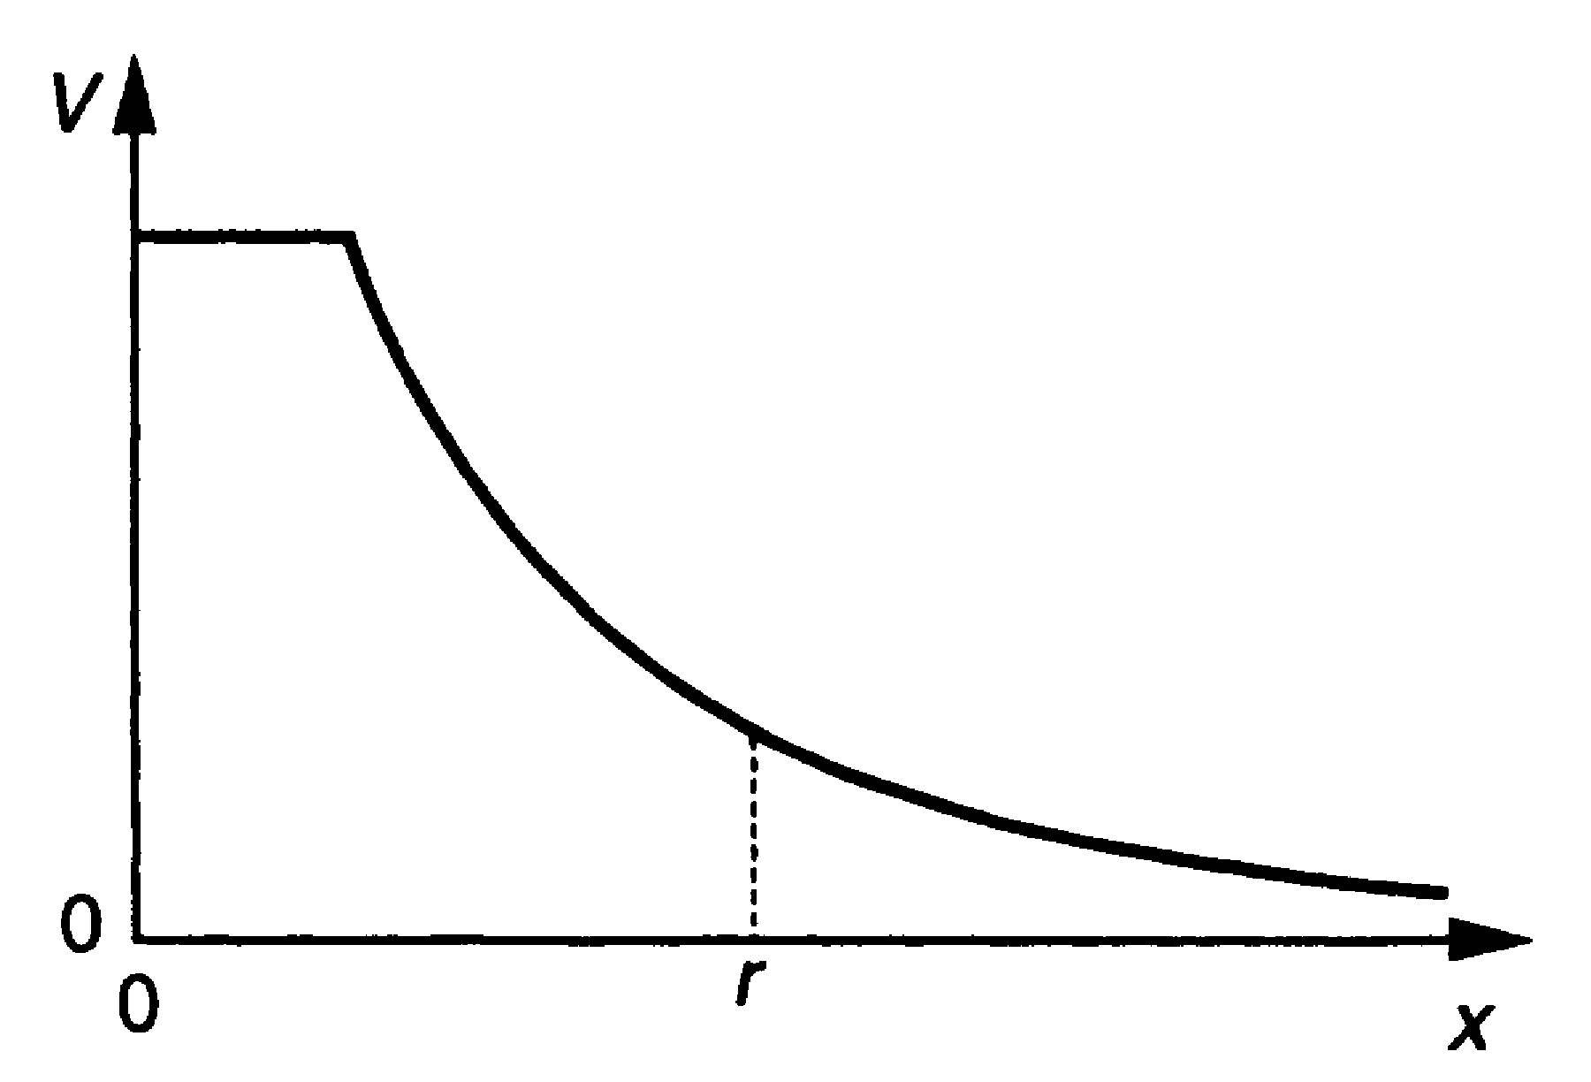

State the feature of the graph which could be used to calculate the magnitude of the electric field E at distance r.

[1]

- An alpha particle moving at 1.5 x 10⁷ m s^{–1} enters a magnetic field. The field has a strength of 0.25 T at right angles to the velocity of the alpha particle.
Calculate the force on the alpha particle in the field.
charge on alpha particle = 3.2 x 10^{–19} C

force = ....................... N [2]

- The graphs show how the electrical potential V around an object depends on the distance d from its centre.

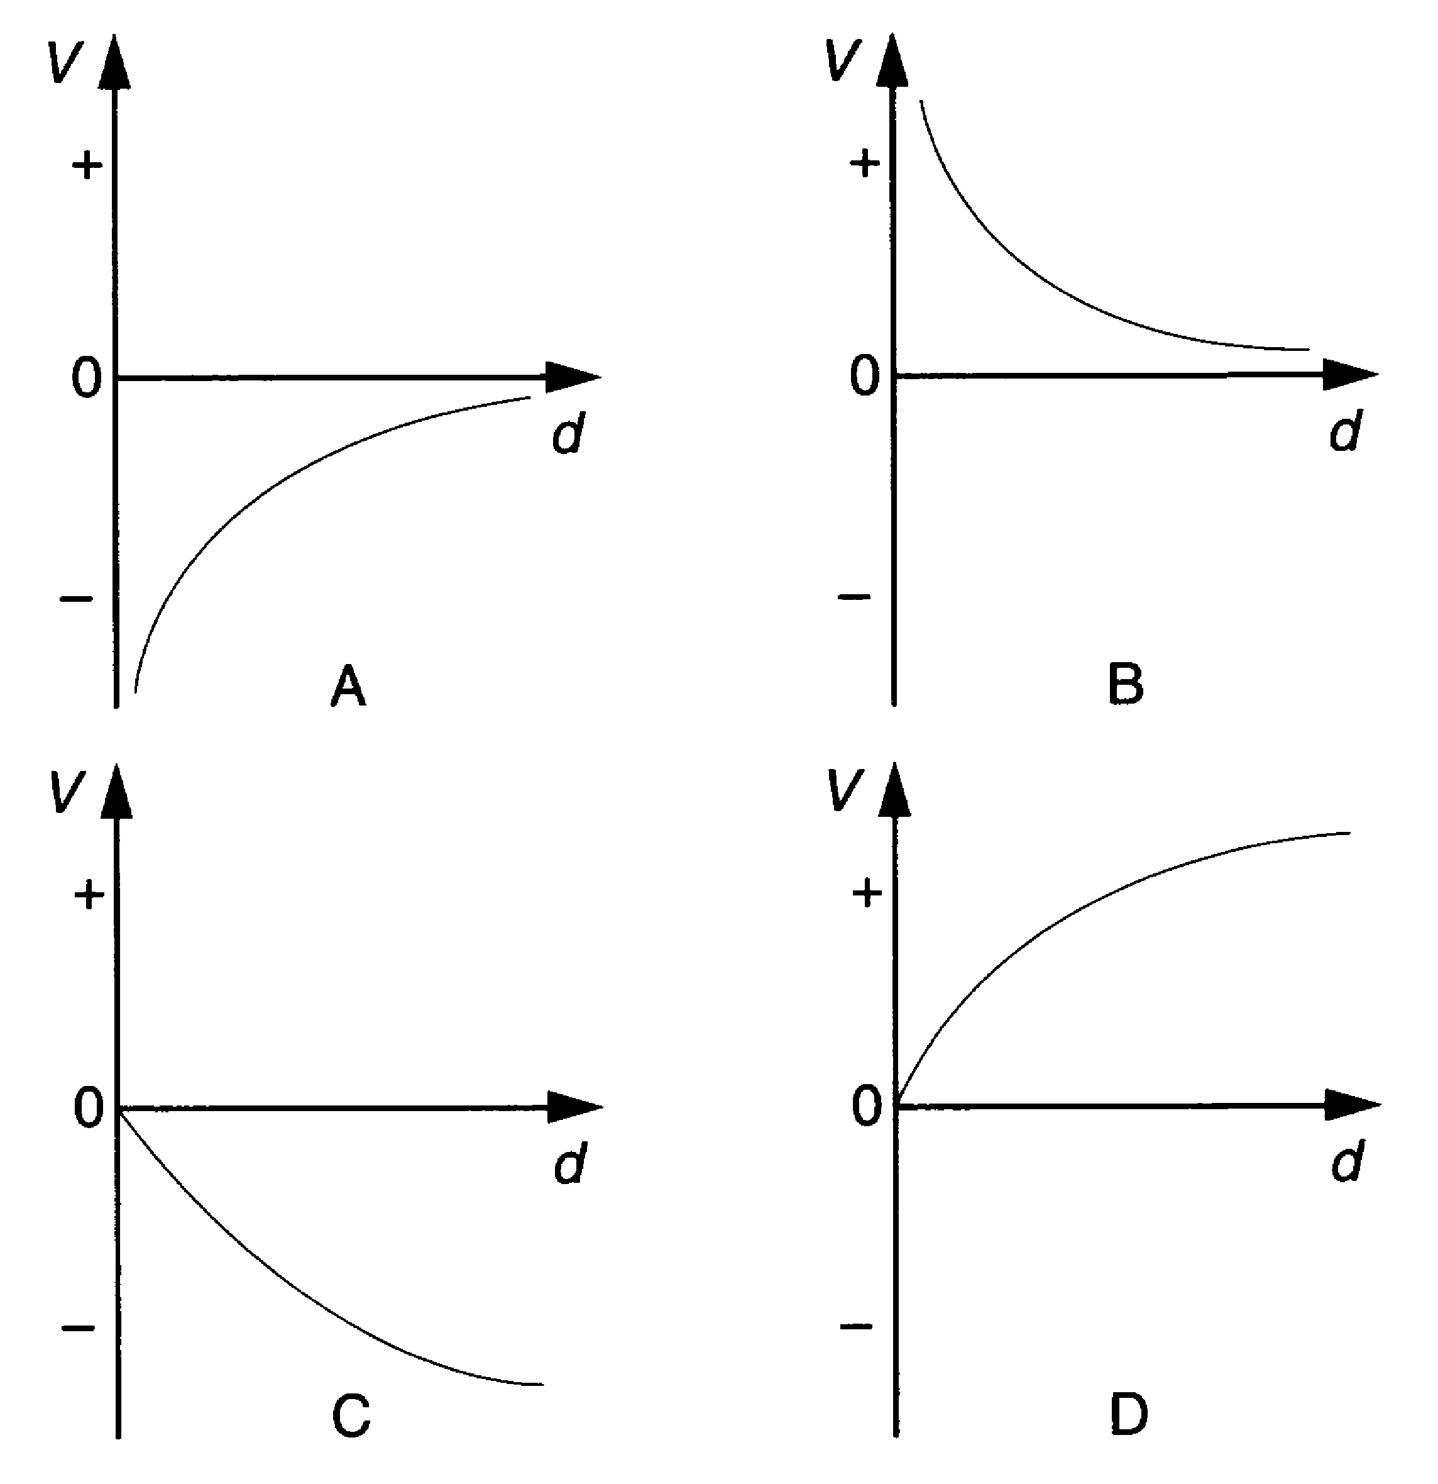

Which graph best shows the variation of potential with distance from a proton?

answer = .................. [1]

- A carbon-12 nucleus has a charge of +1.92 x 10^{–18} C.
Calculate the electric field strength at a distance of 5.0 x 10^{–11} m from the centre of the nucleus. State the unit with your answer.

electric field =.............................. [3]

- This question is about the motion of charged particles in magnetic fields.
Fig. 11.1 shows the path of a beam of ions in a vacuum as they pass through a magnetic field.

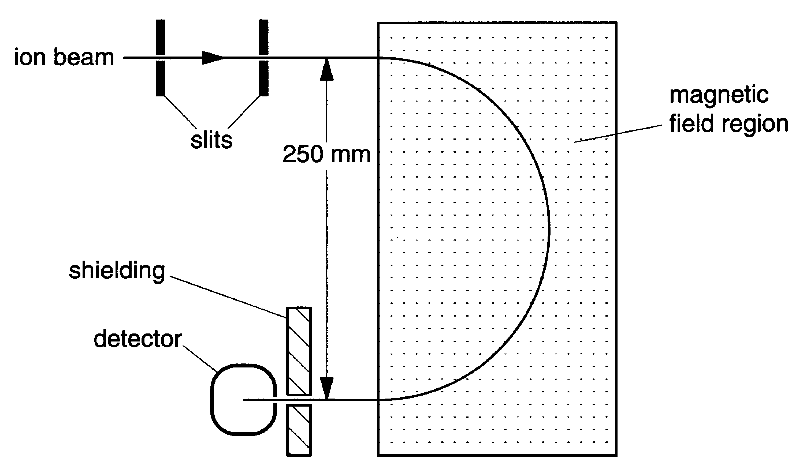

Fig. 11.1

The beam consists of singly ionised neon-20 atoms all with the same speed. After passing through a pair of slits to define the direction of the beam, the ions enter a region of uniform magnetic field at right angles to the plane of the diagram.

(a) Each ion is made by removing one electron from an atom. The beam current is 20 µA. How many neon ions enter the magnetic field region per second?
e = 1.6 x 10^{–19} C

number of ions = .................... s^{–1} [2]

(b) The ions are accelerated as they pass between the slits. The ions enter the first slit with a speed of 100 m s^{–1} and leave the second slit with a speed of 3.0 x 10⁵ m s^{–1}. The mass of a neon-20 atom is 3.32 x 10^{–26} kg.

- Calculate the increase of kinetic energy of a single ion as it passes between the slits.

kinetic energy increase = ..................... J
- Show that the potential difference between the slits must be greater than 5 kV.
e = 1.6 x 10^{–19} C

[4]

- As the beam passes through the magnetic field it follows a circular path of radius 0.125 m.

(i) Explain why the path is circular.

(ii) Each neon-20 ion has a speed of 3.0 x 10⁵ m s^{–1}.
Show that the centripetal force required on an ion of mass 3.32 x 10^{–26} kg is
2.4 x 10^{–14} N.

(iii) By considering the magnetic force on a neon-20 ion, calculate a value for the magnetic flux density.

magnetic flux density = .................... T [6]

- On one occasion the neon-20 beam is contaminated with a small amount of neon-22. However, none of the neon-22 ions arrive at the detector.
Explain why.

[2]

- This question is about the forces in electric fields.

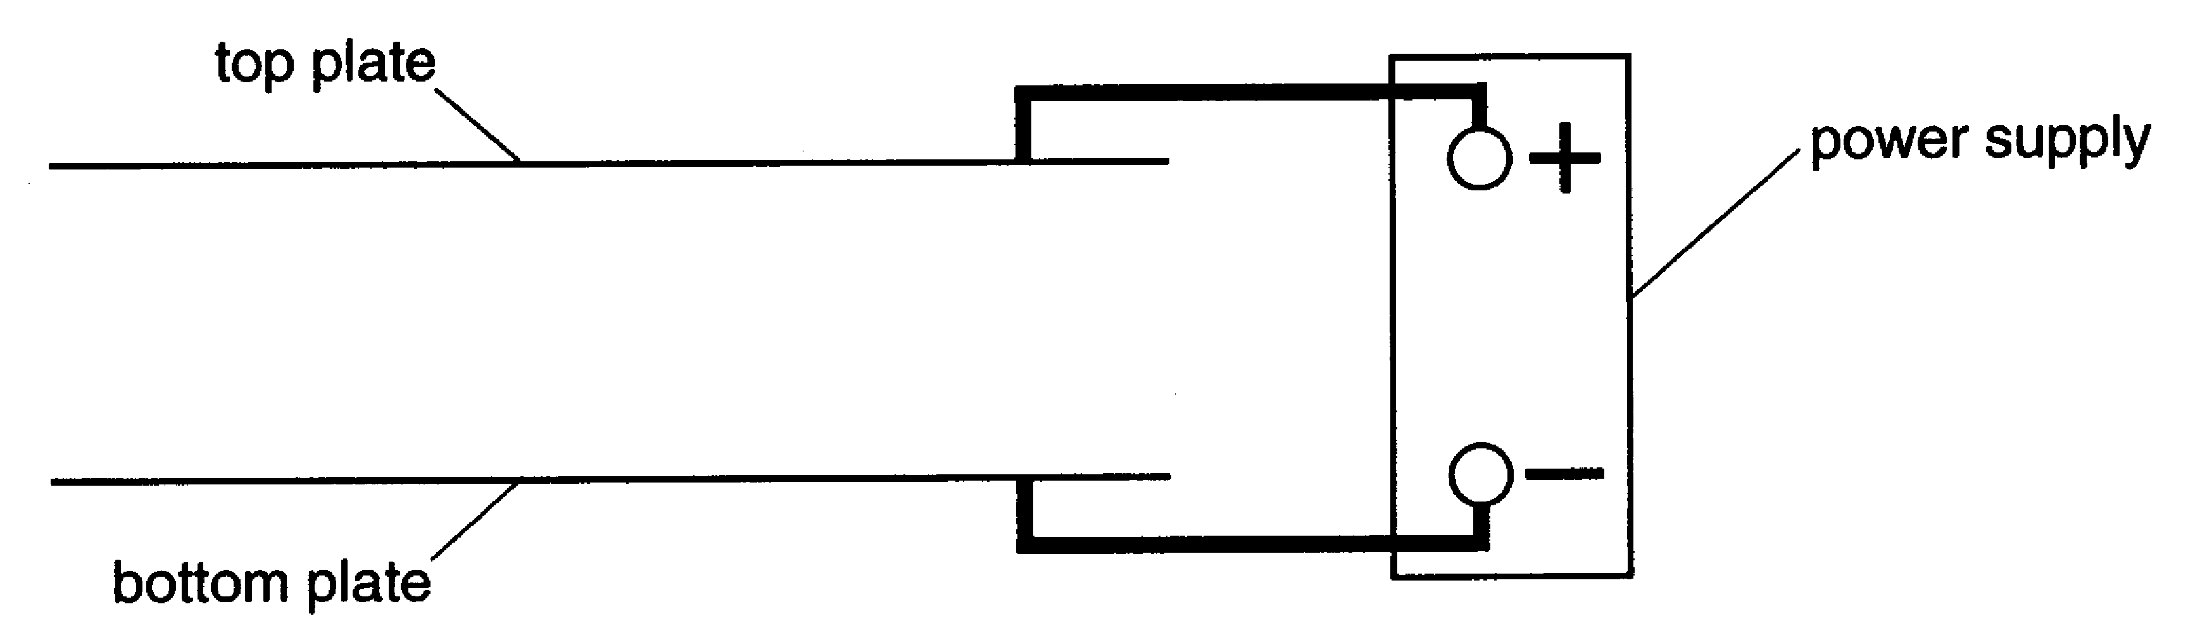

Fig. 12.1

- In Fig. 12.1, the plates are connected to a power supply.
Sketch five field lines in the gap between the plates.
[3]

A small metal sphere is place between the two horizontal plates, as shown in Fig. 12.2.

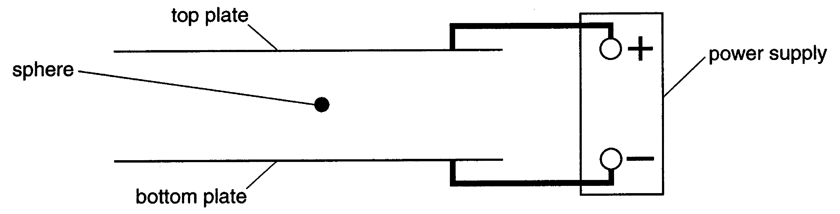

Fig. 12.2

The sphere is charged.
It does not move when the electric field is present.

- What sign of charge does the sphere have? Give reasons for your answer.

[3]
- The magnitude of the charge on the sphere is 4.8 x 10^{–14} C.
How many electrons had to be removed or added to give the sphere this charge?

number of electrons = ....................... [1]
- The mass of the sphere is 7.4 x 10^{–9} kg. The separation of the plates is 10 mm. For the sphere not to move,

(i) show that the electric field strength must be 1.5 x 10⁶ V m^{–1}.

[3]

(ii) calculate the potential difference required across the plates.

potential difference = ....................... V [2]

- The magnitude of the charge on the sphere can be changed by exposing the air between the plates to radiation from a beta source.
Explain how this can alter the charge on the sphere.

[3]

- The diagram shows the path followed by a 4 MeV proton as it almost collides head-on with a large nucleus.

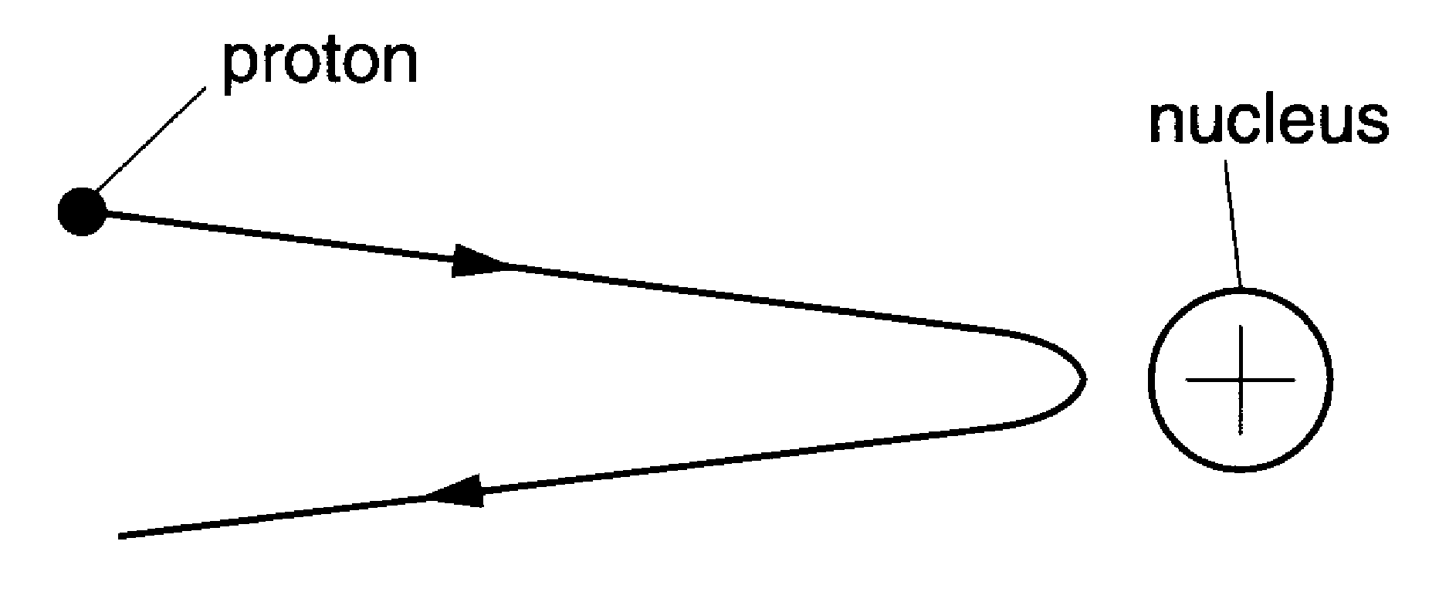

Another proton, with the same initial path, almost collides with the same nucleus. The proton has an energy of more than 4 MeV.
State and explain what difference this change would make to the distance of closest approach with the nucleus.

[2]

- The diagram shows part of the energy level diagram for an atom.

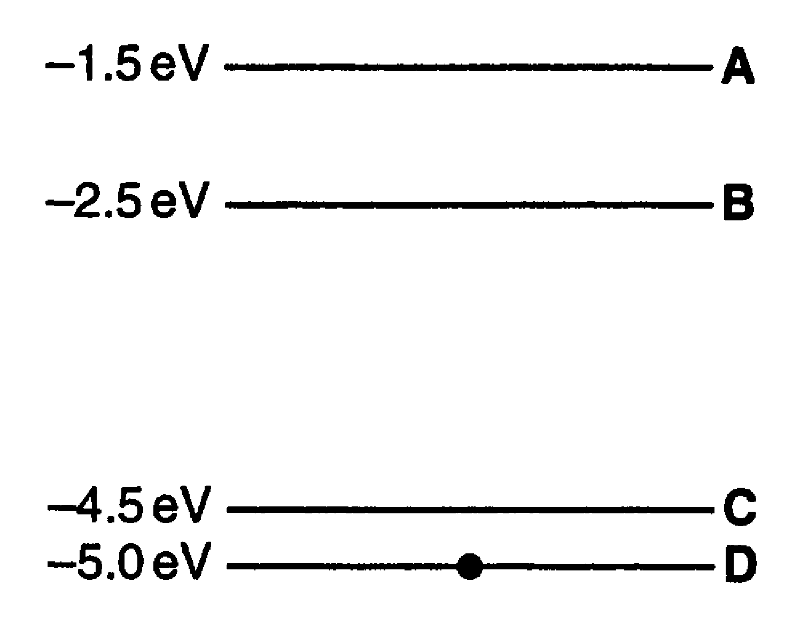

There are four energy levels, labelled A, B, C and D. The atom is initially in energy level D. An electron of energy 3.0 eV collides with the atom. This causes the atom to change energy level.

- If the collision raises the atom to energy level B, how much energy is the colliding electron left with?

energy = ....................... eV [1]

- Which energy level (A, B or C) will the atom definitely not be in after the collision?

energy level ....................... [1]

- This question is about the scattering of electrons from nuclei.

(a) The volume 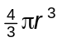of a nucleus of radius r is approximately proportional to the number of nucleons in it.

- What does this tell you about the arrangement of nucleons in a nucleus?

- Show that the radius r of a nucleus is given by the formula
r = r₀ A^{1/3}
where A is the atomic mass number and r₀ is a constant.

- Use the formula to show that the diameter of a neon-20 nucleus is
6.5 x 10^{–15} m. The constant r₀ = 1.2 x 10^{–15} m.

[7]
Electrons are directed towards a sample of neon-20 atoms, as shown in Fig. 15.1.

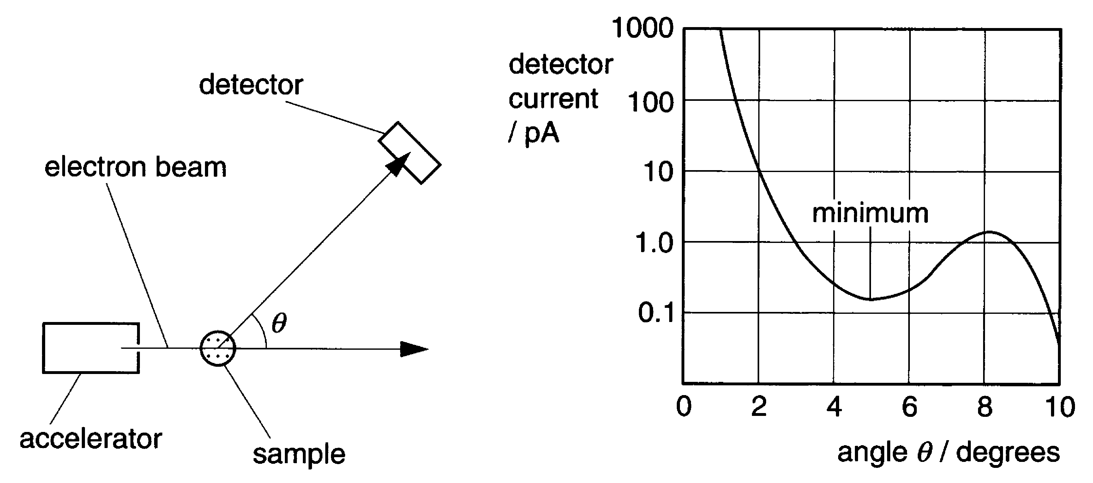

Fig. 15.1
(b) The graph of Fig. 15.1 shows the distribution of the electrons scattered elastically
from the sample. The graph shows a diffraction pattern.
By considering the path of electrons around a nucleus, explain why the graph has a minimum. No calculations are required.

[2]
- The angle θ for the first minimum of the diffraction of waves with wavelength λ around a circular object of diameter b is given by the formula
λ = 1.2 b sin θ
(i) Use the formula to show that the wavelength of the electrons in the beam is about 7 x 10^{–16} m.

(ii) Calculate the momentum of the electrons in the beam.
h = 6.63 x 10^{–34} J s

momentum = .................... N s [2]
- The neon-20 sample is replaced with a sample with the same number of argon-40 atoms. The graph of Fig. 15.2 shows what effect this has on the scattering of the electrons in the beam.

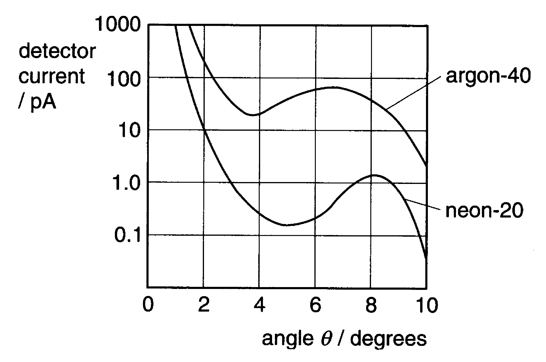

Fig. 15.2

Explain the differences between the two curves in the graph of Fig. 15.2. Both are produced by electron beams of the same energy.

[2]

Quality of Written Communication [4]

- This question is about energy levels of atoms in a crystal.

(a) A beam of infrared radiation is passed through a crystal.
The graph of Fig. 16.1 shows the infrared absorption spectrum of the crystal.

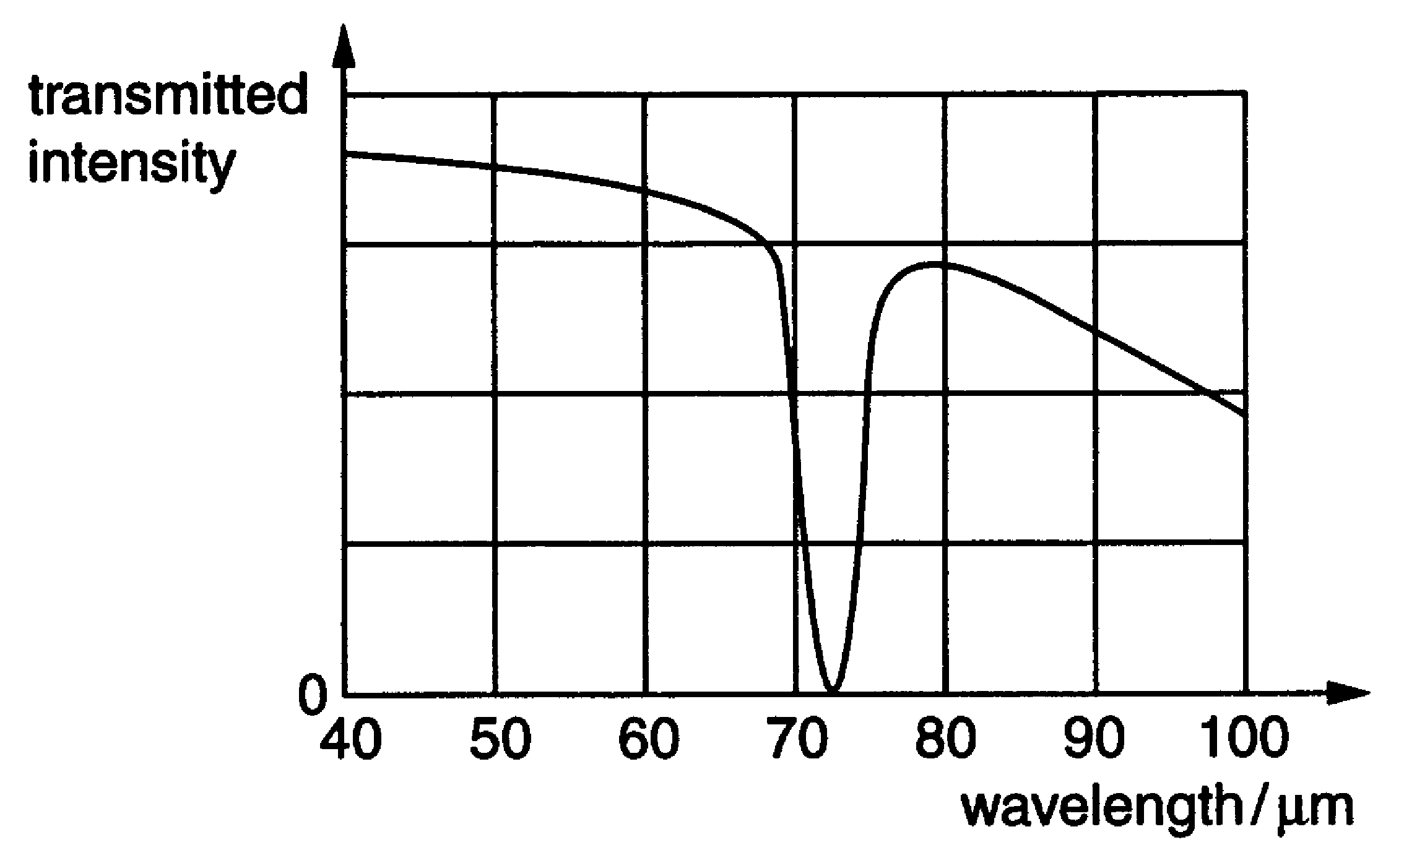

Fig. 16.1

- Show that the frequency of the infrared photons absorbed by atoms in the crystal is about 4 x 10¹² Hz.
c = 3.0 x 10⁸ m s^{–1}

[3]

- The infrared absorption spectrum suggests that the energy levels of atoms in the crystal are evenly spaced, as shown in Fig. 16.2.

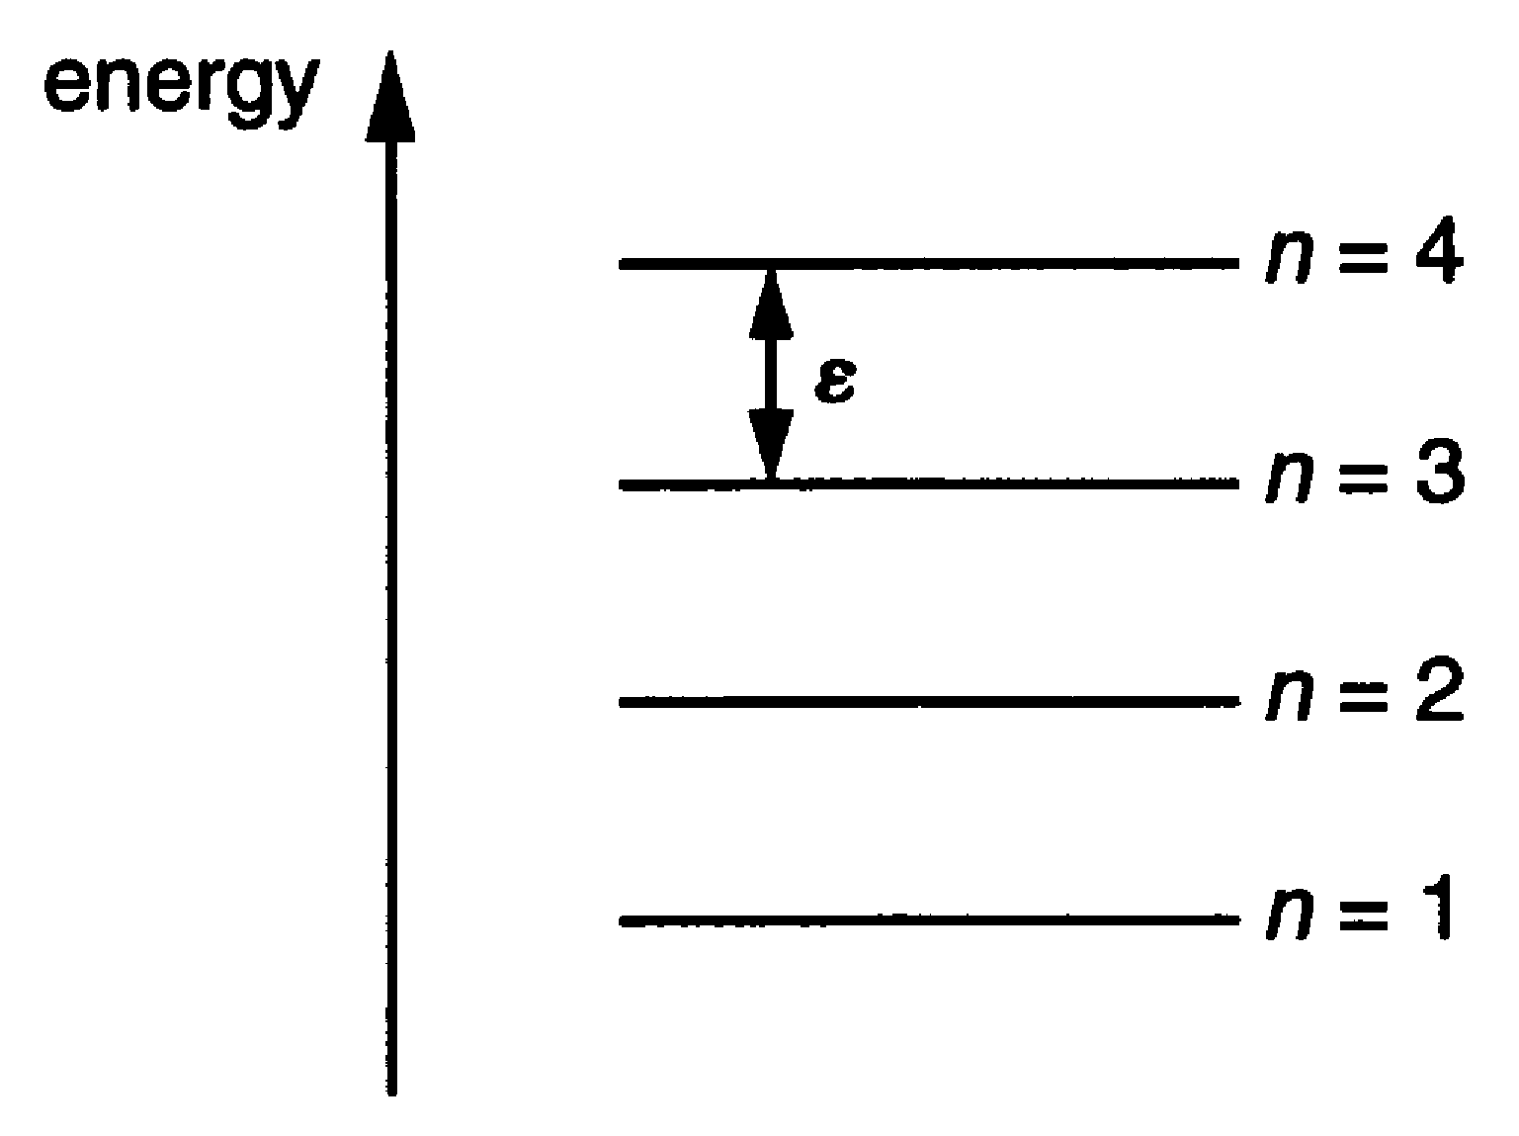

Fig. 16.2

The photons are absorbed when atoms move from one energy level to the next level.
On Fig. 16.2, draw an arrow to show the absorption of an infrared photon by the atom in the state n = 2.
[1]
- Use your answer to (i) to calculate a value for ε, the separation of the energy levels.
h = 6.6 x 10^{–34} J s

ε = ......................... J [2]

(b) The oscillating motion of an atom in the crystal changes when it absorbs or emits an infrared photon. The bonds between each atom and its neighbours restrict its movement. This suggests a very simple model of a particle trapped in a box.
Fig. 16.3 shows a standing wave pattern for an atom in such a box when n = 3.

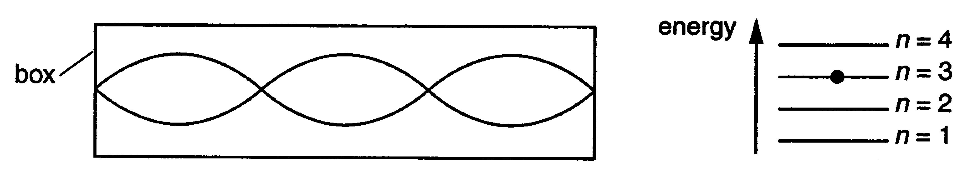

Fig. 16.3

(i) On Fig. 16.4 draw the standing wave for an atom when n =1.

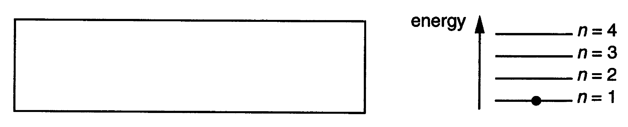

Fig. 16.4
[2]
(ii) The kinetic energy E of an atom of mass m with momentum p is given by the formula
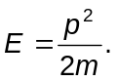
Show that the de Broglie wavelength λ of the atom is given by
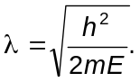

[3]

(iii) When the atom is in its lowest energy state, the energy E is 1.35 x 10^{–21} J.
Calculate the de Broglie wavelength of the atom in its lowest energy state.
m = 5.1 x 10^{–26} kg

wavelength = ........................ m [1]

(c) (i) Use your answer to (b)(i) and (b)(iii) to estimate the length of the box which traps the particle when n =1.

length = ........................ m [1]

(ii) The model only predicts the correct energy levels if the length of the box trapping the particle increases with increasing energy.
Show this by calculating the length of the box for n = 3.

length = ........................ m [2]

[Total: 15]

Quality of Written Communication [4]

- The equation shows a possible neutron-induced fission for a nucleus of plutonium-239.
How many neutrons are emitted?

number of neutrons = ....................... [1]

- Silicon-31 is an emitter of beta particles. It has a half life of 9.4 x 10³ s.

(a) Show that its decay constant λ is about 7 x 10^{–5} s^{–1}.

[1]

(b) The activity of a radioactive source can be calculated with the relationship
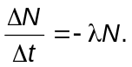
Use the relationship to show that the decay constant has units of s^{–1}.

[1]

(c) Calculate the number of silicon-31 atoms needed to make a source of activity
3 x 10³ Bq.

number of atoms = ............................ [1]

- The typical dose equivalent for a chest X-ray is 2 x 10^{–4} Sv.
A dose equivalent of 1 Sv gives a person a 3% probability of developing cancer.
Calculate the probability of a person developing cancer from one chest X-ray per year for 25 years.

probability = ........................ % [2]

- Cobalt-60 is a radioisotope which emits gamma photons of energy 1.2 MeV.
Calculate the mass loss due to the emission of one gamma photon.

mass = ....................... kg [3]

- This question is about the fusion of hydrogen-2 nuclei.
The fusion of a pair of hydrogen-2 nuclei to make a nucleus of helium-3 and a neutron is given by this symbol equation.
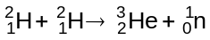
The table gives the masses of the particles in this equation.

particle | mass/u
neutron | 1.0087
hydrogen-2 | 2.0141
helium-3 | 3.0160

(a) The fusion reaction results in a transfer of rest energy to kinetic energy.

- Show that the decrease of mass resulting from the fusion of two hydrogen-2 nuclei is 0.0035 u.

- Calculate the kinetic energy resulting from this mass decrease.
1 u = 1.66 x 10^{–27} kg.

kinetic energy =.................... J [4]
(b) A proton bound in a nucleus can decay into a neutron by emitting a positron and a
neutrino.

(i) Write down a symbol equation to represent the decay of a proton.

(ii) Use the data in the table to calculate the change in mass when a proton decays to a neutron.

particle | mass/u
neutron | 1.0087
positron | 0.00055
proton | 1.0073

change of mass =.................... u

(iii) Use your answer to (b)(ii) to suggest why this decay is not possible for a free proton.

[5]

- This question is about the risks of ionising radiation.
A school purchases the three radioactive sources shown in the table.

source | emission | half-life/year
cobalt-60 | gamma photons | 5.3
strontium-90 | beta particles | 28.1
americium-241 | alpha particles | 458

- All three sources are delivered to the school with the same activity of 4.0 x 10⁴ Bq. This means that the alpha particle source contains the largest number of unstable nuclei. Explain this fact.

[2]

- The sources arrive in a lead-lined box. This absorbs all of the emissions from the alpha and beta sources, but not from the gamma source.

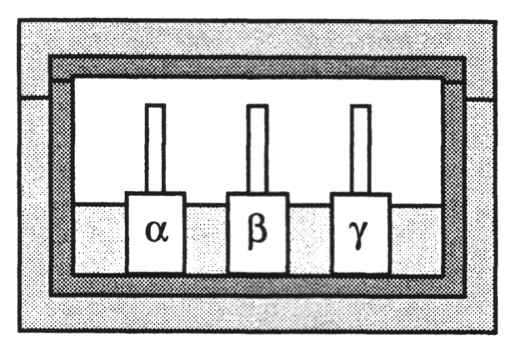

- 10 mm of lead absorbs half of the gamma photons incident on it.
Sketch a graph on the axes below to show how the transmission of the gamma photons through the lead depends on its thickness.

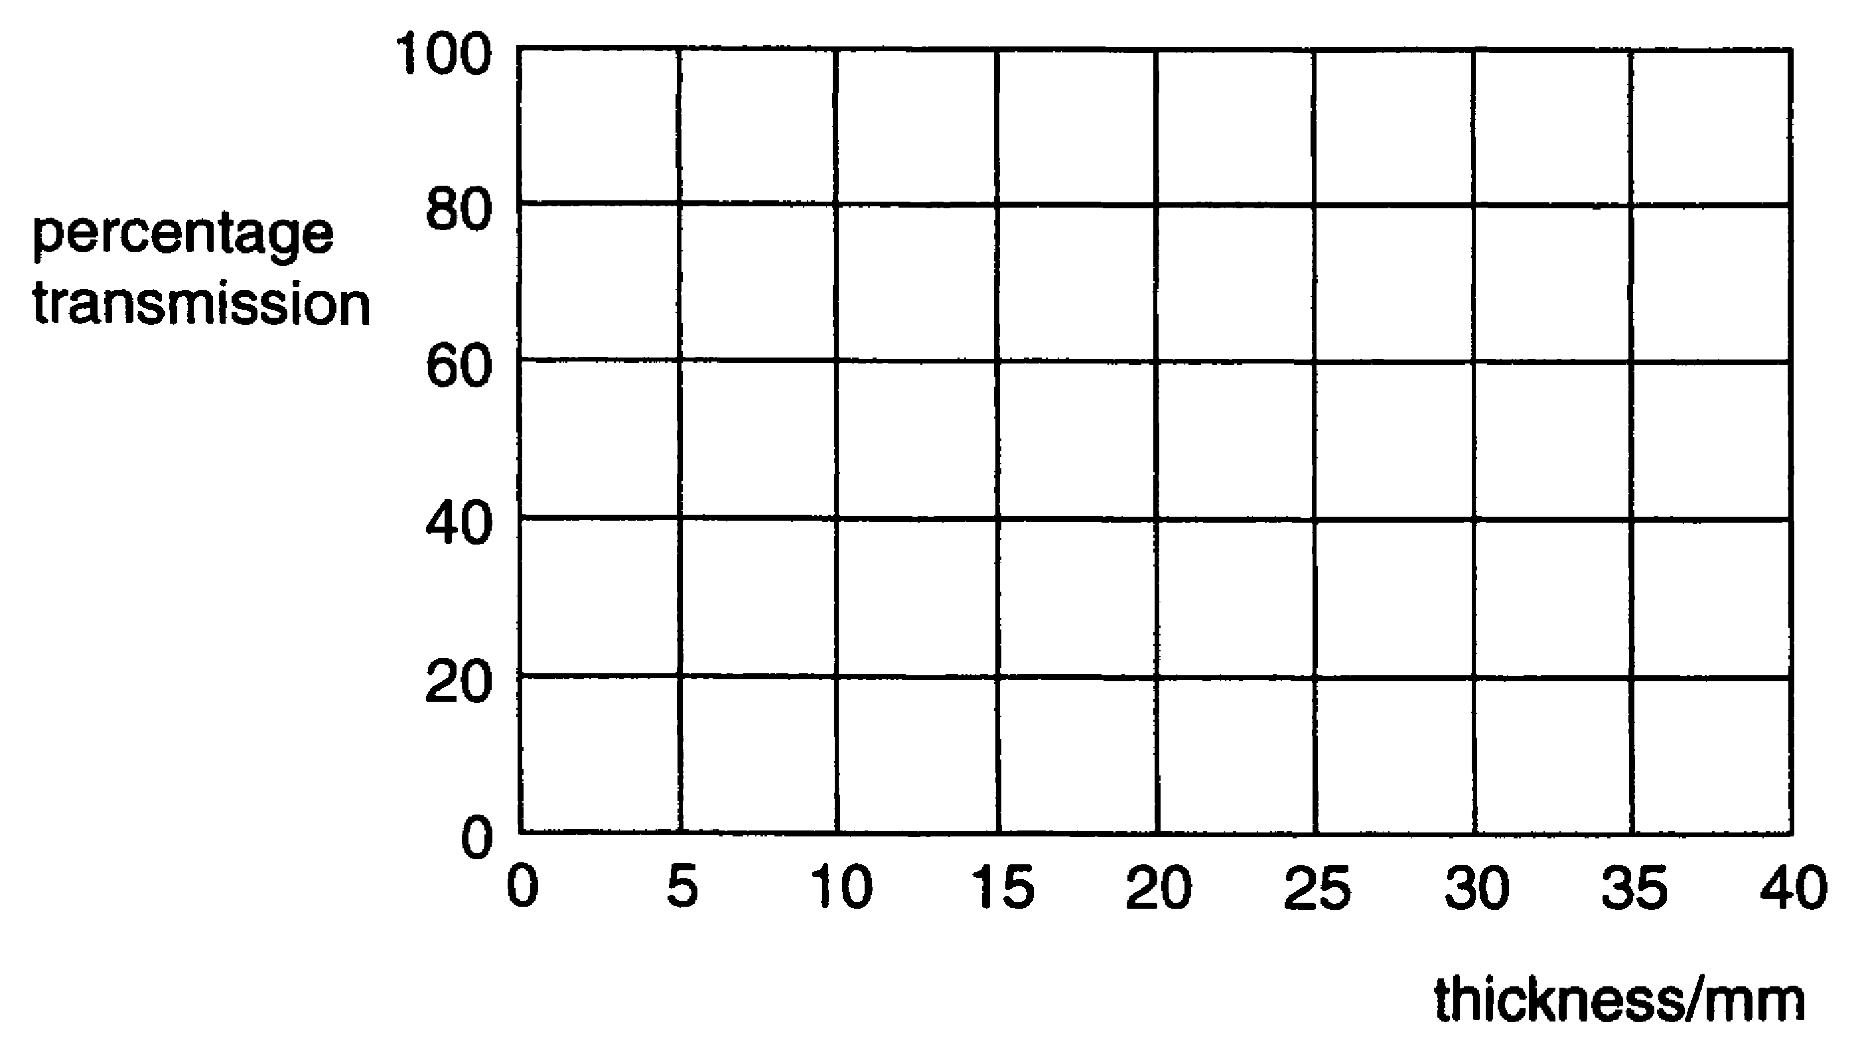
[3]
- The lead of the box is 25 mm thick. The activity of the gamma photon source is 4 x 10⁴ Bq.
Use the graph to estimate the number of gamma photons escaping from the box per second.

number per second = ....................... s^{–1} [2]

- A student keeps the beta particle source in his pocket for an hour before returning it to its box.

(i) Explain why the student can only absorb at most half of the particles emitted by the source when it is in his pocket.

[1]

(ii) The activity of the beta particle source is 4 x 10⁴ Bq.
The energy of each beta particle is 8.8 x 10^{–14} J.
Show that the maximum energy absorbed from the source by the student is about 6 µJ.

[2]
(iii) The student considers the risk that he has taken.
He assumes that the dose of 6 µJ is shared evenly over his mass of 60 kg. This gives a dose equivalent of 0.1 µSv.
The whole-body dose equivalent from background radiation is about 2 mSv per year, equivalent to 4 nSv per hour.
The student concludes wrongly that keeping the beta particle source in his pocket has increased his risk of cancer considerably.
Discuss the student's assumption and conclusion.
[2]

[Total: 12]

- This question is about an electric car.

(a) The car is driven by a dc electric motor. To avoid wasting energy when the car slows down, it is proposed to use the motor as a generator to recharge the batteries. Fig. 23.1 below is a simplified diagram of such a motor/generator.

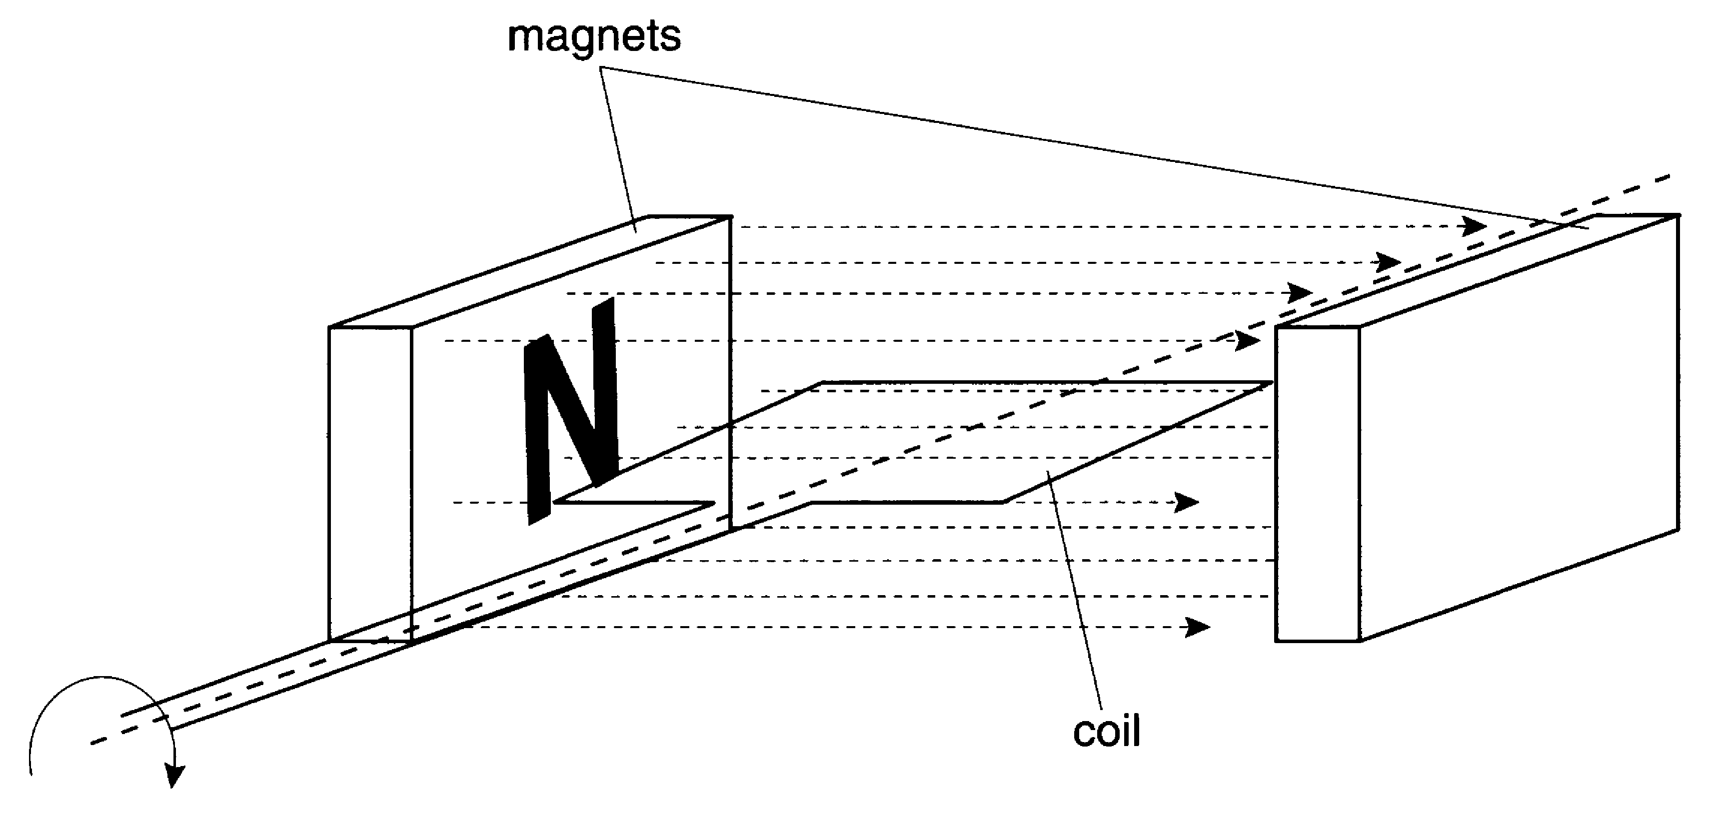

Fig. 23.1

(i) Explain, using the diagram of Fig. 23.1, how an emf is produced in this generator when the coil rotates.

(ii) The graphs A to D in Fig. 23.2 below show the average dc emf produced by the motor/generator as the car comes to a halt when using the motor to decelerate from its maximum speed. Choose the one of which best shows the emf during this time.

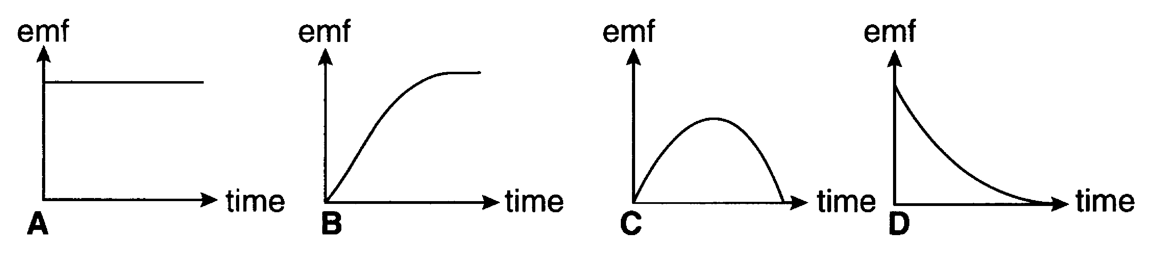

Fig. 23.2
The correct graph is...................... [3]

(b) Electric cars have the disadvantage of poor acceleration. Suggest and explain one reason for this.

[2]

Quality of Written Communication [4]
- This question about nanomotors is based on an advanced notice article on ‘Nanotechnology’.

(a) The article states that good electromagnetic machines need to be large.
Fig. 24.1 shows two electromagnetic motors which differ only in size.

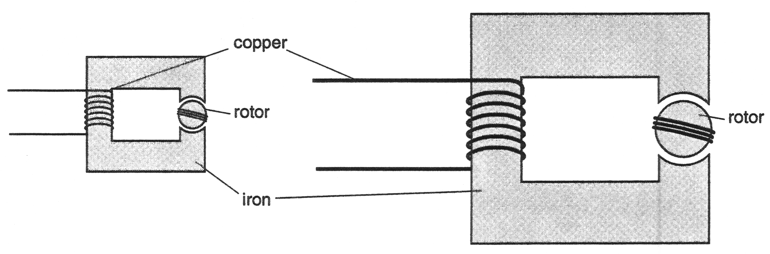

Fig. 24.1

- Considering the electrical circuit, explain why the larger machine can produce a larger flux in the rotor than the smaller one for the same p.d. across the copper coil.

[3]

- Considering the magnetic circuit, explain why the larger machine can produce a larger flux in the rotor than the smaller one for the same current in the copper coil.

[2]

(b) Centripetal forces are less of a problem for small motors.
Explain why centripetal forces can make rapidly-spinning motors break.

[3]
(c) Part of a simple electrostatic motor is shown in Fig. 24.2.

(i) On Fig. 24.2, draw a field line through X to show the electrical field produced by the two charged regions of the stator.
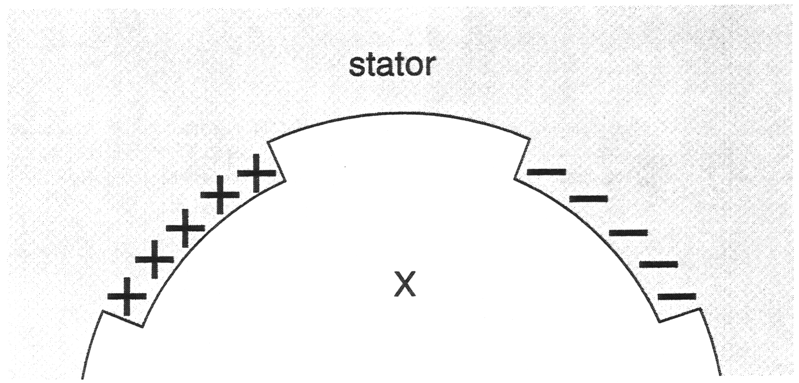

Fig. 24.2
[2]

(ii) Fig. 24.3 below shows a charged part of the rotor between the two conducting parts of the stator. Explain, in terms of the electric field, why the rotor rotates.

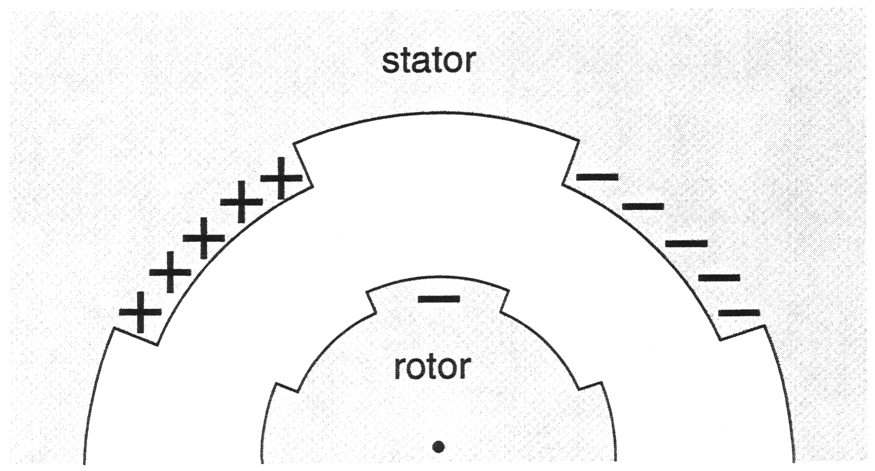

Fig. 24.3

[2]
[Total: 12]

- This question is about the photomultiplier tube in a gamma camera.

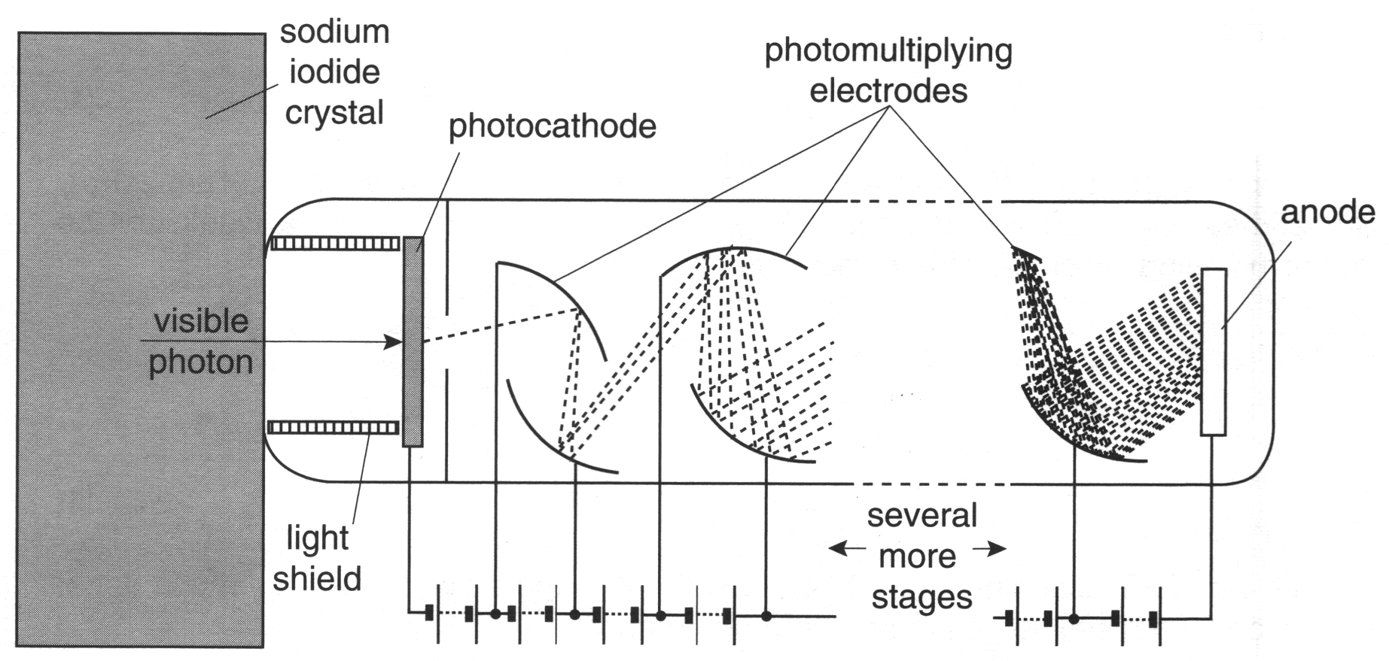

Fig. 25.1

- Explain why the photomultiplier tube needs the opaque light shield shown in Fig. 25.1.

[2]
- The graph of Fig. 25.2 shows the p.d. in the region between the photocathode and the first photomultiplying electrode. It is assumed that the electric field is constant in this region.

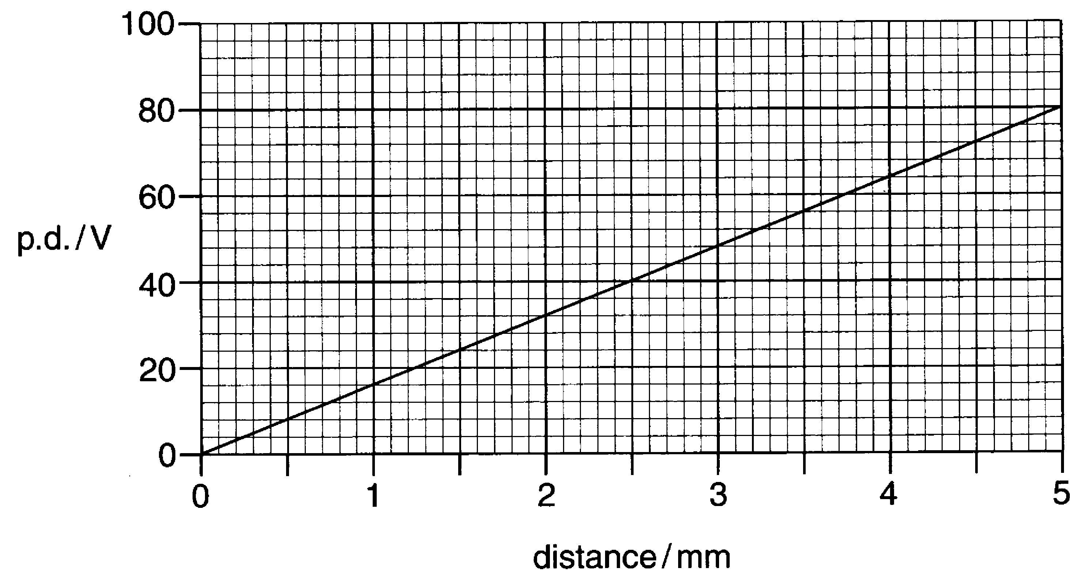

Fig. 25.2

- Explain how this graph shows that the electric field in this region is constant.

[2]

- Show that the electric field in this region is 16 000 V m^{–1}.

[2]

- Show that the force on an electron in this region is about 2.6 x 10^{–15} N.

[2]
- Show that the acceleration of this electron is very much greater than g, the acceleration due to gravity on Earth.

[2]

- This question is about the fundamental particles called positrons, which have the same mass as electrons, but an opposite charge. Fig. 26.1 shows the type of paths that positrons can give in a cloud chamber, where they ionise air molecules.

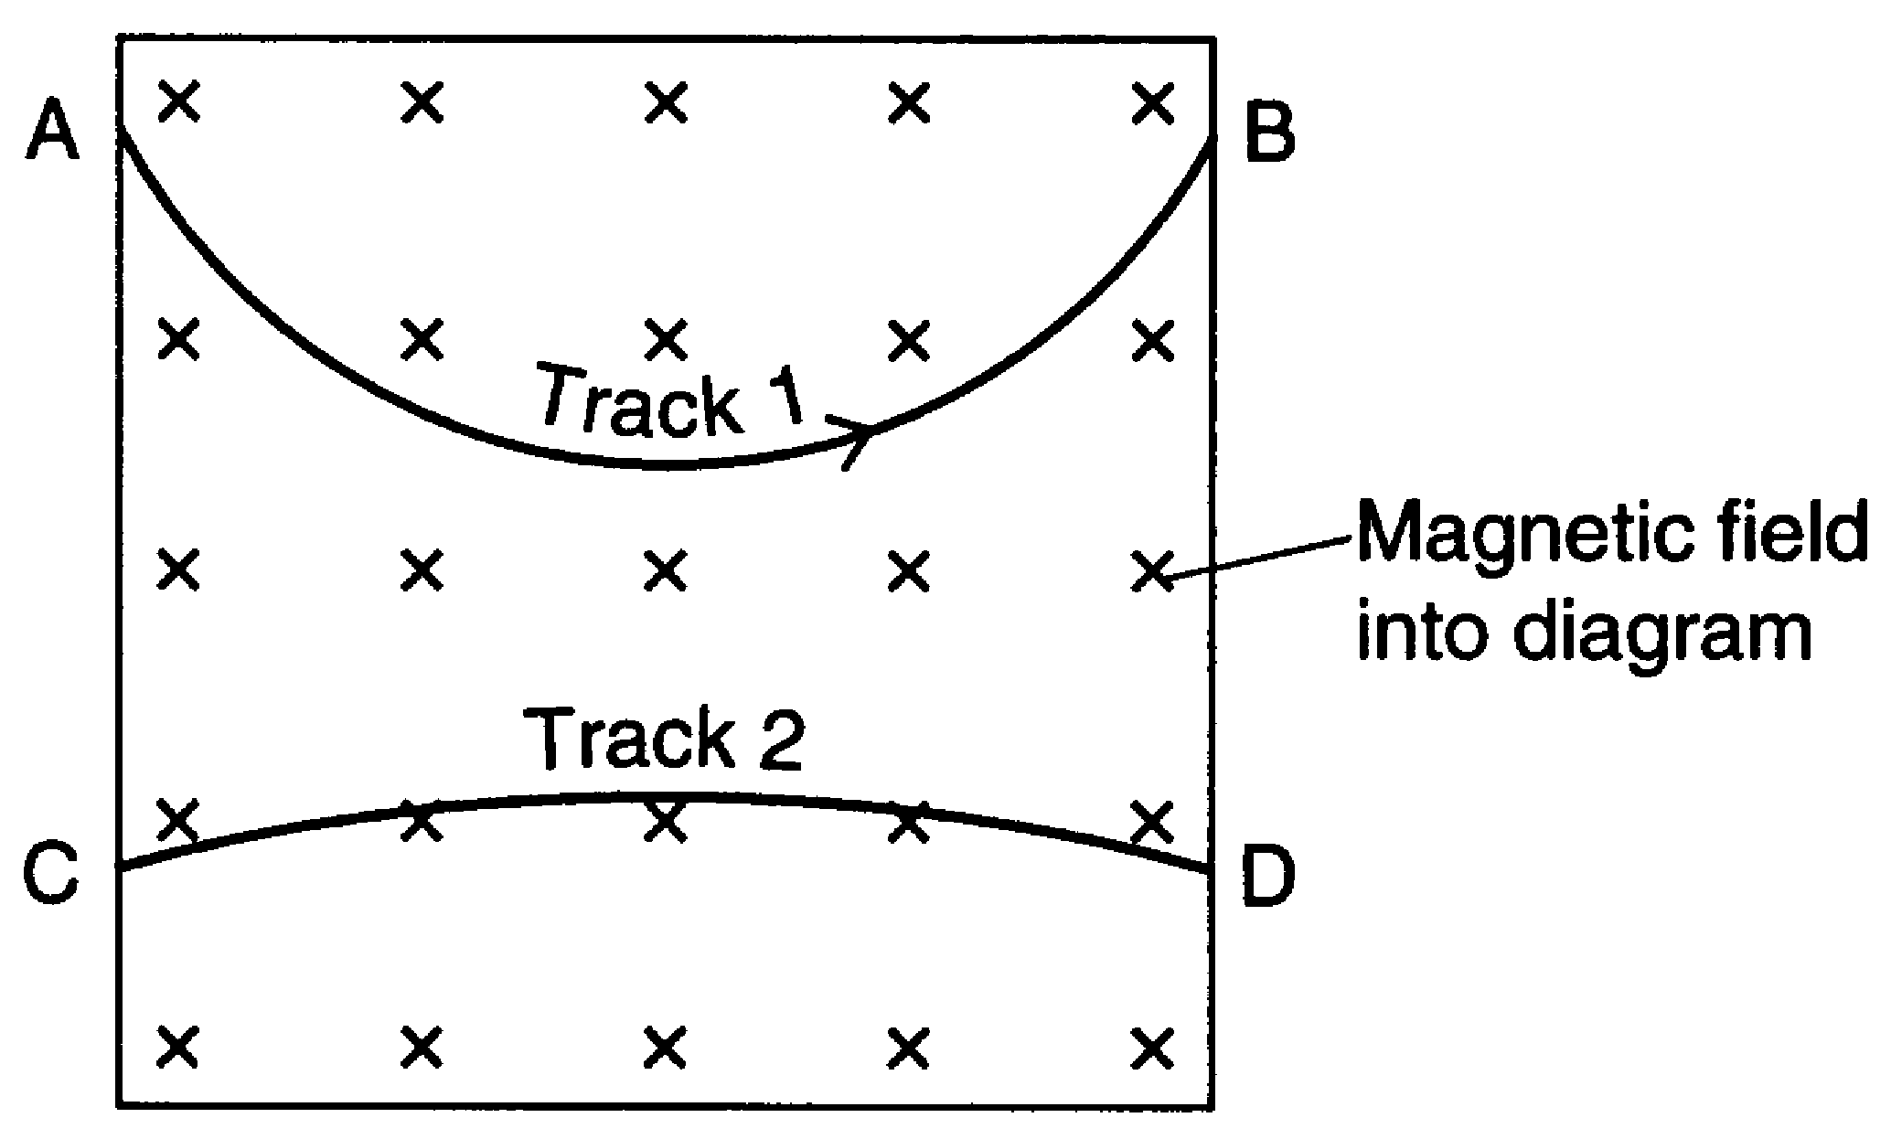
Fig. 26.1

Track 1 was produced by a high-speed positron travelling from A to B. A uniform magnetic field, perpendicular to the diagram, makes the positron travel in a curved path as shown.

- Track 2 was produced by a second positron. What two facts can you deduce about the positron that produced track 2? Explain your reason in each case.
Fact 1:
Explanation:
Fact 2:
Explanation:

[4]

A positron can be produced when a gamma photon (passing near a nucleus) creates an electron and a positron, and no other particles, in pair production as shown in the diagram below.
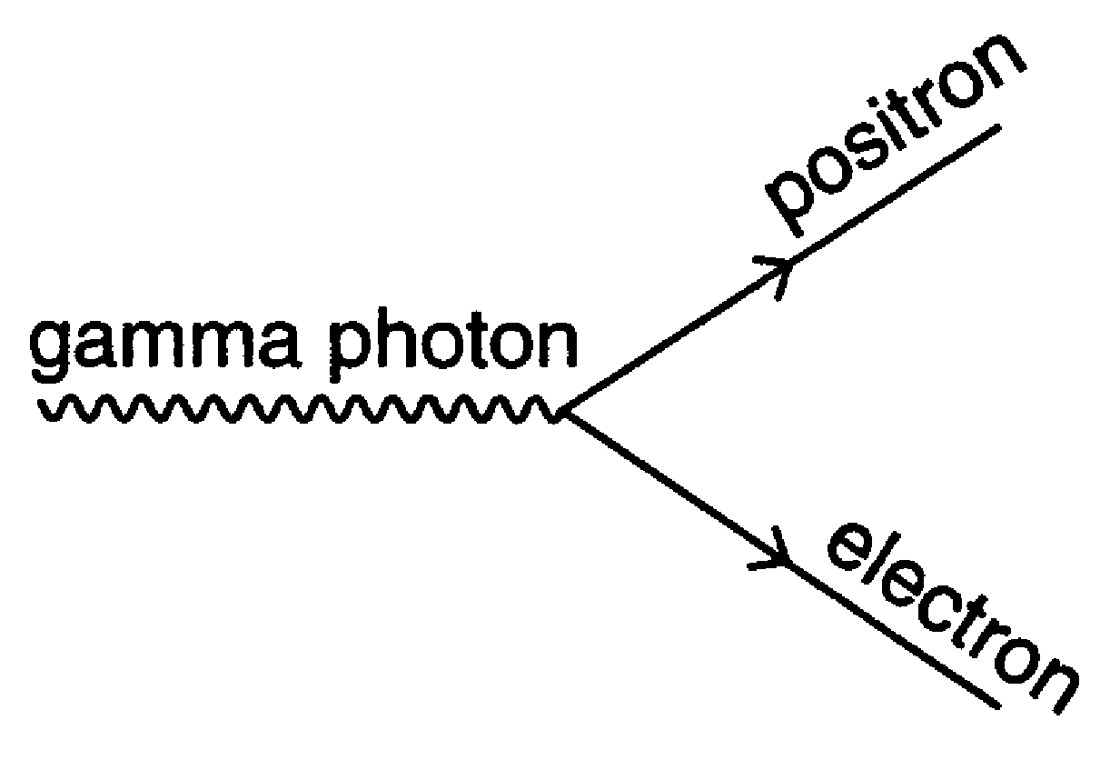
Fig. 26.2

- Explain why, if pair production is possible, the positron must have a charge equal and opposite to that of the electron.

[2]
When pair production occurs in a cloud chamber, Fig. 26.3 shows a typical pattern obtained.

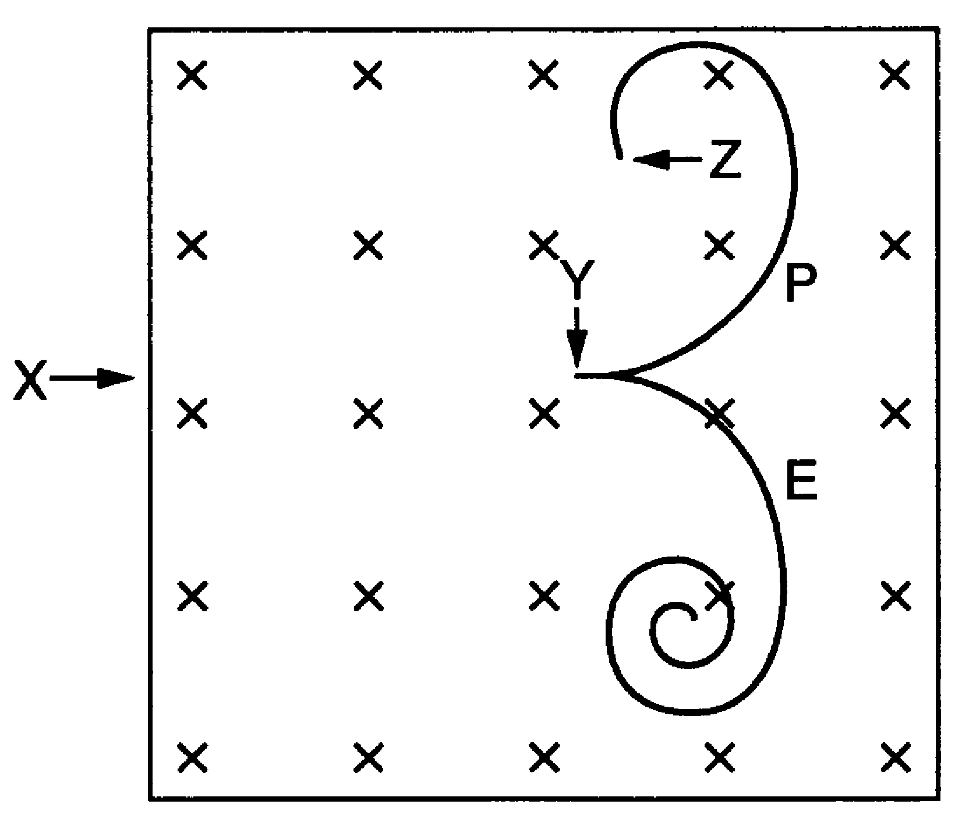

Fig 26.3

In Fig. 26.3, a gamma photon entered the chamber at X, and at Y it converted into a positron (P) and an electron (E).

- Suggest why the gamma photon leaves no track in the cloud chamber in Fig. 26.3.

[2]

- The electron and positron paths spiral inwards because the particles are slowing down. Explain why they are slowing down.

[2]

- The path of the positron suddenly stops at Z. Explain what happens at this point.

[2]

[Total :12]
Quality of Written Communication [4]

- This question is about carbon-14 in the body.
All living matter contains carbon-14, which decays, following the equation:
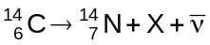

(a) Identify the particle X in this equation.

[1]
(b) The decay constant λ of carbon-14 is 3.8 x 10^{–12} s^{–1}.
Show that the half-life of carbon-14 is about 6000 years.
1 year = 3.2 x 10⁷ s

[3]
(c) A man of mass 65 kg contains about 1.3 x 10^{–11} kg of carbon-14.

- Show that 1.3 x 10^{–11} kg of carbon-14 consists of about 5 x 10¹⁴ atoms of carbon-14.
u =1.7 x 10^{–27} kg

[2]
- A 65 kg man contains about 5 x 10¹⁴ atoms of carbon-14. Show that the activity of the carbon-14 in a 65 kg man is about 2 kBq.

[2]
(d) When an organism dies, the carbon-14 stops being replaced and gradually decays
away.

(i) A preserved human body, about 65 kg in mass, was found in a glacier in the Alps. It is thought to be 5000 years old.
Explain why the activity of the carbon-14 in the body is about 1 kBq.

[1]

(ii) A measurable activity is about 10 Bq (significantly larger than the background count). Estimate the mass of tissue from the preserved body from the glacier which would have an activity of 10 Bq due to carbon-14, and explain why museums are reluctant to allow radiocarbon dating of this sort on their specimens.

[2]

(e) (i) A 65 kg man is constantly receiving a dose from the carbon-14 in his own body.
Each decay releases 2.5 x 10^{–14} J. If the activity of the carbon-14 in his body is
2 kBq, calculate the energy absorbed in the body each second. You can
assume that the body absorbs all the radiation emitted.

energy absorbed each second .................................. J [1]

(ii) Calculate the absorbed dose, in Gy, that a 65 kg man would expect to receive over a year from the carbon-14 in his body.

absorbed dose .................................. Gy [2]

(iii) Carbon-14 is not the only radionuclide in your body. Radioactive potassium-40 is also present. The dose you receive from your carbon-14 is much less than the dose you receive from your potassium-40.
Suggest reasons for this.

[3]

[Total: 17]
Quality of Written Communication [4]

